Supplementary Material - Marine turtle sightings and strandings around the UK and Ireland: long-term insights into conservation status
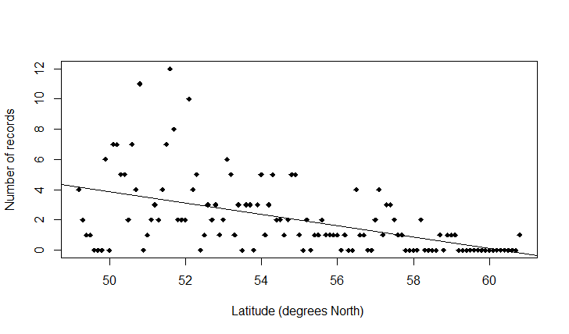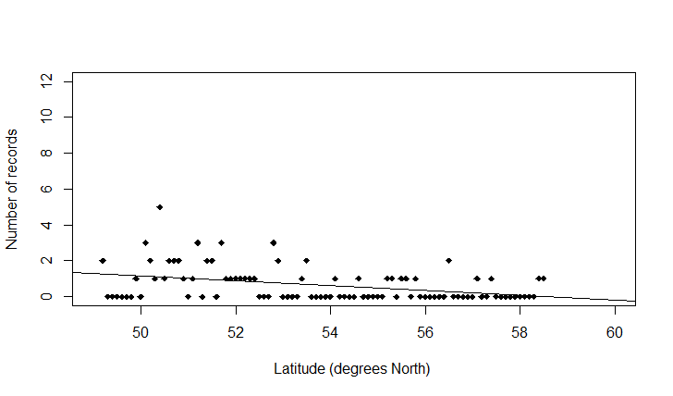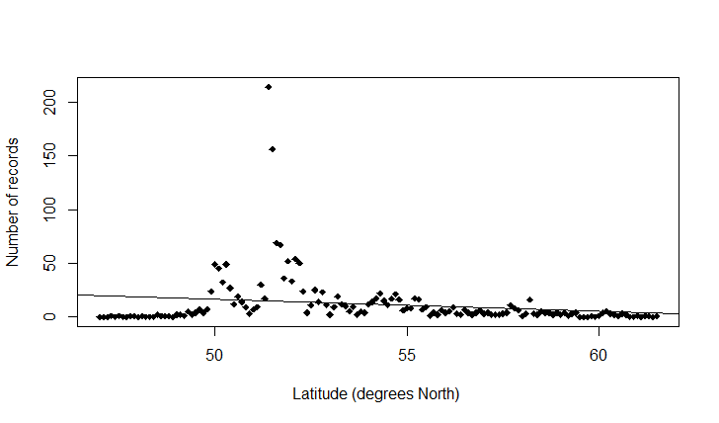
a)
b)
c)
Fig. S1 The number of sightings and strandings records at different latitudes from the UK and Ireland 1910-2018: a) loggerhead turtles (n=236), b) Kemp’s ridley turtles (n=61), c) leatherback turtle (n=1683).

a)
b)
c)

Fig. S2 The number of alive and dead sightings and strandings records at different latitudes from the UK and Ireland 1910-2018: a) loggerhead turtles (n=236), b) Kemp’s ridley turtles (n=61), c) leatherback turtle (n=1683).

