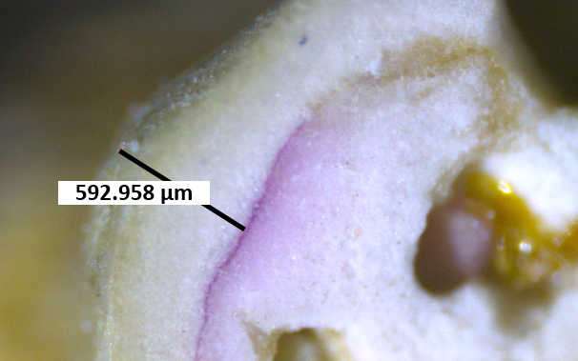

**Supplementary Figure S1** Longitudinal section of rhodolith protuberance. View under microscopy, 1.5 year after alizarin red staining (lines indicate the growth).