Supplementary Material

Supplementary Table S1. Monthly sea surface temperature values (°C) obtained for 133 grid cells in which southern right whale presence had been recorded over the austral winters of 2017 and 2018.
Month | 2017 |  |  |  | 2018
 | n | mean | median |  | n | mean | median
May | 51 | 8.0 | 8.0 |  | 100 | 6.9 | 6.9
June | 22 | 5.1 | 5.0 |  | 17 | 5.7 | 5.6
July | 84 | 4.5 | 4.4 |  | 1 | 3.6 | 3.6
Aug | 76 | 5.4 | 5.5 |  | 27 | 4.4 | 4.4
Sep | 78 | 4.0 | 3.4 |  | 91 | 5.4 | 5.2
Oct | 103 | 6.4 | 6.5 |  | 88 | 6.1 | 6.1

(A)  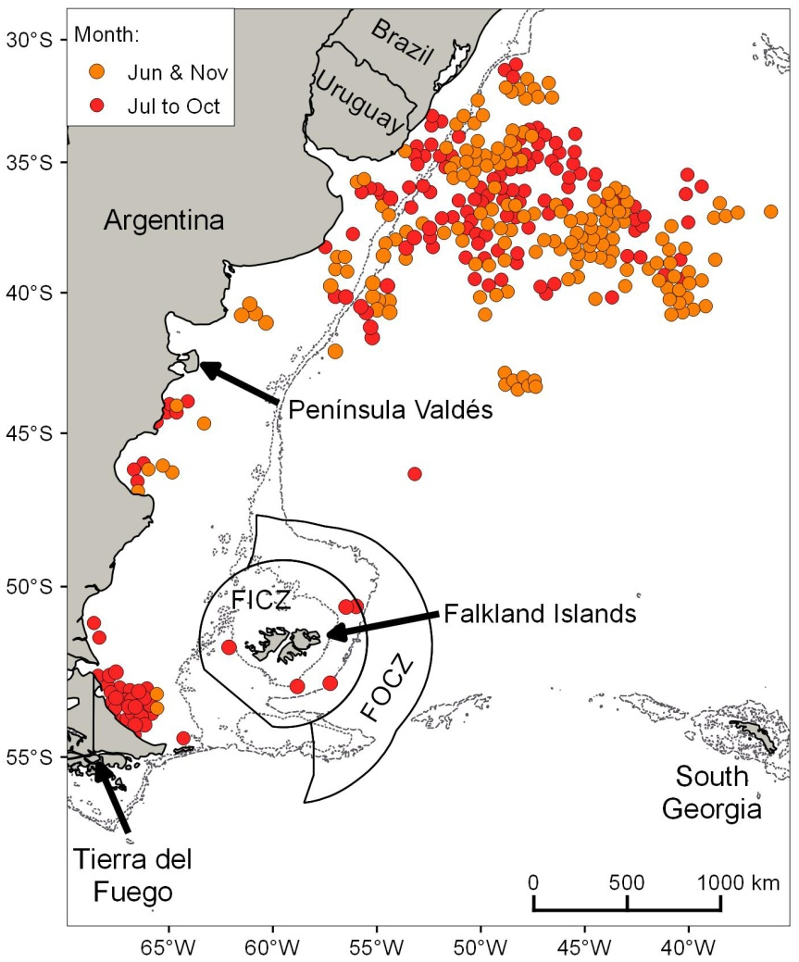 | (B)  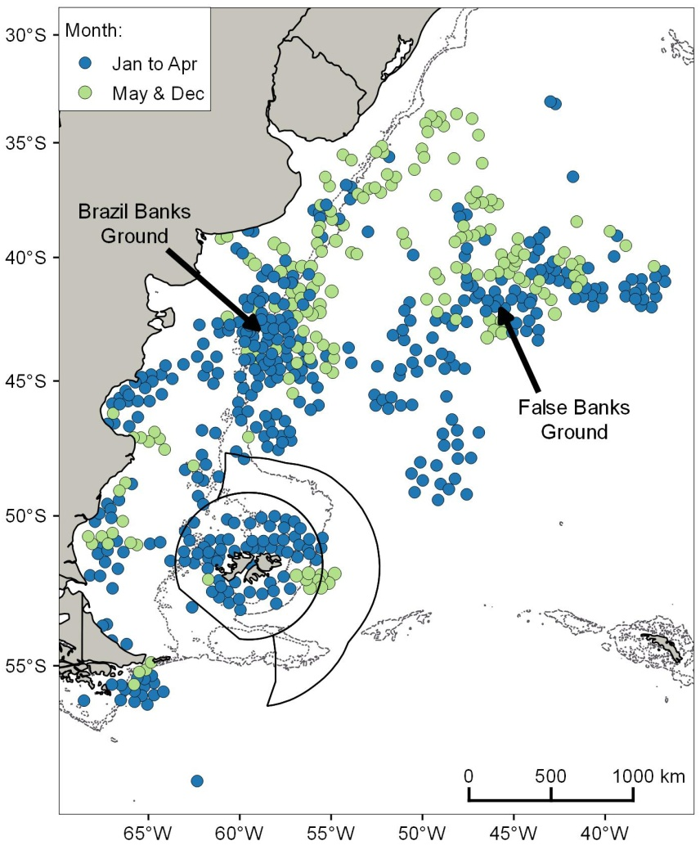
Supplementary Fig. S1. Distribution of right whale catches off the east coast of South America between 1785 and 1913 (Townsend, 1935): (A) June to November; and (B) December to May. FICZ: Falkland Islands Interim Conservation and Management Zone; FOCZ: Falkland Islands Outer Conservation Zone. Bathymetry: 200m and 1,000m.

(A)  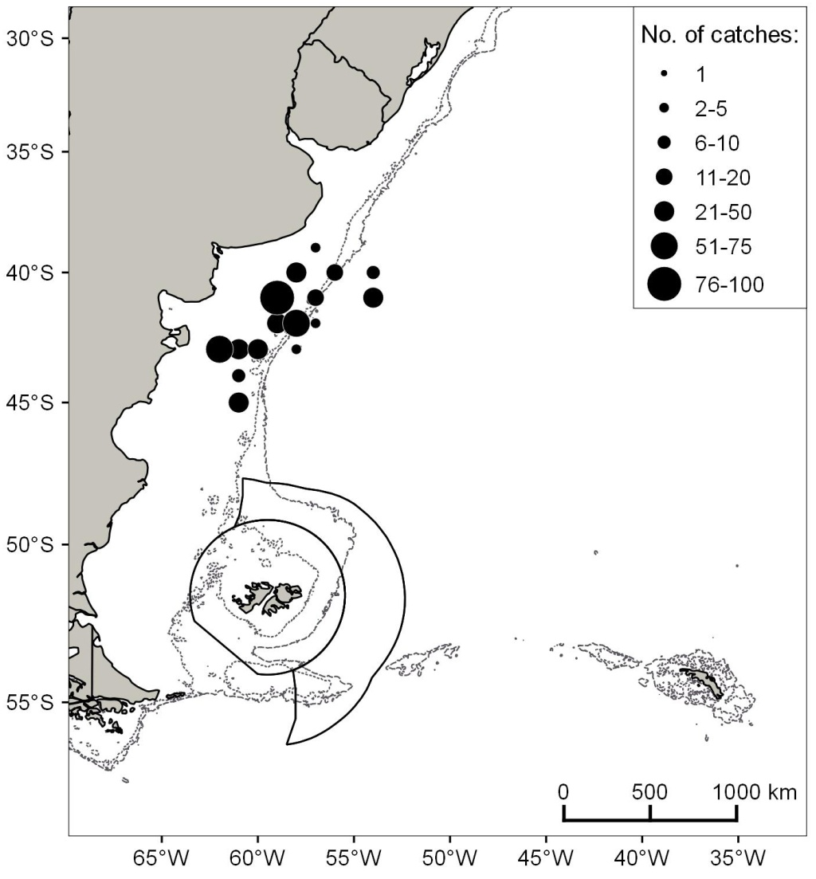 | (B)  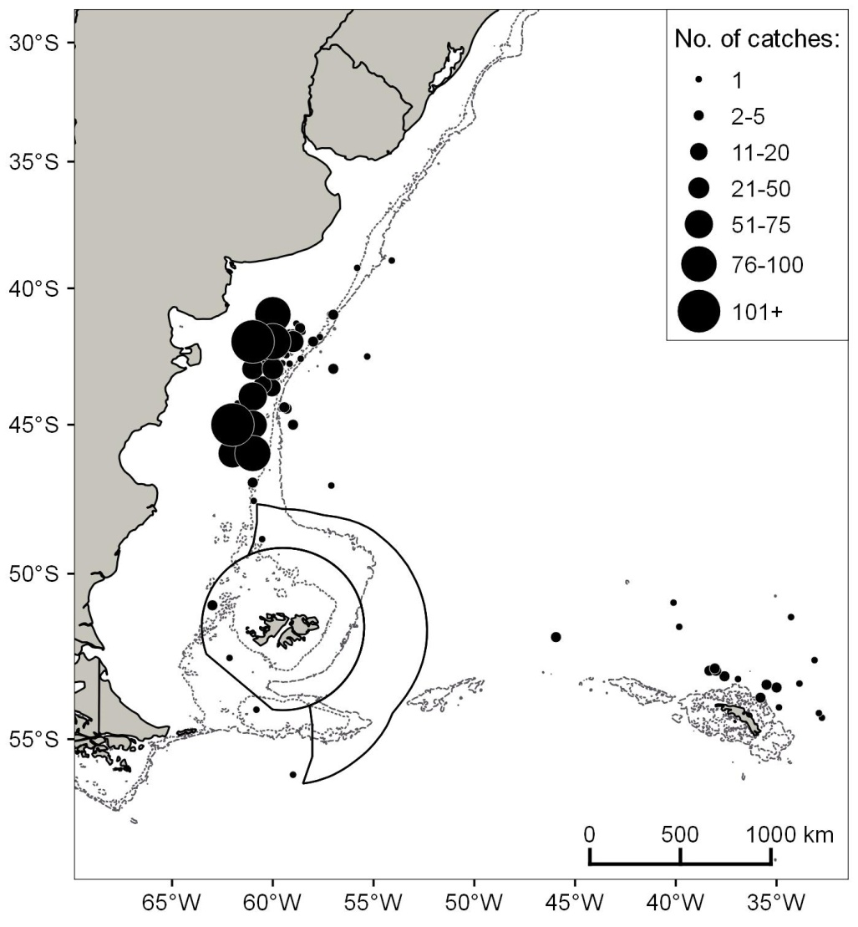
Supplementary Fig. S2. Distribution of Soviet Union right whale catches off the east coast of South America between November and April, 1961–1966 (Tormosov et al., 1998; Allison, 2016b): (A) November; and (B) December to April. The boundaries of the Falkland Island Conservation Zones are shown. Bathymetry: 200m and 1,000m.

(A)
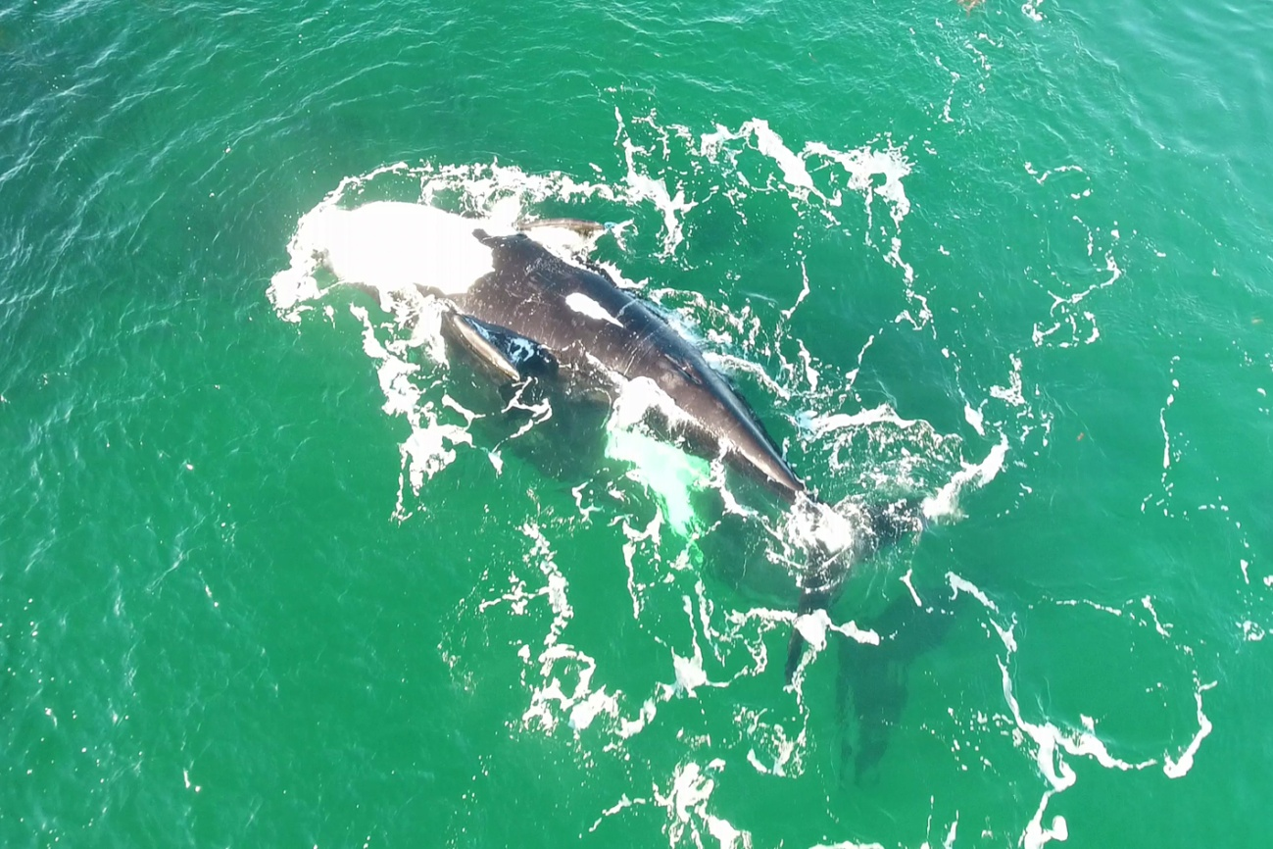
(B)
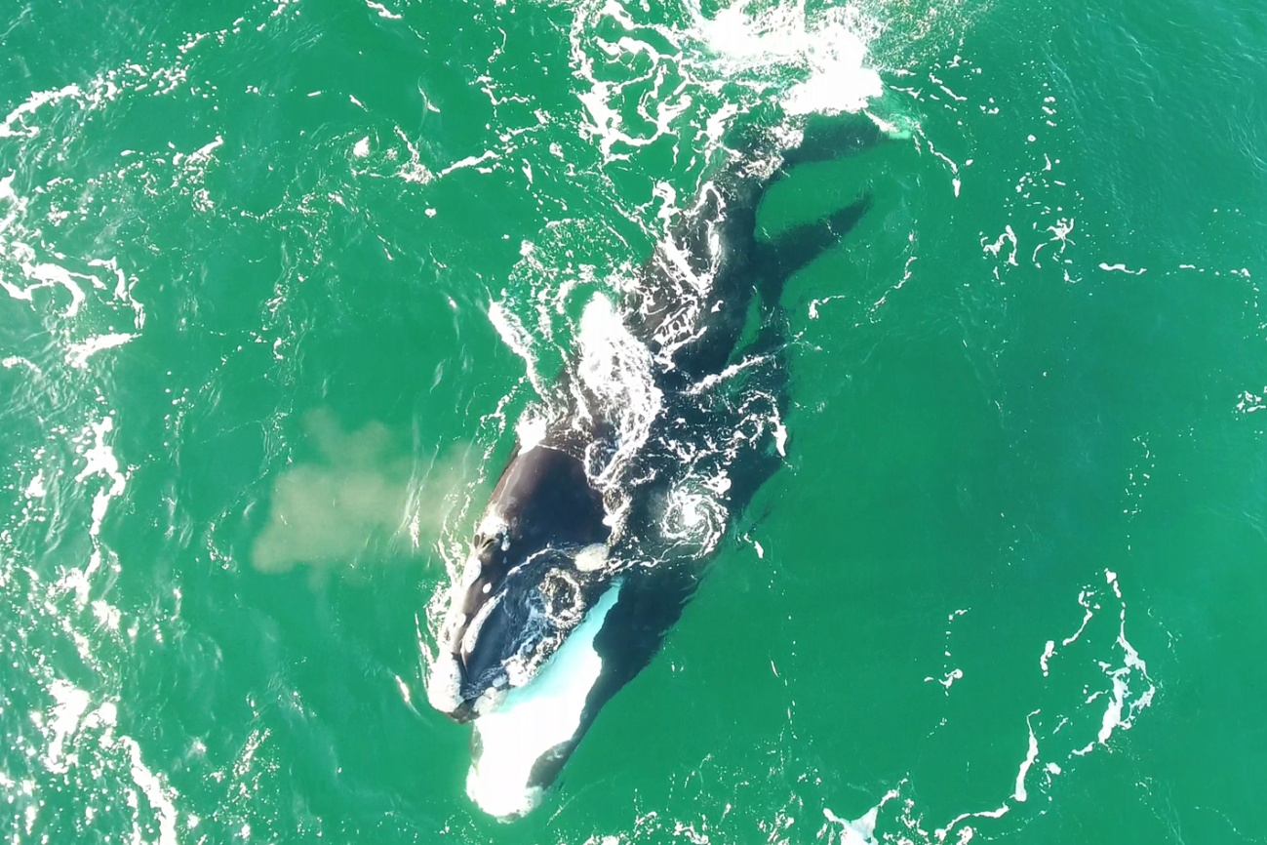
Supplementary Fig. S3. Stills from drone video footage of a pair of southern right whales in Port William on 21 July 2017, exhibiting courtship and/or mating behaviour: (A) adult female laying belly-up at the surface with genital region exposed; and (B) subsurface male swimming belly-to-belly with female.

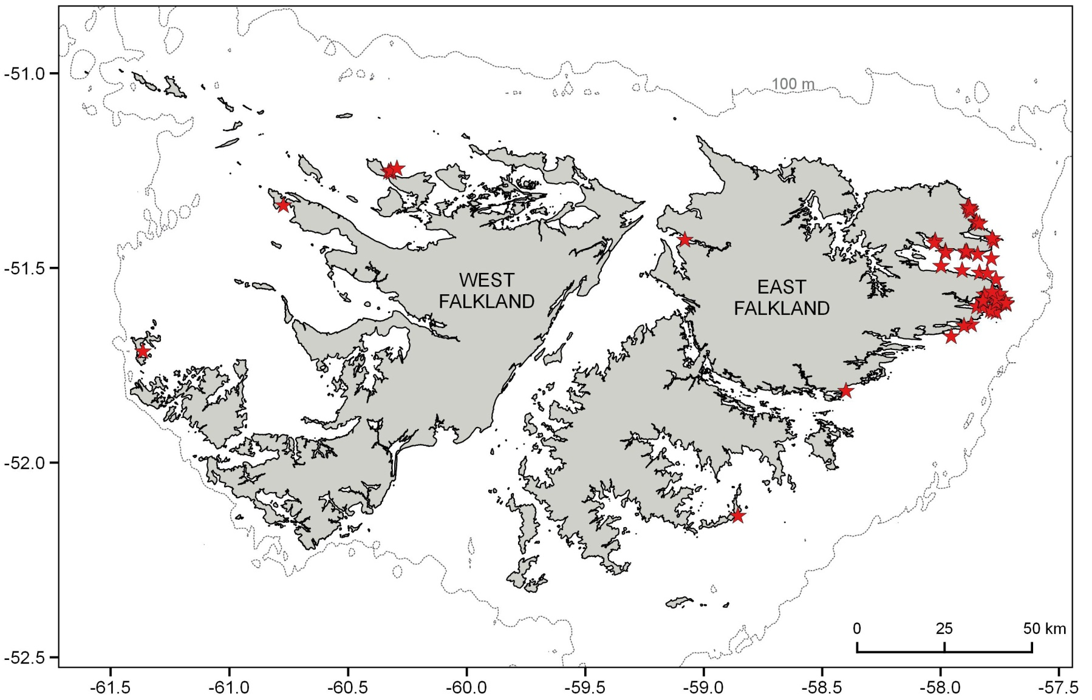
Supplementary Fig. S4. The locations of 69 southern right whale sightings reported incidentally around the Falkland Islands between 2016 and 2018.

