**SUPPLEMENTAL INFORMATION**

**Figure S1.** Record of temperature in outdoor mesocosms over the 5-year study. The dashed line shows the temperature below which molting is thought to cease (10° C; K. Bosley unpub. data)



**Figure S2**. Figure of lipofuscin-based age structure from *Neotrypaea californiensis* collected from the OSU dock site in Yaquina Bay, Oregon. Age classes were assigned based on the lipofuscin accumulation model produced with known-age shrimp (Table 1 in main text).

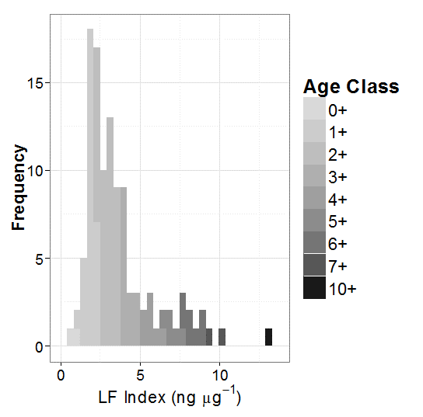

**Table S1**. Results from cohort analysis on LF Index for *Neotrypaea californiensis* sampled from outdoor mesocosms. Table shows sample date, mean lipofuscin index (ng μg-1) with standard deviation (SD), estimated age (yrs) at time of sampling and assigned cohort ID.

|  |  |  |  |  |
| --- | --- | --- | --- | --- |
| Date | Mean LF index | SD | Estimated Age | Cohort |
| 9/17/2013 | 4.049 | 0.397 | 3+ | A |
| 5/14/2014 | 3.204 | 0.365 | 3+ | B |
| 5/14/2014 | 5.114 | 0.583 | 4+ | A |
| 7/25/2014 | 2.167 | 0.314 | 2+ | C |
| 7/25/2014 | 3.598 | 0.521 | 3+ | B |
| 4/1/2015 | 4.518 | 0.296 | 4+ | B |
| 4/1/2015 | 6.424 | 0.421 | 5+ | A |
| 8/27/2015 | 2.253 | 0.139 | 2+ | D |
| 8/27/2015 | 3.885 | 0.239 | 3+ | C |
| 8/27/2015 | 5.094 | 0.314 | 4+ | B |
| 8/27/2015 | 6.444 | 0.397 | 5+ | A |

**Table S2.** Results from cohort analysis on gastric mill lamellae count data for *Neotrypaea californiensis* sampled from outdoor mesocosms. Table shows sample date, mean gastric mill lamellae count (#) with standard deviation (SD), estimated age (yrs) at time of sampling and assigned cohort ID.

|  |  |  |  |  |
| --- | --- | --- | --- | --- |
| Date | Mean # | SD | Estimated Age | Cohort |
| 9/17/2013 | 21.800 | 1.304 | 3+ | A |
| 5/14/2014 | 26.394 | 1.752 | 3+ | B |
| 5/14/2014 | 32.161 | 2.134 | 4+ | A |
| 7/25/2014 | 25.808 | 1.491 | 3+ | B |
| 7/25/2014 | 30.357 | 1.754 | 4+ | A |
| 4/1/2015 | 26.377 | 1.099 | 3+ | C |
| 4/1/2015 | 30.634 | 1.277 | 4+ | B |
| 4/1/2015 | 35.604 | 1.484 | 5+ | A |
| 8/27/2015 | 25.561 | 1.119 | 3+ | C |
| 8/27/2015 | 29.847 | 1.307 | 4+ | B |
| 8/27/2015 | 35.157 | 1.540 | 5+ | A |

**Table S3**. Results from cohort analysis using carapace length data for *Neotrypaea californiensis* sampled from outdoor mesocosms. Table shows sample date, mean carapace length (mm) with standard deviation (SD), and size class.

|  |  |  |  |
| --- | --- | --- | --- |
| Sample Date | Mean | SD | Size Class |
| 11/16/2010 | 1.727 | 0.210 | (0,3.5] |
| 1/26/2012 | 3.949 | 0.511 | (3.5,6] |
| 9/17/2013 | 4.896 | 0.730 | (3.5,6] |
| 9/17/2013 | 7.224 | 1.077 | (6,8.5] |
| 5/14/2014 | 5.707 | 0.681 | (3.5,6] |
| 5/14/2014 | 9.054 | 1.080 | (8.5,12] |
| 7/23/2014 | 5.403 | 0.636 | (3.5,6] |
| 7/23/2014 | 7.521 | 0.822 | (6,8.5] |
| 7/23/2014 | 9.425 | 1.030 | (8.5,12] |
| 4/1/2015 | 5.427 | 0.481 | (3.5,6] |
| 4/1/2015 | 7.643 | 0.676 | (6,8.5] |
| 4/1/2015 | 9.518 | 0.844 | (8.5,12] |
| 8/27/2015 | 3.429 | 0.416 | (3.5,6] |
| 8/27/2015 | 5.925 | 0.718 | (6,8.5] |
| 8/27/2015 | 8.030 | 0.974 | (6,8.5] |
| 8/27/2015 | 12.364 | 1.500 | (12,15] |