APPENDIX 1
Table 1S. Feeding habits, habitats, meadows, frequencies, and relative abundances of molluscs associated with the Halodule wrightii meadows in Barra Grande, Piauí State, northeastern Brazil.
Class | Family | Species | Feeding habits | Habitat | Meadow | Frequency | Relative abundance (%)
Gastropoda | Bullidae | Bulla occidentalis (A. Adams, 1850) | HER | EPI | A, B, C | Constant | 1.01
 | Cerithiidae | Bittiolum varium (Pfeiffer, 1840) | GRA | EPI | C | Rare | 0.07
 | Columbellidae | Columbella mercatoria (Linnaeus, 1758) | HER | EPI | B | Rare | 0.07
 |  | Mitrella pusilla (Sowerby, 1844) | CAR | EPI | A, B | Rare | 0.34
 | Cylichnidae | Acteocina bullata (Kiener, 1834) | CAR | EPI | A, C | Common | 0.20
 | Dorididae | Doris kyolis (Ev. Marcus & Er. Marcus, 1967) | CAR | EPI | C | Rare | 0.07
 | Epitoniidae | Epitonium krebsii (Mörch, 1875) | CAR | EPI | B | Rare | 0.07
 | Fissurelidae | Fissurella sp. | HER | EPI | C | Rare | 0.27
 | Haminoeidae | Haminoea antillarum (d'Orbigny, 1841) | HER | EPI | B, C | Common | 0.41
 | Litiopidae | Alaba incerta (d'Orbigny, 1841) | GRA | EPI | A, B, C | Constant | 21.97
 | Marginellidae | Marginella cloveri (Rios & Matthews, 1972) | CAR | EPI | B, C | Common | 0.27
 |  | Volvarina avena (Kiener, 1834) | CAR | EPI | A, B, C | Common | 0.47
 |  | Volvarina albolineata (d'Orbigny, 1842) | CAR | EPI | B, C | Rare | 0.34
 | Neritidae | Neritina virginea (Linnaeus, 1758) | GRA | EPI | A,B | Constant | 21.64
 |  | Smaragdia viridis(Linnaeus, 1758) | HER | EPI | A, B, C | Constant | 15.21
 | Olivellidae | Olivella floralia (Duclos, 1844) | CAR | EPI | B | Rare | 0.07
 |  | Olivella minuta (Link, 1807) | CAR | EPI | B | Common | 0.74
 | Phasianellidae | Eulithidium affine (C. B. Adams, 1850) | GRA | EPI | A, B, C | Constant | 31.91
 | Pseudomelatomidae | Crassispira fuscescens (Reeve, 1843) | CAR | EPI | B | Rare | 0.07
 | Pyramidellidae | Chrysallida gemmulosa (C. B. Adams, 1850) | PAR | EPI | A, B, C | Common | 0.41
 |  | Odostomia laevigata (d'Orbigny, 1841) | PAR | EPI | A, B, C | Common | 1.42
 |  | Turbonilla brasiliensis (Clessin, 1902) | PAR | EPI | A, B, C | Common | 0.81
 |  | Turbonilla dispar (Pilsbry, 1897) | PAR | EPI | A | Common | 0.20
 |  | Turbonilla sp. | PAR | EPI | A, C | Common | 0.34
 |  | Boonea jadisi (Olsson & McGinty, 1958) | PAR | EPI | A, B, C | Common | 1.42
Polyplacophora | Ischnochitonidae | Ischnochiton striolatus (Gray, 1828) | GRA | EPI | C | Rare | 0.20
Bivalvia | Corbulidae | Caryocorbula cymella (Dall, 1881) | FIL | INF | C | Rare | 1.04
 |  | Caryocorbula swiftiana (C. B. Adams, 1852) | FIL | INF | A, B, C | Common | 2.60
 | Crassatellidae | Crassinella lunulata (Conrad, 1834) | FIL | INF | A, C | Common | 2.08
 | Lucinidae | Codakia orbicularis (Linnaeus, 1758) | FIL | INF | C | Common | 1.04
 |  | Divaricella quadrisulcata (d'Orbigny, 1846) | FIL | INF | A, B, C | Common | 2.60
 |  | Parvilucina pectinella (C. B. Adams, 1852) | FIL | INF | A, B, C | Constant | 6.77
 |  | Phacoides pectinatus (Gmelin, 1791) | FIL | INF | A | Rare | 0.52
 |  | Lucinidae sp.1 | FIL | INF | A | Rare | 0.52
 | Lyonsiidae | Entodesma beana (d'Orbigny, 1853) | FIL | EPI | C | Rare | 0.52
 | Mactridae | Mactrotoma fragilis (Gmelin, 1791) | FIL | INF | B, C | Rare | 2.60
 | Myidae | Sphenia fragilis (H. Adams & A. Adams, 1854) | FIL | EPI | A, B, C | Constant | 13.02
 | Mytilidae | Mytilidae sp1 | FIL | EPI | A, B | Rare | 1.04
 |  | Musculus lateralis (Say, 1822) | FIL | EPI | C | Rare | 1.56
 | Nuculidae | Nucula brasiliana (Esteves, 1984) | FIL | INF | A, B, C | Constant | 14.58
 | Pteriidae | Pinctada imbricata (Röding, 1798) | FIL | EPI | A, B, C | Common | 10.93
 | Semelidae | Cumingia coarctata (G, B, Sowerby I, 1833) | FIL | INF | B, C | Common | 2.60
 |  | Ervilia nitens (Montagu, 1808) | FIL | INF | A | Rare | 0.52
 | Tellinidae | Tellina sp. | FIL | INF | A | Rare | 0.52
 |  | Tellina cf. lineata (Turton, 1819) | FIL | INF | B | Rare | 0.52
 |  | Tellina cf. alternata (Say, 1822) | FIL | INF | A, B, C | Constant | 6.25
 |  | Tellina cf. angulosa (Gmelin, 1791) | FIL | INF | A, B | Constant | 2.60
 |  | Tellina cf. tayloriana(G. B. Sowerby II, 1867) | FIL | INF | A, B | Common | 6.77
 |  | Macoma pseudomera (Dall & Simpson, 1901) | FIL | INF | C | Rare | 0.52
 | Ungulinidae | Diplodonta sp, | FIL | INF | A, B, C | Common | 4.68
 | Veneridae | Anomalocardia brasiliana (Gmelin, 1791) | FIL | INF | A | Constant | 10.41
 |  | Chione subrostrata (Lamarck, 1818) | FIL | INF | A | Rare | 2.60
 |  | Veneridae sp1 | FIL | INF | A | Rare | 0.52
CAR: carnivore; FIL: filter; GRA: grazers; HER: herbivore; PAR: parasite. EPI: epifauna (bissus); INF: infauna.

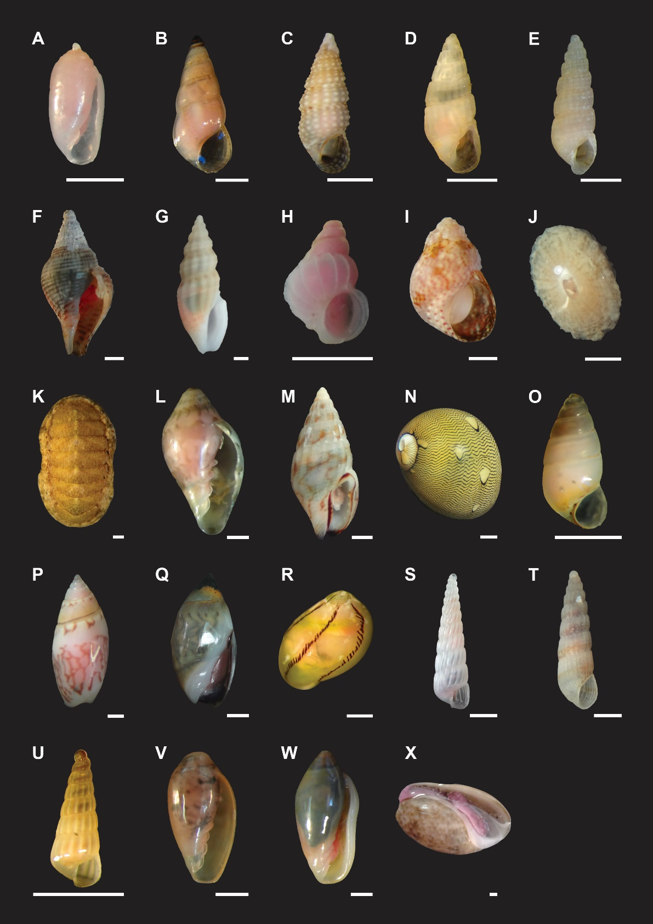
Fig. 1S. Species of Gastropoda and Polyplacophora associated with Halodule wrightii meadows in Barra Grande beach, Piauí, NE Brazil. (A) Acteocina bullata (Kiener, 1834) ; (B) Alaba incerta (d'Orbigny, 1841); (C) Bittiolum varium (Pfeiffer, 1840); (D) Boonea jadisi (Olsson & McGinty, 1958); (E) Chrysallida gemmulosa (C. B. Adams, 1850); (F) Columbella mercatoria (Linnaeus, 1758); (G) Crassispira fuscescens (Reeve, 1843); (H) Epitonium krebsii (Mörch, 1875); (I) Eulithidium affine (C. B. Adams, 1850); (J) Fissurelidae sp.1; (K) Ischnochiton striolatus (Gray, 1828); (L) Marginella cloveri (Rios & Matthews, 1972); (M) Mitrella pusilla (Sowerby, 1844); (N) Neritina virginea (Linnaeus, 1758); (O) Odostomia laevigata (d'Orbigny, 1841); (P) Olivella floralia (Duclos, 1844); (Q) Olivella minuta (Link, 1807); (R) Smaragdia viridis (Linnaeus, 1758); (S) Turbonilla brasiliensis (Clessin, 1902); (T) Turbonilla díspar (Pilsbry, 1897); (U) Turbonilla sp.; (V) Volvarina albolineata (d'Orbigny, 1842); (W) Volvarina avena (Kiener, 1834); (X) Bulla occidentalis (A. Adams, 1850). Scale bars: 1mm.

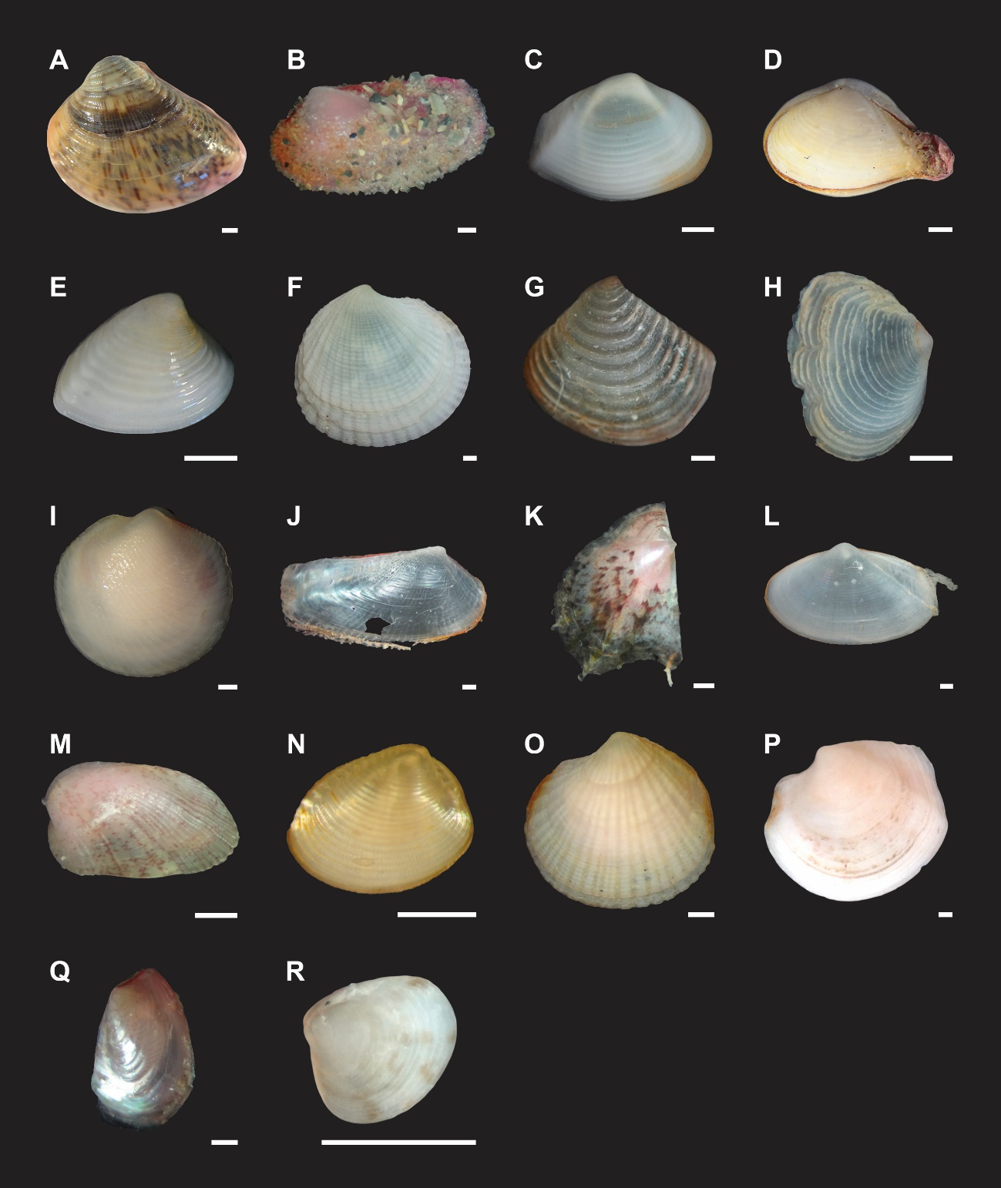
Fig. 2S. Some species of Bivalvia associated with Halodule wrightii meadows in Barra Grande beach, Piauí, NE Brazil. (A) Anomalocardia brasiliana (Gmelin, 1791); (B) Sphenia fragilis (H. Adams & A. Adams, 1854); (C) Caryocorbula cyumella (Dall, 1881); (D Caryocorbula swiftiana (C. B. Adams, 1852) ; (E) Chione subrostrata (Lamarck, 1818); (F) Codakia orbicularis (Linnaeus, 1758); (G) Crassinella lunulata (Conrad, 1834); (H) Cumingia coarctata (G, B, Sowerby I, 1833); (I) Divaricella quadrisulcata (d'Orbigny, 1846); (J) Entodesma beana (d'Orbigny, 1853); (K) Pincatada imbricata (Röding, 1798); (L) Mactrotoma fragilis (Gmelin, 1791); (M) Musculus lateralis (Say, 1822); (N) Nucula brasiliana (Esteves, 1984); (O) Parvilucina pectinellav (C. B. Adams, 1852); (P) Phacoides pectinatus (Gmelin, 1791); (Q) Mytilidae sp1; (R) Veneridae sp.1. Scale bars: 1mm.

