Supplementary Material
Table S1: Full species list of flora and fauna sampled from April, May and June primed (P) and unprimed (UP) dropper sections for 2014 and 2015 and their occurrence per month (max. occurrence per month is 15)
 | April 2014  P | April 2014 UP | May  2014 P | May 2014 UP | June 2014 P | June 2014 UP | April  2015 P | April  2015 UP | May  2015 P | May  2015 UP | June  2015 P | June  2015 UP
Phylum Ochrophyta
Filamentous brown algae sp. | 7 | 10 | 1 | 14 | 4 | 10 | 12 | 15 |  | 14 | 1 | 11
Laminariales juvenile |  |  |  | 9 |  | 15 |  | 12 |  | 14 | 5 | 12
Saccorhiza polyschides |  |  |  |  |  | 3 |  |  |  | 4 |  | 4
Saccharina latissima |  |  |  |  |  |  |  |  |  | 4 |  | 4
Desmarestia viridis |  |  |  |  |  |  |  |  |  |  |  | 2
Phylum Rhodophyta
Polysiphonia sp. |  |  |  | 9 | 3 | 14 | 12 | 10 | 14 | 15 | 5 | 14
Ceramium sp. |  | 2 | 2 | 12 | 3 | 15 | 4 | 3 | 7 | 14 | 4 | 15
Lomentaria clavellosa |  |  |  |  |  | 1 | 2 | 1 | 3 | 6 | 1 | 8
Phylum Chlorophyta
Ulva sp. |  |  |  |  |  |  |  |  |  | 1 |  | 2
Phylum Cnidaria
Class Hydrozoa
Obelia geniculata |  | 1 | 13 | 15 | 4 | 4 | 8 | 7 | 15 | 14 | 11 | 9
Laomedea flexuosa | 2 |  |  |  |  |  |  |  | 9 | 6 |  | 5
Ectopleura larynx |  |  |  |  |  |  |  |  | 7 | 4 | 7 | 5
Dynamena sp. |  |  |  |  |  |  |  | 1 | 1
Kirchenpaueria pinnata |  |  |  |  |  |  |  |  |  |  | 1
Sarsia sp. |  |  |  |  |  |  |  |  |  |  | 1
Phylum Bryozoa
Class Gymnolaemata
Electra pilosa |  |  | 3 |  | 12 |  |  |  | 15 | 1 | 15 | 8
Membranipora membranacea |  |  |  |  |  | 3 |  |  | 2 | 3 | 2 | 4
Vesicularia spinosa |  |  |  |  | 4 |  |  |  |  |  | 6 | 2
Class Stenolaemata
Crisia sp. |  |  |  |  |  |  |  |  | 8 | 1 | 2
Phylum Echinodermata
Class Asteroidea
Asterias juvenile. |  |  | 5 | 1 | 6 |  |  |  | 5 |  | 2
Class Ophiuroidea
Opiuroidea sp. |  |  |  |  | 1
Amphipholis squamata |  |  |  |  |  |  |  |  | 1
Class Crinoidea
Crinoidea sp. |  |  |  |  |  |  |  |  |  |  | 1

Phylum Nematoda
Nematoda indent. |  |  | 5 | 8 | 4 | 14 | 5 | 11 | 15 | 15 | 15 | 15
Phylum Annelida
Class Polychaete
Myrianida sp. | 1 | 1 | 7 | 11 | 10 | 14 | 2 | 1 | 9 | 1 | 14 | 10
Eusyllis blomstrandi |  | 1 | 2 | 3 | 5 | 3 | 3 |  | 11 | 2 | 11 | 5
Polygordius appendiculatus |  |  |  |  | 2
Eunidae sp. |  |  |  |  | 1
Platynereis dumerilii |  |  | 2 |  | 1 | 1 |  |  |  | 5
Harmothoe sp. | 5 |  | 6 | 2 | 8 | 1 |  | 1 | 15 | 2 | 15 | 5
Spirobranchus triqueter |  |  |  | 2 | 2 | 2 |  |  | 15 | 5 | 15 | 7
Eulalia viridis |  |  | 2 | 3 | 2 |  |  |  |  |  | 9 | 4
Nereiphylla rubiginosa |  |  |  | 1 | 1 |  |  |  | 4 | 1 | 9 | 3
Nereimyra punctata |  |  |  |  | 6 |  |  |  | 1 |  | 4
Cossura sp. |  |  |  |  | 1
Pseudopotamilla reniformis |  |  |  |  |  |  |  |  |  |  | 1
Class Oligochaeta
Oligochaeta indent. |  |  |  |  |  |  |  |  | 1 | 3 |  | 4
Phylum Sipuncula
Sipuncula indent. |  |  |  |  | 1 | 1 |  |  |  | 2 |  | 2
Phylum Nemertea
Nemertea indent. |  |  |  |  |  |  | 3 | 1 | 3 | 4 | 13 | 6
Phylum Arthropoda
Acari sp. |  |  |  |  |  | 2 | 2 | 1 | 1
Pycnogonida indent. |  |  | 1 | 1 |  |  | 3 |  | 2 |  | 3
Diptera larvae |  |  |  |  |  |  |  |  |  | 2
Anurida maritima |  |  |  |  |  |  |  |  |  |  | 1
Phylum Crustacea
Order Amphipoda
Jassa fem. | 15 | 12 | 15 | 15 | 15 | 15 | 15 | 15 | 15 | 15 | 15 | 15
Jassa falcata | 3 |  | 5 | 7 | 9 | 10 | 9 | 1 | 13 | 10 | 15 | 13
Parajassa pelagica | 1 |  | 1 | 1 | 3 | 1 | 1 |  |  |  | 2 | 1
Gammarellus homari | 4 | 2 |  | 1 | 1 |  | 10 |  | 5 |  | 2 | 1
Gammarus insensibilis | 3 |  |  | 2 |  |  | 3 | 1 | 1 | 1 | 5 | 2
Aora gracilis |  |  | 1 |  |  |  |  |  | 1
Aora sp. |  |  | 1 |  |  |  |  | 1 | 1 |  |  | 3
Hardametopa nasuta |  | 1 | 3 | 2 | 5 | 3 | 6 |  | 11 | 4 | 12 | 9
Elasmopus rapax | 1 |  | 1
Dexaminidae sp. |  |  |  |  | 1
Gitana sarsi |  |  |  |  | 1 |  |  |  | 2 |  | 5
Suborder Caprellidea
Caprella septentrionalis |  |  |  |  |  |  |  |  |  |  | 9 | 5
Caprella penantis |  |  |  |  | 1
Caprella juvenile |  |  |  |  |  |  |  |  |  |  | 8 | 4

Order Isopoda
Idotea granulosa | 2 |  | 2 | 1 | 2 | 1 | 2 |  | 1 |  | 5 | 1
Idotea balthica |  |  |  |  |  |  | 2
Idotea pelagica |  |  | 1 |  | 6 | 2 |  |  |  | 2 |  | 1
Isopod sp. |  |  |  |  | 1 |  |  |  | 1
Order Decapoda
Pisidia longicornis |  |  | 2 | 2 | 6 | 3 |  |  | 12 |  | 12 | 3
Necora puber |  |  |  |  |  |  |  |  |  |  | 9
Megalopore larvae |  |  |  |  |  |  |  |  |  |  | 4 | 3
Class Copepoda
Harpactocoida indent. | 8 | 8 | 15 | 15 | 3 | 15 | 13 | 13 | 14 | 15 | 14 | 15
Order Cumacea
Cumacea indent. | 1 | 2 | 1 | 1
Class Ostrocoda
Ostracoda indent. |  |  | 2 | 6 | 1 | 7 |  |  |  | 2 | 2 | 1
Class Cirripedia
Balanus sp. |  |  | 2 | 1 | 3 |  |  |  |  | 1 | 2 | 2
Phylum Mollusca
Class Gastropoda
Rissoa parav | 1 | 1 | 13 | 10 | 11 | 9 |  | 1 | 10 | 5 | 15 | 11
Lacuna vincta |  |  | 6 | 8 | 2 | 4 |  |  | 3 | 4 | 2 | 1
Patella pellucida |  |  |  |  |  | 1
Class Bivalvia
Mytilus sp. |  |  | 15 | 15 | 15 | 15 | 8 | 1 | 15 | 15 | 15 | 15
Musculus costulatus |  |  |  |  |  | 1 | 3 | 2 | 3 | 1 | 3 | 1
Kellia suborbicularis |  |  |  | 3 | 4 | 3 |  | 1 | 2 |  | 14 | 3
Anomia epipphium |  |  |  |  | 5 | 1 |  |  |  |  | 15 | 1
Hiatella arctica |  |  |  |  | 1 | 1 | 1 |  | 2 |  | 15 | 2
Turtonia minuta | 2
Lasaea adansoni |  |  | 1
Order Nudibranchia
Polycera quadrilineata |  |  | 7 | 4 |  |  | 6 | 7 | 15 | 6 | 11 | 4
Phyum Chordata
Class Ascidiacea
Ciona intestinalis |  |  |  |  |  |  |  |  |  |  | 6
Class Actinoptergii
Cyclopterus lumpus | 1 |  |  |  |  |  | 1
Total number of species | 16 | 11 | 31 | 31 | 42 | 33 | 25 | 22 | 42 | 38 | 52 | 49

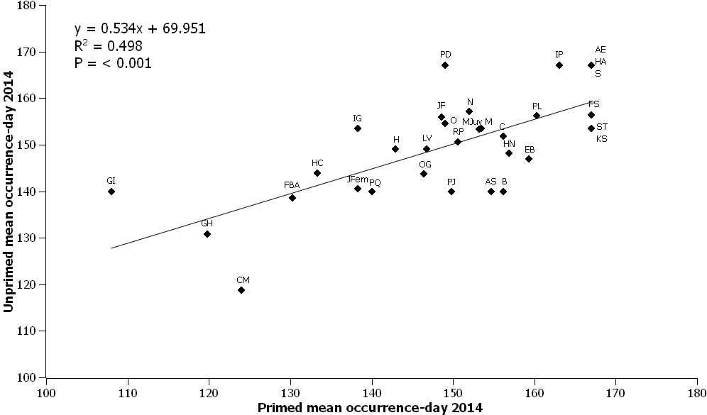
Fig. S1A. The relationship between mean day of year occurrences for all shared species in year 2014 for primed and unprimed treatments.
Legend: GI: Gammarus insensibilis; GH: Gammarellus homari; CM: Cumacea indent.; FBA: filamentous brown algae sp; HC: Harpacticoid Copepods; JFem: Jassa sp. female; IG: Idotea granulosa; PQ: Polycera quadrilineata; H: Harmothoe sp.; OG: Obelia geniculata; LV: Lacuna vincta; PJ: Parajassa pelagica; RP: Rissoa parva; JF: Jassa falcata; O: Ostracoda indent.; PD: Platynereis dumerilii; N: Nematoda indent.; MJuv- Mytilus sp. juvenile; M: Myrianida sp.; AS: Asterias sp.; B: Balanus sp.; C: Ceramiales sp; HN: Hardametopa nasuta; EB: Eusyllis blomstrandi; PL: Pisidia longicornis; IP: Idotea pelagica; AE: Anomia epipphium; HA: Hiatella arctica; S: Sipuncula indent.; PS: Polysiphonia sp; ST: Spirobranchus triqueter; KS: Kellia suborbicularis

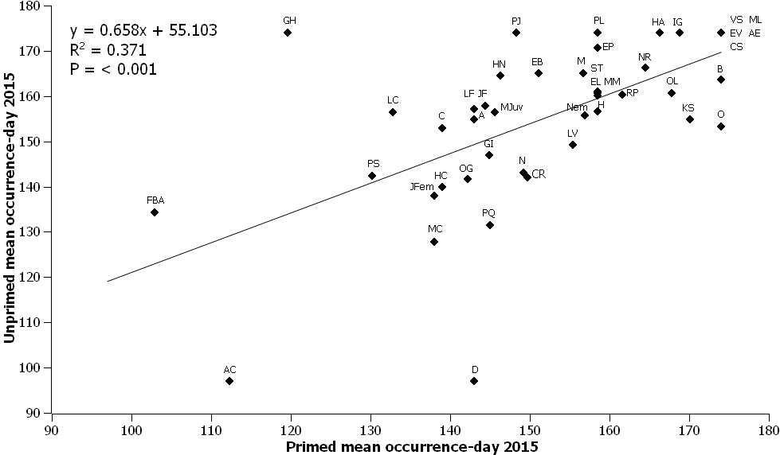
Fig. S1B. The relationship between mean day of year occurrences for all shared species in year 2015 for primed and unprimed treatments.
Legend: FBA: filamentous brown algae sp; AC: Acari sp.; GH: Gammarellus homari; PS: Polysiphonia sp; LC: Lomentaria clavellosa; JFem: Jassa sp. female; HC: Harpacticoid Copepods; OG: Obelia geniculata; MC: Musculus costulatus; C: Ceramiales sp; PQ: Polycera quadrilineata; D: Dynamena sp.; LF: Laomedea flexuosa; GI: Gammarus insensibilis; JF: Jassa falcata; A: Aora sp.; MJuv: Mytilus sp. juvenile; HN: Hardametopa nasuta; PJ: Parajassa pelagica; EB: Eusyllis blomstrandi; N: Nematoda indent.; C: Crisia sp.; LV: Lacuna vincta; Nem: Nemertea indent.; H: Harmothoe sp.; M: Myrianida sp.; ST: Spirobranchus triqueter; MM: Membranipora membranacea; EL: Ectopleura larynx; EP: Electra pilosa; PL: Pisidia longicornis; RP: Rissoa parva; NR: Nereiphylla rubiginosa; HA: Hiatella arctica; IG: Idotea granulosa; OL: Oligochaeta indent.; KS: Kellia suborbicularis; O: Ostracoda indent.; B: Balanus sp.; VS: Vesicularia spinosa; EV: Eulalia viridis; AE: Anomia epipphium; ML: Megalopore larvae; CS: Caprella septentrionalis

