Table supplemental 1. Trophic position values of prey species in the diet of Alopias spp.

Species | Trophic level | Reference
Engraulis ringens | 3.5 | Espinoza (2014)
Fam. Tetradontidae | 3.24 | Cortes (1999)
Merluccius gayi peruanus | 3.7 | Espinoza (2014)
Ancistrocheirus lesueuri | 3.2 | Cortes (1999)
Dodiscus gigas | 3.5 | Espinoza (2014)
Doriteuthis gahi | 3.2 | Cortes (1999)
Gonatus antarcticus | 3.2 | Cortes (1999)
Histioteuthis hoylei | 3.2 | Cortes (1999)
Mastigoteuthis dentata | 3.2 | Cortes (1999)
Octopoteuthis sicula | 3.2 | Cortes (1999)
Ommastrephes bartramii | 3.2 | Cortes (1999)

Figure Supplemental 1.

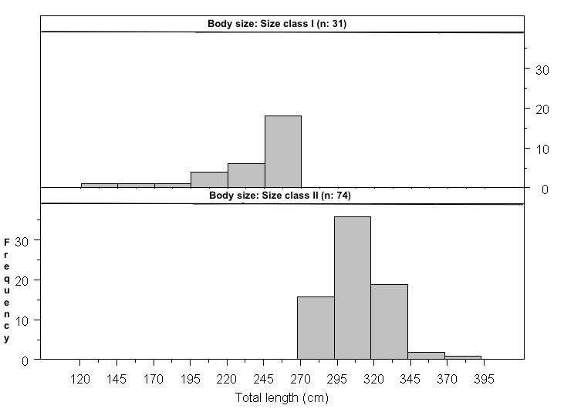
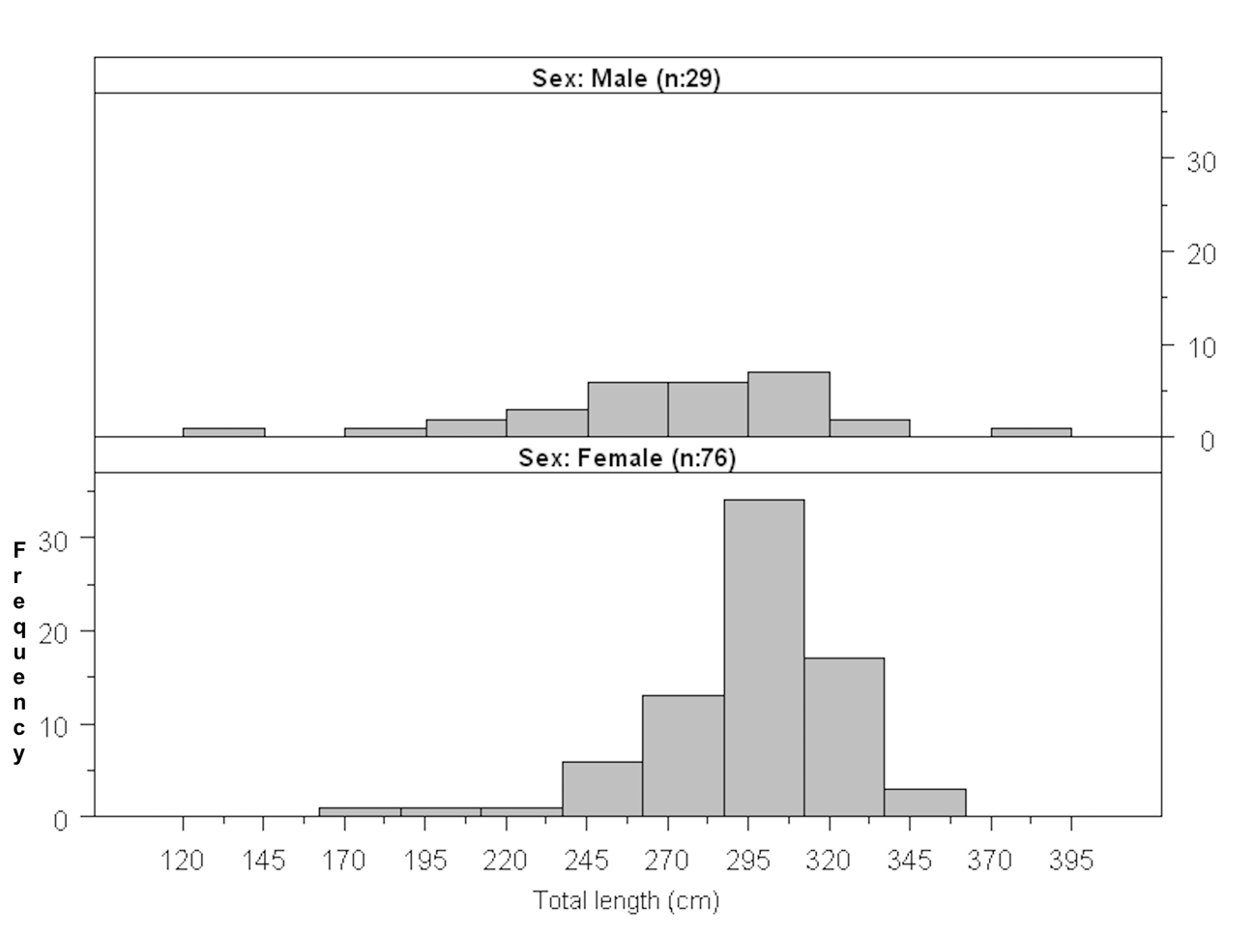
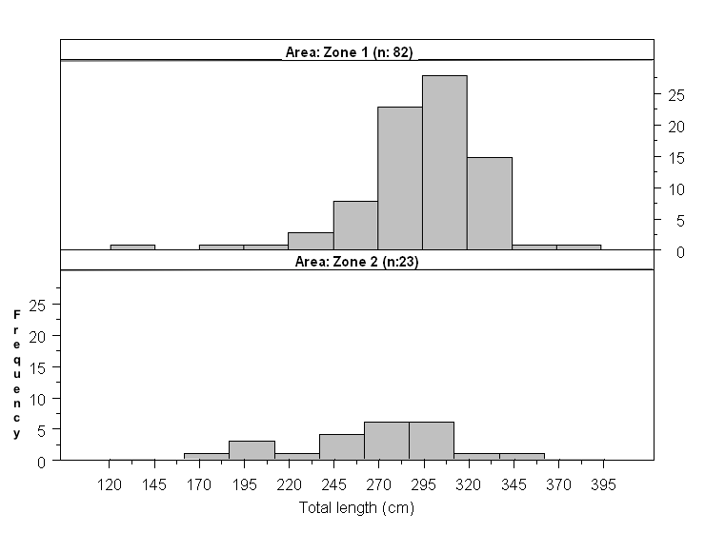
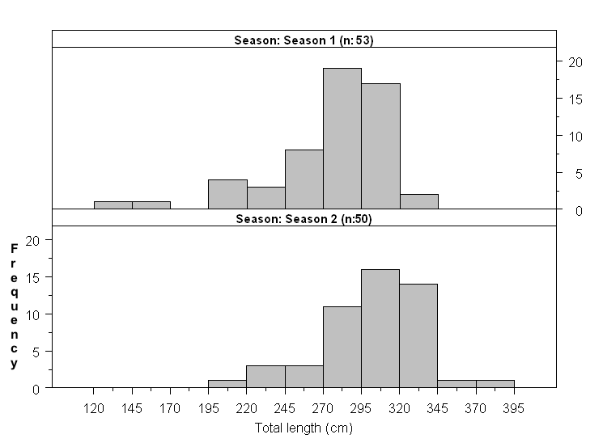

Figure Supplemental 2.

