Table S1 – Species Chao1 richness estimation for a controlled sample size (100 - 1000 sequences) using resampling of bacterial 16S rRNA gene sequences from Xestospongia testudinaria (Xt), sediment (Sd) and seawater (Wt) samples.
Groups | Sample | Sample size | Chao1 | SD
Xt | BSin13Xt001 | 100 | 74,66 | 34,59
 | BSin13Xt011 |  | 102,03 | 38,71
 | BSin13Xt021 |  | 80,89 | 35,52
Sd | BSin13Sd040 |  | 350,54 | 192,10
 | BSin13Sd042 |  | 343,35 | 140,91
 | BSin13Sd043 |  | 289,77 | 100,85
Wt | BSin13Wt036 |  | 140,79 | 51,61
Xt | BSin13Xt001 | 200 | 86,35 | 22,87
 | BSin13Xt011 |  | 116,83 | 21,57
 | BSin13Xt021 |  | 95,53 | 26,35
Sd | BSin13Sd040 |  | 421,90 | 105,68
 | BSin13Sd042 |  | 432,65 | 97,67
 | BSin13Sd043 |  | 374,61 | 80,69
Wt | BSin13Wt036 |  | 187,66 | 46,30
Xt | BSin13Xt001 | 300 | 96,45 | 19,73
 | BSin13Xt011 |  | 125,74 | 18,25
 | BSin13Xt021 |  | 105,97 | 22,42
Sd | BSin13Sd040 |  | 503,84 | 98,83
 | BSin13Sd042 |  | 501,16 | 85,98
 | BSin13Sd043 |  | 436,99 | 71,40
Wt | BSin13Wt036 |  | 230,58 | 48,23
Xt | BSin13Xt001 | 400 | 106,09 | 22,61
 | BSin13Xt011 |  | 133,75 | 16,97
 | BSin13Xt021 |  | 112,80 | 21,24
Sd | BSin13Sd040 |  | 574,52 | 97,56
 | BSin13Sd042 |  | 557,75 | 75,69
 | BSin13Sd043 |  | 491,38 | 69,52
Wt | BSin13Wt036 |  | 266,86 | 49,34
Xt | BSin13Xt001 | 500 | 114,18 | 22,02
 | BSin13Xt011 |  | 138,12 | 15,90
 | BSin13Xt021 |  | 119,13 | 20,69
Sd | BSin13Sd040 |  | 627,48 | 95,64
 | BSin13Sd042 |  | 600,76 | 72,56
 | BSin13Sd043 |  | 538,73 | 69,89
Wt | BSin13Wt036 |  | 296,09 | 49,83
Xt | BSin13Xt001 | 600 | 119,48 | 20,57
 | BSin13Xt011 |  | 143,47 | 14,49
 | BSin13Xt021 |  | 124,62 | 19,62
Sd | BSin13Sd040 |  | 669,87 | 86,95
 | BSin13Sd042 |  | 635,34 | 71,76
 | BSin13Sd043 |  | 569,46 | 66,14
Wt | BSin13Wt036 |  | 316,34 | 47,89
Xt | BSin13Xt001 | 700 | 125,32 | 21,05
 | BSin13Xt011 |  | 148,40 | 13,16
 | BSin13Xt021 |  | 130,46 | 19,89
Sd | BSin13Sd040 |  | 716,53 | 89,10
 | BSin13Sd042 |  | 670,65 | 69,24
 | BSin13Sd043 |  | 606,19 | 64,00
Wt | BSin13Wt036 |  | 331,69 | 42,88
Xt | BSin13Xt001 | 800 | 130,52 | 21,96
 | BSin13Xt011 |  | 152,21 | 12,36
 | BSin13Xt021 |  | 136,30 | 20,34
Sd | BSin13Sd040 |  | 748,11 | 84,63
 | BSin13Sd042 |  | 698,74 | 67,52
 | BSin13Sd043 |  | 636,00 | 67,08
Wt | BSin13Wt036 |  | 344,31 | 38,82
Xt | BSin13Xt001 | 900 | 135,35 | 23,07
 | BSin13Xt011 |  | 156,17 | 10,40
 | BSin13Xt021 |  | 140,32 | 19,99
Sd | BSin13Sd040 |  | 785,36 | 83,97
 | BSin13Sd042 |  | 724,72 | 64,75
 | BSin13Sd043 |  | 658,84 | 61,30
Wt | BSin13Wt036 |  | 357,15 | 35,85
Xt | BSin13Xt001 | 1000 | 139,04 | 23,02
 | BSin13Xt011 |  | 159,02 | 8,18
 | BSin13Xt021 |  | 145,07 | 20,70
Sd | BSin13Sd040 |  | 811,05 | 79,67
 | BSin13Sd042 |  | 751,43 | 64,14
 | BSin13Sd043 |  | 681,39 | 60,62
Wt | BSin13Wt036 |  | 368,22 | 29,85

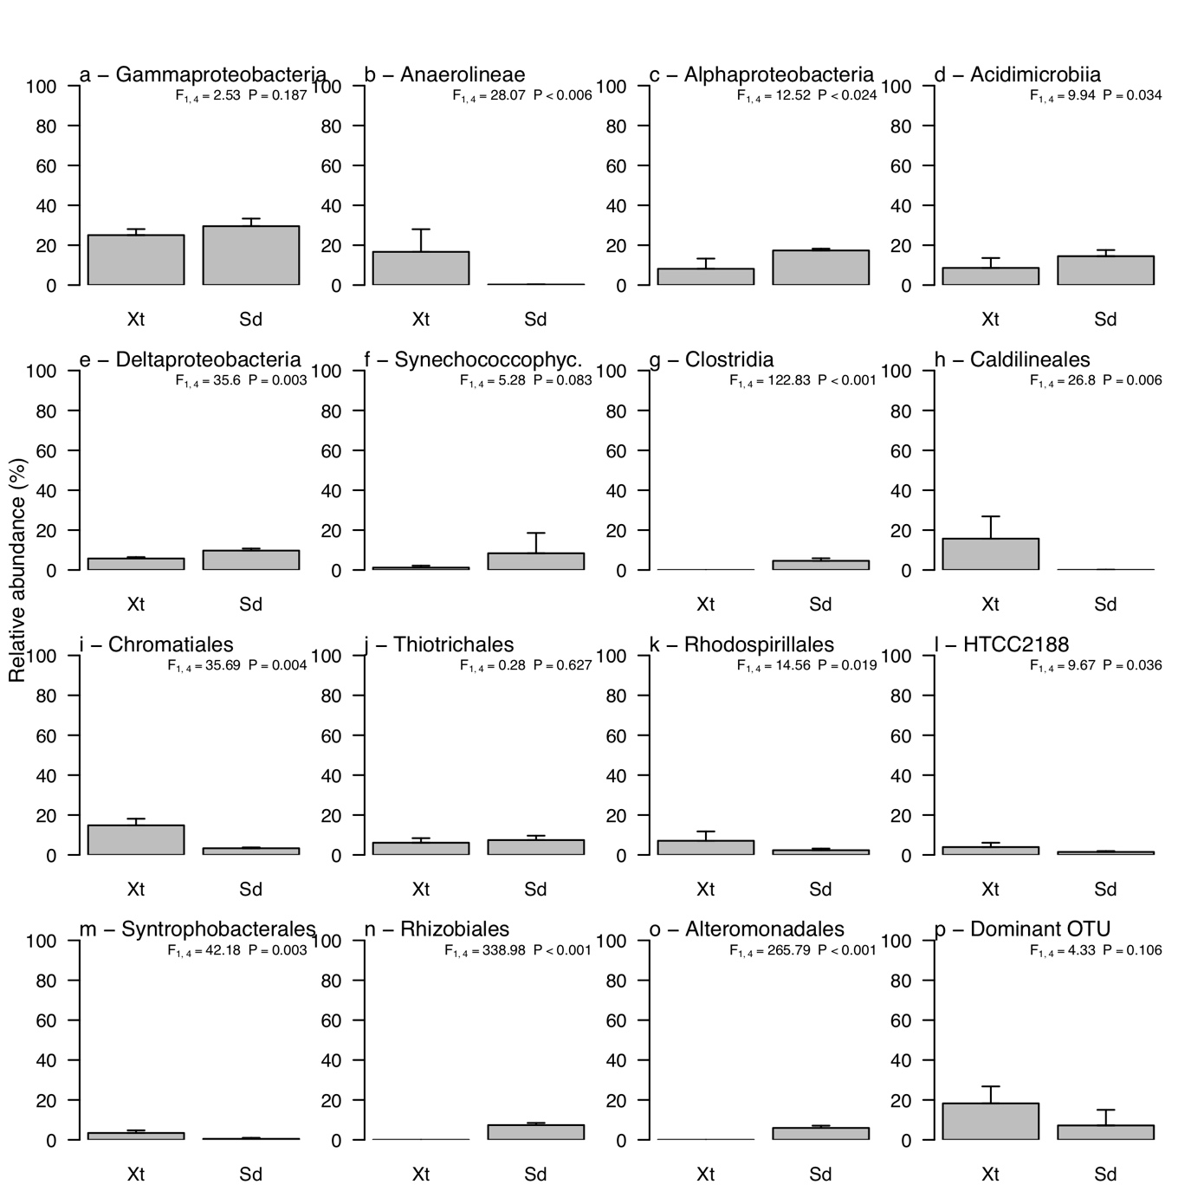
Fig. S1 - Relative abundance of the most abundant bacterial classes (a-g) and orders (h-o) and the most abundant OTU (p) for samples from Xestospongia testudinaria (Xt) and sediment (Sd). Error bars represent a single standard deviation. The dominant OTU represents the mean abundance for the single most dominant OTU in each biotope, thus not necessarily the same OTU.

