Supplementary Material
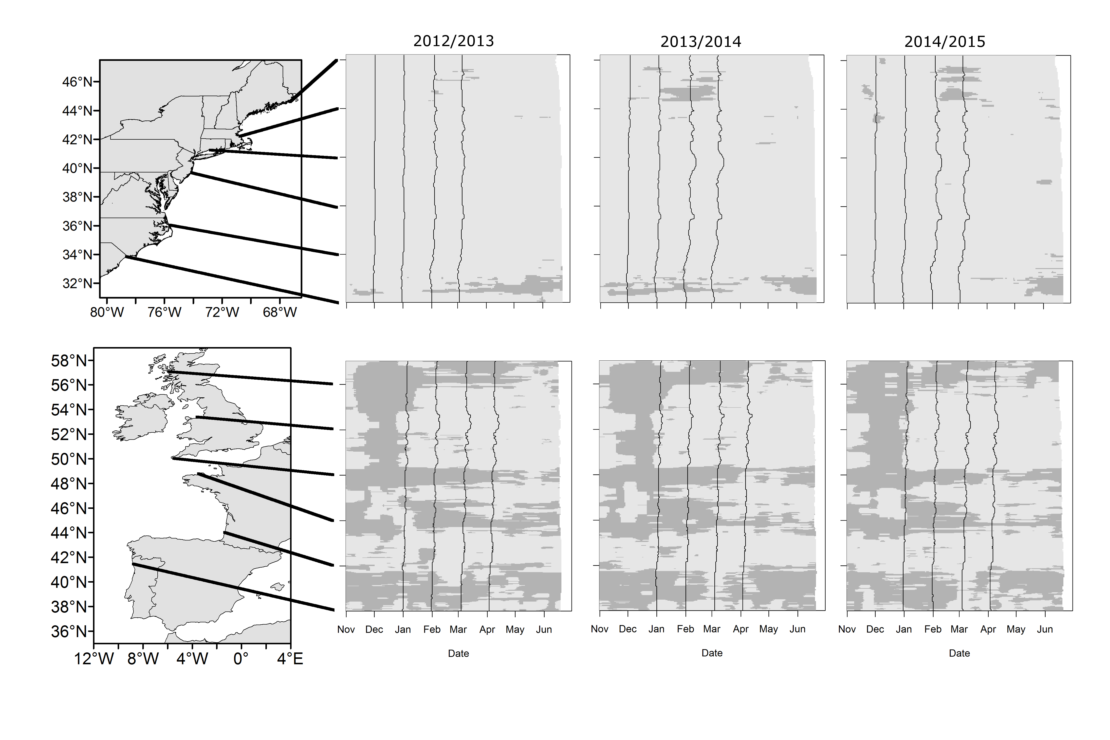

Supplementary Figure 1. Predicted dates of phytoplankton mismatch for the western and eastern Atlantic during the winters of 2012/2013, 2013/2014, and 2014/2015 at 10 km intervals along each coastline. Dark gray represents predicted dates of larval release for phytoplankton mismatch (fewer than 25% of days during larval develop had sufficient food for the duration of larval development if larvae were released on that day) and light gray represents predicted dates of larval release for phytoplankton match (more than 25%
of days during larval develop had sufficient food for the duration of larval development if larvae were released on that day). Black lines running latitudinally mark predicted dates of larval release if eggs were fertilized on November 1st, December 1st, January 1st, and 30 days past the predicted date of larval release for a January 1st fertilization. Black lines between maps and plots match predictions to corresponding locations on the coastline.

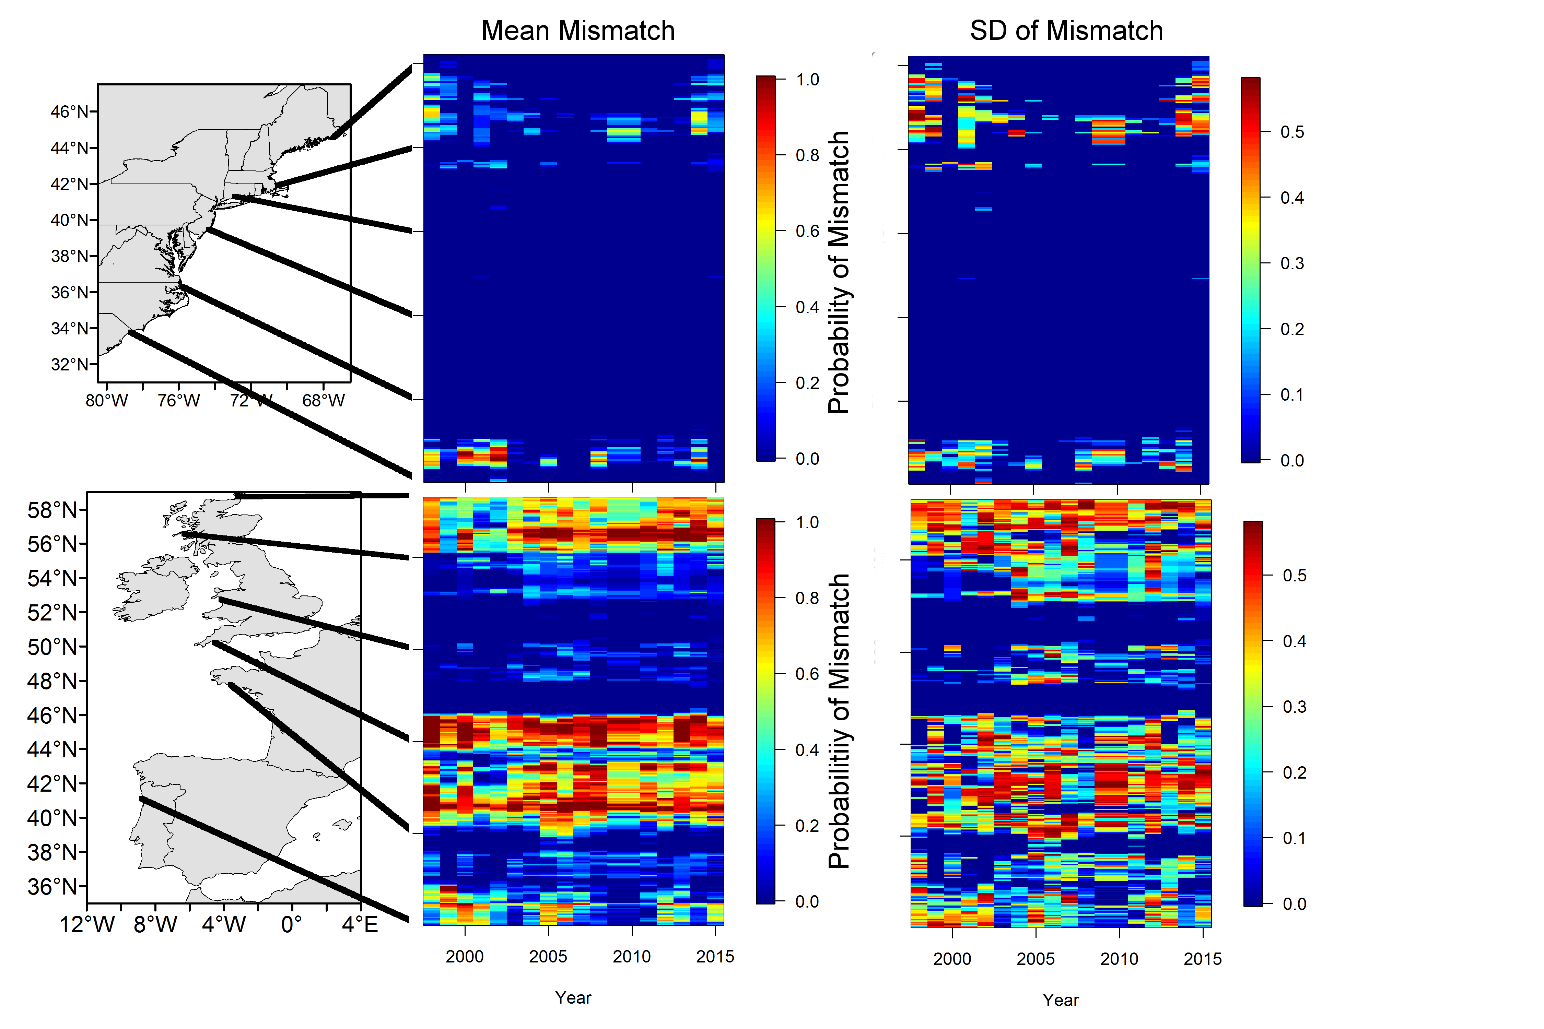Supplementary Figure 2. Mean of predicted probability of phytoplankton mismatch and standard deviation of predicted phytoplankton mismatch between 1998 and 2015 in the western and eastern Atlantic at 10 km intervals along each coastline. Probability of phytoplankton mismatch was calculated as the frequency of mismatch between predicted dates of larval release if eggs were fertilized on November 1st, December 1st, and January 1st, and 30 days past each predicted date of larval release. Black lines between maps and plots match predictions to corresponding locations on the coastline.

