Supplementary information:

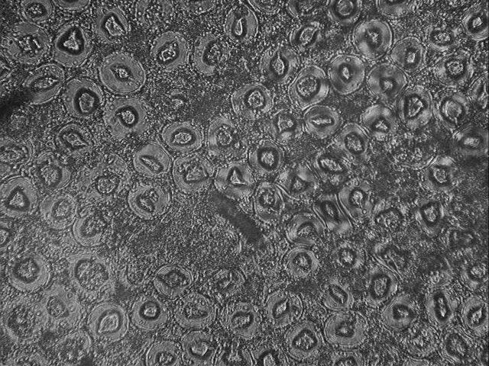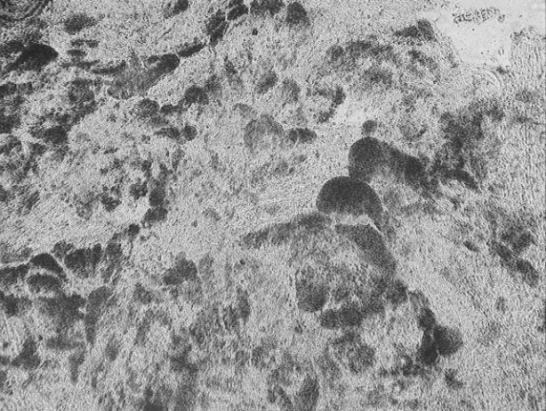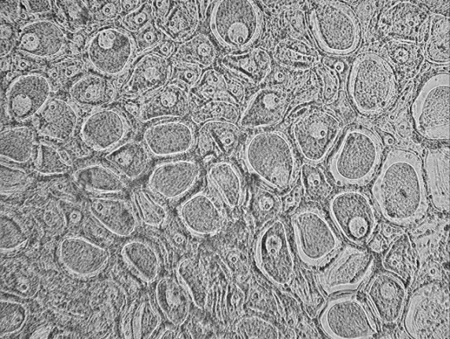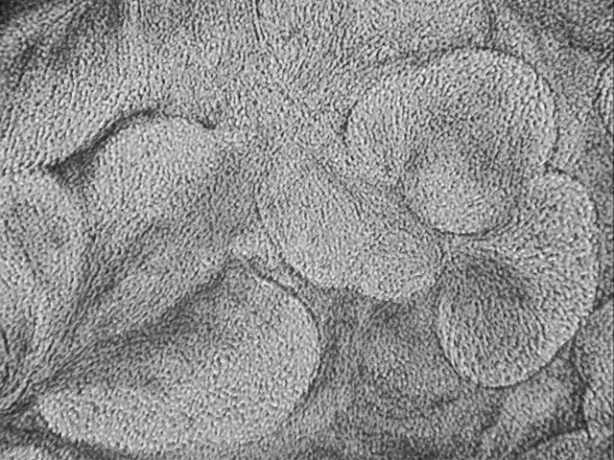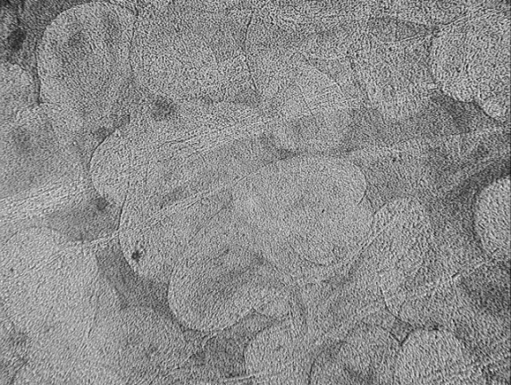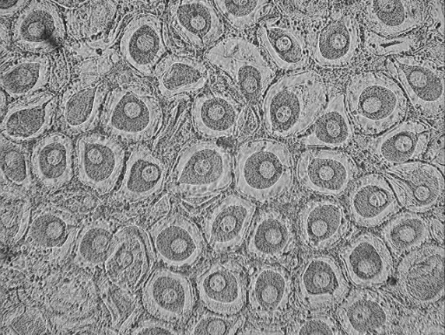
50 µm
50 µm
50 µm
50 µm
50 µm
50 µm
A
F
E
D
B
C

Fig. A. Stages of reproductive cycle observed in Cerastoderma edule following the classification previously described by Seed and Brown (1977): (A) Developing male (stage 1). (B) Developing female (stage 1). (C) Developing male (stage 2). (D) Developing female (stage 2). (E) Ripe male (stage 3). (F) Ripe female (stage 3).

Table A. Morphometric descriptors of samples of C. edule collected from sites in SW England, (Mean ± SE)
 | Site | N | Weight (g) | Length (mm) | Dry tissue Weight(g) | Shell Volume(g)
May | Padstow | 96 | 9.93 ± 0.39ª | 30.53 ± 0.35 ^{ac} | 0.36 ± 0.03^{ab} | 5.68 ± 0.20ª
June | Plym | 60 | 15.48 ± 0.55^{b} | 34.20 ± 0.44^{b} | 0.55 ± 0.04 | 8.47 ± 0.42^{bc}
 | Noss Mayo | 55 | 19.39 ± 0.80^{c} | 35.78 ± 0.58 ^{b} | 0.71 ± 0.02^{c} | 7.77 ± 0.29 ^{b}
 | Bantham | 56 | 18.57 ± 0.92^{c} | 34.46 ± 0.64 ^{b} | 0.67 ± 0.03 ^{c} | 8.73 ± 0.42 ^{bd}
July | Kingsmill | 55 | 12.45 ± 0.27 ^{abc} | 31.57 ± 0.25 ^{c} | 0.33 ± 0.01^{a,b} | 6.71 ± 0.18 ^{ac}
 | Looe | 52 | 22.70 ± 0.76 | 36.39 ± 0.39 ^{b} | 0.68 ± 0.03 ^{c} | 10.21± 0.33^{d}
 | L. Anderton | 67 | 11.08 ± 0.43 ^{bc} | 31.79 ± 0.34^{c} | 0.42 ± 0.02ª | 5.75 ± 0.21 ª
 | Wacker Quay | 50 | 10.58 ± 0.43 ^{ac} | 28.91 ± 0.41^{a c} | 0.27 ± 0.01^{b} | 4.48 ± 0.24 ª
 | Antony | 53 | 12.12 ± 0.40 ^{ac} | 30.19 ± 0.38 ª | 0.27 ± 0.01^{b} | 5.17 ± 0.26 ª
Means that do not share the same letter within columns are significantly different

