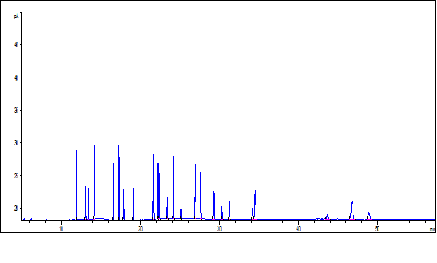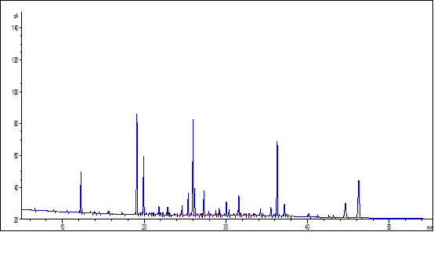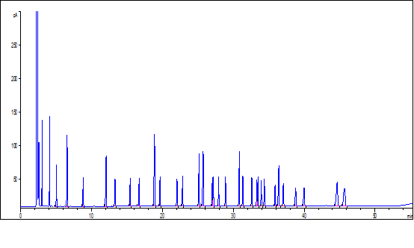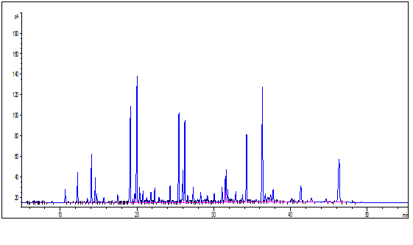

D

B

C

A

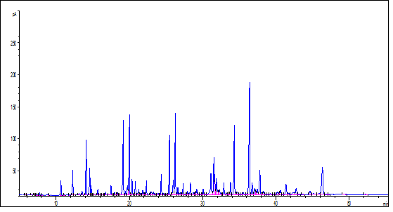

E

Fig. S1 The retention times of commercial known single standard (A: 24 kinds of single standard), mixture standard (B: 37-FAME Mix; C: 46-FAME Mix) and some samples (D: body wall in Rongcheng Bay; E: ovary in Rongcheng Bay)

The signal of A: 14:0, Iso-15:0, Anteiso-15:0, 15:0, 16:0, 16:1ω9, Iso-17:0, 17:0, 18:0, 18:1ω9, 18:1ω7, 18:2ω6, 19:0, 18:3ω3, 20:0, 20:1ω11, 20:2ω6, 20:3ω6, 20:4ω6, 20:5ω3, 22:0, 24:0, 25:5ω6, 22:6ω3.

The signal of B: 14:0, 14-isobr, 14-anteiso, 14:1ω5, 15:0; 6, 16:0, 16-isobr, 16-anteiso, 16:1ω9, 16:1ω7, 16:1ω5, 16:2ω4, 16:3ω3, 16:4ω3, 17:0, 17:1ω9, 17:1ω8, 18:0, 18:1ω11, 18:1ω9, 18:1ω7, 18:2ω6, 18:2ω4, 18:3ω6, 18:3ω3, 18:4ω3, 19:1ω8, 20:1ω11, 20:1ω9, 20:1ω7, 20:2ω9, 20:2ω6, 20:3ω9, 20:3ω6, 20:3ω3, 20:4ω6, 20:4ω3, 20:5ω3, 22:1ω11, 22:1ω9, 22:3ω9, 22:3ω6, 22:4ω6, 22:5ω6, 22:5ω3, 22:6ω3.

The signal of C: C4:0, C6:0, C8:0, C10:0, C11:0, C12:0, C13:0, C14:0, C14:1, C15:0, C15:1, C16:0, C16:1, C17:0, C17:1, C18:0, C18:1ω9c, C18:1ω9t, C18:2ω6c, C18:2ω6t, C18:3ω6, C18:3ω3, C20:0, C20:1ω9, C20:2, C20:3ω6, C20:3ω3, C20:4ω6, C20:5ω3, C21:0, C22:0, C22:1ω9, C22:2, C22:6ω3, C23:0, C24:0, C24:1ω9.

Tabel S1 The composition of fatty acid in the sediment in the gut, body wall, and ovary in Rongcheng Bay and in the body wall in Laoshan Bay

|  |  |  |  |  |
| --- | --- | --- | --- | --- |
|  | The Rongcheng Bay | | | Laoshan Bay |
|  | sediment | Body wall | ovary | Body wall |
| 12:0 | 1.24±0.3 | 26.41±3.73b | 62.26±6.72a | --c |
| 14:0 | 27±20.09 | 1143.57±184.24b | 2076.52±275.45a | 343.52±225.23c |
| 14:1 | 25.07±33 | 2082.73±194.02b | 4361.45±343.69a | 502.43±128.95c |
| 14-anteiso | 12.74±15.79 | 1028.84±92.5b | 1967.08±130.21a | 284.74±72.6a |
| 14:1ω5 | 1.31±1.56 | 215.93±80.37ab | 311.80±54.51a | 138.68±65.83b |
| 15:0 | 4.93±5.17 | 184.95±33.21b | 452.24±71.52a | 38.94±6.03c |
| 15:1 | 5.46±7.03 | 346.71±42.02b | 764.28±90.5a | 52.01±10.86c |
| 16:0 | 143.45±72.15 | 4170.21±251.27b | 7070.67±504.93a | 1666.19±577.19c |
| 16-isobr | 6.62±7.17 | 466.87±24.39b | 959.73±66.63a | 146.83±100.13c |
| 16-anteiso | 3.59±4.19 | 215.46±17.1b | 405.97±42.12a | 82.28±55.6c |
| 16:1ω5 | 6.82±8.37 | 676.19±73.82a | 1338±124.56a | 1231.93±1840.47a |
| 16:1ω7 | 62.66±65 | 4867.19±778.86b | 7750.91±846.84a | 1275.22±1417.11c |
| 16:1ω9 | 6.99±6.6 | 455.31±48.99b | 942.75±75.55a | 94.67±94.83c |
| 16:2ω4 | -- | 356.21±91.92ab | 500.74±93.52a | 234.42±107.85b |
| 16:3ω3 | 3.05±1.85 | 168.05±40.56b | 359.27±81.06a | 86.98±53.65b |
| 16:4ω3 | -- | 79.37±22.26a | 156.41±31.26a | 254.53±244.53a |
| 17:0 | 11.81±10.42 | 523.04±51.58b | 1091.14±123.17a | 108.73±37.94c |
| 17:1 | 2.68±2.27 | 181.64±15.84b | 364.73±32.16a | 33.81±12.05c |
| 18:0 | 105.37±45.14 | 3798.6±308.6b | 5676.45±596.66a | 1717.44±528.96c |
| 18:1ω9 | 35.52±26.94 | 1515.2±175.66a | 1934.98±318.29a | 426.76±185b |
| 18:1ω7 | 45.13±50.55 | 3395.97±203.04b | 7075.99±427.43a | 1233.69±353.8c |
| 18:1ω11 | -- | --b | --b | 93.22±14.27a |
| 18:2ω6 | 22.13±11.37 | 688.77±98.75b | 1183.32±161.37a | 200.24±76.37c |
| 18:2ω4 | -- | 133.13±44.91b | 285.52±41.83a | 63.87±21.86b |
| 18:3ω3 | 4.23±2.38 | 361.96±100.94b | 608.49±85.78a | 115.22±62.47c |
| 18:3ω6 | 4.91±7.36 | 480.49±65.92b | 989.84±66.62a | 196.66±84.32c |
| 18:4ω3 | 3.59±1.52 | 377.96±106.22b | 627.63±113.2a | 196.07±104.65b |
| 20:0 | -- | 947.2±238.65b | 2523.06±403.04a | 197.12±36.03c |
| 20:1ω11 | 15.09±17.7 | 1047.53±167.85b | 3291.08±402.6a | --c |
| 20:1ω9 | 13.22±14.61 | 1594.72±487.34a | 2399.49±471.12a | 364.4±41.2b |
| 20:1ω7 | 6.31±6.72 | 605.14±204.65b | 1472.34±146.28a | 369.86±165.26b |
| 20:2ω6 | 9.63±3.66 | 548.21±79.87b | 1160.26±108.85a | 147.2±16.94c |
| 20:2ω9 | -- | --b | --b | 138.72±32.4a |
| 20:3ω6 | -- | 119.74±52.44b | 267.47±75.53a | 142.12±8.34b |
| 20:4ω6 | 26.15±26.73 | 3131.75±130.45b | 6562.12±677.08a | 1592.63±55.34c |
| 20:4ω3 | 7.05±2.29 | 242.91±56.73b | 410.51±47.41a | 14.15±24.5c |
| 20:5ω3 | 44.45±42.17 | 5380.4±607.11b | 13596.73±1695.13a | 2978.3±1113.68b |
| 22:0 | 9.54±11.14 | 437.4±35.99b | 1660.38±293.07a | 221.68±23.97b |
| 22:1ω11 | -- | 221.1±41.04b | 422.49±94.15a | 27.84±26.94c |
| 22:1ω9 | -- | 494.14±37.4b | 844.36±108.51a | 121±57.2c |
| 22:3ω9 | -- | --b | --b | 467.98±26.52a |
| 22:4ω6 | -- | --b | --b | 190.37±14.93a |
| 22:5ω3 | -- | 286.12±19.47b | 541.97±68.47a | --c |
| 22:6ω3 | 22.52±19.31 | 3749.89±226.59a | 4693.74±735.54a | 1676.87±386.22b |
| **Total** | **700.96±538.92** | **46746.99±4196.47**b | **89164.13±8363.35**a | **19469.33±5706.05c** |
| **ΣSFAs** | **352.87±224.08** | **15086.75±1190.2**b | **28476.23±2138**a | **2674.31±838.57c** |
| **ΣMUFAs** | **193.05±195.6** | **15088.42±1800.75**b | **27784.17±2629.51**a | **5377.28±2186.32c** |
| **ΣPUFAs** | **148.43±114.16** | **16104.94±1384.01**b | **31943.98±3707.86**a | **8696.32±1799.09c** |
| **LC-PUFAs** | **109.79±91.73** | **13459.02±963.29**b | **27232.78±3183.36**a | **7348.33±1534.78c** |

*Different lowercase letters indicate significant differences (P<0.05)