Supplementary material
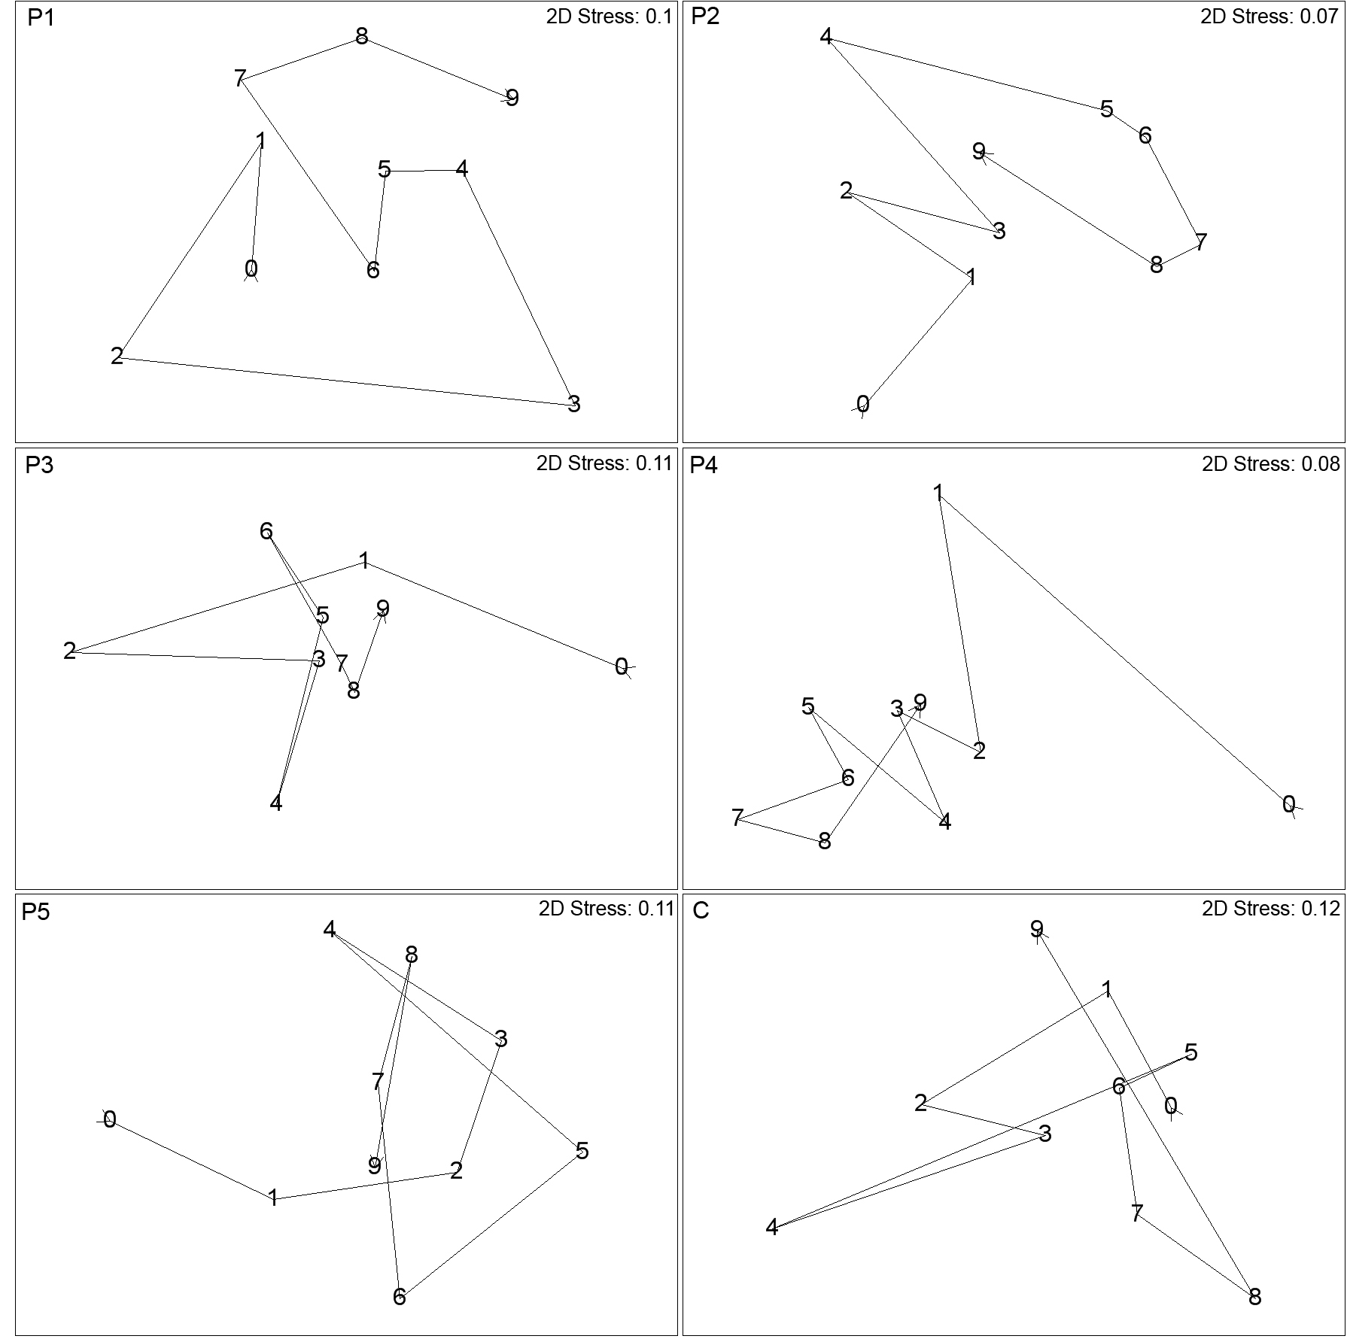Fig S1. Ordination plots (nMDS) showing the effect of Ecklonia radiata on sponge assemblages at Breaker Bay. Lines represent the trajectory of change in the understory of an individual plot though time. Ordination based on Bray-Curtis similarity matrices fourth root-transformed percentage cover data of species, with centroids as treatment averages. P = removal plot, C = control.

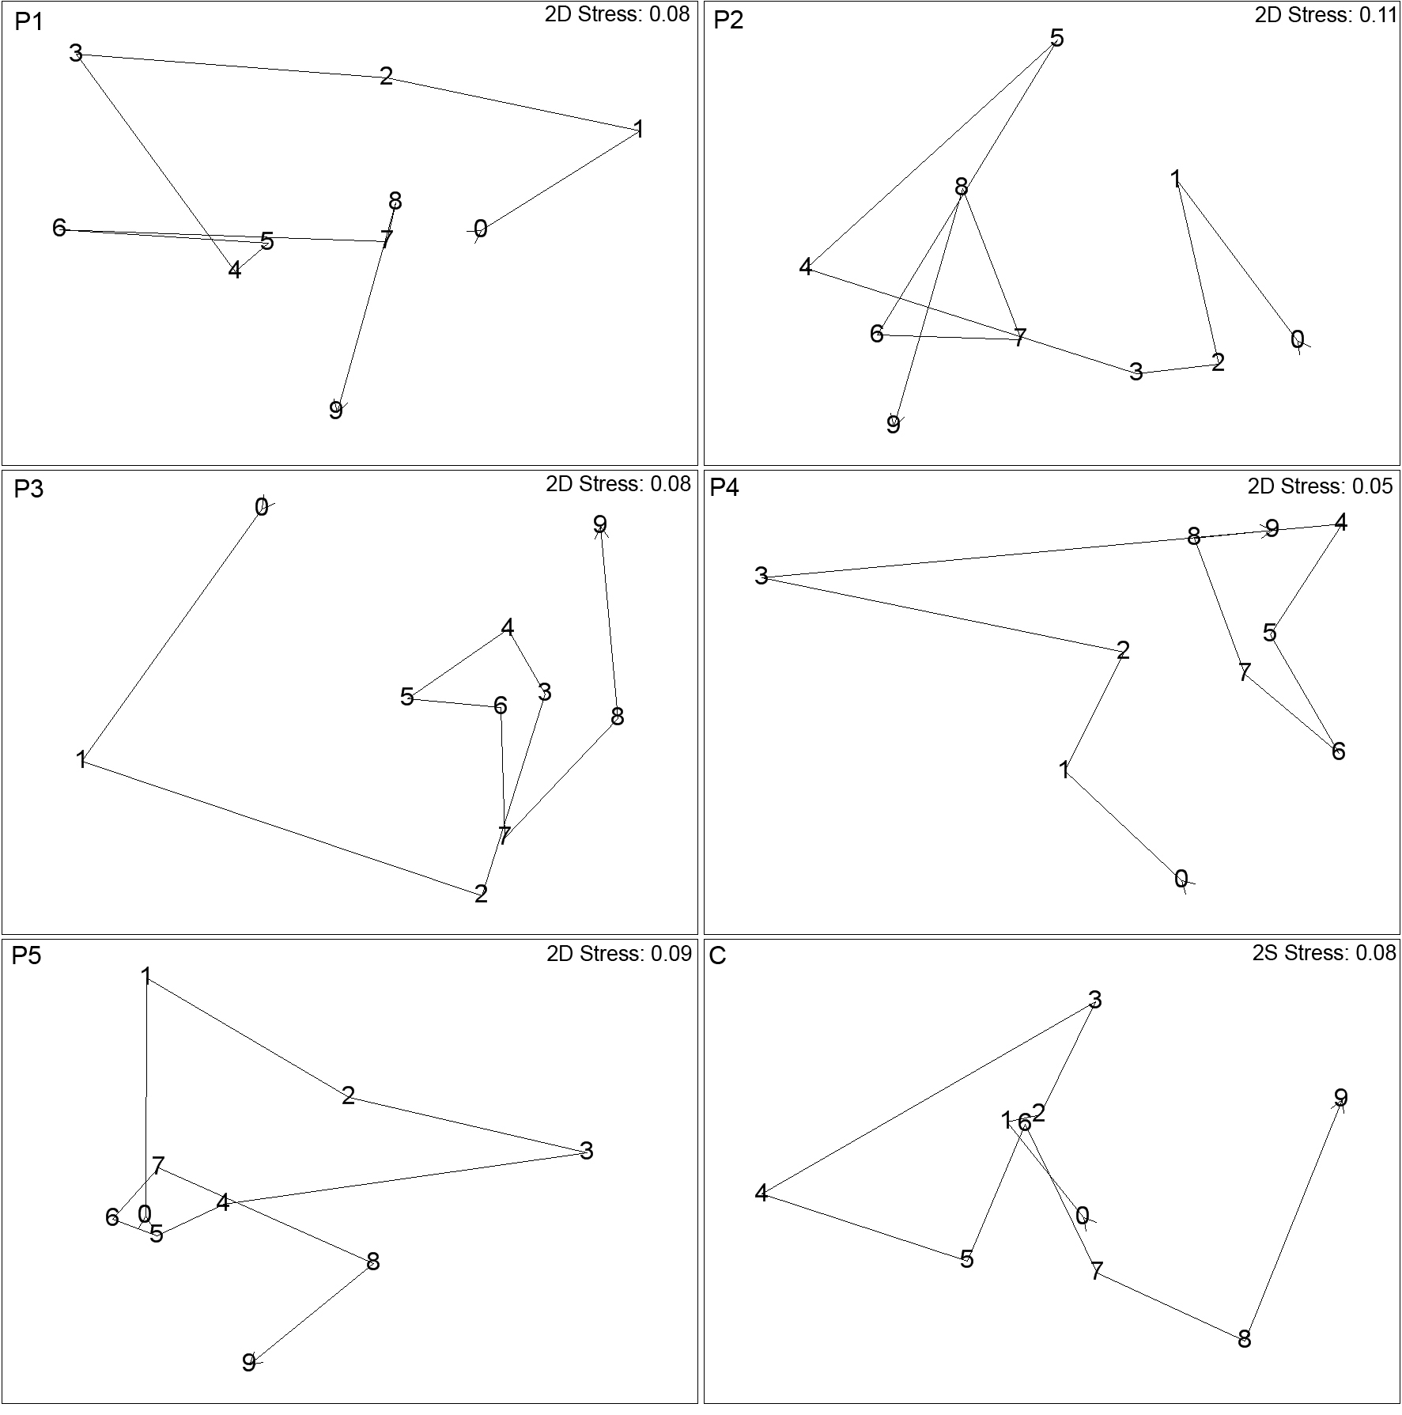
Fig S2. Ordination plots (nMDS) showing the effect of Ecklonia radiata on sponge assemblages at Palmer Head. Lines represent the trajectory of change in the understory of an individual plot though time. Ordination based on Bray-Curtis similarity matrices fourth root-transformed percentage cover data of species, with centroids as treatment averages. P = removal plot, C = control.

