SUPPLEMENTARY MATERIAL
Fig. S1. Phylogenetic hypothesis of Coenogonium resulting from the Bayesian analysis of ITS rDNA sequences. Values at the nodes indicate the statistical supports of Bayesian posterior probability (left), maximum-likelihood bootstrap (middle) and maximum parsimony bootstrap (right). Fully supported branches (1.0/100/100) are marked with an asterisk. Scale bar shows the estimated number of substitutions per site.

Fig. S2. Phylogenetic hypothesis of Coenogonium resulting from the Bayesian analysis of mtSSU sequences. Values at the nodes indicate the statistical supports of Bayesian posterior probability (left), maximum-likelihood bootstrap (middle) and maximum parsimony bootstrap (right). Fully supported branches (1.0/100/100) are marked with an asterisk. Scale bar shows the estimated number of substitutions per site.
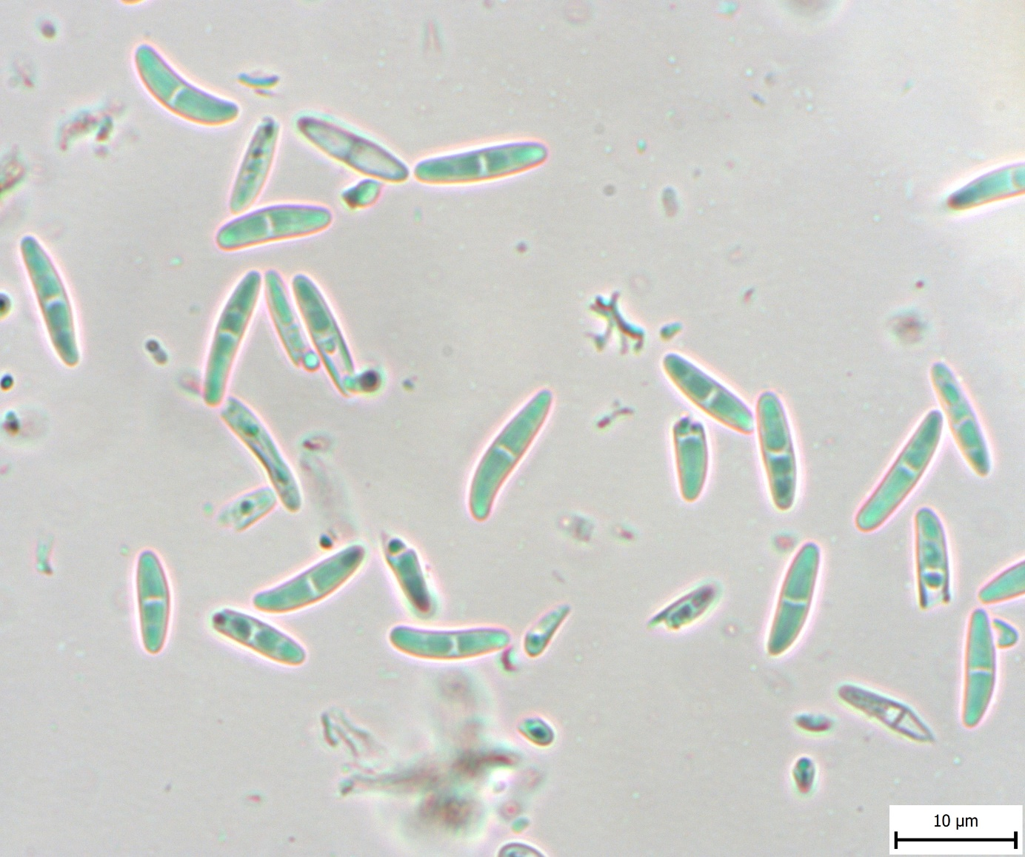
Fig. S3. Coenogonium nimisii, ascospores in water (Sanderson 436).

Fig. S4. Phylogenetic hypothesis (unrooted tree) of Trentepohliales resulting from the Bayesian analysis of rbcL sequences. Values at the nodes indicate the statistical supports of Bayesian posterior probability (left), maximum-likelihood bootstrap (middle) and maximum parsimony bootstrap (right). Fully supported branches (1.0/100/100) are marked with an asterisk. Scale bar shows the estimated number of substitutions per site. Newly obtained sequences are marked in bold, Coenogonium photobionts are marked in orange, Porina photobionts are marked in violet. Clade numbering corresponds to Nelsen et. al. (2011).
