Supplementary file S2: Multivariate models

Partition of variation 1: Full model including both Scots pine and Norway spruce

Table 1. The first four axes from the DCA.
 | DCA 1 | DCA 2 | DCA 3 | DCA 4
Eigenvalues | 0.25 | 0.22 | 0.18 | 0.19
Axis lengths | 2.25 | 2.75 | 2.31 | 2.41

Table 2. Proportion of variation explained by constrained and unconstrained axes.
 | Inertia | Proportion
Constrained | 9.99 | 0.49
Unconstrained | 10.22 | 0.50

Table 3. Eigenvalues for constrained and unconstrained axes
Constrained | RDA 1 | RDA 2 | RDA 3 | RDA 4
 | 4.23 | 3.61 | 1.18 | 0.53
Unconstrained | PC 1 | PC 2 | PC 3 | PC 4
 | 2.77 | 1.63 | 1.34 | 0.96

Table 4. The different variables included in the model were tested in ANOVA with 999 permutations. The interaction between tree species and stand age is significant and was kept in the final model.
 | Df | Variance | F | Pr(>F)
Tree species | 1 | 3.69 | 83.76 | < 0.001
Age | 2 | 2.80 | 31.79 | < 0.001
Level | 1 | 1.30 | 29.54 | < 0.001
Aspect | 1 | 0.15 | 3.51 | 0.006
Tree species × age | 2 | 2.04 | 23.20 | < 0.001

Table 5. The four first RDA axes, resulting from the model, were tested in ANOVA with 999 permutations.
 | Variance | F | Pr(>F)
RDA 1 | 4.23 | 95.92 | < 0.001
RDA 2 | 3.61 | 82.01 | < 0.001
RDA 3 | 1.18 | 26.78 | < 0.001
RDA 4 | 0.53 | 11.95 | < 0.001

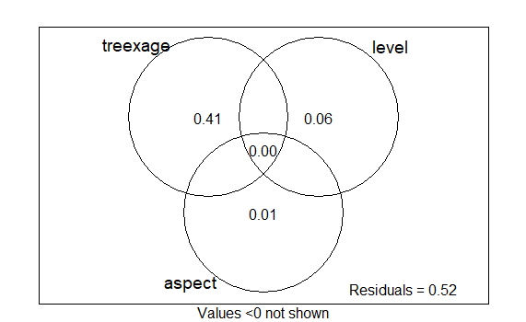

Figure 1. Venn diagram illustrating the different shares of proportion of variation explained by the different variables included in the full model consisting of plots on both Scots pine and Norway spruce.

Partition of variation 2: Reduced model including Scots pine

Table 6. The first four axes from the DCA.
 | DCA 1 | DCA 2 | DCA 3 | DCA 4
Eigenvalues | 0.21 | 0.16 | 0.16 | 0.12
Axis lengths | 2.11 | 2.55 | 2.13 | 1.86

Table 7. Proportion of variation explained by constrained and unconstrained axes.
 | Inertia | Proportion
Constrained | 11.37 | 0.52
Unconstrained | 10.46 | 0.48

Table 8. Eigenvalues for constrained and unconstrained axes.
Constrained | RDA 1 | RDA 2 | RDA 3 | RDA 4
 | 8.43 | 2.02 | 0.70 | 0.23
Unconstrained | PC 1 | PC 2 | PC 3 | PC 4
 | 2.70 | 1.84 | 1.66 | 1.03

Table 9. The different variables included in the model were tested in ANOVA with 999 permutations.
 | Df | Variance | F | Pr(>F)
Age | 2 | 7.98 | 43.87 | < 0.001
Level | 1 | 3.15 | 34.65 | < 0.001
Aspect | 1 | 0.25 | 2.71 | 0.028

Table 10. The four first RDA axes, resulting from the model, were tested in ANOVA with 999 permutations.
 | Variance | F | Pr(>F)
RDA 1 | 8.43 | 92.68 | < 0.0001
RDA 2 | 2.02 | 22.22 | < 0.0001
RDA 3 | 0.70 | 7.64 | < 0.0001
RDA 4 | 0.23 | 2.56 | 0.014

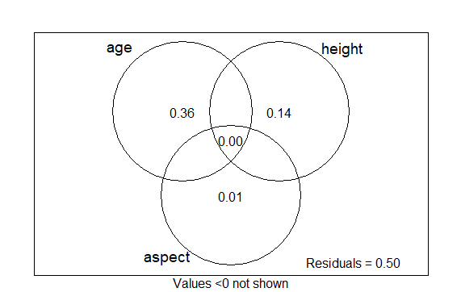
Figure 2. Venn diagram illustrating the different shares of proportion of variation explained by the different variables included in the reduced model consisting of plots on Scots pine.

Partition of variation 3: Reduced model including Norway spruce

Table 11. The first four axes from the DCA
 | DCA 1 | DCA 2 | DCA 3 | DCA 4
Eigenvalues | 0.28 | 0.19 | 0.10 | 0.12
Axis lengths | 2.45 | 1.68 | 1.37 | 1.44

Table 12. Proportion of variation explained by constrained and unconstrained axes.
 | Inertia | Proportion
Constrained | 3.11 | 0.27
Unconstrained | 8.25 | 0.73

Table 13. Eigenvalues for constrained and unconstrained axes.
 | RDA 1 | RDA 2 | RDA 3 | RDA 4
Constrained | 1.62 | 1.16 | 0.26 | 0.07
 | PC 1 | PC 2 | PC 3 | PC 4
Unconstrained | 2.23 | 1.57 | 0.94 | 0.76

Table 14. The different variables included in the model were tested in ANOVA with 999 permutations.
 | Df | Variance | F | Pr(>F)
Age | 2 | 1.76 | 12.24 | 0.001
Level | 1 | 1.10 | 15.27 | 0.001
Aspect | 1 | 0.26 | 3.60 | 0.002

Table 15. The four first RDA axes, resulting from the model, were tested in ANOVA with 999 permutations.
 | Variance | F | Pr(>F)
RDA 1 | 1.61 | 22.55 | < 0.001
RDA 2 | 1.16 | 16.19 | < 0.001
RDA 3 | 0.26 | 3.70 | 0.007
RDA 4 | 0.07 | 0.92 | 0.479

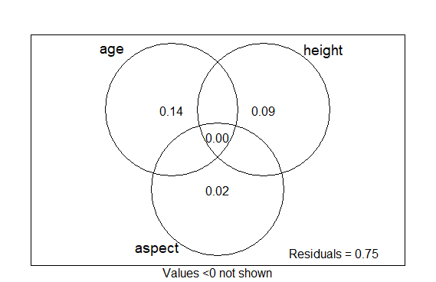
Figure 3. Venn diagram illustrating the different shares of proportion of variation explained by the different variables included in the reduced model consisting of plots on Norway spruce.

