Supplementary Material.
Supplementary Material Table S1. Species list characterized by group of taxa, number of relevés and pH values. B = bryophyte, L = lichen, V = vascular plant.

Species | Group | Number of relevé | pH
Achillea pannonica | V | 3 | 4
Agrostis capillaris | V | 7 | 2
Anthoxanthum odoratum | V | 17 | 3
Artemisia absinthium | V | 1 | 4
Artemisia campestris | V | 1 | 4
Asperula cynanchica | V | 2 | 4
Asplenium septentrionale | V | 1 | 2
Asplenium trichomanes | V | 1 | 3
Briza media | V | 1 | 0
Calluna vulgaris | V | 11 | 1
Carex caryophyllea | V | 2 | 0
Carex fritschii | V | 1 | 2
Cerastium brachypetalum | V | 1 | 3
Chamaecytisus ratisbonensis | V | 2 | 4
Chamaecytisus supinus subsp. aggregatus. | V | 1 | 3
Conyza canadensis | V | 1 | 0
Cotoneaster integerrimus | V | 1 | 4
Crataegus monogyna | V | 3 | 3
Deschampsia flexuosa | V | 11 | 1
Dianthus armeria | V | 1 | 3
Dianthus pontederae | V | 3 | 4
Dorycnium germanicum | V | 1 | 4
Erigeron annua | V | 2 | 4
Erophila verna | V | 1 | 0
Eryngium campestre | V | 2 | 4
Euphorbia cyparissias | V | 7 | 4
Euphorbia seguieriana | V | 2 | 4
Euphrasia stricta | V | 1 | 3
Fagus sylvatica | V | 1 | 4
Festuca rupicola | V | 9 | 4
Festuca vaginata | V | 1 | 5
Festuca valesiaca | V | 1 | 4
Fraxinus ornus (sapling) | V | 2 | 4
Geranium rotundifolium | V | 1 | 4
Geranium sanguineum | V | 2 | 5
Hieracium bauhinii | V | 18 | 3
Hieracium cymosum | V | 2 | 4
Hieracium lachenallii | V | 1 | 2
Hieracium pilosella | V | 5 | 3
Hypericum perforatum | V | 6 | 0
Jasione montana | V | 11 | 2
Juniperus communis | V | 7 | 4
Koeleria cristata | V | 2 | 4
Luzula campestris | V | 14 | 4
Luzula divulgata | V | 7 | x
Luzula luzuloides | V | 1 | 2
Lembotropis nigricans | V | 3 | 2
Linaria genistifolia | V | 2 | 5
Minuartia frutescens | V | 1 | 4
Ornithogalum umbellatum | V | 1 | 4
Papaver dubium | V | 1 | 3
Petrorhagia prolifera | V | 3 | 0
Petrorhagia saxifraga | V | 1 | 4
Peucedanum oreoselinum | V | 3 | 0
Phleum paniculatum | V | 1 | 4
Phleum phleoides | V | 1 | 4
Pinus sylvestris seedling | V | 1 | 5
Pimpinella saxifraga | V | 1 | 3
Plantago lanceolata | V | 2 | 0
Poa bulbosa | V | 1 | 4
Polygonatum odoratum | V | 10 | 4
Potentilla arenaria | V | 1 | 5
Potentilla argentea | V | 5 | 3
Quercus cerris seedling | V | 8 | 3
Quercus petraea seedling | V | 4 | 0
Quercus pubescens seedling | V | 5 | 5
Rhinanthus minor | V | 3 | 0
Rosa canina | V | 1 | 3
Rubus fruticosus | V | 4 | x
Rumex acetosella | V | 18 | 2
Sanguisorba minor | V | 3 | 4
Scabiosa ochroleuca | V | 1 | 4
Scleranthus verticillatus | V | 1 | 3
Sedum acre | V | 2 | 3
Sedum sexangulare | V | 5 | 3
Seseli hippomarathrum | V | 1 | 5
Seseli osseum | V | 1 | 5
Silene otites | V | 1 | 4
Sorbus aucuparia seedling | V | 1 | 2
Stachys recta | V | 1 | 5
Taraxacum laevigatum | V | 1 | 0
Teucrium chamaedrys | V | 2 | 4
Thlaspi arvense | V | 1 | 4
Thesium linophyllum | V | 3 | 4
Thymus glabrescens | V | 3 | 3
Thymus praecox | V | 3 | 5
Trifolium arvense | V | 2 | 4
Trifolium campestre | V | 2 | 4
Trifolium pratense | V | 1 | 3
Trisetum flavescens | V | 4 | 0
Verbascum phlomoides | V | 1 | 4
Veronica officinalis | V | 1 | 2
Vicia lathyroides | V | 1 | 3
Vicia tetrasperma | V | 2 | 3
Viola tricolor | V | 1 | 0
Viscaria vulgaris | V | 9 | x
Vulpia bromoides | V | 2 | x
Acarospora fuscata | L | 5 | 5
Aspicilia caesiocinerea | L | 13 | 5
Caloplaca chrysodeta | L | 1 | x
Candelariella vitellina | L | 9 | 5
Cladonia arbuscula | L | 15 | 2
Cladonia chlorophaea | L | 8 | 2
Cladonia coniocraea | L | 6 | 4
Cladonia convoluta | L | 8 | 8
Cladonia cf. digitata | L | 2 | 1
Cladonia furcata | L | 22 | 4
Cladonia gracilis | L | 7 | 2
Cladonia macilenta | L | 4 | 2
Cladonia mitis | L | 36 | 2
Cladonia cf. pyxidata | L | 5 | 2
Cladonia rangiferina | L | 13 | 2
Cladonia rangiformis | L | 12 | 3
Cladonia squamosa | L | 1 | 2
Cladonia cf. subulata | L | 4 | 3
Cladonia symphycarpa | L | 3 | 8
Cladonia uncialis | L | 21 | 2
Cladonia cf. verticillata | L | 2 | x
Hypogymnia physodes | L | 4 | 3
Hypogymnia tubulosa | L | 1 | 3
Lecanora muralis | L | 9 | 8
Lepraria caesioalba | L | 1 | x
Lepraria incana | L | 2 | x
Lepraria lobificans | L | 2 | 3
Melanelixia glabra | L | 1 | 6
Parmelia saxatilis | L | 2 | 3
Parmelina tiliacea | L | 1 | 5
Physcia tenella | L | 1 | 6
Porpidia crustulata | L | 2 | 4
Protoblastenia rupestris | L | 1 | 9
Pseudevernia furfuracea | L | 1 | 2
Psora decipiens | L | 1 | 8
Rhizocarpon distinctum | L | 5 | 5
Rhizocarpon geographicum | L | 3 | 3
Squamarina cartilaginea | L | 2 | 9
Xanthoparmelia conspersa | L | 9 | 5
Xanthoparmelia loxodes | L | 2 | x
Xanthoparmelia pulla | L | 4 | 4
Xanthoparmelia stenophylla | L | 9 | 5
Buxbaumia aphylla | B | 1 | 2
Ceratodon purpureus | B | 6 | 3
Dicranum muehlenbeckii | B | 1 | 4
Dicranum scoparium | B | 27 | 3
Dicranum spurium | B | 1 | 2
Dicranum polysetum | B | 3 | 3
Hedwigia ciliata | B | 1 | 2
Hypnum cupressiforme | B | 35 | 3
Leucobryum glaucum | B | 2 | 2
Pleurozium schreberi | B | 4 | 2
Pohlia cruda | B | 1 | 3
Pohlia nutans | B | 4 | 2
Polytrichastrum formosum | B | 7 | x
Polytrichum juniperinum | B | 8 | 2
Polytrichum piliferum | B | 21 | 2

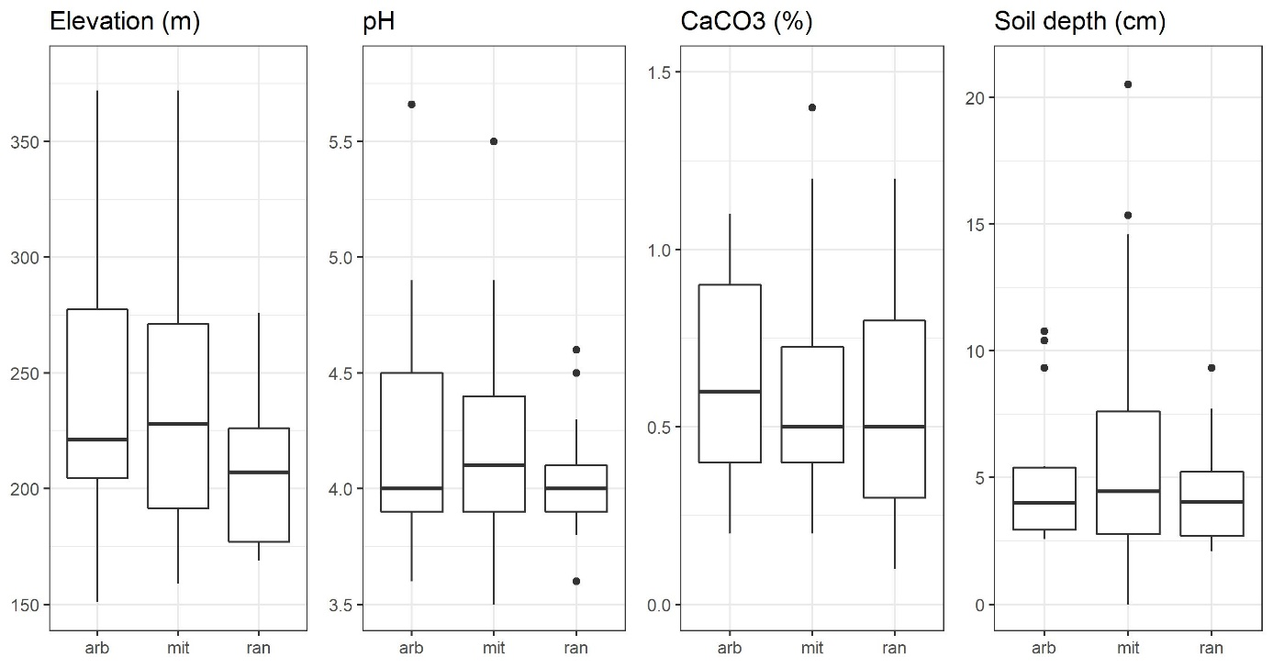
Supplementary Material Fig. S1. Variation of numerical environmental variables (elevation, pH, CaCO₃ and soil depth) between investigated Cladonia species. All boxplots were calculated from all relevés which contain the given Cladonia species, therefore relevés which refer to two or three investigated Cladonia species were considered repeatedly. Boxes define 25 and 75 percentiles; thick horizontal lines show the median; whiskers define 10 and 90 percentiles; points are outliers. Abbreviations: arb = Cladonia arbuscula, mit = C. mitis, ran = C. rangiferina.

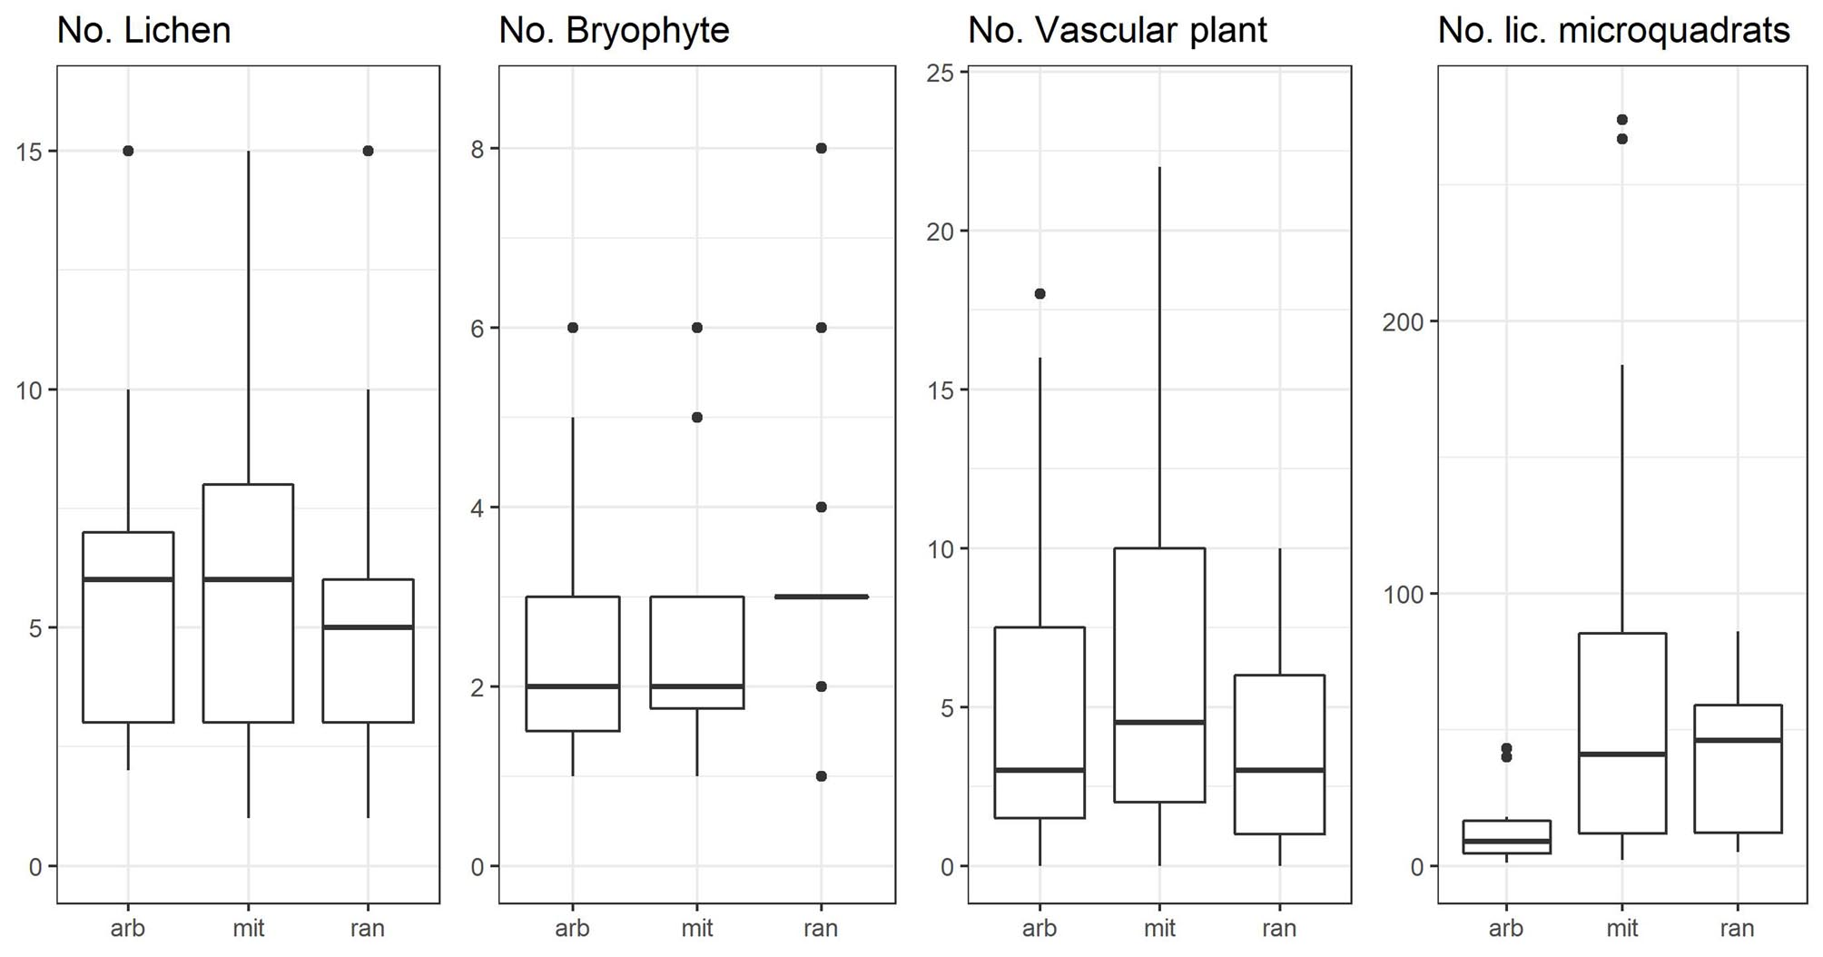
Supplementary Material Fig. S2. Variation in the number of lichen, bryophyte and vascular plant species occurring in relevés and variation of lichen-containing microquadrats between investigated Cladonia species. All boxplots were calculated from all relevés which contain the given Cladonia species; therefore, relevés, which refer to two or three investigated Cladonia species were considered repeatedly. Boxes define 25 and 75 percentiles; thick horizontal lines show the median; whiskers define 10 and 90 percentiles; points are outliers. Abbreviations: No. – number of, lic – lichen, arb = Cladonia arbuscula, mit = C. mitis, ran = C. rangiferina.

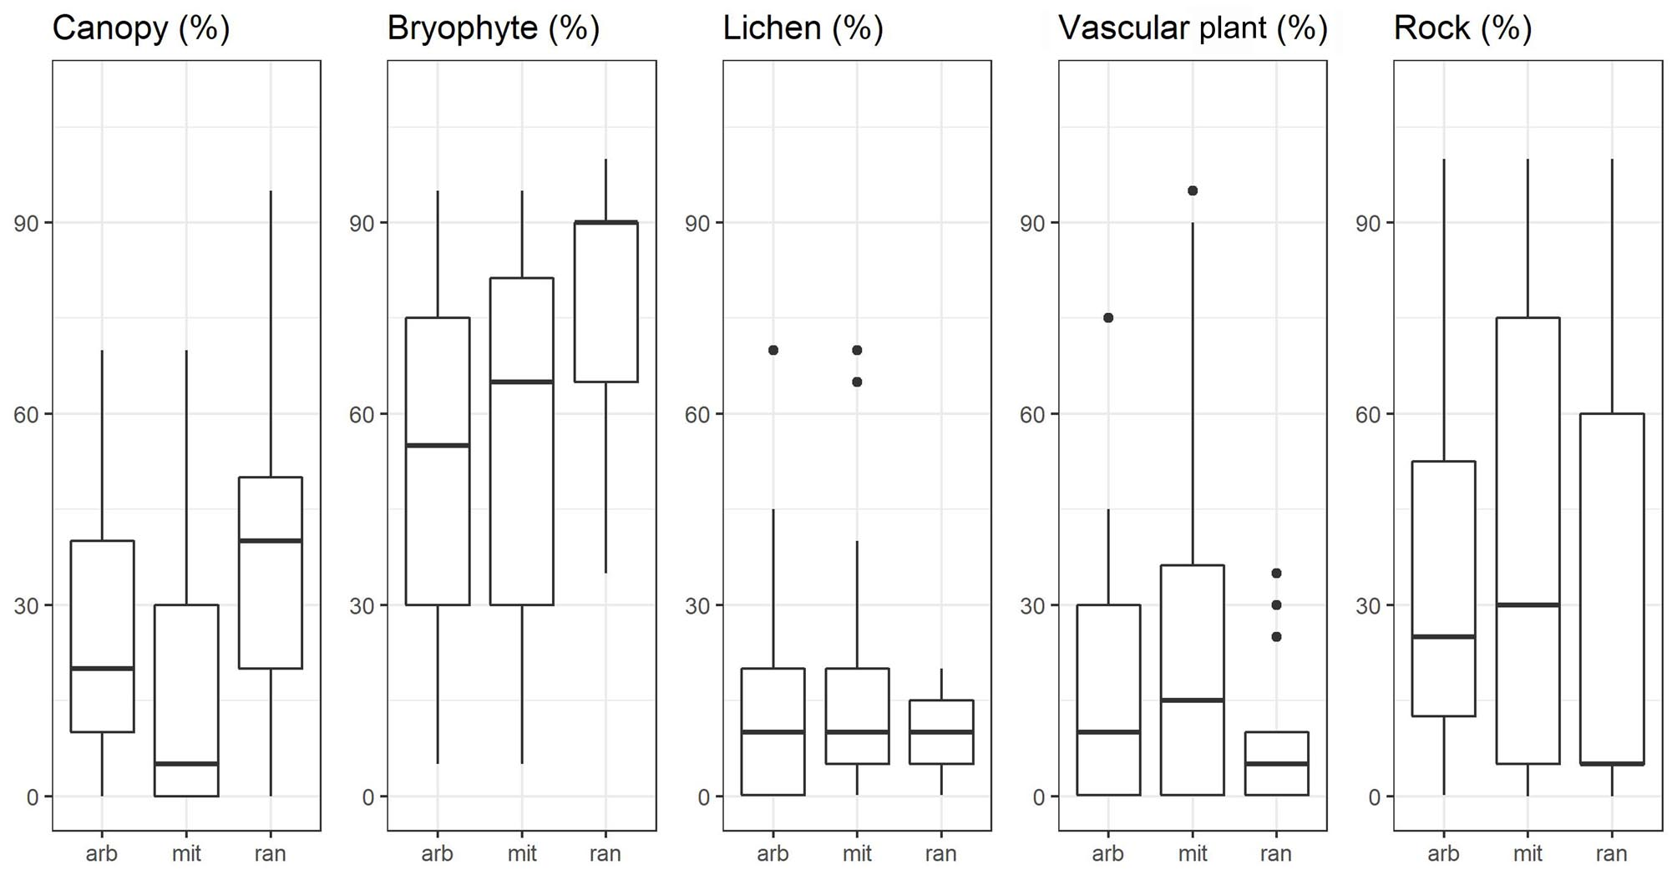
Supplementary Material Fig. S3. Variation in cover of canopy, bryophyte, lichen, vascular plant species and rock between investigated species. All boxplots were calculated from all relevés which contain the given Cladonia species; therefore, relevés which refer to two or three investigated Cladonia species were considered repeatedly. Boxes define 25 and 75 percentiles; thick horizontal lines show the median; whiskers define 10 and 90 percentiles; points are outliers. Abbreviations: arb = Cladonia arbuscula, mit = C. mitis, ran = C. rangiferina.

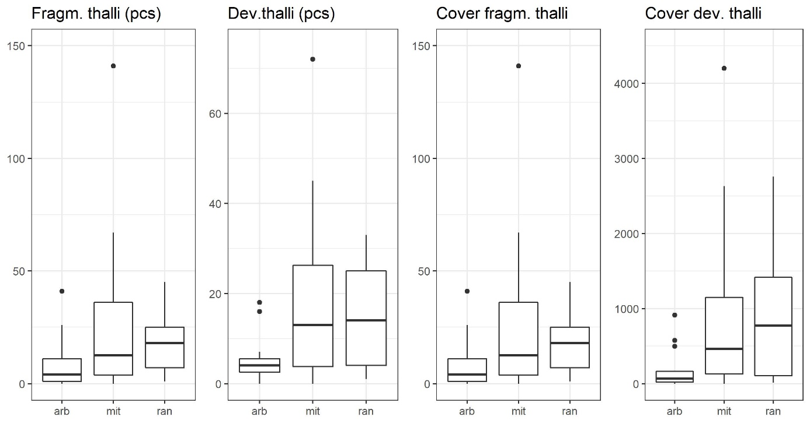
Supplementary Material Fig. S4. Variation in number and cover of fragmented and developed thalli between investigated species. The number and cover of developed and fragmented thalli were recorded in microquadrats. Two data for C. mitis (22391.5 and 16429.25 cm² cover of developed thalli) were excluded from the box plot. All boxplots were calculated from all relevés which contain the given Cladonia species; therefore relevés which refer to two or three investigated Cladonia species were considered repeatedly. Boxes define 25 and 75 percentiles; thick horizontal lines show the median; whiskers define 10 and 90 percentiles; points are outliers. Abbreviations: Fragm. thalli = fragmented thalli, Dev. thalli = developed thalli, pcs = pieces, arb = C. arbuscula, mit = C. mitis, ran = C. rangiferina.

