Supplementary Material File S.2

S2.1 Parameters received from jModelTest based on selection of GTR+I+G substitution model as best suitable according to AIC (Akaike Information Criterion).

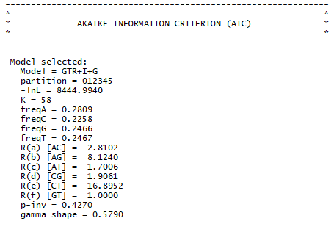

S2.2 Prior distributions for tree calculation based on GTR+I+G substitution model in BEAUTi.

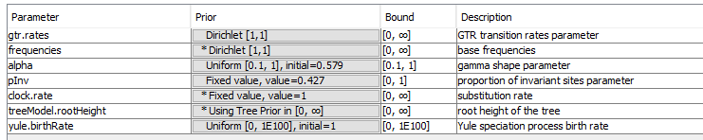

Parameter | Prior | Bound | Description
gtr.rates | Dirichlet [1,1] | [0, ∞] | GTR transition rates parameter
Frequencies | * Dirichlet [1,1] | [0, ∞] | base frequencies
alpha | Uniform [0.1, 1], initial =0.579 | [0.1, 1] | gamma shape parameter
pInv | Fixed value, value=0.427 | [0, 1] | proportion of invariant sites parameter
clock.rate | * Fixed value, value=1 | [0, ∞] | substitution rate
treeModel.rootHeight | * Using Tree Prior in [0, ∞] | [0, ∞] | root height of the tree
Yule.birthRate | Uniform [0, 1E100]. Initial = 1 | [0, 1E100] | Yule speciation process birth rate

Operator parameters:

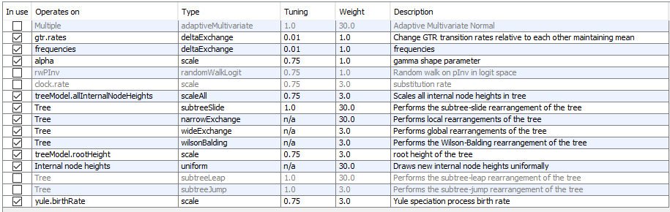

S2.3 Arguments and list of commands for GMYC single threshold applied with SPLITS package in R (according to Fujisawa and Barraclough 2013 and Manual of SPLITS package)

Arguments:

tr | An ultrametric, dichotomous tree object in ape format.
method | Method of analysis, either "single" for single-threshold version or "multiple" for multiple-threshold version.
interval | Upper and lower limit of estimation of scaling parameters, e.g. c(0,10)
quiet | By default shows progress on console. Use quiet = FALSE to disable.

Commands:

library(splits)
tr <- read.tree(file = "C:/PATH/TO/THE/TREE/mcc_tree.newick", text = NULL, tree.names = NULL, skip = 0)
result <- gmyc(tr, method = "single”, interval = c(0, 10))
summary(result)
plot(result)

Fujisawa T and Barraclough TG (2013) Delimiting species using single-locus data and the Generalized Mixed Yule Coalescent approach: a revised method and evaluation on simulated data sets. Systematic Biology 62, 707–724.

