Mass spectrometry as a versatile ancillary technique for the rapid in situ identification of lichen metabolites directly from TLC plates
Pierre Le Pogam^{a,b}, Aline Pillot^{a ,c}, Françoise Lohézic-Le Dévéhatª, Anne-Cécile Le Lamer^{a,d}, Béatrice Legouinª, Alice Gadea^{a,e}, Aurélie Sauvagerª, Damien Ertz^{f}, Joël Boustieª
a Institute of Chemistry of Rennes, ISCR, UMR CNRS 6226, University of Rennes 1, 2 Av. du Prof. Léon Bernard, Rennes Cedex 35043, France
b Institute of Electronics and Telecommunications of Rennes, IETR, UMR CNRS 6164, University of Rennes 1, 263 Av. du Général Leclerc, Rennes Cedex 35042, France
c UMR CNRS 6286, University of Nantes, 2 Rue de la Houssinière, Nantes Cedex 44322, France
d University Paul Sabatier Toulouse 3, 118 Route de Narbonne, 31062 Toulouse, France
e UMR CNRS 6553, ECOBIO, University of Rennes 1, 263 Av. du Général Leclerc, Rennes Cedex 35042, France
f Botanic Garden Meise, Department Bryophytes-Thallophytes (BT), Nieuwelaan 38, B-1860 Meise, Belgium

Analytical process of TLC/MS hyphenation
The hyphenation of TLC with mass spectrometry long represented an analytical challenge as the analytes remain adsorbed at the surface of the silica plate after the migration unlike column-based chromatographic techniques in which compounds are eluted due to a gas or liquid flow. A possible way to solve the apparent incompatibility between the static planar chromatography and the need for a stable supply of liquid sample into the mass spectrometer was the development of elution-based techniques to transfer the TLC-separated compounds into a solvent stream (Morlock & Schwack 2010). A prototype developed and reported by Luftmann in 2004 first addressed this shortcoming with a TLC-MS interface that mostly consisted of a stainless steel plunger that contains a solvent inlet and an outlet capillary (Luftmann 2004). This elution head can be pressed onto the region of interest of the plate to form a tight seal with the carrier foil owing to its cutting edge. The solvent can enter the desorption area through a small hole present at the periphery of the disk when the valve is switched to elution mode, dissolve the compounds and be forwarded to the mass spectrometer via the outlet capillary. A frit is present at the entrance of this latter to prevent silica particles from clogging downwards (Luftmann et al. 2007). From the proof-of-concept described by Luftmann, the commercially available devices include several improvements comprising a laser-light cross to target more accurately the zone to be desorbed. An automated cleaning of the elution head through N₂ flux can be performed on commercial interfaces to eliminate residual clumpy layer particles that might remain at the surface of the cutting edge (Morlock & Schwack 2010). An insight into the TLC/MS interface used in this work is presented in Figure S1.
Figure S1 : Overview of the TLC-MS interface available from CAMAG (images taken from CAMAG website http://www.copybook.com/pharmaceutical/companies/camag/articles/tlc-mass-spectrometry). When the elution head is lowered and the valve switched to elution mode, the solvents move through the head and elute the zone previously positioned by the laser crosshairs. The extracted compound is then transferred online into the mass spectrometer but can also be collected for further offline analyses. When the valve is in bypass position, the solvent flow is directed into the mass spectrometer.
During the analysis of an extract, several mass spectrometric detections can be achieved on different spots of the plates. The ionization process is monitored in real time through the Total Ion Chromatogram (TIC) which is a chromatogram obtained by summing up intensities of all mass spectral peaks belonging to the same scan. Mass spectra can then be retrieved by left dragging along the TIC regions of interest. As recommended elsewhere, the impact of background signals originating from the plate and solvent residues on the mass spectra was reduced by subtracting a background mass spectrum obtained from a blank position of the plate (Morlock 2014; Taha et al. 2015). Afterwards, when screening for a specific signal (e.g deprotonated molecule of an expected metabolite), Reconstructed Ion Chromatogram (RIC) can be retrieved for a particular m/z value. This function is also of interest when the signal to noise ratio (S/N) is poor and it is questionable whether the peaks are related to genuine molecules or to artefacts. Hence, if signals are ascribed to a single desorption area, it can reliably be assigned to an authentic molecule signal. Adversely, if the Reconstructed Ion Chromatogram results in a permanent signal or in a peak present at each desorption spot, it can be assumed that it corresponds to an artefact. This whole analytical process is presented in Figure S2, illustrated by the example of Pertusaria amara chemical profiling.
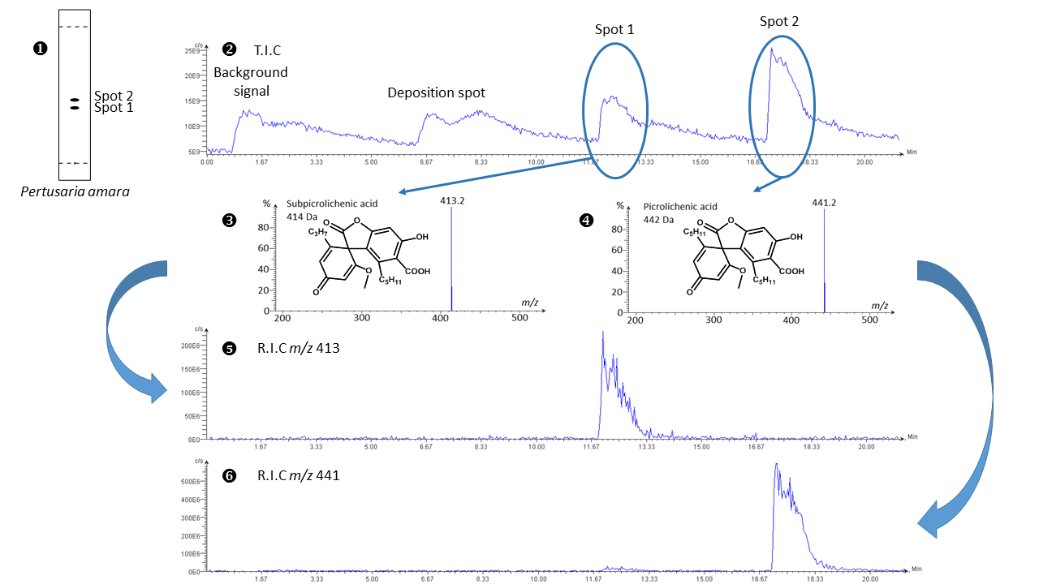
Figure S2 : Workflow diagram of TLC-MS analysis: chemical profiling of Pertusaria amara. TLC of the crude acetone extract of Pertusaria amara (1), Total Ion Chromatogram obtained from the TLC-NI-ESI-MS analysis of P. amara (2), NI-ESI mass spectrum retrieved from spot 1 (subpicrolichenic acid), (3) and spot 2 (picrolichenic acid) (4) and Reconstructed Ion Chromatograms retrieved from m/z 413 (5) and m/z 441 (6).

Chemical structures of pure molecules detected by TLC-NI-ESI-MS
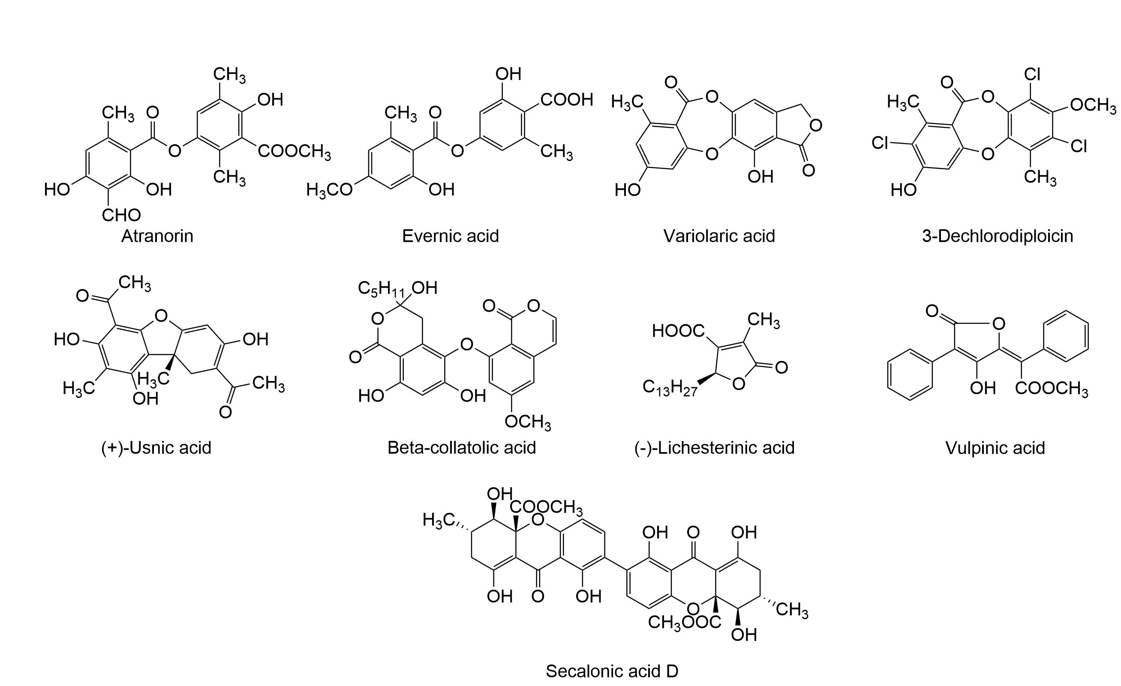
Figure S3 : Chemical structure of single compounds investigated in the course of this study
Settings of DART-MS analyses
DART-HRMS analyses were performed using a JEOL JMS-T100CS (AccuTOF CS) orthogonal time-of flight (TOF) mass spectrometer (Peabody, MA) equipped with an IonSense DART Source (Danvers, MA). Ultra-high purity helium was used as reagent gas at a flow rate of 4 L min⁻¹ and under a temperature value of 523 K. The following DART-needle, discharge electrode, and the grid electrode voltage values used were 3500, 150, and 250 V, respectively. The voltage values of orifice 1, orifice 2, and the ring lens were set at 15, 5, and 10 V, respectively. The orifice 1 temperature was kept at 353 K. The detector voltage was set at 2300 V. The mass spectra were recorded every second with a resolution of 6000 (fwhm definition). The mass scale was calibrated using the [M-H]⁻ ion series of a poly(ethyleneglycol) sulfate diluted in a CH₂Cl₂/MeOH mixture (1:1, v/v). To perform accurate mass measurements, the mass drift compensation procedure available on the main program that controls the AccuTOF CS was used to compensate for the m/z drift in the range of m/z 100 to 500. DART-MS analysis of the intact pieces of Usnea trachycarpa were performed by holding unprocessed pieces of lichen between tweezers directly under the helium stream.
DART-MS analysis of Usnea trachycarpa
To retrieve the elemental composition of the unknown compound of Usnea trachycarpa, a DART-HRMS analysis was attempted from the whole lichen. From an intact piece of Usnea trachycarpa, negative-ion mode (NI) DART-MS displayed signals that could be attributed to all paraconic acids detected using the TLC-MS approach. The corresponding mass spectrum is presented in Figure S4 and the associated exact mass measurements are collated in Table S1.
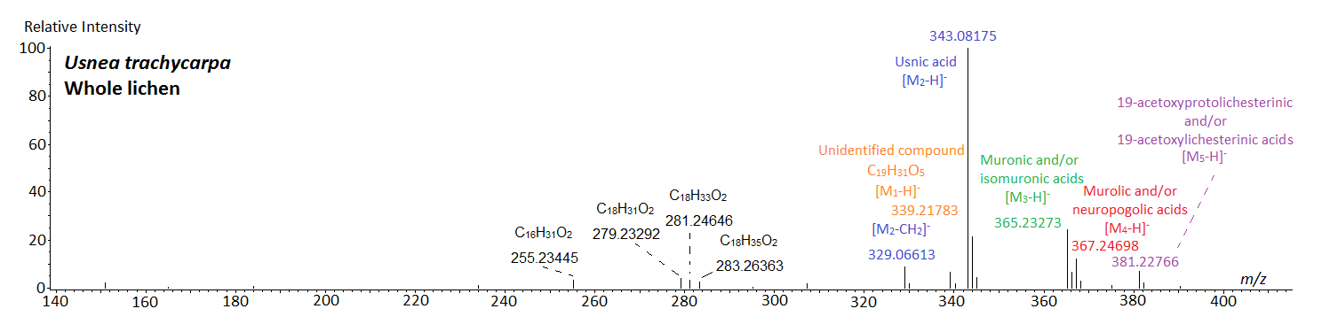
Figure S4 : NI- DART mass spectrum of a solid piece of Usnea trachycarpa.
Table S1: Results of exact mass measurements performed from the mass spectrum of the Fig. S3 related to the NI-DART-MS of a whole piece of Usnea trachycarpa.
Measured mass | Proposed formulae | Calculated mass  (error in ppm) | Assignment
255.23445 | C₁₆H₃₁O₂ | 255.23240 (8.03) |  | C_{16:0}
279.23292 | C₁₈H₃₁O₂ | 279.23240 (1.86) |  | C_{18:2}
281.24646 | C₁₈H₃₃O₂ | 281.24805 (-5.66) |  | C_{18:1}
283.26363 | C₁₈H₃₅O₂ | 283.26370 (-0.27) |  | C_{18:0}
329.06727 | C₁₇H₁₃O₇ | 329.06613 (3.47) |  | Fragment of usnic acid
339.21783 | C₁₉H₃₁O₅ | 339.21715 (2.00) |  | Unknown compound
343.08175 | C₁₈H₁₅O₇ | 343.08178 (-0.07) |  | Usnic acid
365.23273 | C₂₁H₃₃O₅ | 365.23280 (-0.17) |  | Muronic/Isomuronic acid(s)
367.24698 | C₂₁H₃₅O₅ | 367.24845 (-4.00) |  | Murolic/Neuropogolic acid(s)
381.22766 | C₂₁H₃₃O₆ | 381.22771 (-0.15) |  | 19-acetoxyprotolichesterinic/19-acetoxylichesterinic acid(s)

References
Luftmann, H. (2004) A simple device for the extraction of TLC spots: direct coupling with an electrospray mass spectrometer. Analytical and bioanalytical chemistry 378: 964–968.
Luftmann, H., Aranda, M. & Morlock, G. E. (2007) Automated interface for hyphenation of planar chromatography with mass spectrometry. Rapid Communications in Mass Spectrometry 21: 3772–3776.
Morlock, G. & Schwack, W. (2010) Coupling of planar chromatography to mass spectrometry. TrAC Trends in Analytical Chemistry 29: 1157–1171.
Morlock, G. E. (2014) Backgroung mass signals in TLC/HPTLC–ESI-MS and practical advices for the use of the TLC-MS interface. Journal of Liquid Chromatography & Related Technologies 37: 2892–2914.
Taha, M.N., Krawinkel, M. B. & Morlock, G. E. (2015) High-performance thin-layer chromatography linked with (bio)assays and mass spectrometry – A suited method for discovery and quantification of bioactive components ? Exemplarily shown for turmeric and milk thistle extracts. Journal of Chromatography A 1394: 137-147.

