Appendix

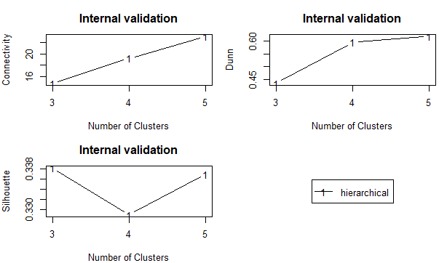

Figure A.1. Skills Profiles Cluster Analysis Validation Methods: Internal Validation
Note: Connectivity, Dunn Index and Silhouette Width. Connectivity [0, ∞] should be minimised, Silhouette Width ([-1; 1]) and Dunn Index ([0, ∞]) should be maximised. See Julia Handl, Joshua Knowles and Douglass B. Kell, ‘Computational Cluster Validation in Post-Genomic Data Analysis’, Bioinformatics, 21: 15 (2005), pp. 3201–12.
Source: Authors’ elaboration.

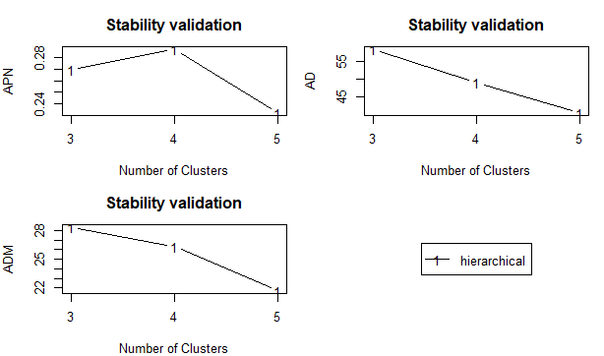

Figure A.2. Skills Profiles Cluster Analysis Validation Methods: Stability Validation
Note: Three stability measures are used to compare the results from clustering based on the full data to clustering based on removing each column, one at a time: a measure of average proportion of non-overlap (APN), a measure of the average distance (AD) and a measure of the average distances between means (ADM). K. Y. Yeung, D. R. Haynor and W. L. Ruzzo, ‘Validating Clustering for Gene Expression data’, Bioinformatics, 17: 4 (2001), pp. 309–18.
Source: Authors’ elaboration.

Table A.1. Skills Profiles Validation Measures Aggregation Rank
Rank | Option
1 | hierarchical-5
2 | hierarchical-4
3 | hierarchical-3
Algorithm: CE, Distance: Spearman. Score: 1.09.
Note: Rank aggregation measure (Pihur et al., 2007); uses the default cross-entropy method with weighted Spearman’s foot-rule to order results.
Source: Authors’ elaboration.

