<JLO 22-0449.R1; supplementary material>

Table 1. Search command
Term | Search string
Obstructive sleep apnoea | “obstructive sleep apnea” [mh][tiab] OR “obstructive sleep apne*a” [mh][tiab] “OSA” [mh][tiab] OR “sleep apnea syndrome” [mh][tiab]
Sleep-disordered breathing | OR “sleep disordered breathing” [mh][tiab] OR “SDB” [mh][tiab]
Untreated sleep apnoea progression | AND “sleep apnea adj3 progression” [tiab] OR “sleep apnea adj3 evolution” [tiab] OR “untreated sleep apnea” [tiab] OR “longitudinal study” [tiab] OR “longitudinal follow up” [tiab]
CPAP treatment | AND “positive airway pressure” [tiab] OR “CPAP” [tiab]
Polysomnographic outcomes | AND “apnea hypopnea index” [mh][tiab] OR “AHI” [tiab] OR “oxygen desaturation index” [mh][tiab] OR “ODI” [tiab]
Functional outcomes | OR “Epworth sleepiness score” [mh][tiab] OR “ESS” [tiab] OR “mean sleep latency test” [mh][tiab] OR “MSLT” [tiab] OR “maintenance of wakefulness test” [mh][tiab] OR “MWT” [tiab]
Adult population | AND “adult” [tiab] NOT “children” [tiab] NOT “paediatric” [tiab]
OSA = obstructive sleep apnoea; SDB = sleep disordered breathing; CPAP = continuous positive airway pressure; ODI = Oxygen Desaturation Index; MSLT = Multiple Sleep Latency Test

Figure 1. Population, Intervention, Comparison, Outcome (‘PICO’) terms on Embase or Cochrane Central Register of Controlled Trials
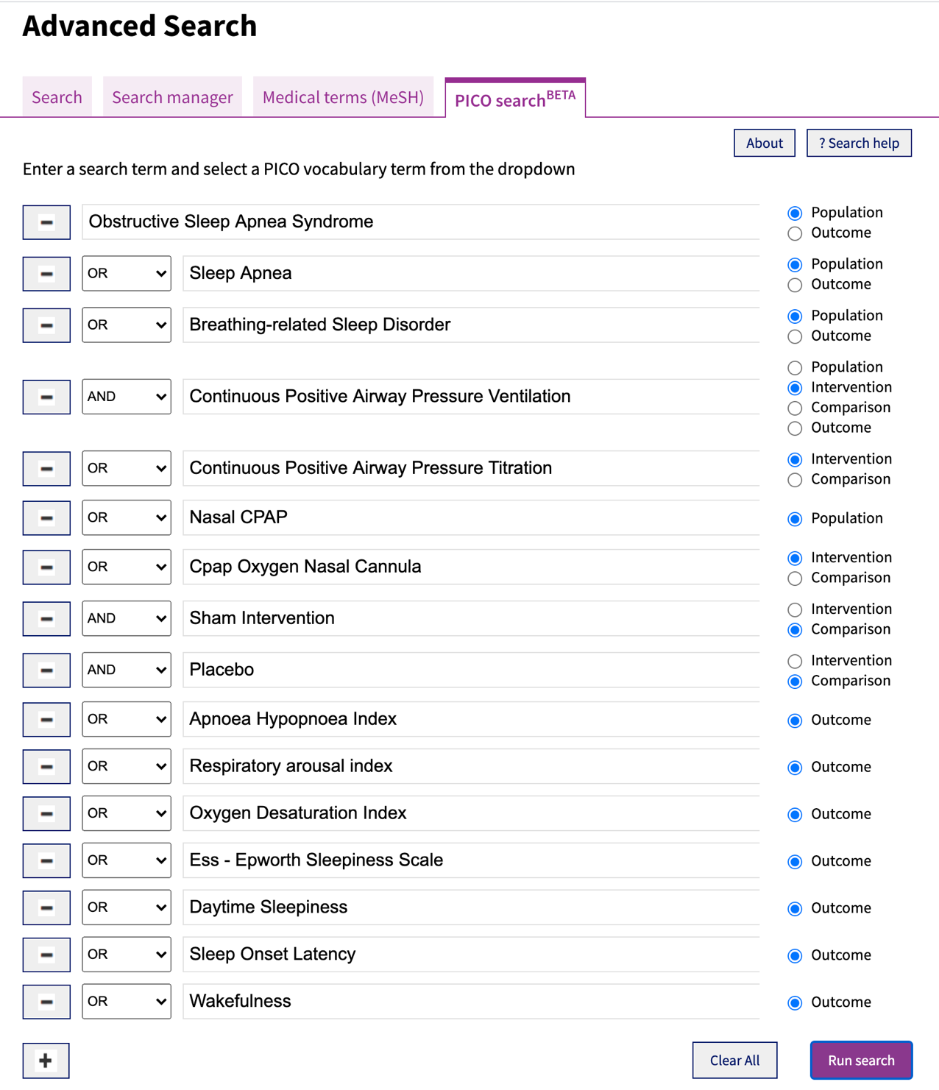
CPAP = continuous positive airway pressure

