Supplementary material 1

A. Theatre set-up for remote or resource-limited location

Fig. 1

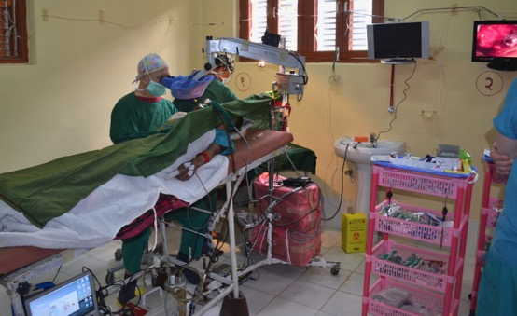

Legend: Surgical set-up on ear outreach camp in a small peripheral hospital in Nepal.

The photograph demonstrates the following items in use in a typical remote environment:

Simple operating table

Head of table elevated with wooden blocks

Portable operating microscope

Microscope stand locally made, lightweight for travel, heavy boxes on stand for stability

Video camera in microscope, enables teaching, and recording to laptop

Pulse oximeter on finger

Patient number written on wrist with permanent marker pen

Local anaesthesia with sedation

Metal bar holds drape off patient’s face

Single drape, with hole for ear

Sterile drape wrapped on microscope head

Sterile cover for drill cable and motor

Disposable sharps disposal box, can be burnt

Simple trolley for anaesthetic drugs and equipment

Small spotlight attached to microscope arm

Cables held off floor to avoid fluids from irrigation

Portable surgical suction

Dental drill system takes universal burrs

Out of shot, oxygen concentrator and bipolar diathermy

Fig. 2

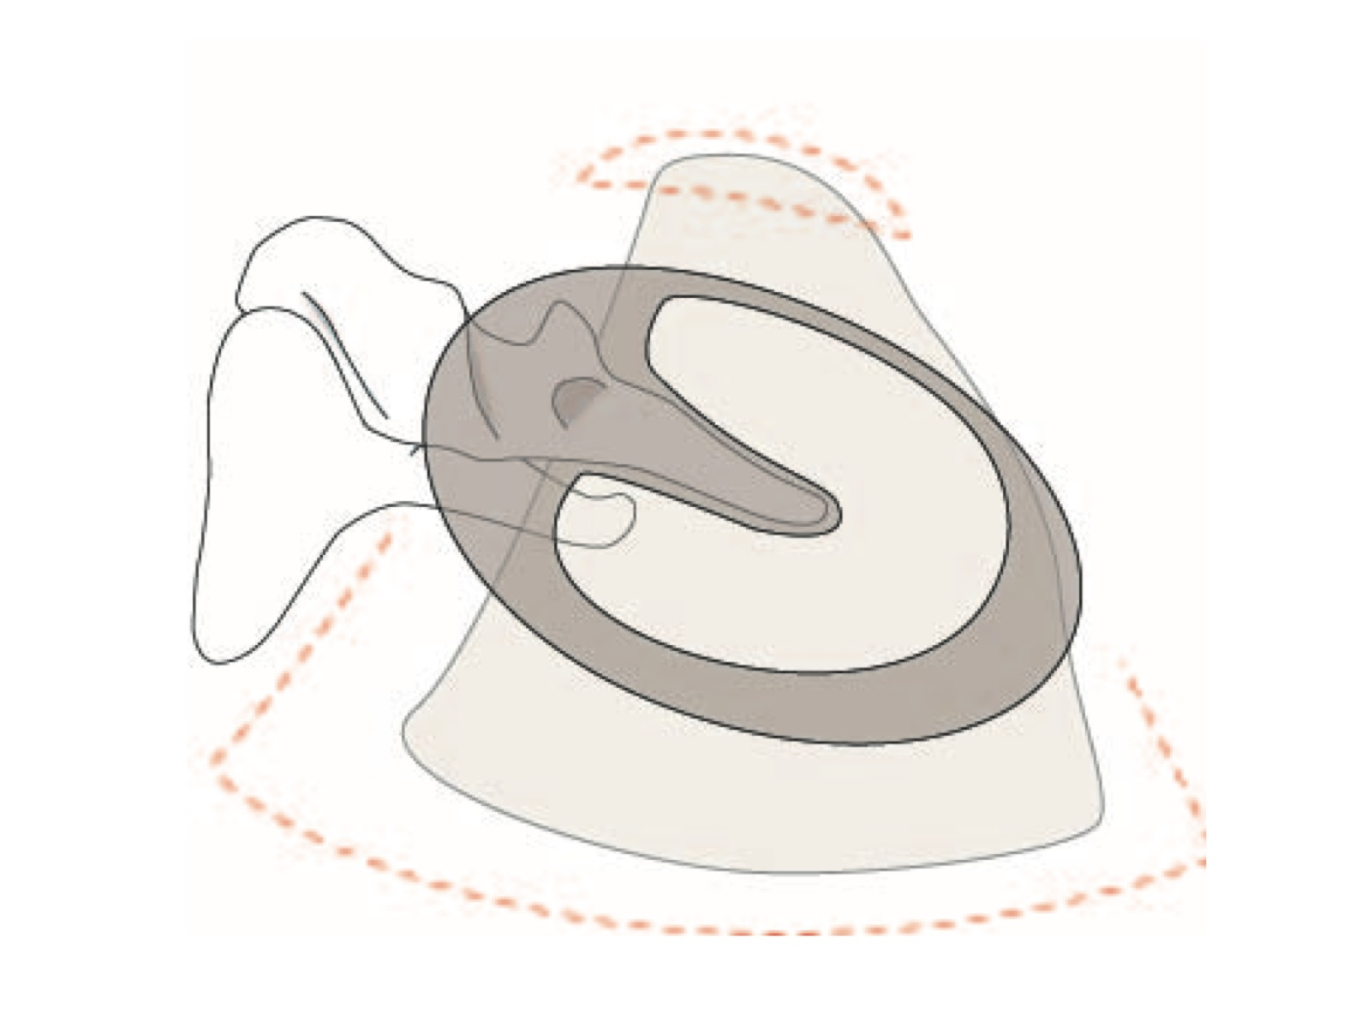

Legend: Right ear with subtotal perforation.

The underlay graft is placed medial to drum and malleus handle and pulled up antero-superiorly, into a small tunnel passing under the anterior annulus.

B. Equipment requirements for ear clinic and operating theatre in resource-limited or remote locations

1. Ear out-patient clinic, basic equipment, check list

Otoscope and speculi (with spare bulb)

Ear syringe

Aural speculi

Ear wax and f. b. hooks and ring probes

Crocodile forceps – fine and large

Cup forceps –fine and large

Tuning fork 512 Hz

Barany noise box

Nasal speculum

Tongue depressor

Headlight (with adjustable focus, to obtain small spot light size)

Forceps

Stitch scissors

Kidney dishes

Gauze

Cotton wool

Swab sticks/cotton buds

Batteries (for headlight and otoscope)

Stationary (medical records, carbon paper etc.)

Teaching materials (anatomy diagrams, posters etc.)

Reference textbook, pharmacopeia

Optional, small portable surgical suction

Pharmaceuticals

2. Ear operating theatre, basic equipment, check list

Operating microscope and stand (with spare bulbs and fuses)

Lens cleaning tissues/liquid

Drill motors, footswitch, cables (with spare fuses)

Drill hand-pieces

Drill burrs, cutting (2, 3, 4, 5, 6 mm) and diamond (0.5, 1, 1.5, 2, 3, 4 mm)

Drill covers (sterile cloth tubes with ties).

Drill oil

Bipolar diathermy machine, with forceps, cables and footswitch

Electrical cable extensions and sockets

Operating Spotlight (with spare bulbs)

Suction machines (with spare parts, including filters)

Generator ? (1000 W) (with fuel, oil)

Pulse oximeter and cables, finger clip

Surgeons stool

Operating table

Instrument trolley

Goggles for eye protection when drilling

Surgical face masks

Surgical gowns

Surgical gloves (check hand sizes of surgeons)

Examination gloves

Hats

Drapes

Microscope handle covers/drapes (a sterilised cloth square with two holes for the eyepieces and one larger hole for the objective lens can be wrapped around the microscope head and secured with a towel clip)

Scrub clothes for theatre staff

Theatre shoes

Patient head-ring

Buckets, bowls, jugs, funnel, gallipots, trays to soak instruments

Hand scrub soap and nail brushes

Insect repellent

Syringes, needles, IV sets

Fine needles for LA infiltration in ear canal (ideally long, 25 g, grey hub)

Garbage bags (plan for waste disposal)

Sharps disposal containers

Thermometer

Bone wax?

Gelatine sponge (Gelfoam)

Ribbon gauze

Eardrops and ointments

Sutures

Patient weighing scales

Cleaning materials

Biopsy specimen bottles and formalin

Fly swat

Patient blanket (‘space’ blankets)

Ossiculoplasty/stapes prostheses if required/available

Scalpel blades (size 15)

Autoclave

Bandages

Suction tubing (disposable, or Silastic to re-sterilise)

Tool kit (general maintenance, electrical)

Surgical instrument sets (major ear, grommet, plastic)

Pharmaceuticals  
  
 3. Ear surgery, standard surgical instrument sets

i).Major ear operation set

The following will, from experience prove more than adequate for the majority of surgeons. Some items will not be required for all surgeons

Scalpel handle No. 3 × 2

Needle holder, small × 1

Towel clips: × 4

Artery clips; mosquito × 3

Sponge holder × 2

Periosteal elevators: Large × 1, Small × 1

Toothed forceps (Adson) × 1

Non-toothed forceps small (Adson) × 1

wide (dressing/cartilage slicing) × 1

Ossicle holding forceps (Derlacki) × 1

Double Hook, large blunt or ‘cats-paw’ type retractor × 1

Skin hook, fine × 1

Self-retaining retractors: small 2 /3 teeth × 2

large,3 /4 teeth × 2

Lempert’s endaural speculum × 1

Aural speculi set of various sizes (split, Tumarkin, or surgeon’s preference)

Scissors: stitch × 1

curved, blunt tipped dissecting × 1

curved sharp tipped dissecting × 1

Gallipots: × 5

Suckers; large lumen × 1

Zöllner type (medium) × 1

suction needles or tips (various sizes)…14–25 g

Suction adapter with control hole on side (House type, or longer) × 1

(Steel spinal needles with sharp ends removed make good reusable option)

Suction cleaning wires, various thicknesses

Suction tubing: Silastic, rubber or plastic, 2 metres × 1

Micro-forceps: large cup forceps × 1

fine cup forceps: straight × 1

right × 1

left × 1

micro-scissors × 1

malleus nibbler × 1

crocodile forceps: large × 1

fine × 1

Graft cutting metal plate (or steel gallipot) × 1

Vein press × 1 (if a surgeon’s preference)

Micro-instruments: protective tray/rack × 1

curette: large (2–3 mm) × 1

small (1–2 mm) × 1

Rosen canal knife (‘frying pan’): large × 1

small × 1

Plester (‘half-moon’) × 1

Beales and/or Hughes elevator × 1  
 Thomassin double ended dissector × 1

(Or hockey stick/whirly bird (right and left), × 2)

Wullstein dissecting needle: gentle curve × 1

sharp/severe curve × 1

right angle needle: large hook (2 mm) × 1

small (0.5 mm, stapes) × 1  
 ? Sickle knife × 1

Bipolar forceps and cable (diathermy is not essential but speeds surgery)

Vented tray/protective instrument container for ear instrument sterilisation

ii). Stapes operation surgical instrument set

Major ear set, with the following additions:

Piston length trimming block × 1

Prosthesis measuring rod × 1

Stapes prosthesis crimper × 1

Micro-instruments:

stapes footplate perforators: (0.2, 0.4, 0.6, 0.8 mm) × 1 each

stapes hooks: 45°: (0.2, 0.4 mm). × 1 each

90° (0.2 0.4, 0.6 mm) × 1 each

Stapes drill system (low speed, fine diamond burrs: 0.5, 0.6, 0.7, 0.8 mm), if available

Stapes piston prostheses, preferably single length (e.g. 5–6 mm, trimmable)

iii). Minor ear surgical instrument set (Grommet set)

* myringotomy knife (fine and sharp)
* towel clip
* fine crocodile forceps
* small scissors
* ring probe
* wax hook
* fine curved (Wullstein) needle
* aural speculi, set × various sizes (split Tumarkin speculi best)
* Zollner type suction
* fine suctions
* wires to clean suctions
* gallipot
* box for instruments
* Suction tubing

## iv). Plastic surgical set

* It may be useful to have a fine instrument set
* For procedures such as repair of split ear lobe; excision of preauricular sinus, keloids, skin tags; removal of cysts; biopsies etc.

Supplementary material 2

Meatoplasty technique

This technique is usually performed together with a post-aural skin crease incision.

The method described is essentially a traditional Korner flap (Lee KJ, Lee KE. Soft tissue surgery of mastoidotympanoplasty. *Laryngoscope* 1985;**95**:107–10), but with cartilage removed from the concha by undermining the skin. Thus creating a long skin flap based posteriorly in the concha and extending down almost to the posterior tympanic annulus. This technique retains the deep tissues in the flap as well as the skin strip.

Incision 1: parallel to annulus, some millimetres lateral to annulus, exact position varies with procedure. This incision runs from about 12 o’clock superiorly to about 6 o’clock inferiorly. It may be made naked eye from posteriorly via the post-aural skin incision, after pushing the canal skin forwards; or from anteriorly, via a speculum in the meatus, using a microscope

Incision 2: place size 15 scalpel blade deep in ear canal about 2–3 mm lateral to lateral process of malleus, via meatus. The tip of the blade should be visible from behind the pinna, in the top edge of incision 1. Run the blade up roof of canal, hard on bone, just anterior to 12 o’clock, then at meatus turn incision line sharply posteriorly across upper part of conchal bowl. How far posteriorly depends on size of mastoid cavity. It is better to make the meatus too big than too small. Final extent can be decided after the bone work is complete.

Incision 3: place scalpel deep in canal, a few mm lateral to annulus at about 6 o’clock, again the tip of blade should be visible in lower edge of incision 1. Run blade up canal floor to reach the meatus, then turn sharply posteriorly and into the lower part of the conchal bowl. Ensure that incisions 2 and 3 create a strip of skin, running from near annulus, up laterally into conchal bowl. It should include all underlying soft tissues and conchal cartilage and never be less than about 1 cm wide. It is best to make each incision without removing the blade from the wound, ensuring that it goes right through all underlying tissues with a sawing motion, and that the blade is visible from behind, in the post-aural wound. If the blade is removed and replaced then it may be hard to create a neat single skin incision. When making incisions hard on to bone, take care in case of any exposed structures such as dura, particularly in revision cases.

Once the size of cavity and meatus has been decided, then remove cartilage from the portion of flap that runs into conchal bowl. Do this by undermining the conchal skin on the lateral surface of the flap. Run the 15 blade under the skin, lateral to conchal cartilage, turn blade and cut through the cartilage both posteriorly and then anteriorly, then pass blade behind the cartilage and sever from the deeper soft tissues. The square/oblong piece of cartilage can then be removed, without cutting the skin flap or the deeper soft tissues, thus the flap retains a skin base and a soft tissue base. This provides thickness and some vascular supply. In the past the author used to strip all underlying soft tissue, but this creates a very long skin flap several times longer than the width of its base. This seemed an unnecessary waste of the underlying supportive soft tissues. Similarly, removing conchal cartilage via the post-aural incision severs this soft tissue strip.

At first this technique may seem difficult, but it is very effective. If cartilage is exposed in the skin edges above and below the flap, it is best to trim this back to prevent granulations.

After placing a small pack in the deeper ear canal, then suturing the post-aural wound, the flap can be placed permeatally behind the pack to lie on bone or graft materials in the cavity. Further packing may then be inserted. Because the conchal cartilage is cut, the flap has no spring and it does not require suturing to secure it in place; packing provides adequate pressure. Suturing the flap back may provide false reassurance about meatal size, in time the spring of any residual cartilage will overcome the sutures and result in a smaller meatus.

Supplementary material 3

Ossiculoplasty techniques

There are relatively few common situations to consider:

1. Loss of extreme tip of long process of incus (LPI) or thin fibrous connection

A curl of bone obtained from the canal wall with a curette will often fit on the stapes head and be retained in position by the remaining LPI.

A so-called ‘Sade’ tripod, a tiny inverted pyramid or tetrahedron of bone or cartilage can be placed between malleus handle, LPI and stapes head (Sadé J, Kremer S, Luntz M. 'Tripod' ossiculoplasty in incudal lesions. *Arch Otolaryngol Head Neck Surg* 1989;**115**:596–9).

2. Eroded LPI

Incus interposition, or in its absence, malleus head or cortical bone graft interposition.

There are many possible ways to carve an interposition. In the senior author’s practice, because of its stability, he uses the ossicle or bone, grooved at each end, to fit under slight tension from malleus handle and neck, to the stapes head and neck. The tensor tympani tendon should be retained intact. This technique has been utilised many hundreds of times. (Fig. 3 a, and Fig. 4 a, b, c, d, e.)

3. Low stapes with high facial canal, no usable malleus handle

If the malleus handle lies far anterior, medialised or absent, then an incus, malleus head or cortical bone interposition will be needed from stapes head direct to drum. To improve stability, the interposition is hollowed to fit over the stapes arch as well as head and the top surface is made as wide and flat as possible (Fig. 3 b, c and Fig. 5 a, b.).

Some surgeons place a cartilage graft directly on the stapes head, as described below (in option 5) for open cavities.

3. Loss of stapes superstructure

An incus interposition is placed from the footplate to malleus handle (retaining the tensor tympani tendon intact). The short process of incus sits on footplate of stapes. The diseased LPI is shortened. The malleoincudal joint is grooved, near base of LPI, and fitted medial to the malleus neck. (Fig. 3 d).

4. Loss of incus (± malleus)

Cortical bone total ossicular replacement prosthesis. A piece of thick cortical bone is harvested from postero-superior to the mastoid process (using a 2 mm cutting burr to define and undermine the margins, then broken out with a periosteal elevator). It is carved with a flat surface to lie under the drum, and a thin slightly curved columella that will reach the footplate. If there is no mucosa on the horizontal facial canal, a small piece of soft tissue is interposed to try and avoid ankylosis (Fig. 3 e).

5. Open cavity with low facial ridge and high intact stapes.

A formal ossiculoplasty may not be needed. The so-called type III tympanoplasty, whereby temporalis fascia is left to lie on the stapes head can undoubtedly sometimes give a good hearing outcome, but it often leads to moist retraction pockets or recurrent cholesteatoma around the stapes. Thus it is our practice to always lay a sheet of cartilage over the stapes and up to the horizontal facial canal and posterior annulus. If necessary a small donut of cartilage through which a hole has been drilled with a 2 mm diamond burr is one way to add height to the stapes. Due to the elasticity of the cartilage the actual hole will be about 1 mm, and a suitable fit for the stapes head.

6. Fixation of malleus or incus with intact chain (± absent LPI).

Divide the incudo-stapedial joint, explore attic, and remove the bony ankylosis or tympanosclerosis widely, ensure the anterior malleolar ligament is not fixed. Replace the LPI on the stapes head. If necessary remove incus and malleus head then do an incus interposition as above (see number 2).

7. Fixation of stapes

Tympanosclerosis filling the oval window niche or coincidental otosclerosis with footplate fixation may occur. Small pieces of tympanosclerosis may be removed with care, but risks sensorineural hearing loss. Staged malleo-stapedotomy may be an option, but is technically more difficult and less successful than standard stapedotomy. It also requires a long stapes prosthesis, usually 6.0–6.5 mm in length.

Fig.3

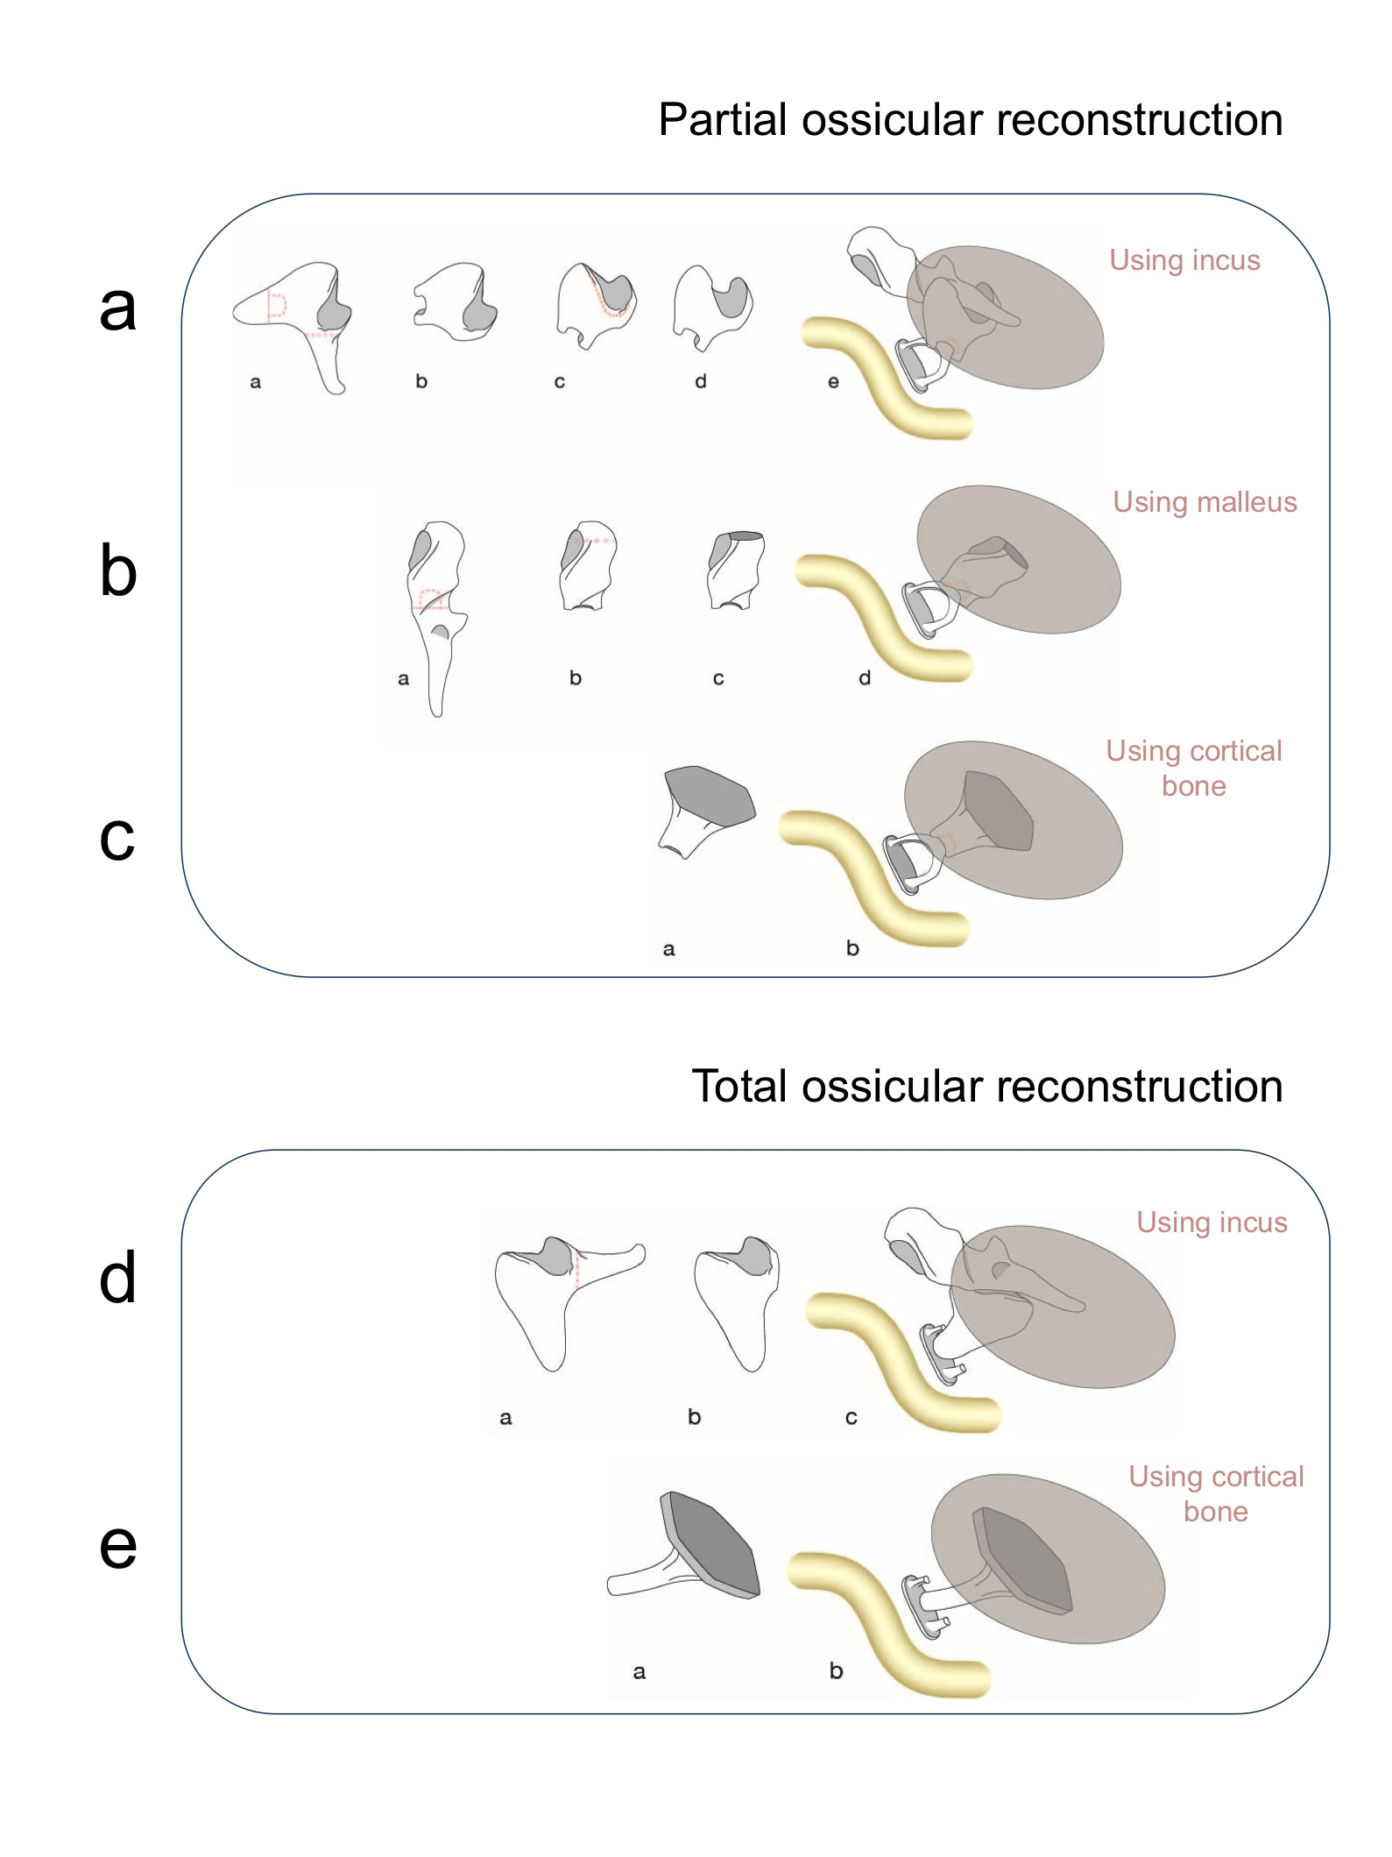

Legend: Diagrams illustrating partial and total ossicular reconstruction

Fig. 3a Technique for carving the incus, for incus interposition (stapes to malleus).

Using a 2 mm diamond burr, remove all incus long process remnant; remove short process until it is 1–1.5 mm wide. Drill a deep slot through short process and body, using 0.5 or 0.6 mm diamond burr. Hollow inside slot and body of incus, to make acetabulum for stapes head; check size and widen slightly, until a 1 mm diamond burr will fit inside. (Using 1 mm from start will damage the slot). Drill groove across malleoincudal joint with 1 mm burr. Thus the slot and groove are at about 90 degrees to each other. Insertion technique. Place ossicle in middle ear, put needle in the slot in short process, push ossicle forwards to locate groove in incus body onto malleus handle, continue to push gently forwards until slot in short process and its acetabulum can drop onto stapes head, neck and arch. Ideally tensor tendon should be intact, to provide tension and stable fit. The incus body is best if placed in a position high on the handle of malleus, near the tensor, to provide maximum vertical angle of contact with stapes. If fit is not ideal, turn incus over and because of slight asymmetries, other side may be better. Once in place the reconstruction is normally very stable and the tympanic membrane graft can be placed under tip of malleus handle. Reconstruction is the same whether malleus head is present or absent.

Notes:

1. If malleus handle is too medialised, then removing the malleus head may enable the handle to become more lateral.

2. If incus position is not ideal, it can be placed under the drum, just posterior to the malleus handle. It is less stable but usually effective, and more vertical. If chorda tympani is intact this may help stability.

Figs. 3b Technique using the malleus head

a). Remove malleus head from handle; make a deep slot through the malleus neck with 0.5–0.6 mm diamond burr, then hollow inside head to make acetabulum for stapes head, expand till a 1 mm diamond burr fits inside.

b). Flatten head of malleus, down to height required in order to fit from stapes to drum (with cartilage underlay).

c). Fit over stapes head, stapedius tendon, and stapes arch. It must fit snuggly well down over all the stapes superstructure to be stable. Should make stable vertical assembly. Can lay cartilage and fascia tympanic grafts over this stapes to malleus assembly.

Fig. 3c The same technique as Fig. 3b, but using an autologous cortical bone graft.

It is important that the graft fits snuggly, well down over the stapes arch in order to be stable. The height needed depends on the depth of the stapes. By keeping some height, rather than placing drum or cartilage directly onto stapes the intention is to maintain a middle-ear space and ventilation pathway.

Fig. 3d Technique using the incus as a total ossicular replacement prosthesis.

Remove minimum necessary of the diseased long process from the incus. Create a small groove across the base of the long process with 1 mm diamond burr. With no further work, place the short process on the mid-footplate and the groove in long process under the malleus neck. The fit is usually surprisingly accurate with minimal shaping. It is best if healthy mucosa and periosteum can be preserved on incus and facial canal to prevent ankylosis. Tensor tendon should be intact, to provide tension.

Fig. 3e Cortical bone total ossicular replacement prosthesis, carved to shape.

Remove a thick piece of dense cortical bone as the graft. Best donor site near the ear is the posterior end of the temporal line, at postero-superior limit of mastoid process. Drill to shape initially with a cutting burr then with diamond burrs and constant irrigation. Make a thin pillar extending from underside of platform. This pillar should be about 1–1.5 mm in thickness. It can be gently curved, to avoid facial canal. Check size in ear and trim pillar to suitable length. If possible preserve mucosa on facial canal, and when placing this graft angle it away from the facial canal. May need to place Gelfoam or soft tissue between pillar and canal to avoid ankylosis. At first sight this looks difficult to create but with care is not hard and can be effective when synthetic total ossicular replacement prostheses are not available. The lateral surface should be wide, to improve stability when the drum, with underlay fascia and cartilage grafts are placed over it

Fig. 4

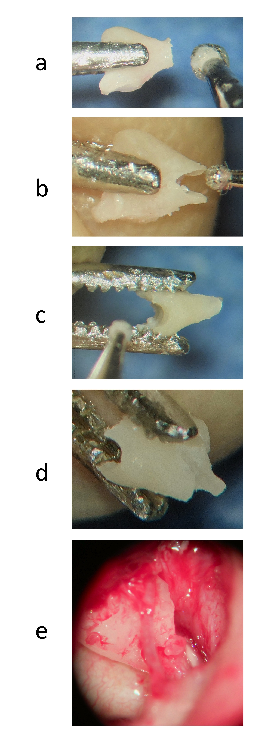

Legend: Incus, stapes to malleus interposition technique, photographs

These photographs further illustrate the technique in Figure 3a.

The incus is best held in the jaws of a Derlacki ossicle forceps, maintaining the same position in the jaws throughout the process.

a). Shortening the incus short process with 2 mm diamond burr

b). After drilling a slot and internal acetabulum in the shortened short process and body, using a 0.5 mm diamond burr, this is checked and slightly widened with a 1 mm diamond burr (the stapes head is approximately 1 mm in diameter)

c). A groove is drilled across the incudomalleal joint surface of incus body using a 1 mm diamond burr

d). The completed shaped incus, ready for interposition

e). The incus in place under mild tension between the superior part of the malleus handle, and the stapes head, right ear. (In this photograph there is a small piece of soft tissue on the stapes, this is not the stapes head, the stapes head is inside the acetabulum within the slot in incus short process).

Fig. 5

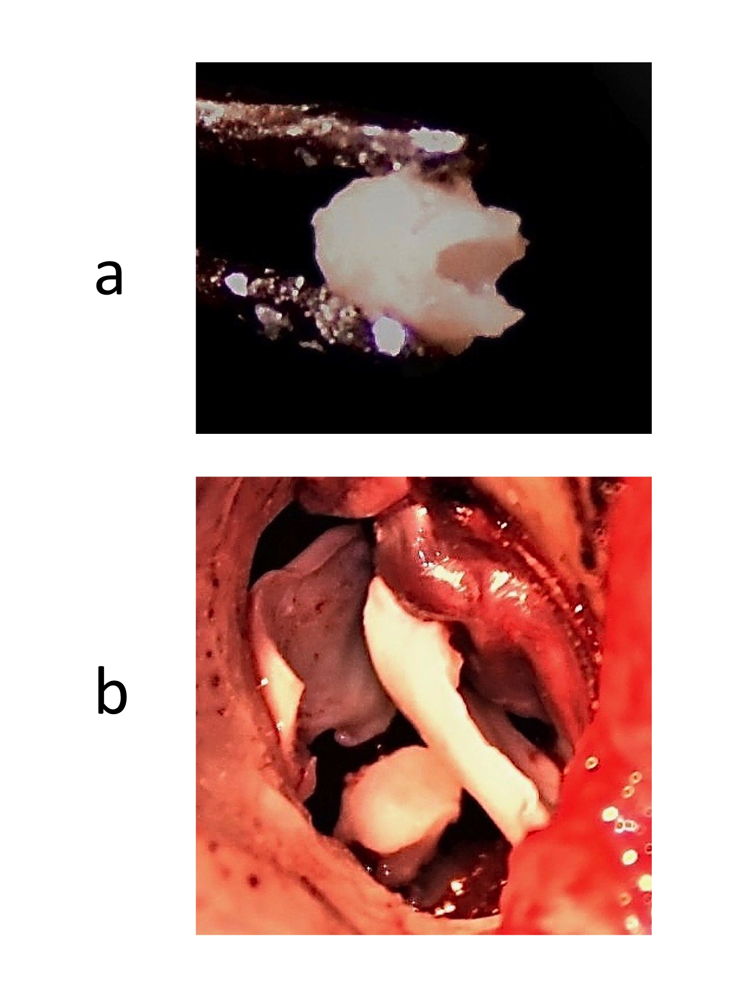

Legend: Photographs of stapes to drum interposition grafts

Fig. 5a Malleus head shaping

A groove and acetabulum being created in the neck of the malleus. When deep enough, these will sit on the stapes head and down over the stapes crura as a sleeve, for stability.

Fig. 5b Similarly, but using an autologous cortical bone graft

The graft fits over the stapes superstructure. It has been flattened on its lateral surface. Cartilage grafts will be placed in the atticotomy and as a drum underlay, to sit on the ossiculoplasty graft.