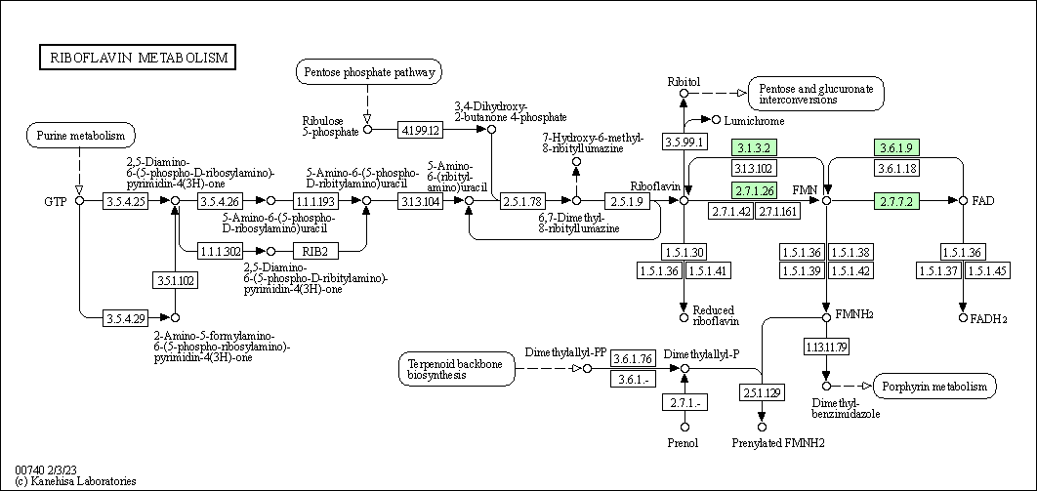

Figure S1. The metabolism pathway for riboflavin. The box with green color indicates the pathway presented in Cruznema velatum.
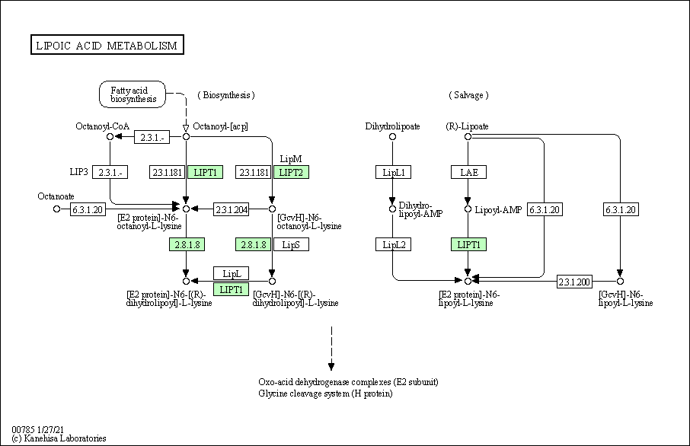
Figure S2. The metabolism pathway for lipoic acid. The box with green color indicates the pathway presented in Cruznema velatum.

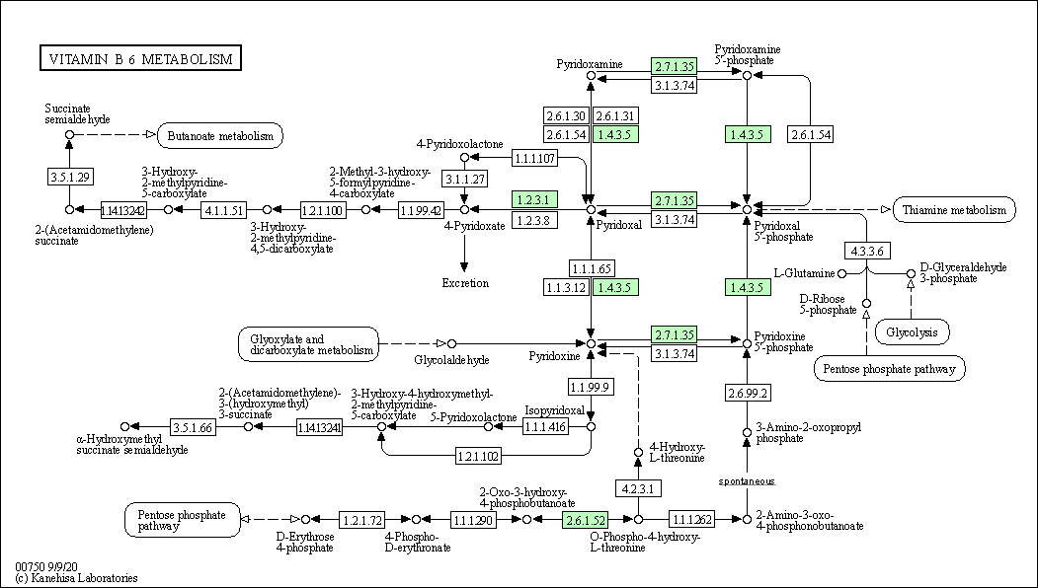
Figure S3. The metabolism pathway for vitamin B6. The box with green color indicates the pathway presented in Cruznema velatum.
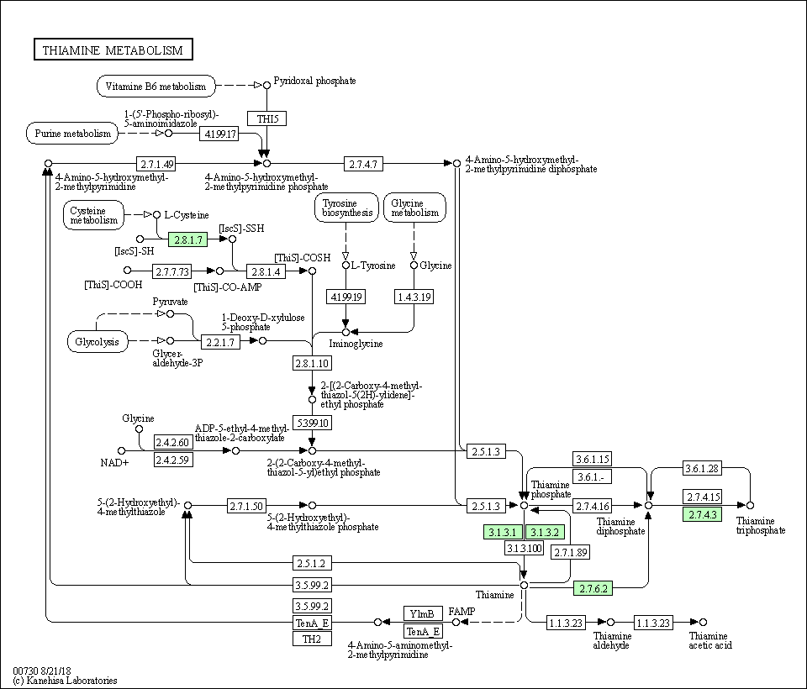
Figure S4. The metabolism pathway for thiamine. The box with green color indicates the pathway presented in Cruznema velatum.

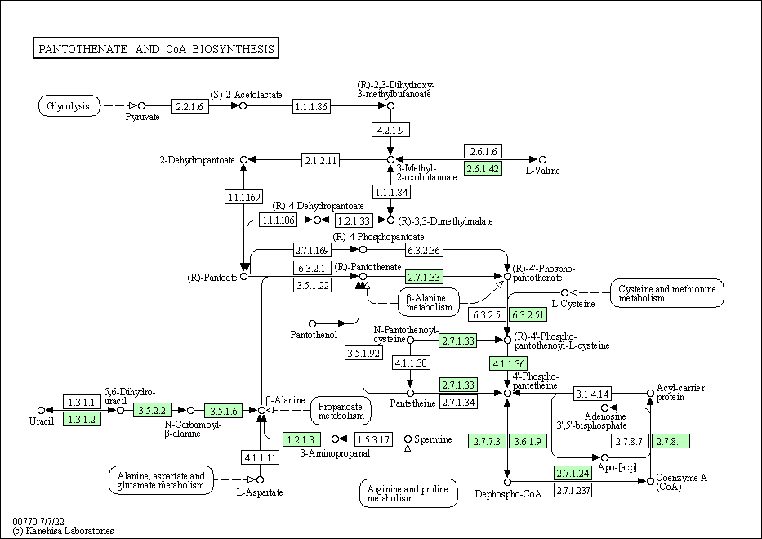

Figure S5. The metabolism pathway for pantothenate and CoA. The box with green color indicates the pathway presented in Cruznema velatum.
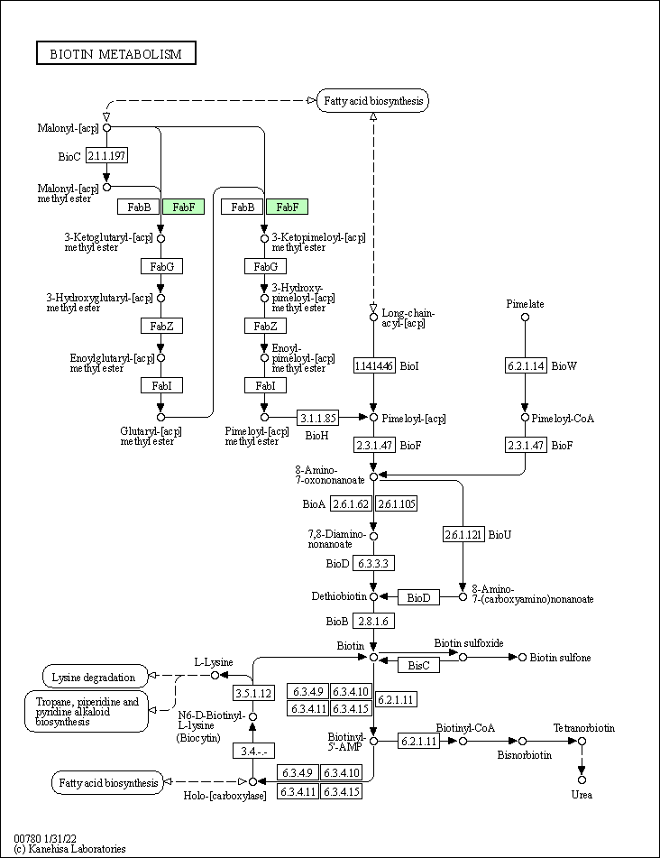
Figure S6. The metabolism pathway for biotin. The box with green color indicates the pathway presented in Cruznema velatum.
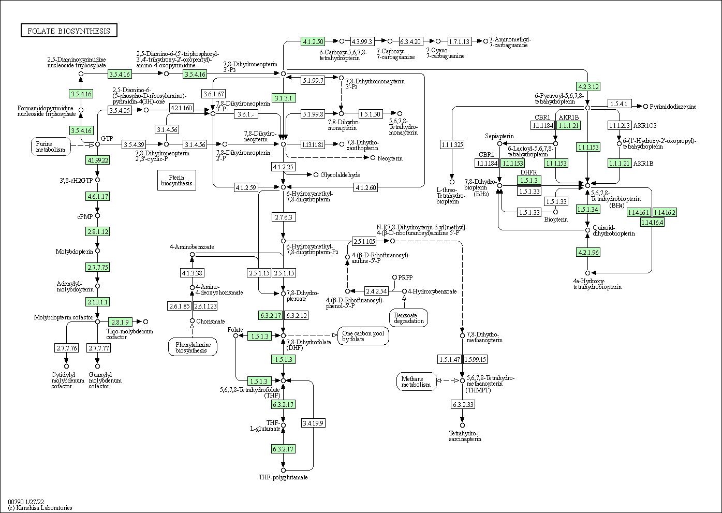
Figure S7. The metabolism pathway for folate. The box with green color indicates the pathway presented in Cruznema velatum.

