Supplementary material
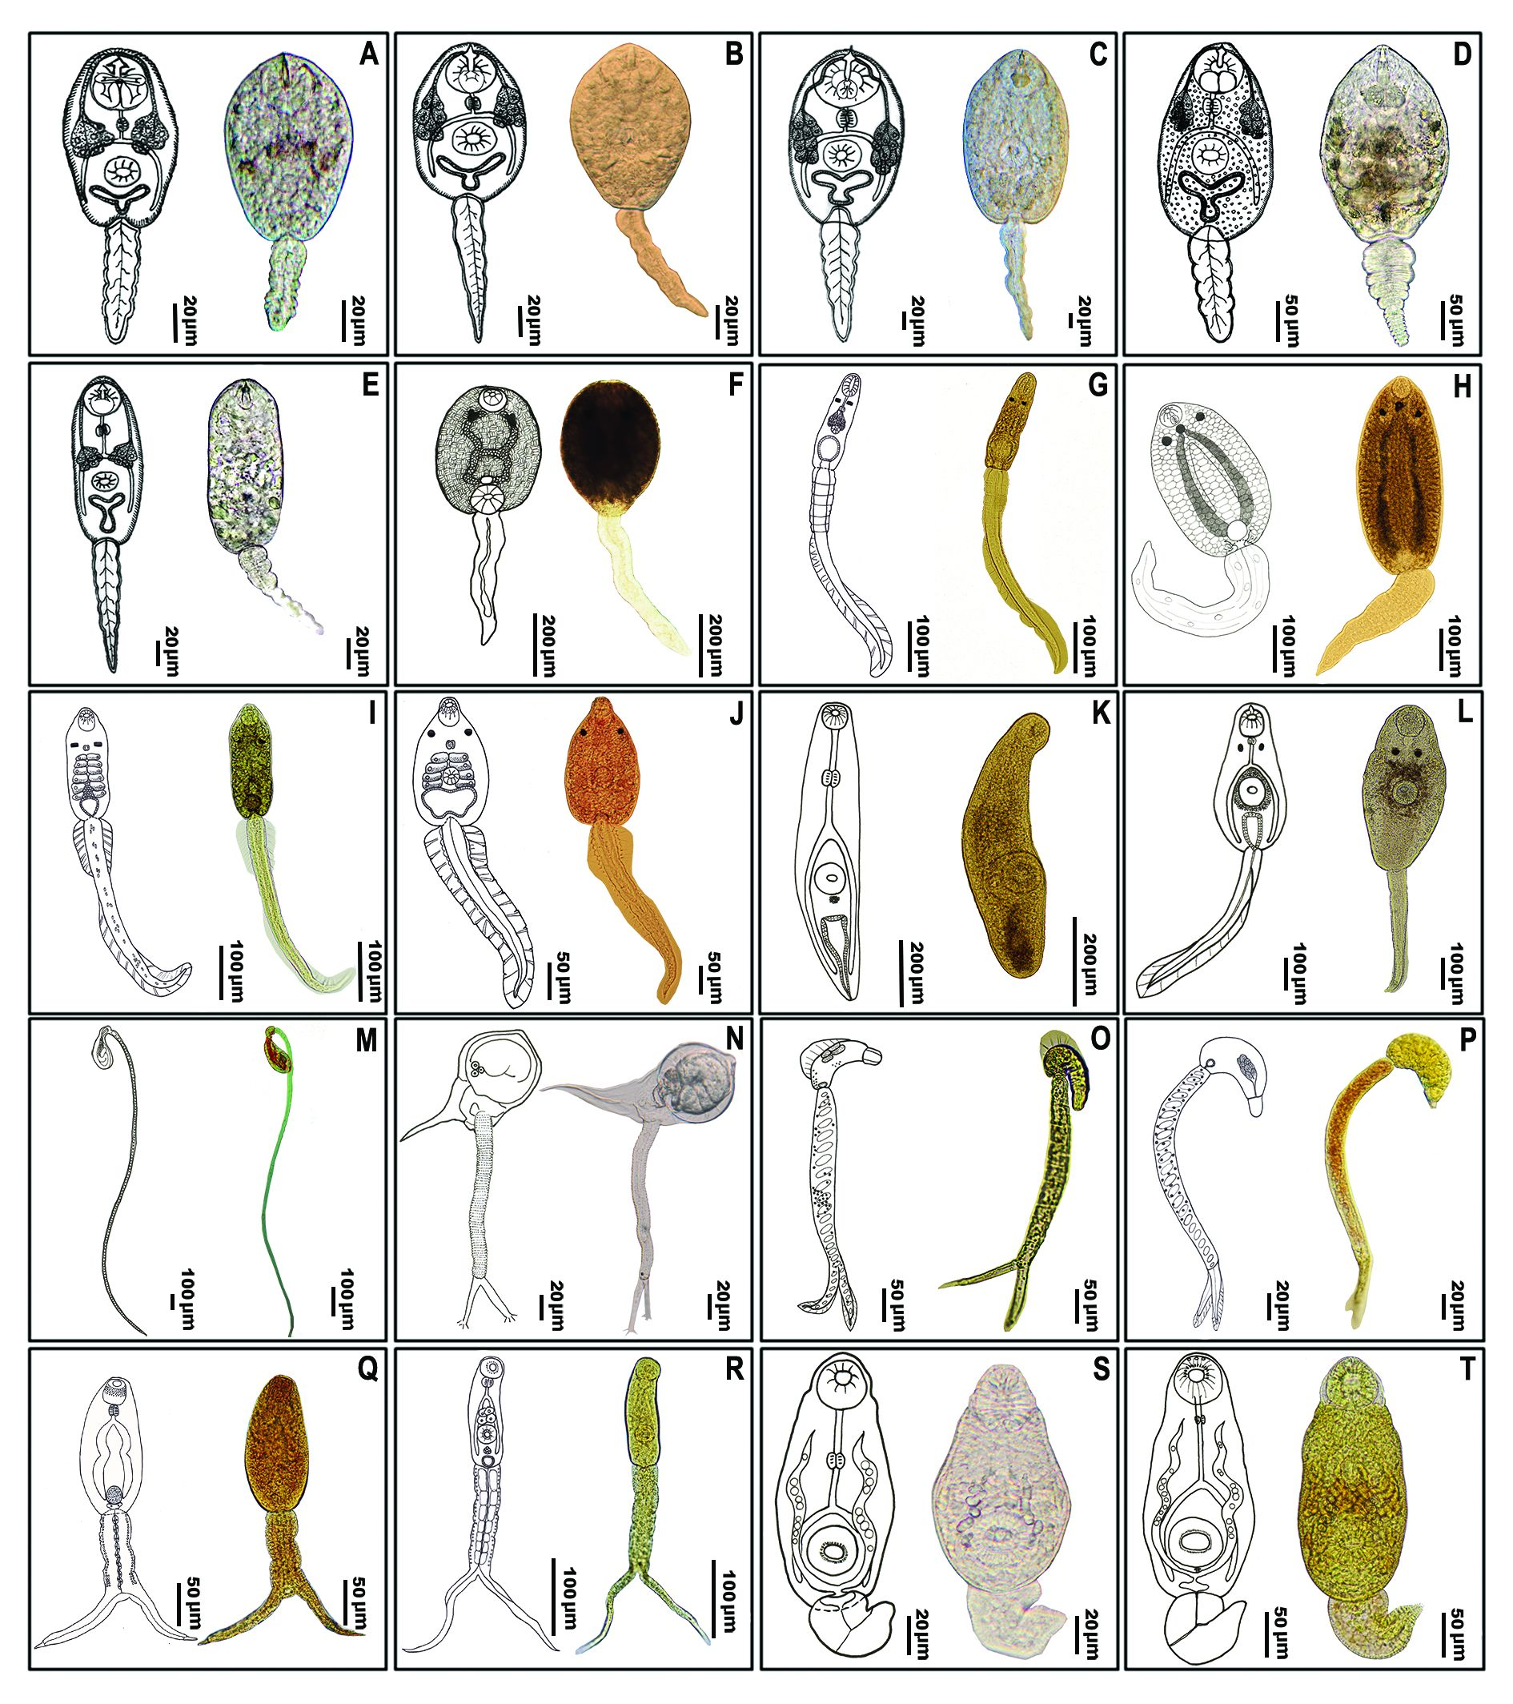
Figure S1. Morphological types of cercariae from which sequences presented in this paper were obtained, reproduced from Kiatsopit et al. (2016). The letter code used for individual morphotypes in this figure is the same as that in Table 1. Note that we did not obtain DNA data from furcocercous cercaria 2 (letter P in the figure).

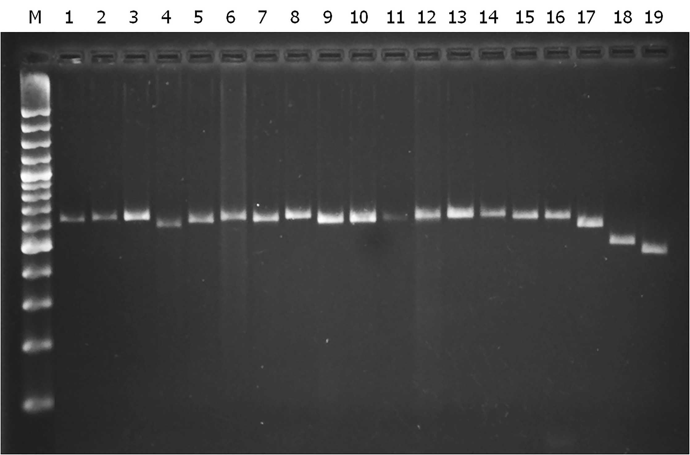

Figure S2. Agarose gel electrophoresis illustrates lengths of 28S ribosomal RNA PCR products. Lane M: 100 bp ladder, 1: Mutabile cercaria, 2: Monostome cercaria, 3: Amphistome cercaria, 4: Xiphidiocercaria virgulate 1, 5: Xiphidiocercaria virgulate 5, 6: Xiphidiocercaria virgulate 2, 7: Xiphidiocercaria virgulate 3, 8: Xiphidiocercaria virgulate 4, 9: Echinostome cercaria 1, 10: Echinostome cercaria 2, 11: Ophthalmoxiphidiocercaria, 12: Opisthorchis viverrini cercaria, 13: Parapleurolophocercous cercaria 2, 14: Parapleurolophocercous cercaria 1, 15: Longifurcate-pharyngeate cercaria 1, 16: Longifurcate-pharyngeate cercaria 2 , 17: Furcocercous cercaria 1, 18: Cystophorous cercaria 2, 19: Cystophorous cercaria 1.

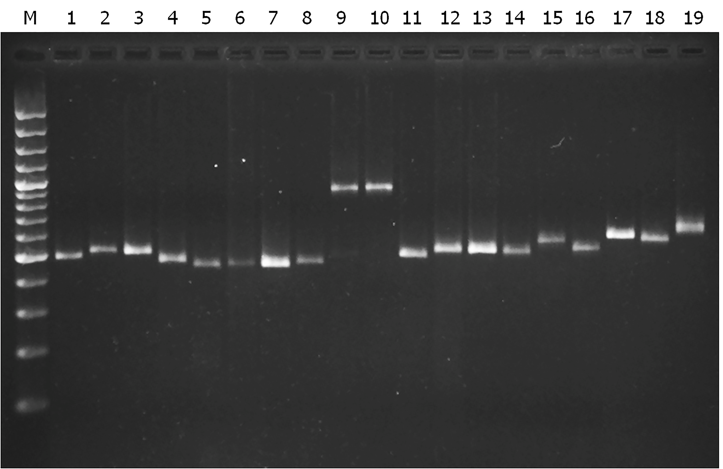

Figure S3. Agarose gel electrophoresis illustrates lengths of PCR products from second internal transcribed spacer region (ITS2). Lane M: 100 bp ladder, 1: Mutabile cercaria, 2: Monostome cercaria, 3: Amphistome cercaria, 4: Xiphidiocercaria virgulate 1, 5: Xiphidiocercaria virgulate 5, 6: Xiphidiocercaria virgulate 2, 7: Xiphidiocercaria, virgulate type 3, 8: Xiphidiocercaria, virgulate type 4, 9: Echinostome cercaria 1, 10: Echinostome cercaria 2, 11: Ophthalmoxiphidiocercaria, 12: Opisthorchis viverrini cercaria, 13: Parapleurolophocercous cercaria 2, 14: Parapleurolophocercous cercaria 1, 15: Longifurcate-pharyngeate cercaria 1, 16: Longifurcate-pharyngeate cercaria 2 , 17: Furcocercous cercaria 1, 18: Cystophorous cercaria 2, 19: Cystophorous cercariae 1.

