SUPPLEMENTARY FILES

Influence of breed and parasite challenge on the immune response to naturally acquired intestinal nematode infection in sheep

Ana Cláudia A. Albuquerque* ^{1,2}; Fabiana Alves de Almeida ²; Cesar Cristiano Bassetto ²; José Gabriel Gonçalves Lins^{1,2}; Alessandro F. T. Amarante ²

¹ UNESP – São Paulo State University, School of Veterinary Medicine and Animal Science, Rua Professor Doutor Walter Mauricio Correa s/n, 18618-681, Botucatu, SP, Brazil.
² UNESP – São Paulo State University, Institute of Biosciences, Rua Professor Dr. Antônio Celso Wagner Zanin, 250, 18618-689, Botucatu, SP, Brazil.

* Corresponding author
E-mail: ac.alb@hotmail.com

Table S1. Anthelmintics administered to lambs under suppressive treatments.
Experimental weeks | Treatments
 | Monepantel | Combination | Moxidectin
Arrival |  | x
2 | x
4 | x
6 |  |  | x
8 | x
10 | x
12 | x
13 |  | x
18 | x
21 Slaughter
Combination: Albendazole + Levamisole + Monepantel.

Table S2. Mean (minimum-maximum) values of Cooperia curticei in Santa Ines and Ile de France lambs under suppressive or targeted selective treatment (TST) programmes with anthelmintics.
Development stages | Santa Ines |  | Ile de France |  | Effects (P-value)
 | Suppressive (n=9) | TST (n=10) | Suppressive (n=10) | TST (n=9) | Breed |  | Treatment programme | Breed x Treatment
Early L₄ | 16 (0-80) | 296 (0-1060) | 42 (0-120) | 875 (240-2230) | 0.0080 |  | <0.0001 | ns
 | 0.64 (±0.26) | 1.61 (±0.39) | #1.16 (±0.27) | 2.84 (±0.11)
Female late L₄ | 12 (0-70) | 111 (0-470) | 18 (0-70) | 253 (40-490) | 0.0106 |  | 0.0008 | ns
 | 0.50 (±0.25) | 1.05 (±0.37) | 0.84 (±0.24) | 2.29 (±0.13)
Male late L₄ | 3 (0-10) | 23 (0-110) | 4 (0-20) | 149 (10-400) | 0.0137 |  | <0.0001 | 0.0061
 | 0.35 (±0.17) a* | 0.87 (±0.25) a | 0.34 (±0.17) a | 2.01 (±0.15) b
Female L₅ | 0 | 28 (0-120) | 7 (0-50) | 232 (0-490) | 0.0194 |  | <0.0001 | ns
 | 0 | 0.84 (±0.29) | 0.30 (±0.20) | 1.90 (±0.36)
Male L₅ | 0 | 31 (0-140) | 2 (0-20) | 194 (0-440) | ns |  | <0.0001 | ns
 | 0 | 0.95 (±0.27) | 0.13 (±0.13) | 1.83 (±0.35)
Adult female | 1 (1-10) | 517 (0-1410) | 1 (0-10) | 979 (0-3350) | ns |  | <0.0001 | ns
 | 0.12 (±0.12) | 1.92 (±0.43) | 0.10 (±0.10) | 2.40 (±0.38)
Adult male | 1 (1-10) | 368 (0-1140) | 0 | 660 (0-2510) | ns |  | <0.0001 | ns
 | 0.12 (±0.12) | 1.92 (±0.41) | 0 | 2.20 (±0.36)
Total worm burden | 33 (0-110) | 1374 (0-3360) | 74 (0-190) | 3339 (600-8400) | 0.0292 |  | <0.0001 | ns
 | 0.93 (±0.31) | 2.58 (±0.37) | 1.58 (±0.22) | 3.38 (±0.13)

L4: fourth stage larvae; L5: fifth stage juveniles.

* Means (± standard error) of log transformed values followed by different letter in the same line differ from each other by Tukey’s test (P<0.05).

ns = not significant (P>0.05).

Table S3. Mean (minimum-maximum) values of Trichostrongylus colubriformis in Santa Ines and Ile de France lambs under suppressive or targeted selective treatment (TST) programmes with anthelmintics.
Development stages | Santa Ines |  | Ile de France |  | Effects (P-value)
 | Suppressive (n=9) | TST (n=10) | Suppressive (n=10) | TST (n=9) | Breed | Treatment programme | Breed x Treatment
Early L₄ | 0 | 24 (0-60) | 0 | 156 (20-570) | 0.0052 | <0.0001 | 0.0016
 | 0 a * | 0.83 (±0.28) b | 0 a | 1.97 (±0.16) c
Female late L₄ | 2 (0-10) | 56 (0-300) | 1 (0-10) | 428 (20-1060) | 0.0145 | <0.0001 | 0.0008
 | 0.23 (±0.15) a | 1.16 (±0.29) b | 0.10 (±0.10) a | 2.46 (±0.16) c
Male late L₄ | 1 (0-10) | 90 (0-290) | 4 (0-30) | 487 (60-1450) | 0.0095 | <0.0001 | 0.0163
 | 0.12 (±0.12) a | 1.44 (±0.29) b | 0.25 (±0.17) a | 2.56 (±0.13) c
Female L₅ | 2 (0-10) | 136 (0-400) | 2 (0-20) | 969 (440-2040) | 0.0197 | <0.0001 | 0.0012
 | 0.23 (±0.15) a | 1.67 (±0.30) b | 0.13 (±0.13) a | 2.93 (±0.08) c
Male L₅ | 0 | 166 (0-660) | 1 (0-10) | 1772 (640-3060) | 0.0006 | <0.0001 | .0005
 | 0 a | 1.55 (±0.35) b | 0.10 (±0.10) a | 3.19 (±0.08) c
Adult female | 1 (0-10) | 2806 (0-6690) | 0 | 4748 (1780-18030) | ns | <0.0001 | 0.0412
 | 0.26 (±0.17) a | 2.61 (±0.05) b | 0 a | 3.55 (±0.10) b
Adult male | 1 (0-10) | 2806 (0-6690) | 5 (0-30) | 2744 (190-14810) | ns | <0.0001 | ns
 | 0.12 (±0.12) | 2.52 (±0.49) | 0.36 (±0.19) | 3.07 (±0.19)
Total worm burden | 10 (0-30) | 6997 (0-16190) | 13 (0-50) | 11253 (4670-35150) | ns | <0.0001 | ns
 | 0.77 (±0.20) | 2.93 (±0.53) | 0.67 (±0.23) | 3.98 (±0.08)

L4: fourth stage larvae; L5: fifth stage juveniles.

*Means (± standard error) of log transformed values followed by different letter in the same line differ from each other by Tukey’s test (P<0.05).

ns = not significant (P>0.05).

Table S4. Mean (minimum-maximum) values of Strongyloides papillosus in Santa Ines and Ile de France lambs under suppressive or targeted selective treatment (TST) programmes with anthelmintics.
Stage of development | Santa Ines |  | Ile de France |  | Effects (P-value)
 | Suppressive (n=9) | TST (n=10) | Suppressive (n=10) | TST (n=9) | Breed | Treatment programme' | Breed x Treatment
Early L₄ | 0 a | 0 | 0 | 39 (0-180) | 0.0259 | 0.0193 | 0.0193
 | 0 a * | 0 a | 0 a | 0.74 (±0.32) b
Late L₄ | 0 | 15 (0-50) | 10 (0-60) | 62 (0-310 | 0.0136 | 0.0002 | ns
 | 0 | 0.72 (±0.25) | 0.44 (±0.23) | 1.4 (±0.23)
L₅ | 4 (0-20) | 19 (0-80) | 3 (0-20) | 110 (0-790) | ns | 0.0034 | ns
 | 0.37 (±0.19) | 0.77 (±0.26) | 0.23 (±0.16) | 1.29 (±0.30)
Adult female | 107 (10-460) | 5179 (80-36370) | 431 (0-2490) | 20244 (760-78870) | ns | <0.0001 | ns
 | 1.71 (±0.18) | 3.01 (±0.25) | 1.90 (±0.32) | 4.00 (±0.20)
Total worm burden | 113 (10-470) | 5244 (80-36460) | 447 (0-2520) | 20526 (790-79260) | ns | <0.0001 | ns
 | 1.77 (±0.18) | 3.05 (±0.25) | 1.91 (±0.32) | 4.00 (±0.20)

L4: fourth stage larvae; L5: fifth stage juveniles.

* Means (± standard error) of log transformed values followed by different letter in the same line differ from each other by Tukey’s test (P<0.05).

ns = not significant (P>0.05).

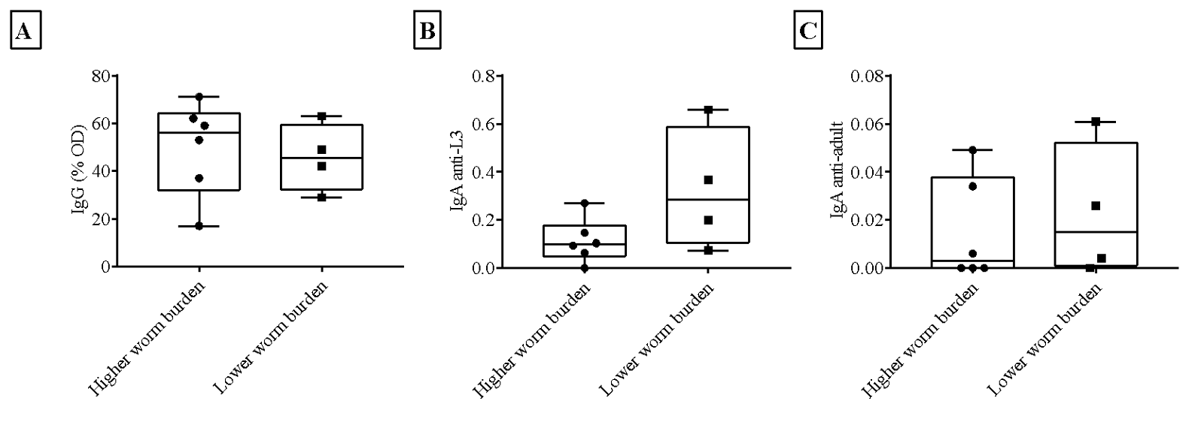

Figure S1. Percentages of optical density of IgG against Trichostrongylus colubriformis L3 (A), IgA anti-L3 (B) and anti-adult (C) of T. colubriformis in Santa Ines lambs under Target Selective Treatment (TST), presenting low and high worm burden. The ends of the box are the upper and lower quartiles; the median is marked by a vertical line inside the box; and the two lines outside the box extend to the highest and lowest observations.

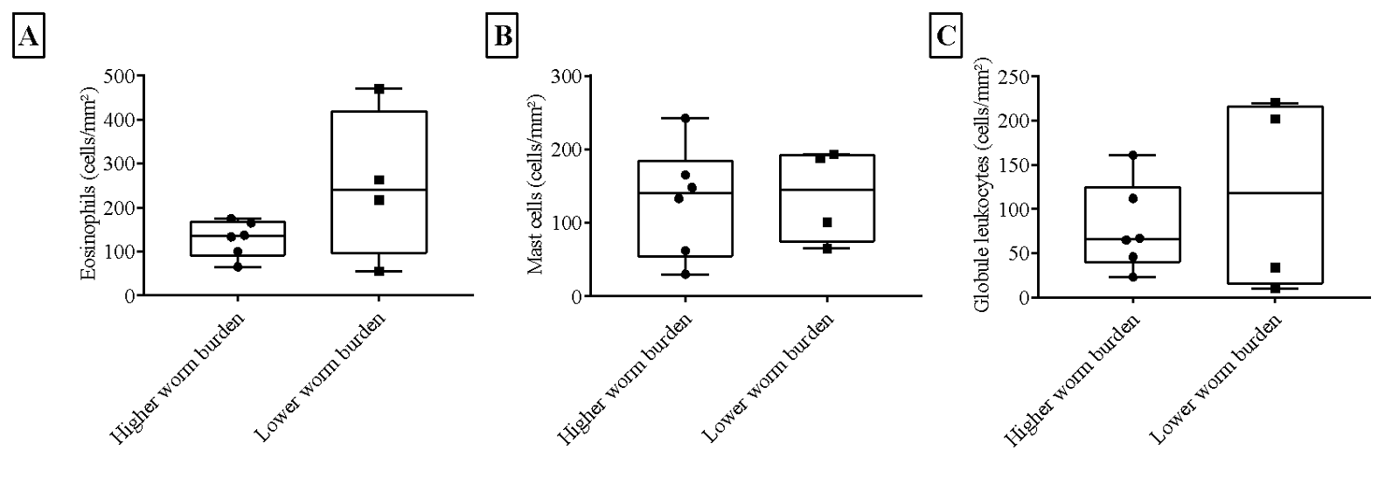

Figure S2. Number of eosinophils (A), mast cells (B) and globule leukocytes (C) in the intestinal mucosa of Santa Ines lambs under Target Selective Treatment (TST), presenting low and high Trichostrongylus colubriformis burden. The ends of the box are the upper and lower quartiles; the median is marked by a vertical line inside the box; and the two lines outside the box extend to the highest and lowest observations.

