Journal of Helminthology
Lack of Trade-offs in Host Offspring Produced During Fecundity Compensation
Annabell A. Davis, J. Trevor Vannatta, Stephanie O. Gutierrez, Dennis J. Minchella

Supplemental Material
Experimental Timeline
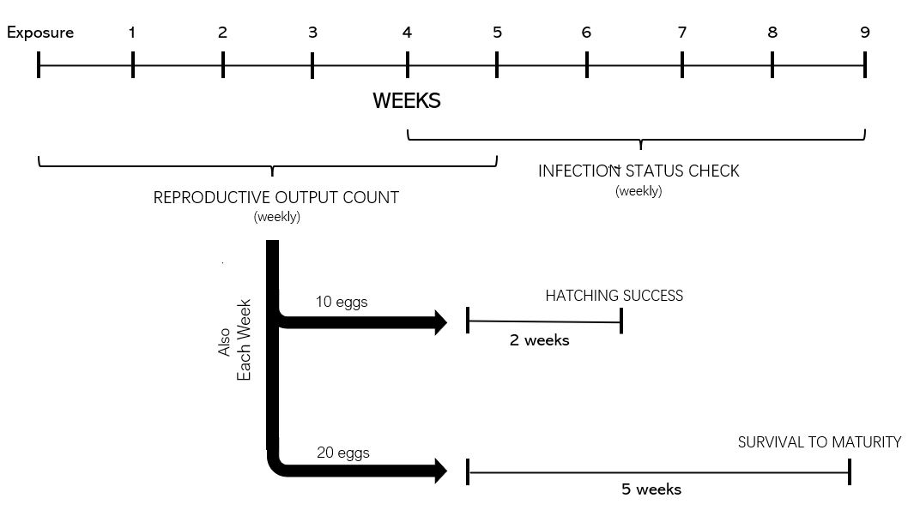
Figure S1: A timeline of the entire experiment depicting durations of data collection of different parts of the study

Egg Laying Accuracy

To further understand the impacts of Schistosoma mansoni infection on Biomphalaria glabrata reproduction, the egg laying accuracy of snail parents was also analysed. Parent snails that were infected (37 total), uninfected (40 total), and exposed to miracidia but did not shed cercariae (designated exposed, but uninfected; 10 total) were compared. Egg laying accuracy was considered the ability to allot a single yolk to a single egg case. Mistakes that were seen were empty egg cases and multiple yolks in one egg as determined using a light microscope. This was done each week post exposure for a total of 5 weeks (the length of time between exposure and parasitic castration of the infected parent snail). Egg laying accuracy analysis was done using a binomial GLMM with parent snail and week included as random factors.
Biomphalaria glabrata snails exposed to S. mansoni, but not infected, were more likely to make errors in allotting a single yolk to a single egg case than either infected (p=0.0249, Table S1) or uninfected snails (p=0.0285, Table S1) as seen in Figure S2. There was no significant difference between infected and uninfected snails (p= 0.9959, Table S1).
While we did not see a difference between infected and uninfected snails in likelihood to make errors in allotting a single yolk to a single egg case, we did observe that snails that were exposed to S. mansoni infection but not infected, were more likely to make errors. These snails could have possessed low susceptibility (resistance) to infection by the parasite, which has been previously associated with low fecundity and abnormal egg production (Minchella & LoVerde, 1983, Cooper et al., 1994). Snails may be allocating less energy towards ensuring proper reproduction leading to the increased number of inconsistencies in egg cases (multiple yolks or no yolks). Instead, this energy could be allocated more towards immunological maintenance to limit the potential risk of infection.

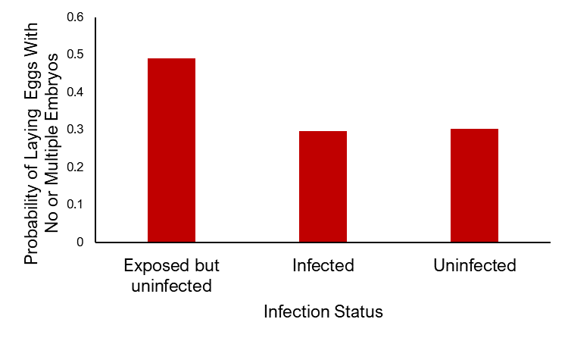
0.51
0.30
0.30
b
b
a
Figure S2: Infection status of B. glabrata and the probability of laying eggs with no or multiple embryos per week, indicating errors in allotting a single yolk to a single egg case. N= 10 exposed but uninfected snails with 53 observations, 37 infected snails with 185 observations, and 40 uninfected snails with 188 observations. Values above bars show the plotted value. Different letters over bars indicate significant differences between groups.

Table S1: Pairwise comparison results of infected, uninfected, and exposed but uninfected snails using generalized linear mixed model with binomial error distribution with snail and week as random factors.
Contrast | Estimate | Standard Error | Degrees of Freedom | Z Ratio | P Value
Exposed but Uninfected versus Uninfected | -0.9425 | 0.371 | Inf | -2.541 | 0.0285
Uninfected versus Infected | 0.0221 | 0.259 | Inf | 0.086 | 0.9959
Exposed but Uninfected versus Infected | 0.9646 | 0.372 | Inf | 2.592 | 0.0249

