Supplementary material - Journal of Helminthology
Distribution of Pomphorhynchus laevis s.l. (Acanthocephala) among fish species at a local scale: importance of fish biomass-density

Marie-Jeanne Perrot-Minnot, Loïc Bollache, Clément Lagrue

Supplementary Figure S1.

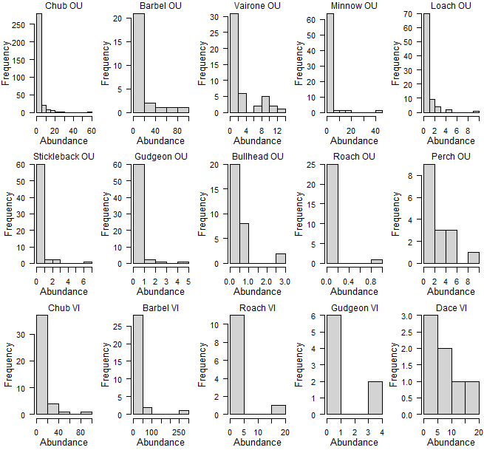

Fig. S1 Abundance distribution of intestinal P. laevis s.l. in different fish species sampled in the Ouche (OU) and Vingeanne rivers (VI), showing aggregate distributions of parasites among individual fish.

Supplementary Figure S2
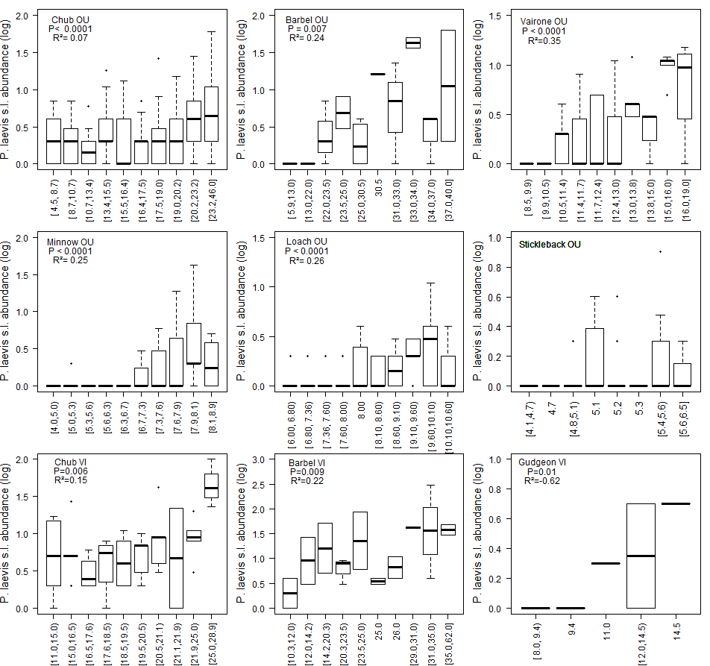
Fig. S2. Relationship between Pomphorhynchus laevis s.l. abundance (log10+1) and individual body size in nine fish species from two localities (OU: Ouche river; VI: Vingeanne river). For illustrative purpose, we categorized fish size in deciles (equal number of individuals per category), except for gudgeon in the Vingeanne river (quintiles), using the package Hmisc v4.2.0 (Harrell, 2019) The results of fitting the abundance of P. laevis s.l. to fish size using log-linear relationship are reported as P-value and adjusted R². Fish species for which sample size was low (< 7) are not reported.

Harrell F. E. Jr, with contributions from Charles Dupont and many others. (2019). Hmisc: Harrell Miscellaneous. R package version 4.2-0. https://CRAN.R-project.org/package=Hmisc

Supplementary figure S3

(a) (b)
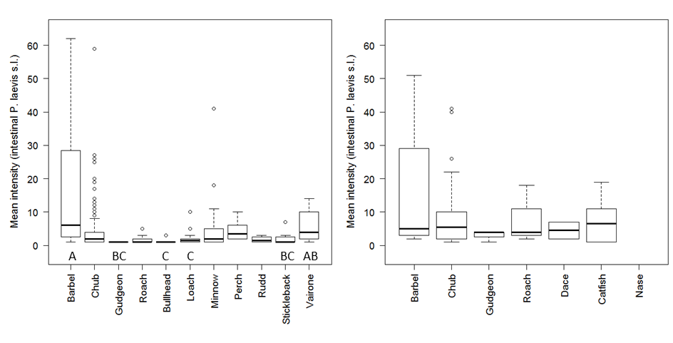
Fig. S3. Mean intensity of intestinal Pomphorhynchus laevis s.l. in fish host from the (a) Ouche and (b) Vingeanne rivers. Mean intensity in fish species with different letters are significantly different, after post-hoc paired comparison (Dunn tests with B–Y method), those without letter are not significantly different from any other species.

Supplementary Figure S4
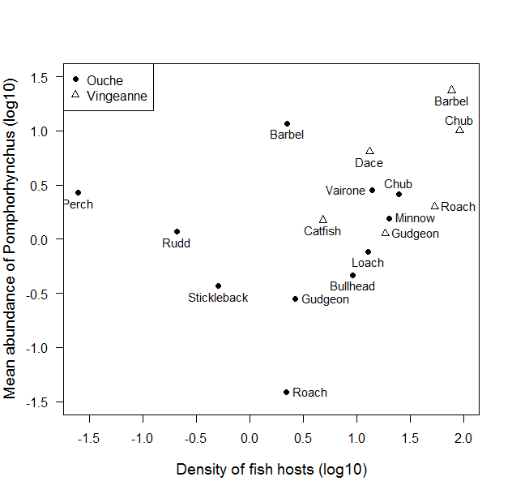

Fig. S4. Relationship between fish density (nb.m-2) and mean abundance of intestinal Pomphorhynchus laevis s.l. after log-transformation, across nine fish species from the Ouche River.

Supplementary figure S5

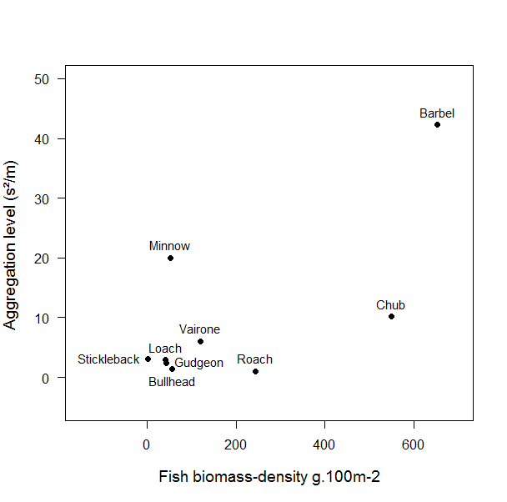

Fig. S5. Relationship between parasite aggregation level (estimated using the variance-to-mean ratio of abundance) and fish biomass-density, among nine fish species from the Ouche River.

Supplementary figure S6

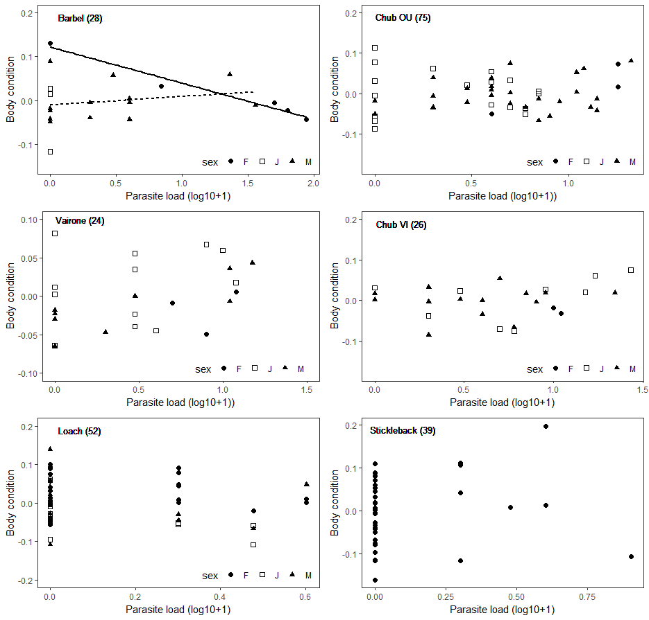
Fig. S6. Relationship between body condition of individual fish and Pomphorhynchus laevis s.l. abundance, according to fish host sex and species. Body condition is measured as the residuals of the regression of whole body weight on body size (log10-transformed). Significant relationships are represented by a regression line. Numbers in bracket are sample sizes.
Supplementary figure S7

(a) (b)
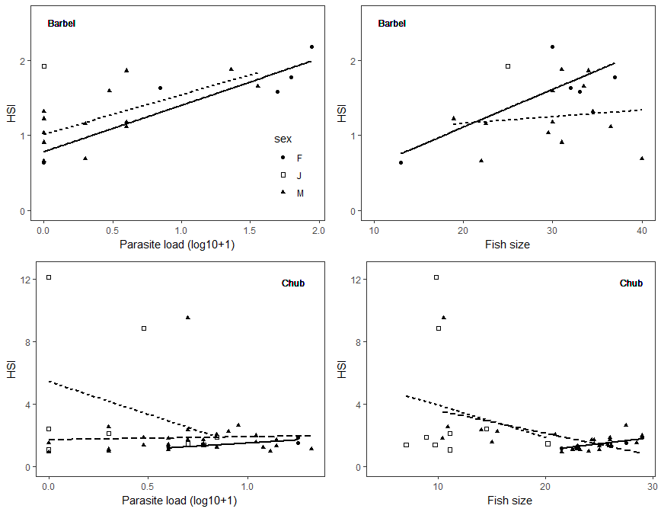
(c) (d)
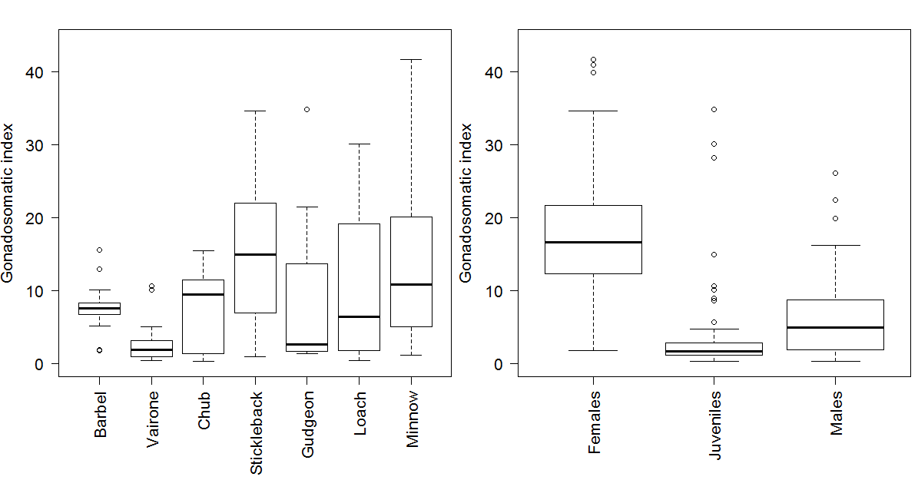
Fig. S6. Individual hepatosomatic index (HIS) in relation to (a) parasite load and (b) individual fish size, according to sex (female: plain line), for barbel and chub; and gonadosomatic index according to fish species (c) and sex (d) in the Ouche locality.

