Table 1: Multiple comparison of the mean positive cell numbers with the different studied groups by One-way ANOVA test (Tukey HSD). ; CD3, CD4, CD8, CD19, CD56, Foxp3 and Ki67 are present as relative number 0-100, and CD68 was present as number per high power microscopic field.
Dependent Variable | (I) Disease | (J) Disease | Mean Difference (I-J) | Std. Error | P | 95% Confidence Interval
 |  |  |  |  |  | Lower Bound | Upper Bound
CD3⁺ T cell | CE | HC | -22.980 | 14.762 | .273 | -58.539 | 12.578
 |  | CH | 2.748 | 14.762 | .981 | -32.811 | 38.306
 | HC | CE | 22.980 | 14.762 | .273 | -12.578 | 58.539
 |  | CH | 25.728 | 20.089 | .412 | -22.661 | 74.117
 | CH | CE | -2.748 | 14.762 | .981 | -38.306 | 32.811
 |  | HC | -25.728 | 20.089 | .412 | -74.117 | 22.661
CD4⁺ Th cell | CE | HC | -6.685 | 8.492 | .712 | -27.139 | 13.770
 |  | CH | 14.393 | 8.492 | .216 | -6.061 | 34.848
 | HC | CE | 6.685 | 8.492 | .712 | -13.770 | 27.139
 |  | CH | 21.078 | 11.556 | .171 | -6.757 | 48.913
 | CH | CE | -14.393 | 8.492 | .216 | -34.848 | 6.061
 |  | HC | -21.078 | 11.556 | .171 | -48.913 | 6.757
CD8⁺ CTL | CE | HC | -9.005 | 4.899 | .167 | -20.806 | 2.796
 |  | CH | -8.239 | 4.899 | .221 | -20.041 | 3.562
 | HC | CE | 9.005 | 4.899 | .167 | -2.796 | 20.806
 |  | CH | .766 | 6.667 | .993 | -15.294 | 16.825
 | CH | CE | 8.239 | 4.899 | .221 | -3.562 | 20.041
 |  | HC | -.766 | 6.667 | .993 | -16.825 | 15.294
CD19⁺ B cell | CE | HC | 14.576 | 9.406 | .276 | -8.080 | 37.232
 |  | CH | 12.308 | 9.406 | .397 | -10.349 | 34.964
 | HC | CE | -14.576 | 9.406 | .276 | -37.232 | 8.080
 |  | CH | -2.268 | 12.800 | .983 | -33.099 | 28.563
 | CH | CE | -12.308 | 9.406 | .397 | -34.964 | 10.349
 |  | HC | 2.268 | 12.800 | .983 | -28.563 | 33.099
CD56⁺ NK cell | CE | HC | -.686 | .439 | .270 | -1.743 | .371
 |  | CH | -.477 | .439 | .526 | -1.534 | .580
 | HC | CE | .686 | .439 | .270 | -.371 | 1.743
 |  | CH | .209 | .597 | .935 | -1.230 | 1.648
 | CH | CE | .477 | .439 | .526 | -.580 | 1.534
 |  | HC | -.209 | .597 | .935 | -1.648 | 1.230
FoxP3⁺ Treg | CE | HC | -2.014 | 2.178 | .627 | -7.261 | 3.234
 |  | CH | .971 | 2.178 | .896 | -4.276 | 6.218
 | HC | CE | 2.014 | 2.178 | .627 | -3.234 | 7.261
 |  | CH | 2.985 | 2.964 | .576 | -4.156 | 10.125
 | CH | CE | -.971 | 2.178 | .896 | -6.218 | 4.276
 |  | HC | -2.985 | 2.964 | .576 | -10.125 | 4.156
CD68⁺ MΦ | CE | HC | 26.570 | 34.111 | .717 | -55.596 | 108.736
 |  | CH | 29.320 | 34.111 | .668 | -52.846 | 111.486
 | HC | CE | -26.570 | 34.111 | .717 | -108.736 | 55.596
 |  | CH | 2.750 | 46.420 | .998 | -109.063 | 114.563
 | CH | CE | -29.320 | 34.111 | .668 | -111.486 | 52.846
 |  | HC | -2.750 | 46.420 | .998 | -114.563 | 109.063
CE: cystic echinococcosis, HC: hepatocellular carcinoma, CH: chronic hepatitis

Table 2: Multiple comparison of the mean positive cell numbers with the different E. granulosus genotypes in CE patients using the One-way ANOVA test (Tukey HSD). ; CD3, CD4, CD8, CD19, CD56, Foxp3 and Ki67 are present as relative number 0-100, and CD68 and eosinophils were present as number per high power microscopic field.
Cells | (I) Genotype | (J) Genotype | Mean Difference  (I-J) | Std. Error | P | 95% Confidence Interval
 |  |  |  |  |  | Lower Bound | Upper Bound
Eosinophil | G1 | G3 | 14.473 | 38.628 | .926 | -79.011 | 107.957
 |  | G6 | 28.140 | 33.814 | .685 | -53.696 | 109.975
 | G3 | G1 | -14.473 | 38.628 | .926 | -107.957 | 79.011
 |  | G6 | 13.667 | 49.406 | .959 | -105.901 | 133.234
 | G6 | G1 | -28.140 | 33.814 | .685 | -109.975 | 53.696
 |  | G3 | -13.667 | 49.406 | .959 | -133.234 | 105.901
CD3⁺ T cell | G1 | G3 | 19.397 | 17.637 | .519 | -23.287 | 62.081
 |  | G6 | -12.760 | 15.439 | .689 | -50.125 | 24.605
 | G3 | G1 | -19.397 | 17.637 | .519 | -62.081 | 23.287
 |  | G6 | -32.157 | 22.558 | .336 | -86.750 | 22.436
 | G6 | G1 | 12.760 | 15.439 | .689 | -24.605 | 50.125
 |  | G3 | 32.157 | 22.558 | .336 | -22.436 | 86.750
CD4⁺ Th | G1 | G3 | 3.745 | 10.075 | .927 | -20.639 | 28.129
 |  | G6 | 7.627 | 8.820 | .665 | -13.718 | 28.972
 | G3 | G1 | -3.745 | 10.075 | .927 | -28.129 | 20.639
 |  | G6 | 3.882 | 12.887 | .951 | -27.305 | 35.069
 | G6 | G1 | -7.627 | 8.820 | .665 | -28.972 | 13.718
 |  | G3 | -3.882 | 12.887 | .951 | -35.069 | 27.305
CD8⁺ CTL | G1 | G3 | 3.189 | 5.739 | .844 | -10.700 | 17.077
 |  | G6 | 5.188 | 5.024 | .560 | -6.970 | 17.345
 | G3 | G1 | -3.189 | 5.739 | .844 | -17.077 | 10.700
 |  | G6 | 1.999 | 7.340 | .960 | -15.765 | 19.762
 | G6 | G1 | -5.188 | 5.024 | .560 | -17.345 | 6.970
 |  | G3 | -1.999 | 7.340 | .960 | -19.762 | 15.765
CD19⁺ B cell | G1 | G3 | 1.997 | 11.589 | .984 | -26.050 | 30.044
 |  | G6 | -4.717 | 10.145 | .888 | -29.269 | 19.835
 | G3 | G1 | -1.997 | 11.589 | .984 | -30.044 | 26.050
 |  | G6 | -6.714 | 14.823 | .893 | -42.587 | 29.158
 | G6 | G1 | 4.717 | 10.145 | .888 | -19.835 | 29.269
 |  | G3 | 6.714 | 14.823 | .893 | -29.158 | 42.587
CD56⁺ NK cell | G1 | G3 | .316 | .526 | .820 | -.957 | 1.589
 |  | G6 | -.047 | .461 | .994 | -1.162 | 1.067
 | G3 | G1 | -.316 | .526 | .820 | -1.589 | .957
 |  | G6 | -.363 | .673 | .852 | -1.992 | 1.265
 | G6 | G1 | .047 | .461 | .994 | -1.067 | 1.162
 |  | G3 | .363 | .673 | .852 | -1.265 | 1.992
FoxP3⁺ Treg | G1 | G3 | 1.551 | 2.458 | .804 | -4.397 | 7.499
 |  | G6 | 1.653 | 2.151 | .724 | -3.554 | 6.860
 | G3 | G1 | -1.551 | 2.458 | .804 | -7.499 | 4.397
 |  | G6 | .102 | 3.143 | .999 | -7.505 | 7.709
 | G6 | G1 | -1.653 | 2.151 | .724 | -6.860 | 3.554
 |  | G3 | -.102 | 3.143 | .999 | -7.709 | 7.505
CD68⁺ MΦ | G1 | G3 | -12.047 | 40.974 | .954 | -111.208 | 87.115
 |  | G6 | -64.297 | 35.868 | .183 | -151.101 | 22.508
 | G3 | G1 | 12.047 | 40.974 | .954 | -87.115 | 111.208
 |  | G6 | -52.250 | 52.406 | .582 | -179.078 | 74.578
 | G6 | G1 | 64.297 | 35.868 | .183 | -22.508 | 151.101
 |  | G3 | 52.250 | 52.406 | .582 | -74.578 | 179.078

Table 3: The regression model of the variables with significant relationship in patients with CE
Model | Mean Square | F | R Square | P
CD19-Ki-67
Regression | 479.076 | 5.190 | .183 | .032
CD4-CD19
Regression | 2081.415 | 8.659 | .153 | .005
CD8-Foxp3
Regression | 361.972 | 4.239 | .81 | .045
Age-Ki-67
Regression | 942.595 | 4.540 | .165 | .044

Supplementary figures
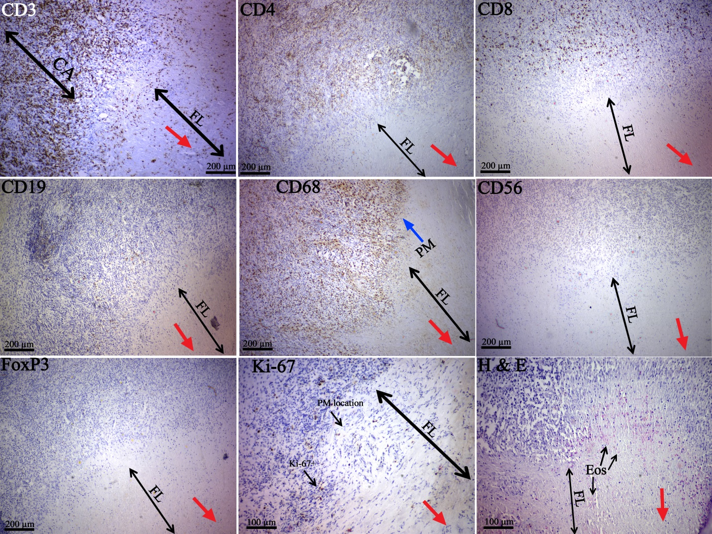
Figure 1: The studied cell-types in a 37-year-old patient with massive immune cell aggregation around the liver hydatid cyst. The red arrows point towards the location of the parasite and a considerable number of eosinophils and macrophages are visible in the border of the fibrous layer and inflammatory site (H&E and CD68). There are few proliferating cells in the area that palisading macrophages are present (CD68 and Ki-67). All of the micrographs are correspond to the same individual.
CA, immune cell aggregation site; FL, fibrous layer; PM, palisading macrophages; Eos, eosinophil.
CD3 (10X), CD4 (10X), CD8 (10X), CD19 (10X), CD68 (10X), CD56 (10X), Foxp3 (10X), Ki-67 (20X), and H&E (20X)

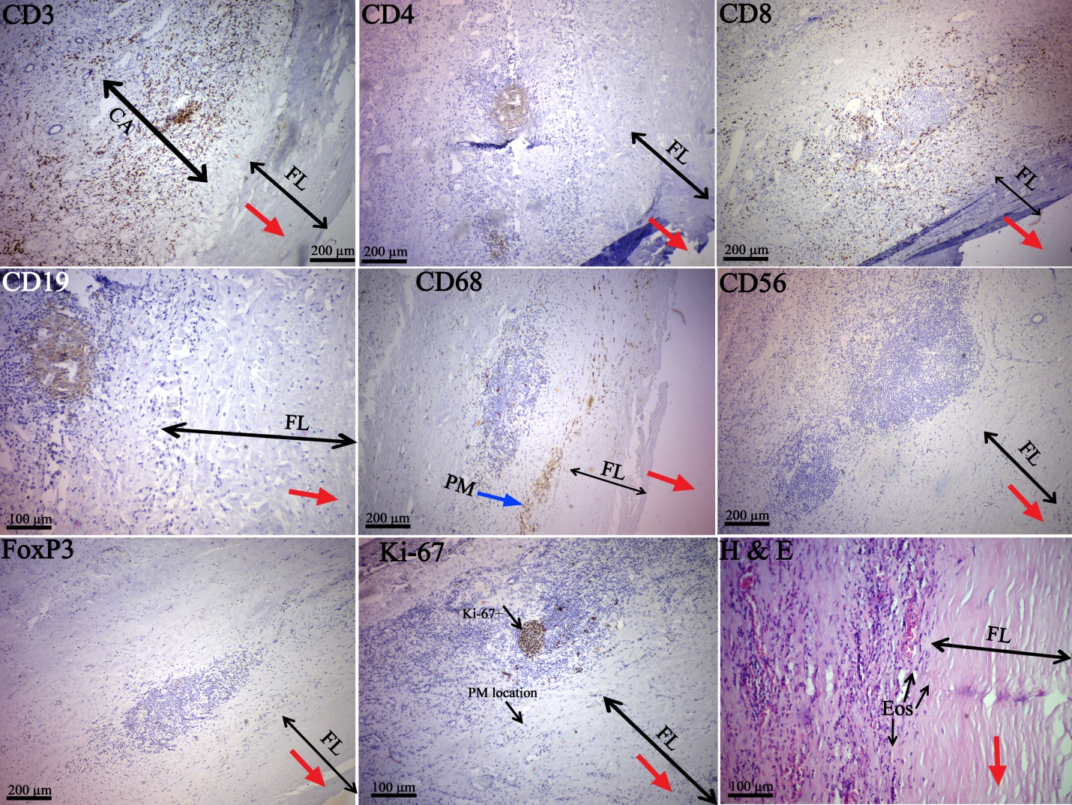
Figure 2: The studied cell-types in a 31-year-old patient with liver hydatid cyst. The red arrows point towards the location of the parasite and a considerable number of eosinophils and macrophages are visible in the border of fibrous layer and inflammatory site (H&E and CD68). There are few proliferating cells in the area that palisading macrophages are present (CD68 and Ki-67), however there are many Ki-67+ cells in the area where B cells are located (micrographs CD19 and Ki-67). All of the micrographs are correspond to the same individual.
CA, immune cell aggregation site; FL, fibrous layer; PM, palisading macrophages; Eos, eosinophil.
CD3 (10X), CD4 (10X), CD8 (10X), CD19 (20X), CD68 (10X), CD56 (10X), Foxp3 (10X), Ki-67 (20X), and H&E (20X)

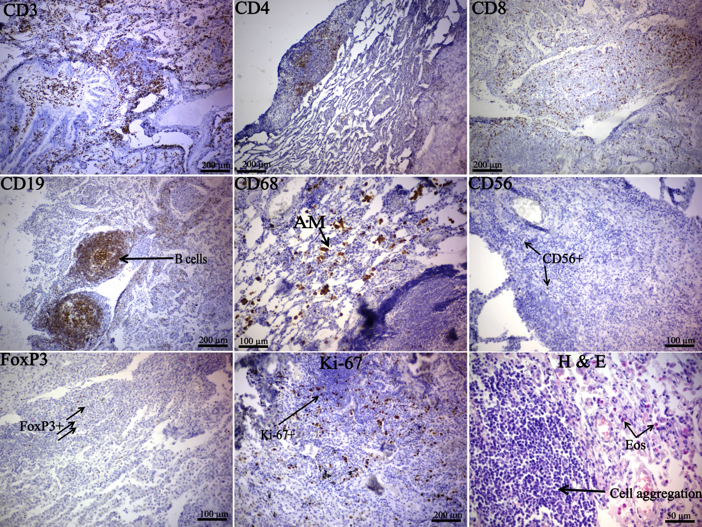
Figure 3: The studied cell-types in a 26-year-old patient with lung hydatid cyst. There was no apparent fibrous layer and massive inflammatory cell aggregation was filled all over the tissue, thus the location of hydatid cyst could not be determined. Considerable numbers of eosinophils are visible around the immune cell aggregation sites (H&E). There is no layer of palisading macrophages. All of the micrographs are correspond to the same individual. As it is shown in the Ki-67 stained micrograph, unlike the other figures, there is no Ki-67+ cluster at the core of the B-cell-rich follicle. This may be caused by the location where the follicle is cut during tissue section preparation. If the section cuts the follicle at the margin, the Ki-67+ cells may not be detectable. In one section, there were some B-cell-rich follicles with Ki-67+ cell-rich core and some (that may cut from the margin) did not have the Ki-67+ cell-rich core
CA, immune cell aggregation site; Eos, eosinophil; AM, alveolar macrophages.
CD3 (10X), CD4 (10X), CD8 (10X), CD19 (10X), CD68 (20X), CD56 (20X), Foxp3 (20X), Ki-67 (10X), and H&E (40X)

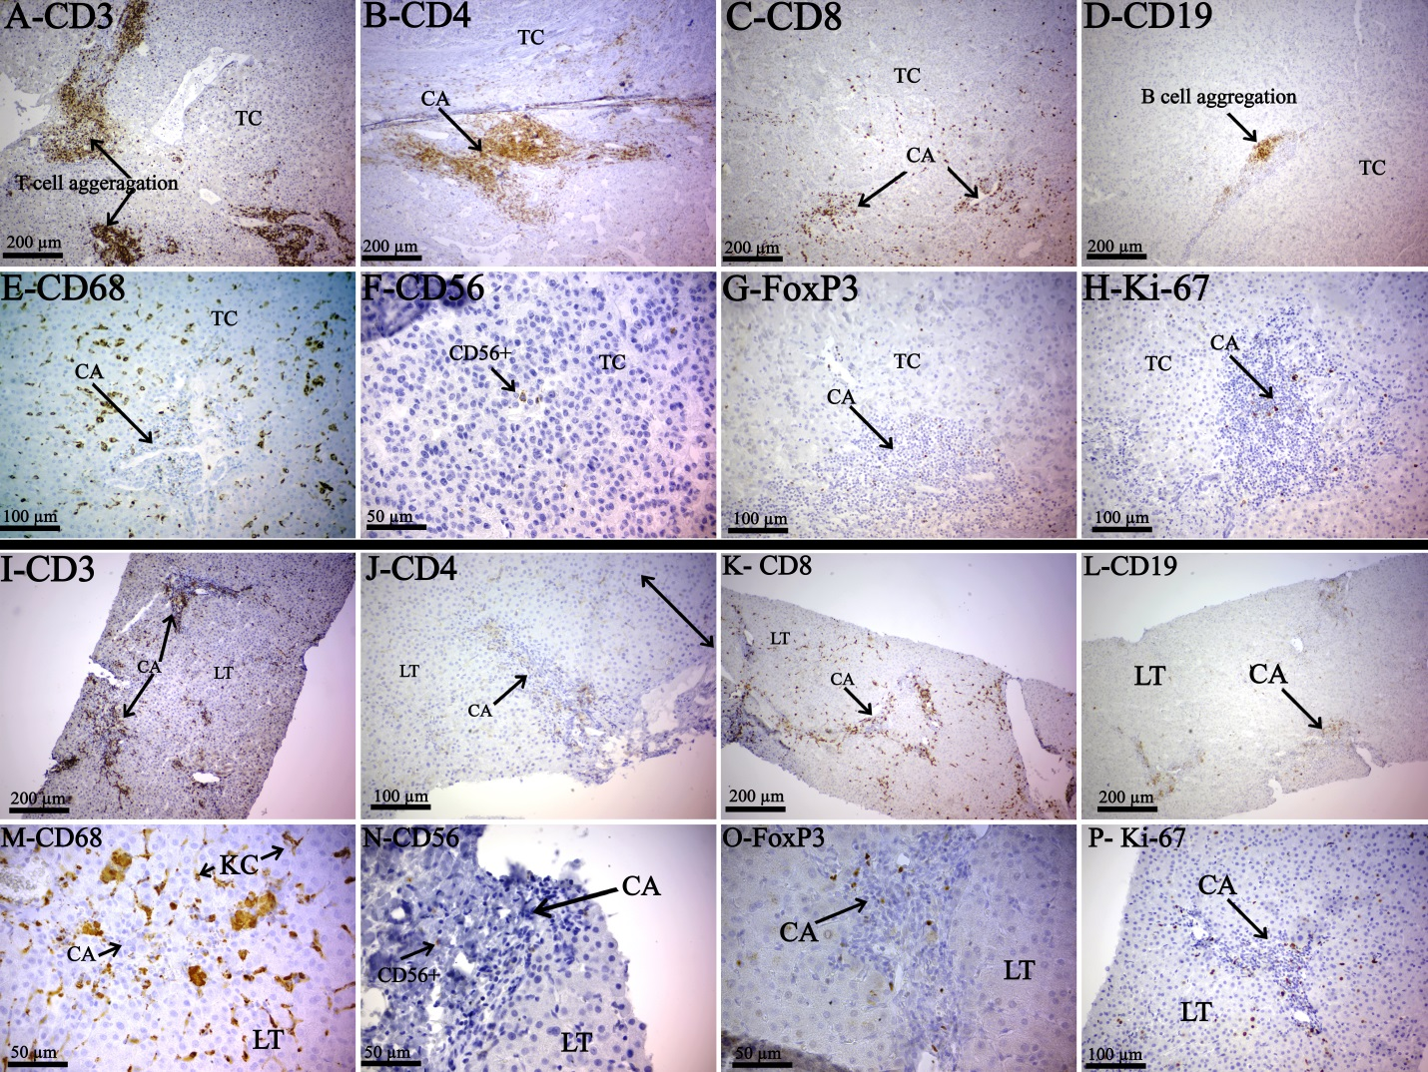
Figure 4: The studied cell-types in patients with hepatocellular carcinoma (A-H) and chronic hepatitis (I-P).. The overall inflammatory response is similar, yet there is no such arrangement seen in liver hydatid cysts. The micrographs correspond to the same individual
CD3 (A, I; 10X), CD4 (B; 10X, J; 20X), CD8 (C; 20X, K; 10X), CD19 (D,L; 10X), CD68 (E; 20X, M, 40X), CD56 (F, N; 40X), Foxp3 (G; 20X, O; 40X), Ki-67 (H, P; 20X).
TC, tumor cells; CA, immune cell aggregation; LT, liver tissue; KC, kupffer cells.

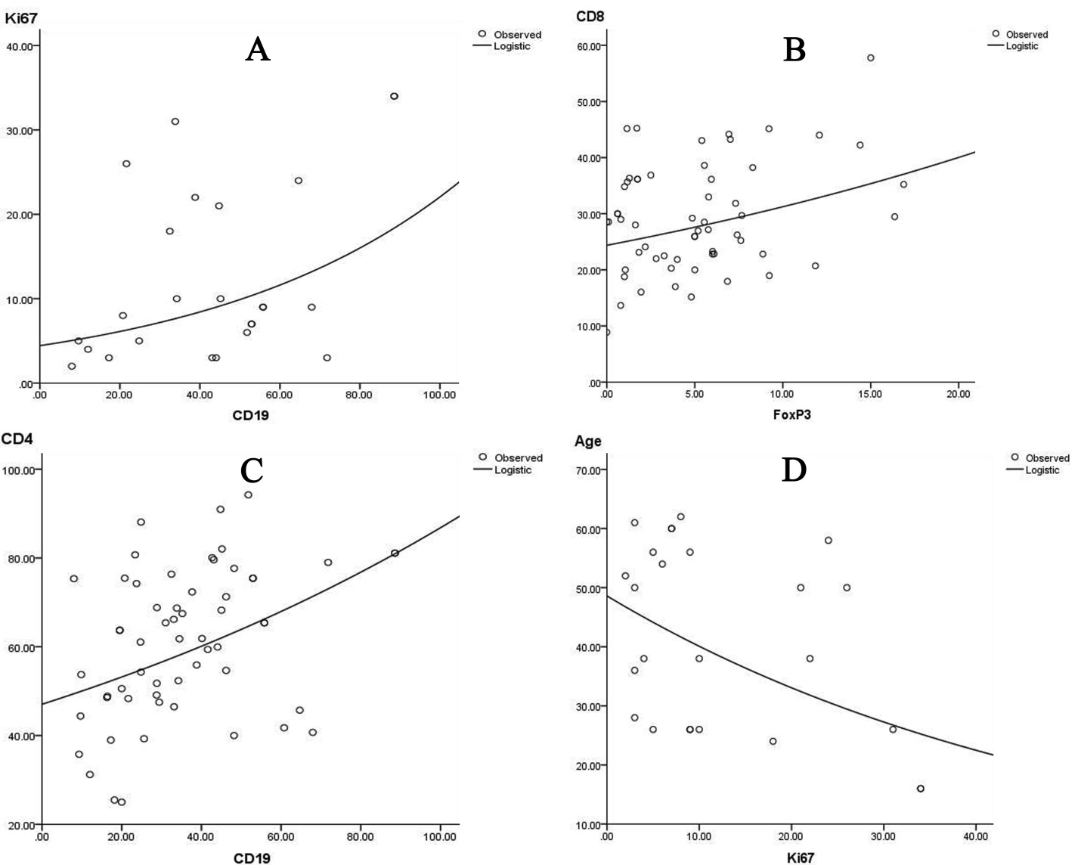
Figure 5: Correlation between quantity of CD19 and Ki-67 (A; R Square=0.183, P=0.032), CD8 and Foxp3 (B; R Square=0.81, P=0.045), CD4 and CD19 (C; R Square=0.153, P=0.005), and age and Ki-67 proliferating cells (D; R Square=0.165, P=0.044) showing significant relationship.

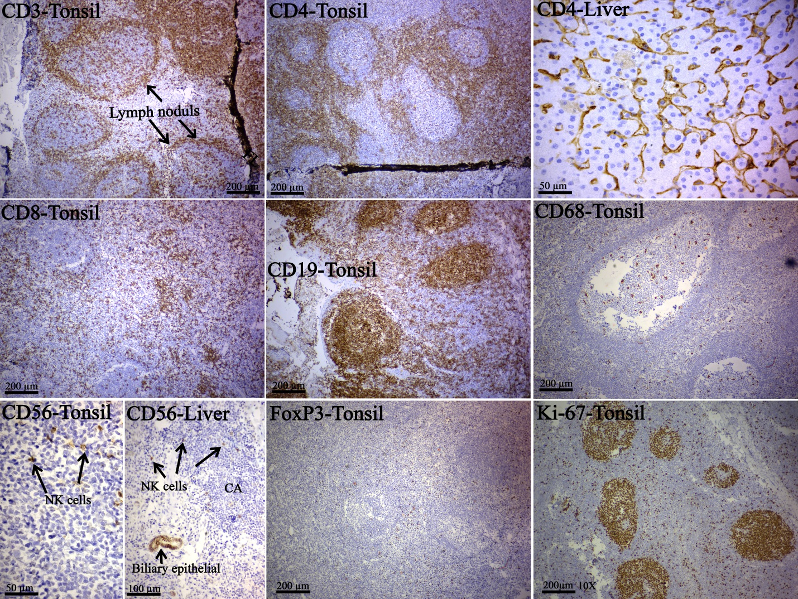
Figure 6: The positive controls used in the study for different markers.
CD3: human normal tonsil; as shown in the micrograph, in the interfollicular zone, T cells show a strong membranous staining.
CD4: human normal tonsil. Tonsil: the packed T-helper cells in the T-zone and the sporadic cells in the germinal center display a moderate to strong staining reaction. Normal liver: kupffer cells and endothelial cells of liver sinusoids express a weak to moderate staining reaction and the hepatocytes are negative.
CD8: human normal tonsil. In the interfollicular zone, T cells show a strong membranous staining.
CD19: human normal tonsil. In the mantle zone and the germinal center, the B cells show a moderate to strong membranous staining.
CD68: human normal tonsil. The macrophages, in the germinal center, show a moderate to strong cytoplasmic staining.
CD56: human normal tonsil. A weak to moderate membranous staining is shown by the NK cells. Liver: the biliary epithelial layer shows weak to moderate staining reaction and could be used as the internal control in liver hydatid cysts.
FoxP3: human normal tonsil. Regulatory T cells show a weak to moderate staining reaction.
Ki-67: human normal tonsil; tissue showing the expression of the MKI67 (Ki-67), a proliferation marker, in the nuclei of proliferating cells. These cells are mostly present in the germinal centers.

