Characterizing Bed Roughness on the Antarctic Continental Margin
Santiago Munevar Garcia, Lauren M. Simkins, Francesca A.M. Falcini and Leigh A. Stearns

Supplemental Material
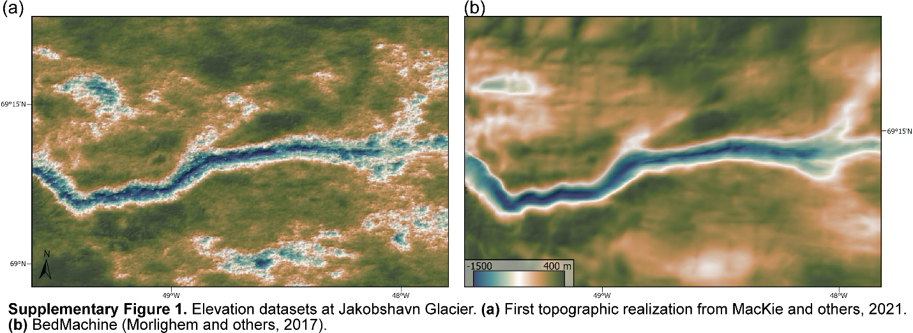

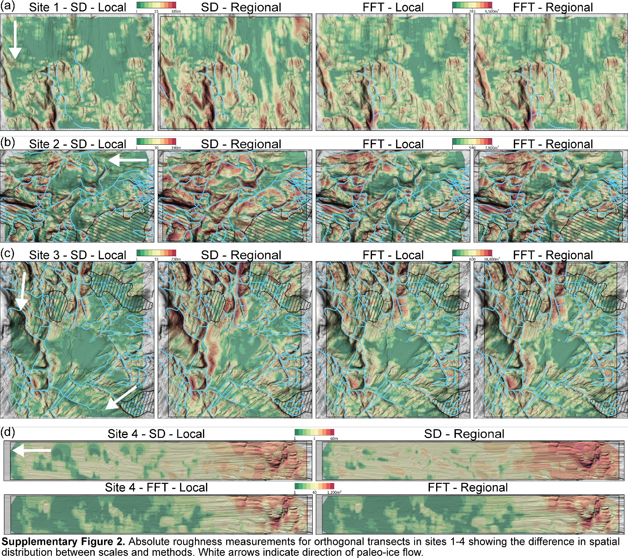

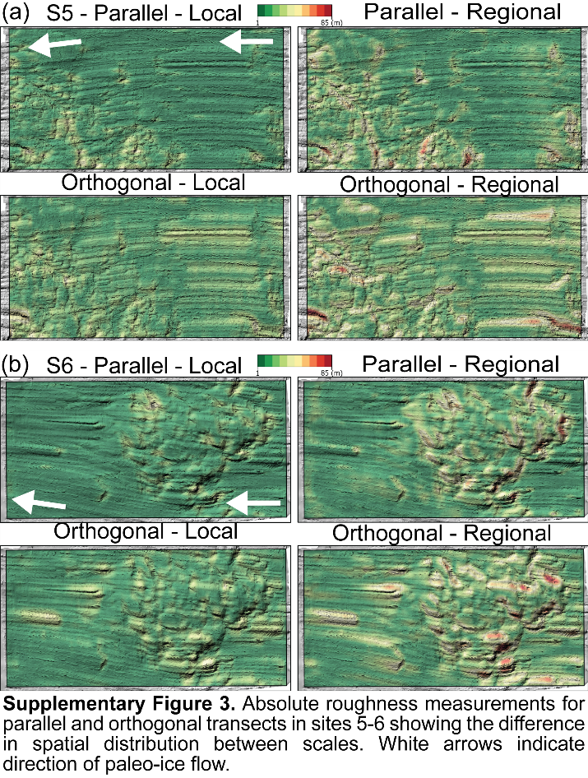
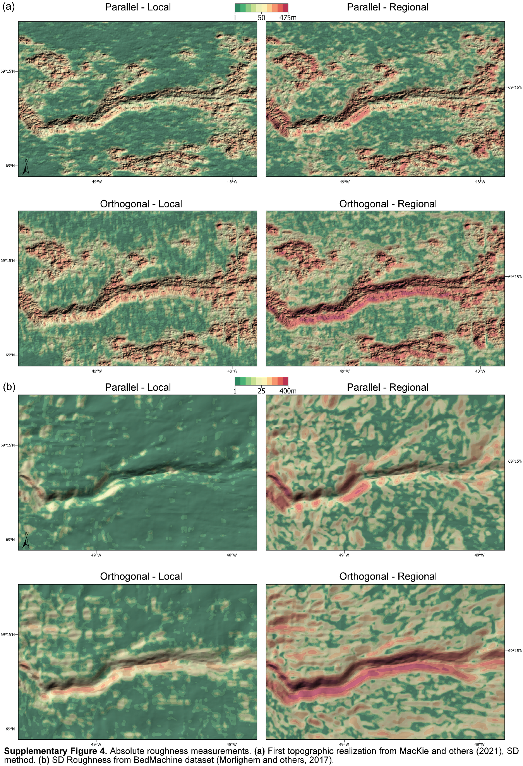
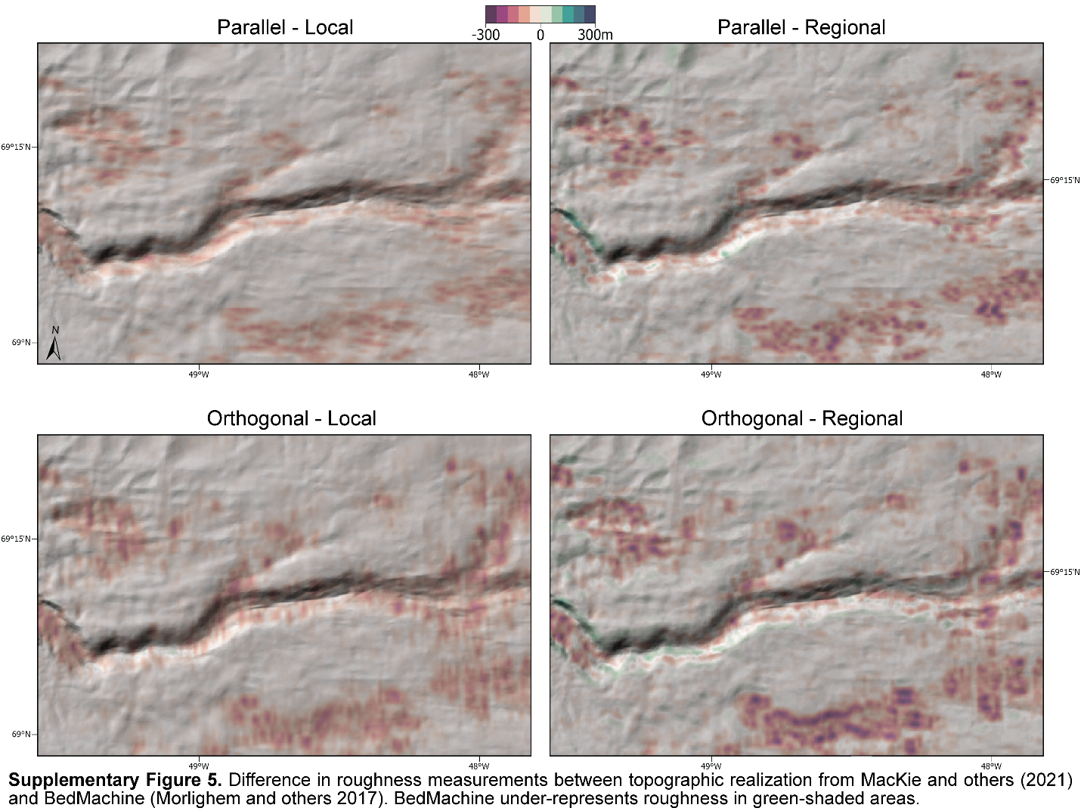
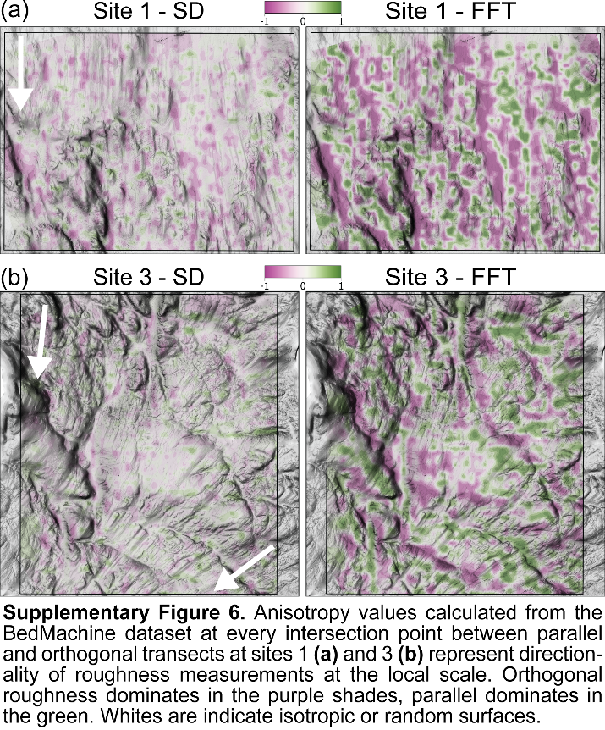
Supplementary Table 1. Channel vs Site Roughness
Site | Method | Scale | Orientation | Channel mean | Site mean | Difference
1 | SD | Local | Parallel | 9 m | 8 m | 1 m
 |  |  | Orthogonal | 18 m | 13 m | 5 m
1 | SD | Regional | Parallel | 14 m | 14 m | 0 m
 |  |  | Orthogonal | 27 m | 22 m | 5 m
2 | SD | Local | Parallel | 20 m | 18 m | 2 m
 |  |  | Orthogonal | 27 m | 25 m | 2 m
2 | SD | Regional | Parallel | 34 m | 33 m | 1 m
 |  |  | Orthogonal | 39 m | 40 m | -1 m
3 | SD | Local | Parallel | 22 m | 20 m | 2 m
 |  |  | Orthogonal | 25 m | 23 m | 2 m
3 | SD | Regional | Parallel | 34 m | 33 m | 1 m
 |  |  | Orthogonal | 39 m | 38 m | 1 m

Supplementary Table 2. Roughness from high-resolution bathymetry and BedMachine
Site | Method | Scale | Orientation | Range | Median | Range (BM) | Median (BM)
1 | SD | Local | Parallel | 61 m | 5 m | 120 m | 8 m
 |  |  | Orthogonal | 110 m | 10 m | 100 m | 10 m
1 | SD | Regional | Parallel | 120 m | 9 m | 140 m | 11 m
 |  |  | Orthogonal | 200 m | 15 m | 160 m | 14 m
1 | FFT | Local | Parallel | 3,700 m² | 15 m² | 16,100 m² | 51 m²
 |  |  | Orthogonal | 9,500 m² | 72 m² | 9,900 m² | 88 m²
1 | FFT | Regional | Parallel | 5,700 m² | 18 m² | 17,300 m² | 52 m²
 |  |  | Orthogonal | 13,300 m² | 80 m² | 12,000 m² | 85 m²
2 | SD | Local | Parallel | 87 m | 16 m | 150 m | 19 m
 |  |  | Orthogonal | 85 m | 22 m | 130 m | 21 m
2 | SD | Regional | Parallel | 190 m | 28 m | 190 m | 26 m
 |  |  | Orthogonal | 180 m | 34 m | 220 m | 29 m
2 | FFT | Local | Parallel | 5,810 m² | 170 m² | 22,000 m² | 290 m²
 |  |  | Orthogonal | 7,830 m² | 360 m² | 15,900 m² | 380 m²
2 | FFT | Regional | Parallel | 9,020 m² | 210 m² | 23,600 m² | 310 m²
 |  |  | Orthogonal | 8,520 m² | 420 m² | 18,300 m² | 400 m²
3 | SD | Local | Parallel | 74 m | 17 m | 160 m | 19 m
 |  |  | Orthogonal | 130 m | 19 m | 160 m | 21 m
3 | SD | Regional | Parallel | 160 m | 28 m | 180 m | 27 m
 |  |  | Orthogonal | 240 m | 29 m | 250 m | 28 m
3 | FFT | Local | Parallel | 5,600 m² | 220 m² | 28,200 m² | 320 m²
 |  |  | Orthogonal | 16,700 m² | 290 m² | 22,900 m² | 360 m²
3 | FFT | Regional | Parallel | 7,700 m² | 250 m² | 33,800 m² | 330 m²
 |  |  | Orthogonal | 23,900 m² | 290 m² | 25,900 m² | 360 m²
4 | SD | Local | Parallel | 35 m | 2 m | 39 m | 3 m
 |  |  | Orthogonal | 35 m | 3 m | 46 m | 3 m
4 | SD | Regional | Parallel | 70 m | 3 m | 55 m | 4 m
 |  |  | Orthogonal | 57 m | 4 m | 62 m | 4 m
4 | FFT | Local | Parallel | 1,200 m² | 2 m² | 1,600 m² | 7 m²
 |  |  | Orthogonal | 1,200 m² | 9 m² | 2,200 m² | 7 m²
4 | FFT | Regional | Parallel | 1,400 m² | 2 m² | 1,500 m² | 7 m²
 |  |  | Orthogonal | 1,500 m² | 9 m² | 2,300 m² | 7 m²

Suppl. Table 3. Misrepresentation of BedMachine-derived roughness
Site | Scale | Orientation | Mean (m) | Min (m) | Max (m) | Range (m)
1 | Local | Parallel | 4.4 | -27 | 79 | 106
 |  | Orthogonal | 1.4 | -47 | 72 | 119
1 | Regional | Parallel | 0.2 | -100 | 120 | 220
 |  | Orthogonal | -1.5 | -101 | 73 | 174
2 | Local | Parallel | 4.9 | -49 | 128 | 177
 |  | Orthogonal | 0.6 | -74 | 100 | 174
2 | Regional | Parallel | -0.3 | -82 | 115 | 197
 |  | Orthogonal | -4.1 | -103 | 142 | 245
3 | Local | Parallel | 4.7 | -54 | 119 | 173
 |  | Orthogonal | 3.2 | -67 | 105 | 172
3 | Regional | Parallel | 0.2 | -100 | 120 | 220
 |  | Orthogonal | -2.3 | -154 | 130 | 284
4 | Local | Parallel | 1.3 | -18 | 25 | 43
 |  | Orthogonal | -0.4 | -14 | 27 | 41
4 | Regional | Parallel | 0.3 | -34 | 38 | 73
 |  | Orthogonal | -0.9 | -23 | 30 | 53
5 | Local | Parallel | 5.4 | -10 | 42 | 52
 |  | Orthogonal | 11.4 | -7 | 55 | 62
5 | Regional | Parallel | 6.4 | -31 | 70 | 101
 |  | Orthogonal | 11.7 | -20 | 76 | 96
6 | Local | Parallel | 1.6 | -27 | 36 | 63
 |  | Orthogonal | 5.9 | -30 | 36 | 66
6 | Regional | Parallel | 3.2 | -52 | 67 | 119
 |  | Orthogonal | 5 | -87 | 64 | 150

