Supplement of ‘Constraints on Subglacial Melt Fluxes from Observations of Active Subglacial Lake Recharge’
Contents of this file:
Text S1 – S5
Fig. S1 – S16
Tables S1 – S8
Overview:
This document contains a detailed description of our time series approach (Text S1), a justification for what we consider recharge through subglacial melt production (Text S2), a calculation of how the predicted geothermal heat flux at Cook E2 was calculated (Text S3), a description of unobservable lake activity within our studied catchments (Text S4), and a breakdown of recharge within connected lake networks considering each lake individually (Text S5).
Figures in this document consist of elevation time series for every lake within each of our studied regions (Figs. S1 – S6), maps of predicted subglacial routing for each of our three approaches (Figs. S7 – S12), evidence of the impact of the hole filling approach on subglacial routing (Fig. S13), a bar graph of modelled recharge rates for each individual lake (Fig. S14), and a scatter plot of recharge rate against drainage volume and area (Figs. S15 – S16).
The tables in this document consist of documentation of volume change during lake activity (Table. S1), the exact modelled recharge rates for our studied lakes under each routing approach and melting map (Tables S2 – S5), observed recharge rates derived from altimetry (Table S6), and predicted connectivity within the Thwaites and SLC lake networks (Tables S7 – S8).
Text S1: Detailed Description of Time series Approach
We calculate the temporal height change for specific areas using an adapted version of the point-to-point method outlined in Gray and others, (2015) and Gray and others, (2019). An area is selected over which we want to determine the behaviour of surface elevation through time, and the corresponding data is segmented into separate periods at 45-day intervals. We incorporate a 45-day search radius in each time period to ensure redundancy and stable results. There is some overlap in the data between sequential periods, but this will not skew results as the average of the epochs within each search radius centralizes around the time intervals. We index our data at a 500-meter gridding, which has a computational speed advantage over the method stated in Gray and others, (2019) as it eliminates the need to compare the distance of all possible arrangements of data points. Within each grid cell, we estimate the temporal height change by comparing every height point in one time period against every other point in the later periods. With this, the mean height changes for each cell and the time difference are available. For each possible arrangement of periods, we remove outliers iteratively by omitting cells with an average height change greater than three standard deviations away from the average of all the cells until no further outliers are detected. Our final elevation difference between two pairwise unique periods (e.g. period 1 and period 5) is calculated by taking the mean of elevation differences in each cell. We also collect the standard deviations for future statistical analysis. Additional time series is created using the multi-period approach outlined in Gray and others, (2019). Different points will be used to create the A- B and C height change when comparing the average height change from one period (A) to any two other periods (B and C). For example, the height difference A – B can be calculated as the height difference from A – C minus the height difference from B – C, assuming B and C are consecutive. This is repeated for all possible arrangements of periods. If there are N 45-day periods, then there are N-1 estimates of height change from the first period to any subsequent period. One of these estimates is the direct calculation between the two periods; the other N-2 are calculated indirectly using the other periods. This approach allows us to check for statistical error and consistency. When calculating the final time series, we take the weighted average of all possible time series. The direct estimate is given a weight of 1, whilst indirect estimates are given a weight of $1/{\sqrt{2}}$ . The statistical error for any time-dependent elevation in our final time series is determined by taking the mean of the standard deviations and dividing it by the square root of the number of samples. We convert our elevation change time series to volume change time series by integrating our temporal change against the total area of our lake masks. The statistical error from our time series is carried over into the volume change estimates, giving us a statistical bound on volume change based on the elevation change observed at each lake.
Text S2: Justification for why observed behaviour amounts to subglacial recharge
We identify subglacial lakes exhibiting recharge activity by examining distinct patterns in their elevation change profiles. The presence of one of two characteristic patterns serves as an indication of recharge activity. The first pattern is characterised by a steady and consistent increase in volume after a drainage event. The second pattern involves the identification of a localised region displaying a rate of elevation change that exceeds the surrounding background. It is crucial to ensure that any volume gain observed in these lakes is not attributed to an external source, such as the drainage of an upstream feature. The justification for the inclusion of each lake is as follows:
Thwaites:
Thw₇₀: Deducting the off-lake signal from the on-lake signal results in a clear period of elevation gain, which follows directly after a drainage event in 2013. Recharge activity is present at this lake.
Thw₁₂₄: The on-lake signal has a distinct signal from 2013 – 2017 compared to the off-lake signal. Furthermore, deducting the two signals from each other results in an evident period of elevation gain following a drainage event in 2013. Recharge activity is present at this lake.
Thw₁₄₂: Deducting the off-lake signal from the on-lake signal results in a clear period of elevation gain, which follows directly after a drainage event in 2013. Recharge activity is present at this lake.
Thw₁₇₀: Deducting the off-lake signal from the on-lake signal results in a clear period of elevation gain, which follows directly after a drainage event in 2013. Recharge activity is present at this lake.
Mercer and Whillians
L78: The on-lake signal closely matches the behaviour of the off-lake signal, despite a couple of spikes. This may signify some limited lake activity. However, the ‘inter-spikes’ periods do not display any signal of steady elevation gain – which is a clear recharge signal. Therefore, this lake is unlikely to display any sign of recharge activity.
SLM: There is an apparent period of elevation gain in the on-lake signal from 2015 until 2018. This behaviour has a distinct magnitude difference compared to the off-lake signal. Furthermore, this elevation gain follows directly after a drainage event between 2012 and 2015. By looking at the behaviour of the lakes upstream, it is unlikely that this elevation gain is caused by water transfer. Therefore, this period of elevation gain has likely captured a period of subglacial recharge.
SLE: After 2014, the on-lake signal grew in magnitude compared to the off-lake signal. Whilst this alone cannot justify subglacial recharge, the IceSat-1 on-lake signal shows that the lake terminated a drainage event in 2006 before regaining volume at a nearly constant rate (Siegfried & Fricker, 2018). This implies that volume gain at this lake is likely collecting water lost during this drainage event. Therefore, we infer the volume gain observed to be caused by subglacial recharge.
L12: No specific lake activity is observed – therefore, no recharge activity is observed.
L10: No specific lake activity is observed – therefore, no recharge activity is observed.
SLW: The on-lake and off-lake signals grow at the same magnitude. This implies there is no observable lake activity and hence no recharge activity.
SLC: There is a precise period of elevation gain in the on-lake signal from 2014 until 2020, which is distinct from the off-lake signal. This period of elevation gain comes directly after a drainage event terminated in 2014. The on-lake elevation gain signal is indicative of subglacial recharge.
USLC: The lake appears to undertake a minor drainage event from 2011 – 2013. Following this event on-lake signal appears to gain elevation. What is notable about this elevation gain is that the on-lake signal has a slightly larger magnitude compared to the off-lake signal. The magnitude of this increase appears primarily consistent, except for a short spike in 2018. This spike could be attributed to further upstream drainage at a lake, but the coverage of the SARIn mode of CryoSat-2 does not allow us to explore the upstream lakes. However, as this period of on-lake elevation gain is present after a minor drainage event and the magnitude of the increase is consistent, we mainly attribute the elevation gain to recharge through subglacial melt production.
Whillians 6: There appears to be a period of lake activity in the on-lake signal, with drainage events in 2010, between 2014 and 2016, and between 2019 and 2020. However, in between the events, the gain in elevation is not constant. We assume that a lake is fed with a continuously constant supply of subglacial water from melt production. Under such an assumption, supply to a lake and corresponding elevation gain would also be constant. We instead observe rapid spikes in the inter-drainage period. We theorize that such spikes could be caused by the transfer of water into the lake from an upstream source which we cannot observe as it might exist outside of the CryoSat-2 SARIn mode. Whilst this lake has a degree of recharge; it is also intermixed with what might be an outside source. Therefore, any rate of recharge derived from this lake is not representative of subglacial melt production.
Slessor
Slessor 1: No specific lake activity is observed – therefore, no recharge activity is observed.
Slessor 2: There is a clear sign of elevation gain in the on-lake signal, distinct from the behaviour of the off-lake signal from 2015 until 2020. This period of elevation gain directly follows a drainage event between 2014 and 2015. Recharge activity is very clearly present at this lake.
Slessor 3: The signal of lake activity is very noisy due to the lack of continuous temporal coverage. No significant or reliable lake activity is observed.
Lambert
Lambert 1: No specific lake activity is observed – therefore, no recharge activity is observed.
Lam₈₀: The on-lake signal appears to gain elevation at a constant rate which has a distinctively different magnitude to the off-lake signal. This elevation gain is localized (See Fig. 6a) and remains constant over the study period. As this lake was just discovered, it is impossible to know if this elevation gain has followed from a drainage event as we only have observations from 2010 until 2020. Given the constant rate of elevation gain within a strictly localized region, we assume that this behaviour is caused by subglacial recharge.
Lam₁₁₀: There is a sudden increase in the on-lake signal between 2015 and 2017, which is distinctive from the off-lake signal. On either side of this period of elevation gain, the lake appears to be losing elevation at a steady rate. Given that the increase in elevation is constant, we assume that this increase is caused by subglacial recharge. It is worth noting that the behaviour at this lake is highly uncertain, so we provide two explanations for the gain in elevation. The first, and the theory we hold onto, is that the lake experienced a minor drainage event between 2011 and 2015 before regaining its lost elevation. A change in the system’s hydrology may have allowed the lake to start regaining its volume instead of discharging downstream. An alternative explanation might be that the discharge of an undiscovered upstream source outside the CryoSat-2 SARIn mode causes water transfer.
David
David 1: No specific lake activity is observed – therefore, no recharge activity is observed.
David s1: There is a clear on-lake signal of elevation gain, which is distinctive to the off-lake signal. This signal of elevation gain is localized to the boundaries of David s1 (see Fig. 7a). The period of elevation gain does not appear constant; instead, there seems to be a seasonal component to the elevation gain. The cause of this component is unclear, but it could be attributed to patchy CryoSat-2 coverage. However, when looking at this elevation gain, the trend in elevation gain is constant. Therefore, we attribute this increase due to subglacial recharge.
Cook
Cook E1: No specific lake activity is observed – therefore, no recharge activity is observed.
Cook E2: The on-lake signal appears to be increasing compared to the off-lake signal. This increase follows a drainage event which was detected in 2009 (McMillan and others, 2013). Therefore, we attributed this increase in elevation to recharge through subglacial melt production.

Text S3: Calculating geothermal heat flux at Cook E2 using observed recharge rates.
Recharge rate at Cook E2 (R): 0.056 km³ yr⁻¹ = 5.6 x 10⁷ m³ yr⁻¹
Size of the Cook E2 drainage basin (A): 1.037 x 10⁹ m²
Average melting rate (m_{r}) over the drainage basin: R/A = 0.054 m yr⁻¹
For reference, the average melting rate over the drainage basin in the Martos melt map is 0.0079 m yr⁻¹.
By equation (1),
$$G_{m}= m_{r}-F_{m}+ V_{m}$$
Where G_{m} is the proportion of melt caused by geothermal heat production, F_{m} is the proportion of melt caused by friction, and V_{m} is the proportion of melt caused by vertical dispersion.
The average frictional melt component (F_{m}) over the Cook E2 basin is 1.49 x 10⁻⁵ m yr⁻¹
The average vertical dispersion melt component (V_{m}) over the Cook E2 basin is 1.77 x 10⁻⁴ m yr⁻¹
Therefore the average proportion of melt caused by geothermal heat production (G_{m}) is 0.054 m yr⁻¹. Effectively, the impact of frictional heating and vertical dispersion in this region is negligible, so the melting rate is forced primarily through geothermal heat production.
The average geothermal heat flux (G) can be found with
$$G= G_{m}ρ_{i}L_{i}$$
Where $ρ_{i}$ represents the density of ice (916.7 km m⁻³) and L_{i} represents the latent heat of fusion (3.34 x 10^5 J m⁻³). Under this calculation, the geothermal heat flux is 1.66 x 10⁷ J yr⁻¹ m⁻², equivalent to 0.526 W m⁻² or 526 mW m⁻². For reference, heat flux in the Cook E2 drainage basin under the Martos melt map is approximately 40 mW m⁻².
Text S4: Unobservable Active Subglacial Lakes in Our Studied Catchments
The Slessor, David, and Whillians catchments have additional subglacial lakes located further inland and outside the SARIn collection mode. The Slessor region has four additional subglacial lakes, with Slessor 4 and Slessor 5 all existing on the same drainage pathway as Slessor 2 (Smith and others, 2009). If we could observe these two lakes, and if they display signs of recharge, we could perform the same analysis as for the Thwaites and SLC networks. This might produce total recharge rates closer to modelled values, giving us a stricter bound on melt production within the region. The David region has four other subglacial lakes located further upstream. David S2 exists on the same pathway as David S1, but the modelled routing in this region is relatively unconstrained, with the stochastic D8 approach suggesting many potential flow paths (Fig. 8a). As such, there is a high degree of ambiguity regarding the hydrological connection between these two lakes. David S3 – S5 all exist on branching flow paths, so they are unlikely to be connected. The Whillians region has two different subglacial lakes, all located on separate flow paths and unlikely to interact with either SLE or the SLC network.
Figures S1 – S6: Time series for each region
Fig. S1: Time series for Thwaites
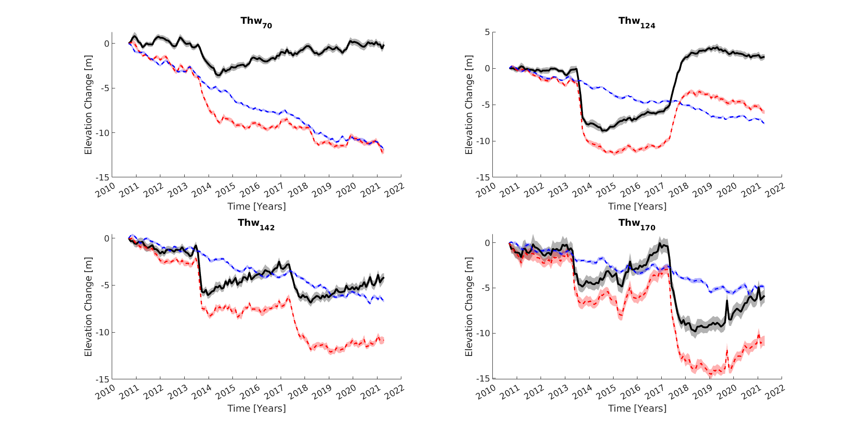
Fig. S1. Elevation time series for lakes within the Thwaites region. The on-lake time series is represented by the red dashed line, while the off-lake time series is depicted by the blue dashed line. The black line corresponds to the on-lake signal with the background thinning component removed
Fig. S2: Time series for Mercer and Whillans
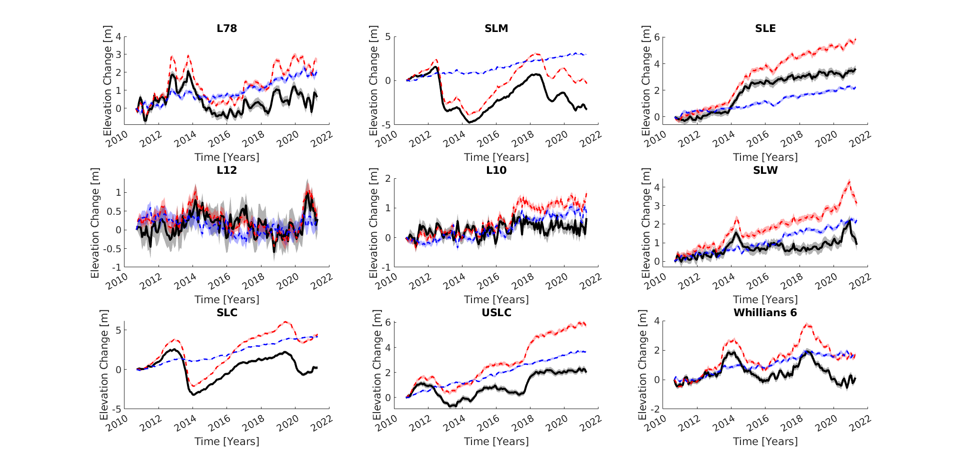
Fig. S2. Elevation time series for lakes within the Mercer and Whillans region. The on-lake time series is represented by the red dashed line, while the off-lake time series is depicted by the blue dashed line. The black line corresponds to the on-lake signal with the background thinning component removed
Fig. S3: Time series for Slessor
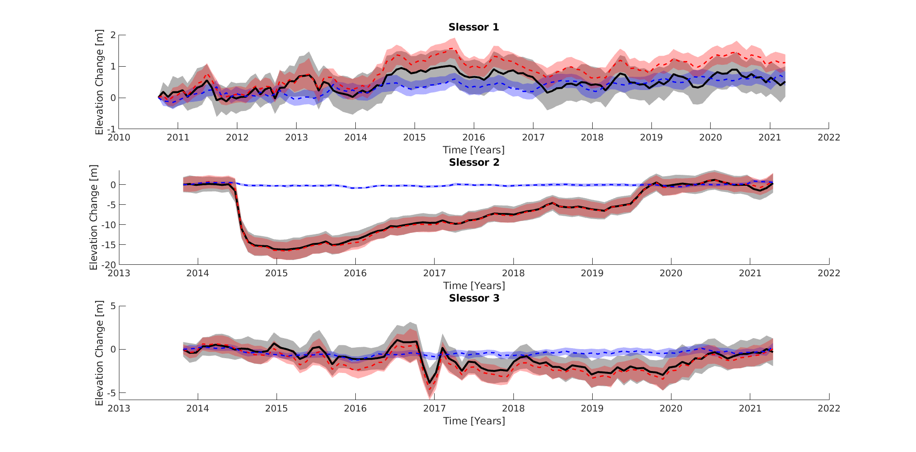
Fig. S3. Elevation time series for lakes within the Slessor region. The on-lake time series is represented by the red dashed line, while the off-lake time series is depicted by the blue dashed line. The black line corresponds to the on-lake signal with the background thinning component removed
Fig. S4: Time series for Lambert
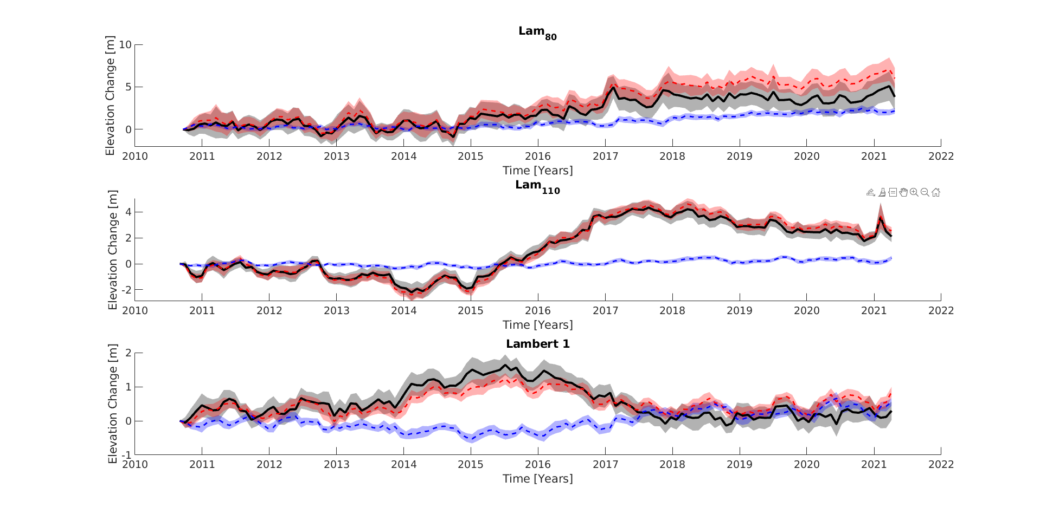
Fig. S4. Elevation time series for lakes within the Lambert region. The on-lake time series is represented by the red dashed line, while the off-lake time series is depicted by the blue dashed line. The black line corresponds to the on-lake signal with the background thinning component removed
Fig. S5: Time series for David
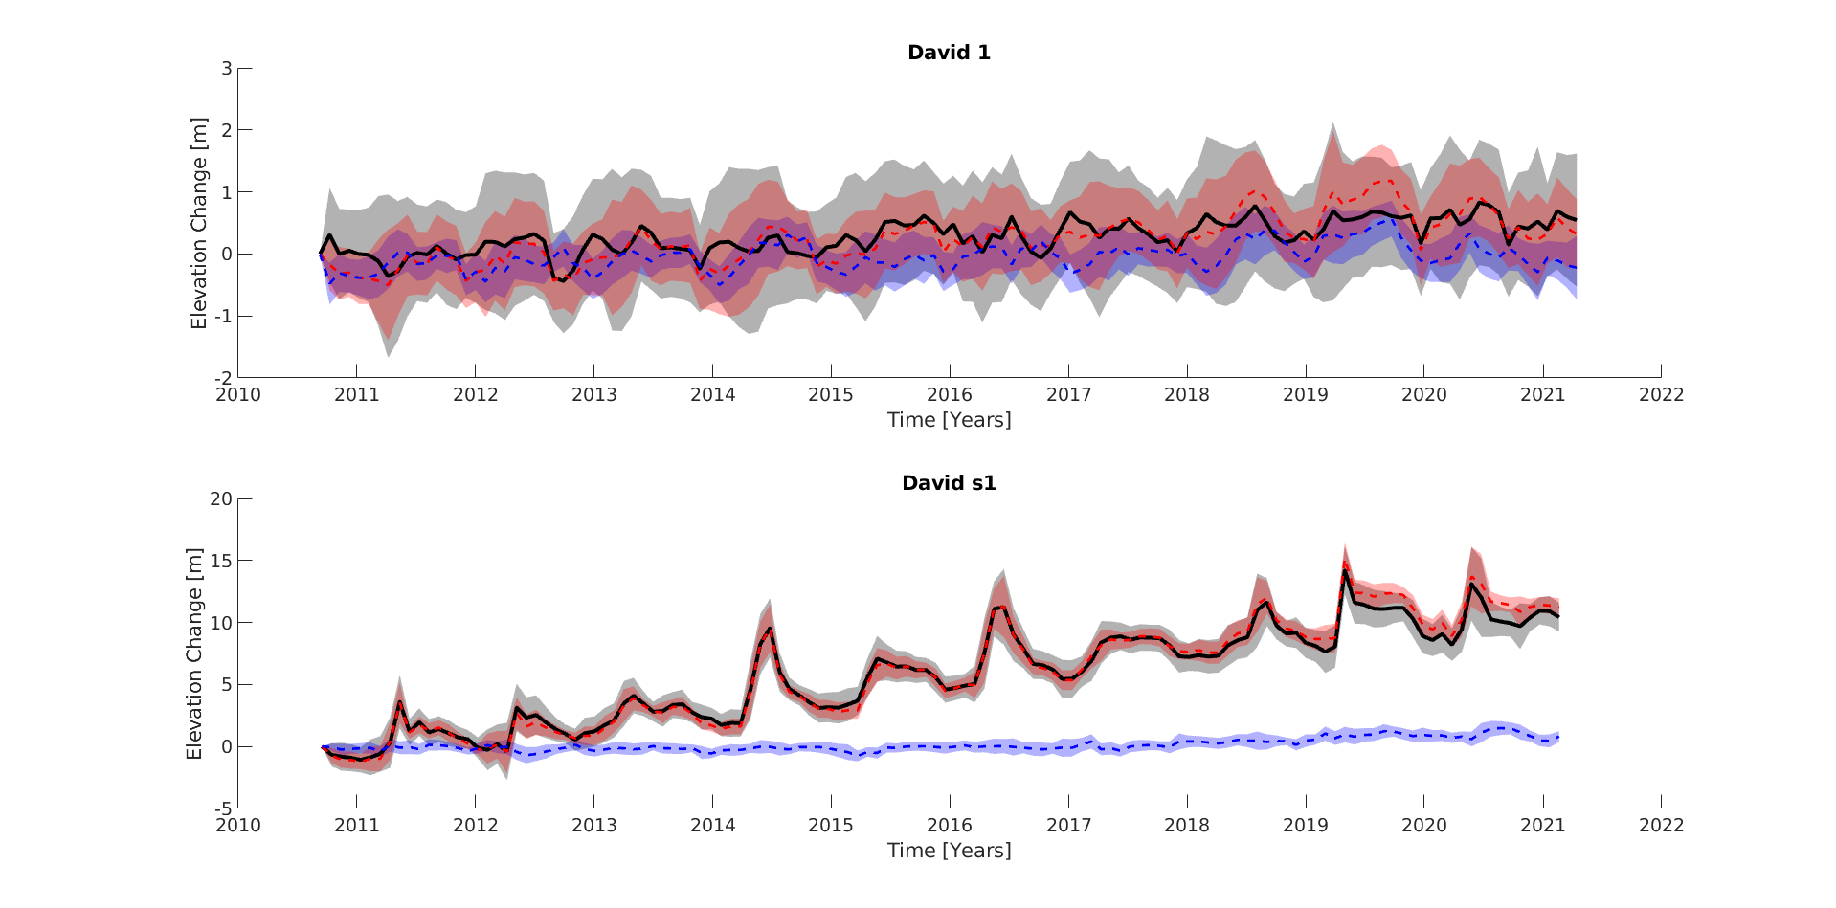
Fig. S5. Elevation time series for lakes within the David region. The on-lake time series is represented by the red dashed line, while the off-lake time series is depicted by the blue dashed line. The black line corresponds to the on-lake signal with the background thinning component removed
Fig. S6: Time series for Cook
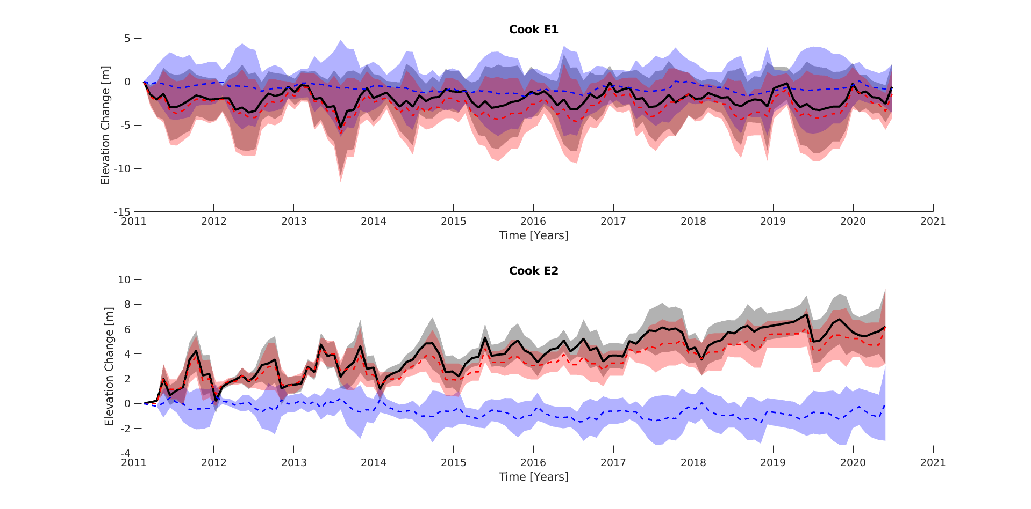
Fig. S6. Elevation time series for lakes within the Cook region. The on-lake time series is represented by the red dashed line, while the off-lake time series is depicted by the blue dashed line. The black line corresponds to the on-lake signal with the background thinning component removed
Figures S7 – S12: Flux maps for each region
Fig. S7: Flux map for Thwaites
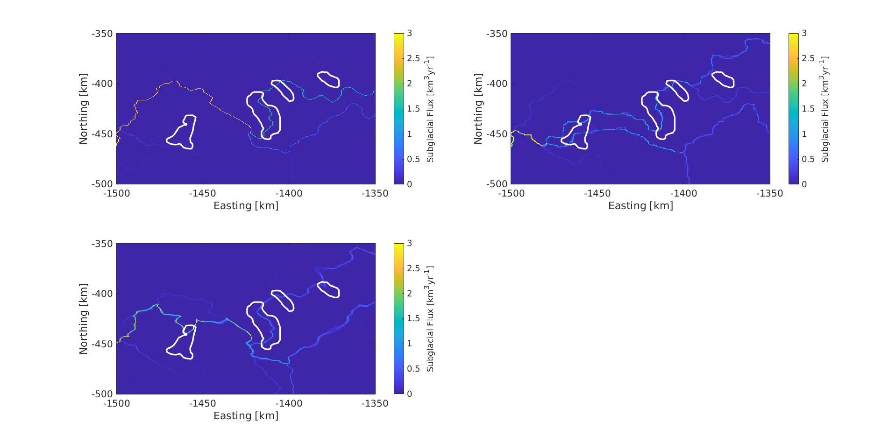
Fig. S7. Subglacial flux maps for lakes within the Thwaites lake region. a) TopoToolBox flux, b) Le Brocq Flux, and c) Mauro flux
Fig. S8: Flux map for Mercer and Whillans
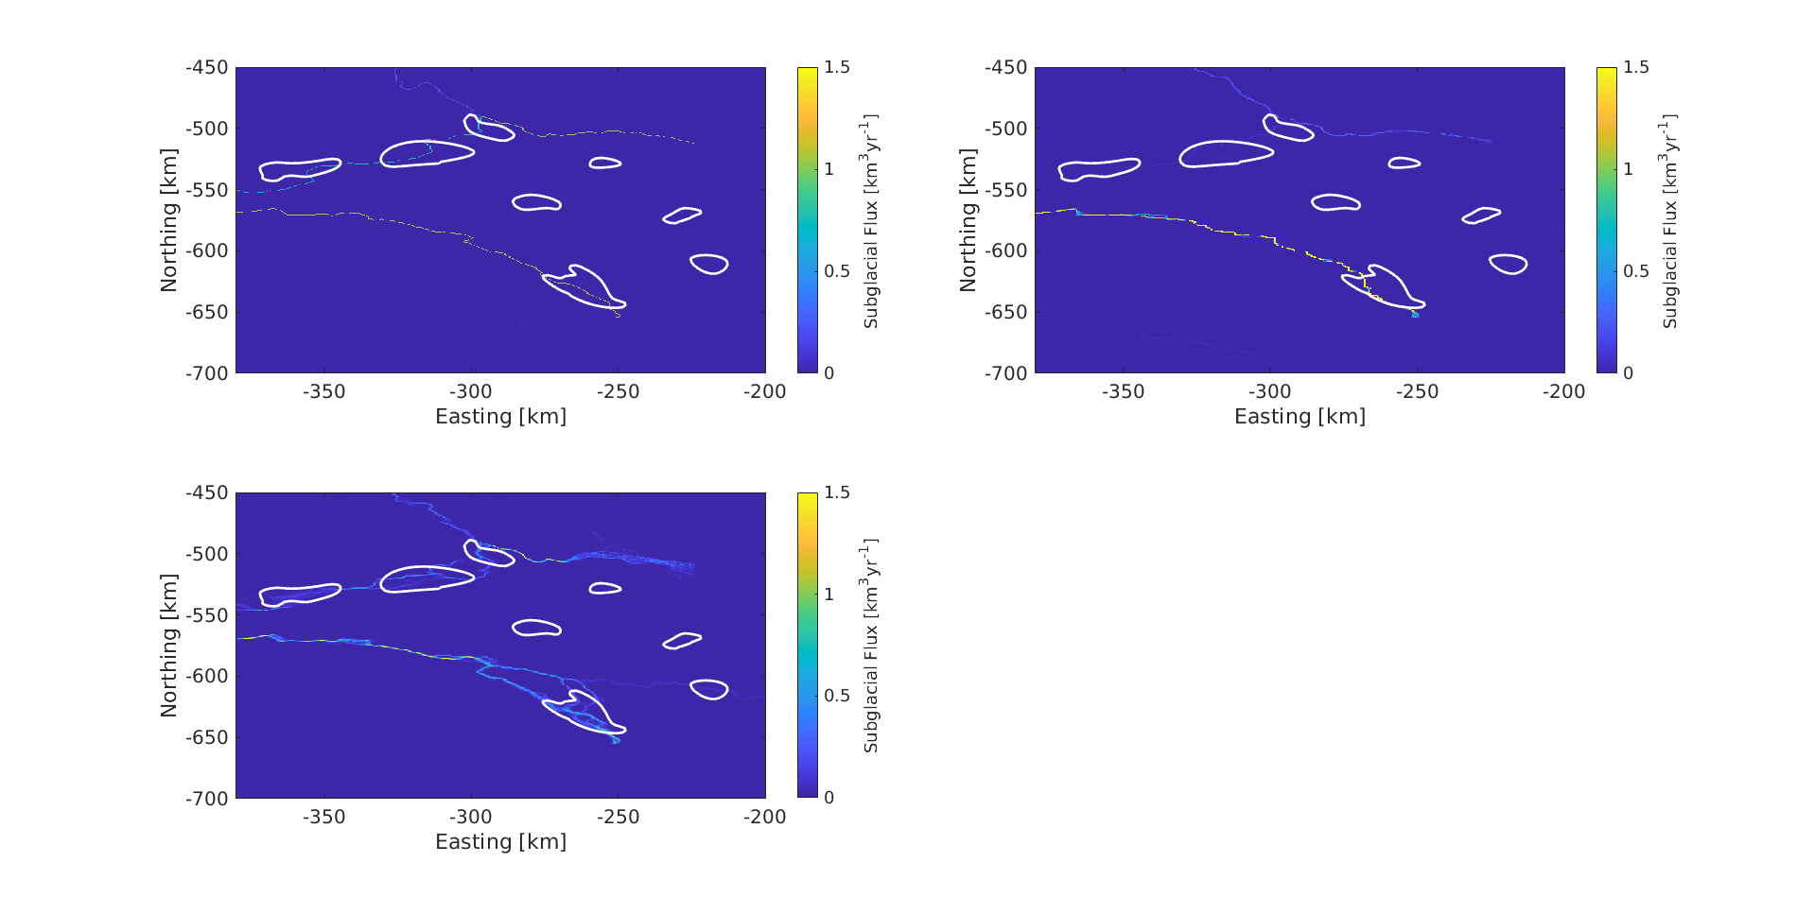
Fig. S8. Subglacial flux maps for lakes within the Mercer and Whillans lake region. a) TopoToolBox flux, b) Le Brocq Flux, and c) Mauro flux
Fig. S9: Flux map for Slessor
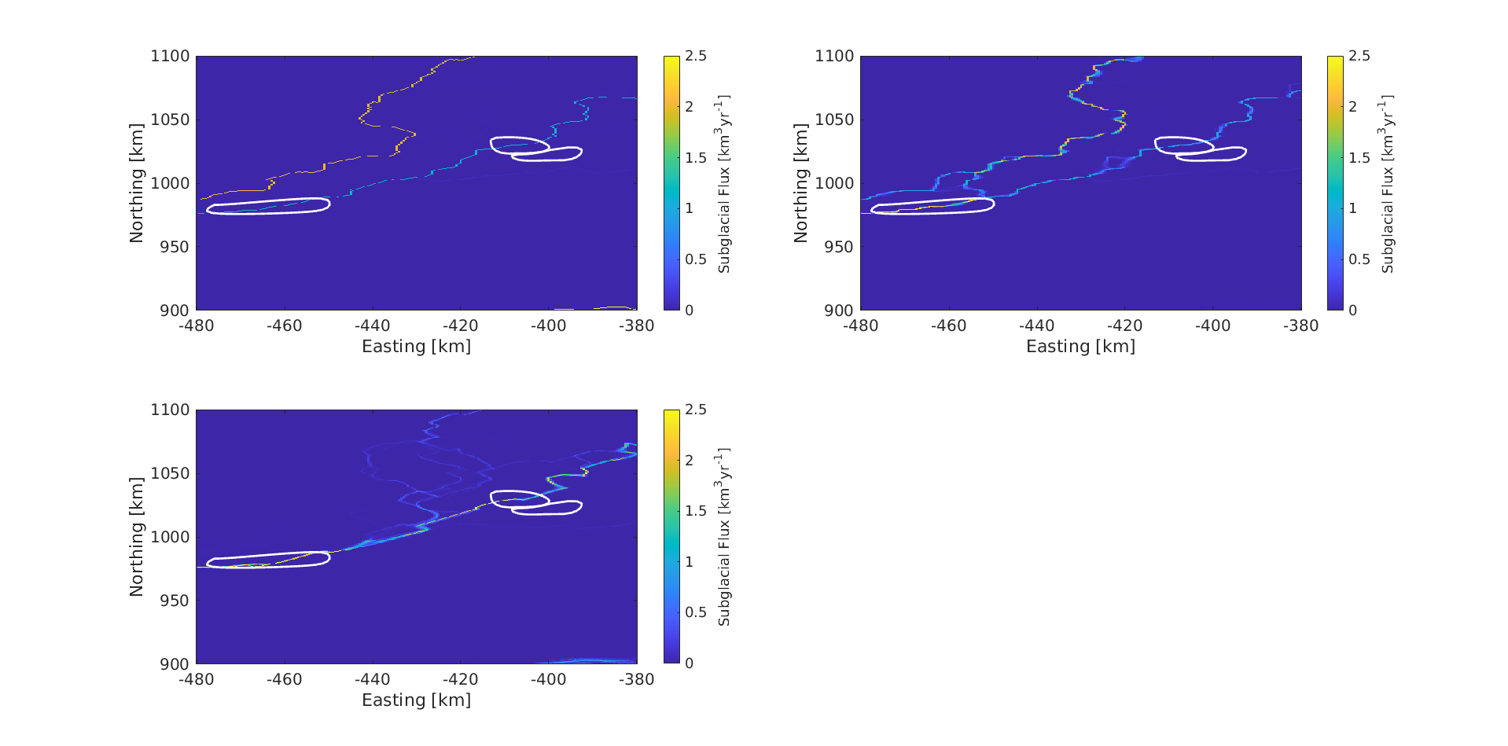
Fig. S9. Subglacial flux maps for lakes within the Slessor lake region. a) TopoToolBox flux, b) Le Brocq Flux, and c) Mauro flux
Fig. S10: Flux map for Lambert
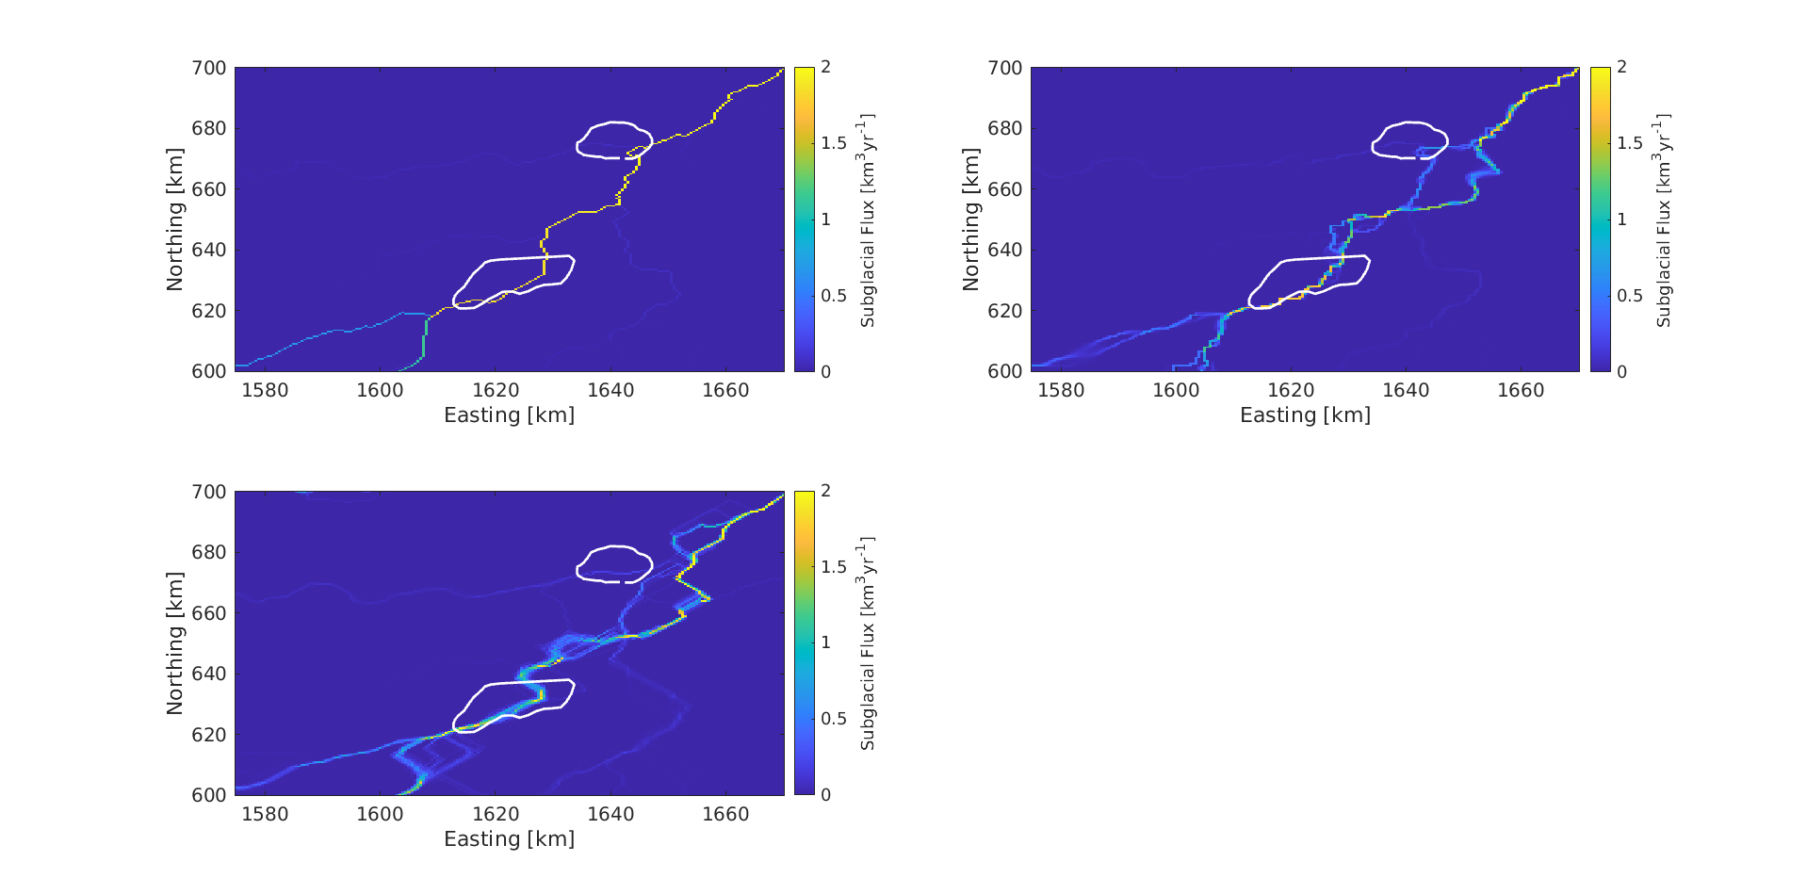
Fig. S10. Subglacial flux maps for lakes within the Lambert lake region. a) TopoToolBox flux, b) Le Brocq Flux, and c) Mauro flux
Fig. S11: Flux map for David
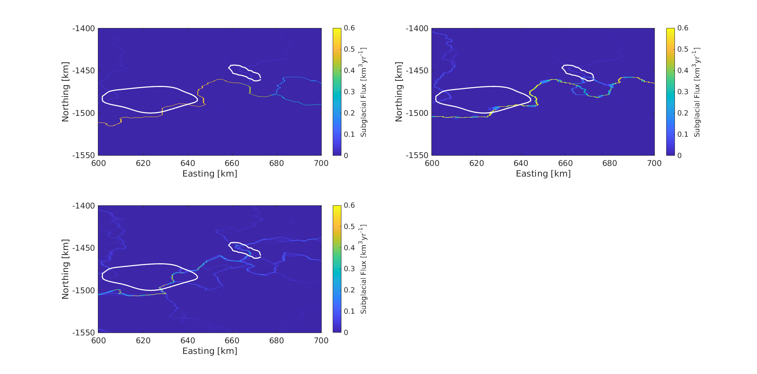
Fig. S11. Subglacial flux maps for lakes within the David lake region. a) TopoToolBox flux, b) Le Brocq Flux, and c) Mauro flux
Fig. S12: Flux map for Cook
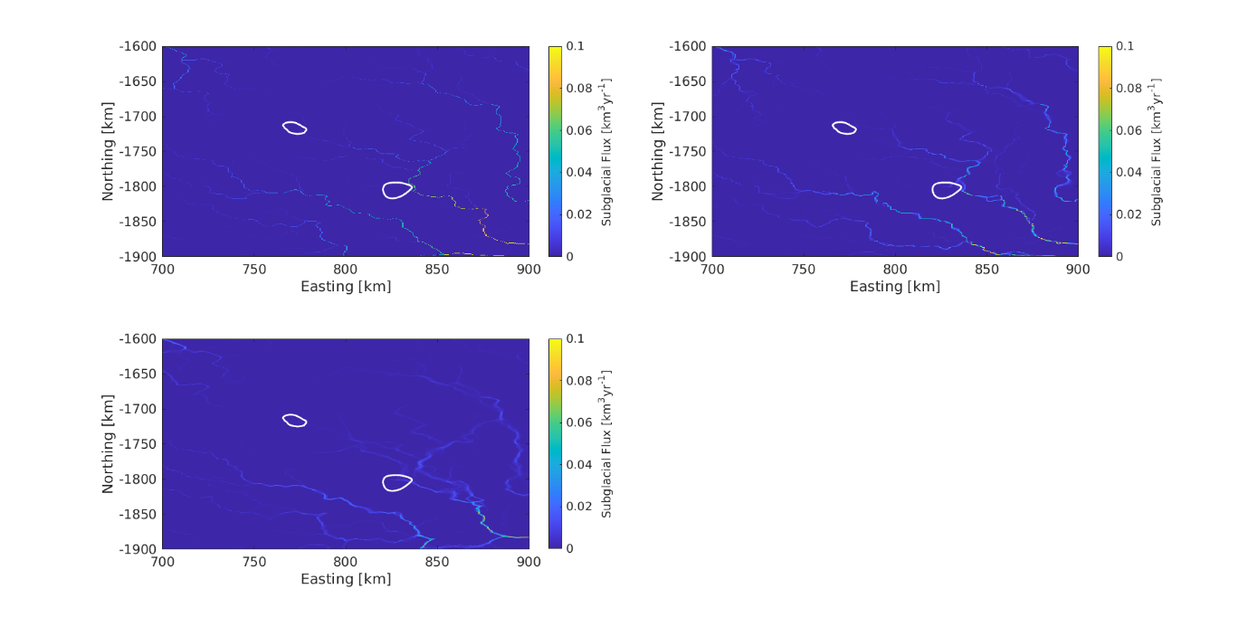
Fig. S12. Subglacial flux maps for lakes within the Cook lake region. a) TopoToolBox flux, b) Le Brocq Flux, and c) Mauro flux
Fig. S13: Effect of the hole-filling approach of subglacial routing
Fig. S13. Maps displaying the difference in hydro potential and change in routing over the Thwaites glacier depending on which hole-filling approach is implemented. a) Difference between the TopoToolBox and Le Brocq hydropotential maps following the application of their respective hole-filling approaches. b) The Le Brocq routing over Thwaites forced using a hydropotential map with holes filled using the Le Brocq approach. c) The TopoToolBox routing over Thwaites forced using a hydropotential map with holes filled using the TopoToolBox approach. d) The TopoToolBox routing over Thwaites forced using a hydropotential map with holes filled using the Le Brocq approach.
Fig. S14. Bar graphs of modelled and observed recharge rates for individual active lakes

Table S1: Volume Changes during Drainage Events
Subglacial Lake | Start Date | End Date | Volume Change (km³)
Thw₇₀ | April 2013 | May 2014 | -0.90
Thw₁₂₄ | April 2013 | May 2014 | -3.83
Thw₁₂₄ | March 2017 | March 2018 | +3.20
Thw₁₄₂ | April 2013 | May 2014 | -0.55
Thw₁₄₂ | March 2017 | March 2018 | -0.81
Thw₁₇₀ | April 2013 | May 2014 | -0.45
Thw₁₇₀ | March 2017 | March 2018 | -1.91
USLC | July 2010 | September 2013 | -0.71
SLM | May 2012 | April 2014 | -1.08
SLM | May 2018 | January 2019 | -0.49
SLM | December 2019 | August 2020 | -0.33
SLC | November 2012 | January 2014 | -1.38
SLMC | June 2019 | July 2020 | -0.66
SLE | October 2013 | March 2015 | +0.45
Slessor 2 | April 2014 | October 2014 | -1.91
Lam₁₁₀ | September 2010 | December 2014 | -0.38
Lam₁₁₀ | March 2017 | February 2021 (ongoing) | -0.45

Table S2: Recharge Rates for Subglacial lakes across Antarctica (Maule)
Subglacial Lake | D8 Recharge Rate (km³yr⁻¹) | FD8 Recharge Rate (km³yr⁻¹) | Stochastic D8 Recharge Rate  (km³yr⁻¹)
Thw₇₀ | 0.2080 | 3.4000 | 3.3830
Thw₁₂₄ | 2.1660 | 1.2600 | 1.3950
Thw₁₄₂ | 2.1403 | 1.2547 | 1.0793
Thw₁₇₀ | 0.0910 | 1.1126 | 0.7591
Cook E2 | 0.0083 | 0.0073 | 0.0078
David s1 | 0.1128 | 0.3274 | 0.3748
Lam₈₀ | 5.1900 | 0.1426 | 0.2314
Lam₁₁₀ | 4.9170 | 1.0881 | 4.2650
Slessor 2 | 2.0667 | 0.7435 | 3.5050
SLM | 1.3033 | 0.1055 | 1.9030
SLE | 1.9956 | 0.9842 | 1.9210
SLC | 1.2947 | 0.0922 | 1.2570
USLC | 1.2720 | 0.0647 | 1.2310

Table S3: Recharge Rates for Subglacial lakes across Antarctica (Martos)
Subglacial Lake | D8 Recharge Rate (km³yr⁻¹) | FD8 Recharge Rate (km³yr⁻¹) | Stochastic D8 Recharge Rate  (km³yr⁻¹)
Thw₇₀ | 0.2110 | 2.6700 | 2.5940
Thw₁₂₄ | 1.7590 | 0.9654 | 0.9422
Thw₁₄₂ | 1.7405 | 0.9104 | 0.7704
Thw₁₇₀ | 0.0790 | 0.7772 | 0.5515
Cook E2 | 0.0053 | 0.0047 | 0.0052
David s1 | 0.0450 | 0.1777 | 0.1981
Lam₈₀ | 2.0790 | 0.1075 | 0.1615
Lam₁₁₀ | 1.8469 | 0.7291 | 1.6130
Slessor 2 | 1.0970 | 0.4864 | 2.1220
SLM | 0.7783 | 0.0738 | 0.9888
SLE | 2.0140 | 0.7554 | 1.9400
SLC | 0.7740 | 0.0665 | 0.7428
USLC | 0.7595 | 0.0471 | 0.7314

Table S4: Recharge Rates for Subglacial lakes across Antarctica (Shen)
Subglacial Lake | D8 Recharge Rate (km³yr⁻¹) | FD8 Recharge Rate (km³yr⁻¹) | Stochastic D8 Recharge Rate  (km³yr⁻¹)
Thw₇₀ | 0.2120 | 3.4400 | 3.4570
Thw₁₂₄ | 2.2700 | 1.3150 | 1.3440
Thw₁₄₂ | 2.2406 | 1.2349 | 1.4713
Thw₁₇₀ | 0.1023 | 1.3401 | 0.8566
Cook E2 | 0.0050 | 0.0045 | 0.0049
David s1 | 0.0930 | 0.2631 | 0.3301
Lam₈₀ | 4.6750 | 0.1384 | 0.2121
Lam₁₁₀ | 4.4070 | 1.0246 | 3.8540
Slessor 2 | 1.9959 | 0.7051 | 3.3190
SLM | 0.9932 | 0.0900 | 1.5150
SLE | 1.9888 | 0.7653 | 1.9270
SLC | 0.9856 | 0.0785 | 0.9556
USLC | 0.9665 | 0.0551 | 0.9328

Table S5: Recharge Rates for Subglacial lakes across Antarctica (Shapiro)
Subglacial Lake | D8 Recharge Rate (km³yr⁻¹) | FD8 Recharge Rate (km³yr⁻¹) | Stochastic D8 Recharge Rate  (km³yr⁻¹)
Thw₇₀ | 0.2200 | 4.4000 | 4.5390
Thw₁₂₄ | 3.0502 | 1.7503 | 1.7420
Thw₁₄₂ | 1.8500 | 1.8500 | 1.0600
Thw₁₇₀ | 0.1140 | 1.6067 | 1.2392
Cook E2 | 0.0060 | 0.0053 | 0.0057
David s1 | 0.0950 | 0.2568 | 0.2932
Lam₈₀ | 4.6280 | 0.1415 | 0.1901
Lam₁₁₀ | 4.3470 | 1.1057 | 3.8130
Slessor 2 | 1.8896 | 0.6768 | 2.9140
SLM | 1.0920 | 0.1007 | 1.6160
SLE | 2.4430 | 0.8915 | 2.2890
SLC | 1.0830 | 0.0873 | 1.0470
USLC | 1.0610 | 0.0609 | 1.0240

Table S6: Observed Recharge rates, with uncertainty, for subglacial lakes across Antarctica
Subglacial Lake | Observed Recharge Rates (km³yr⁻¹)
Thw₇₀ | 0.1800 ± 0.0164
Thw₁₂₄ | 0.5700 ± 0.0435
Thw₁₄₂ | 0.1000 ± 0.0103  (Second recharge event: 0.0875 ± 0.0110)
Thw₁₇₀ | 0.1400 ± 0.0228  (Second recharge event: 0.1650 ± 0.0240)
Cook E2 | 0.0560 ± 0.0082
David s1 | 0.1600 ± 0.0141
Lam₈₀ | 0.0600 ± 0.0088
Lam₁₁₀ | 0.5100 ± 0.0257
Slessor 2 | 0.3500 ± 0.0196
SLM | 0.2600 ± 0.0060
SLE | 0.0800 ± 0.0050
SLC | 0.2700 ± 0.0135
USLC | 0.1800 ± 0.0267

Text S5: Subglacial Lake Connectivity and Recharge
We perform an analysis where we look at the recharge of each lake individually and subtract that recharge from our modelled values and consider flow towards the rest of the connected lake network. We only consider this analysis at the two hydrologically connected lake networks: Thwaites and SLC. At Thwaites, the D8 routing scheme fails to hydrologically connect the lakes (Fig. S7), so this analysis cannot be performed. Likewise, within the SLC network, the FD8 scheme cannot account for recharge at USLC (Fig. S14), so this analysis cannot be performed. The results of this analysis is displayed in Tables S7 and S8.
Thwaites
Table S7: Predicted hydrological connectivity between lakes within the Thwaites lake network.
Routing Algorithm | Lake | Influx  (km³ yr⁻¹) | Altimetry-Derived Recharge Rate (km³ yr⁻¹) | Outflux  (km³ yr⁻¹)
FD8 | Thw₁₇₀ | 1.21 | 0.14 | 1.07
 | Thw₁₄₂ | 1.07 | 0.10 | 0.97
 | Thw₁₂₄ | 0.97 | 0.57 | 0.40
Stochastic D8 | Thw₁₇₀ | 0.85 | 0.14 | 0.71
 | Thw₁₄₂ | 0.71 | 0.10 | 0.61
 | Thw₁₂₄ | 0.61 | 0.57 | 0.04

Whillians
Table S8: Predicted hydrological connectivity between lakes within the SCL lake network.
Routing Algorithm | Lake | Influx  (km³ yr⁻¹) | Altimetry-Derived Recharge Rate (km³ yr⁻¹) | Outflux  (km³ yr⁻¹)
Stochastic D8 | USLC | 0.98 | 0.21 | 0.77
 | SLC | 0.77 | 0.27 | 0.50
 | SLM | 0.50 | 0.26 | 0.24
D8 | USLC | 1.02 | 0.21 | 0.81
 | SLC | 0.81 | 0.27 | 0.54
 | SLM | 0.54 | 0.26 | 0.28

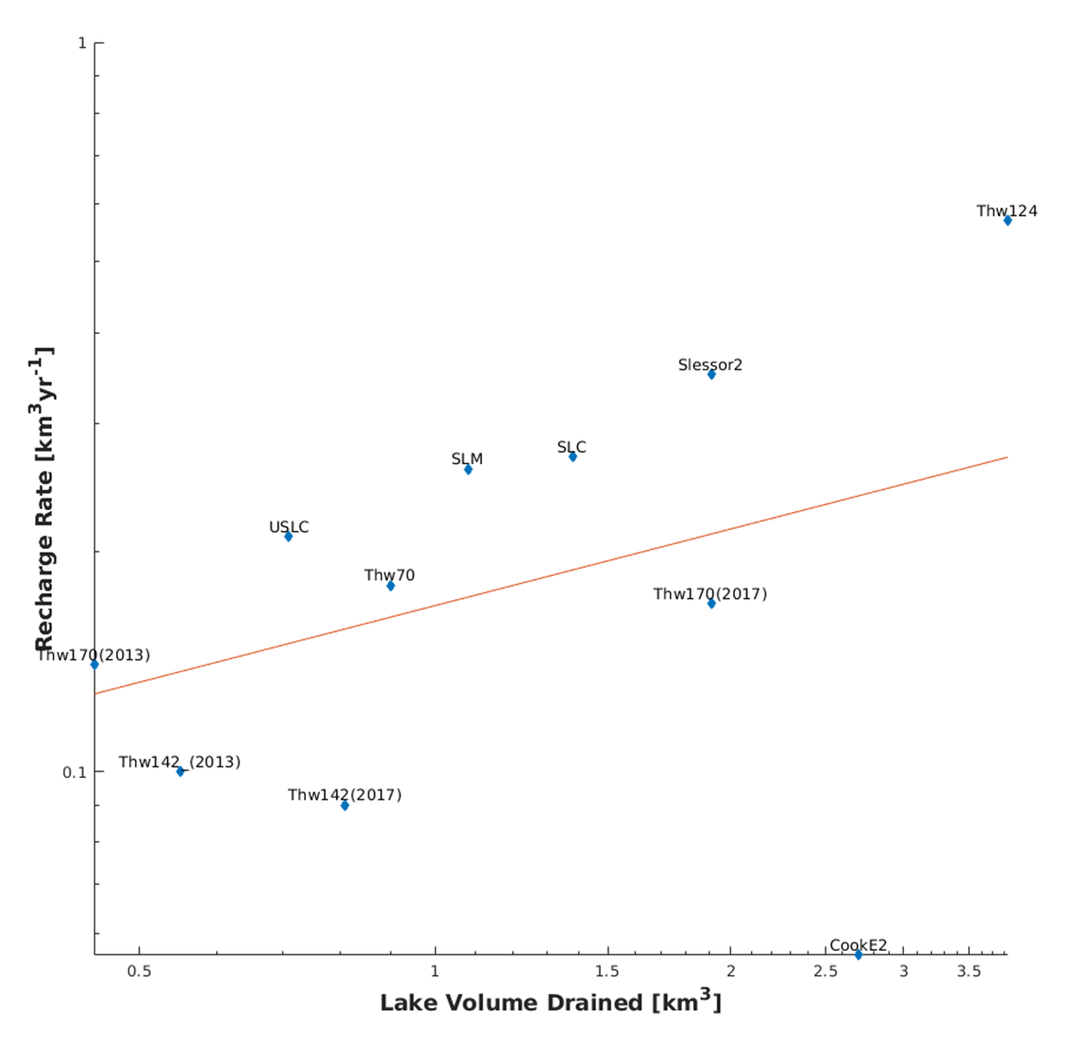
Fig. S15. Scatter plot of volume of drainage event against recharge rate
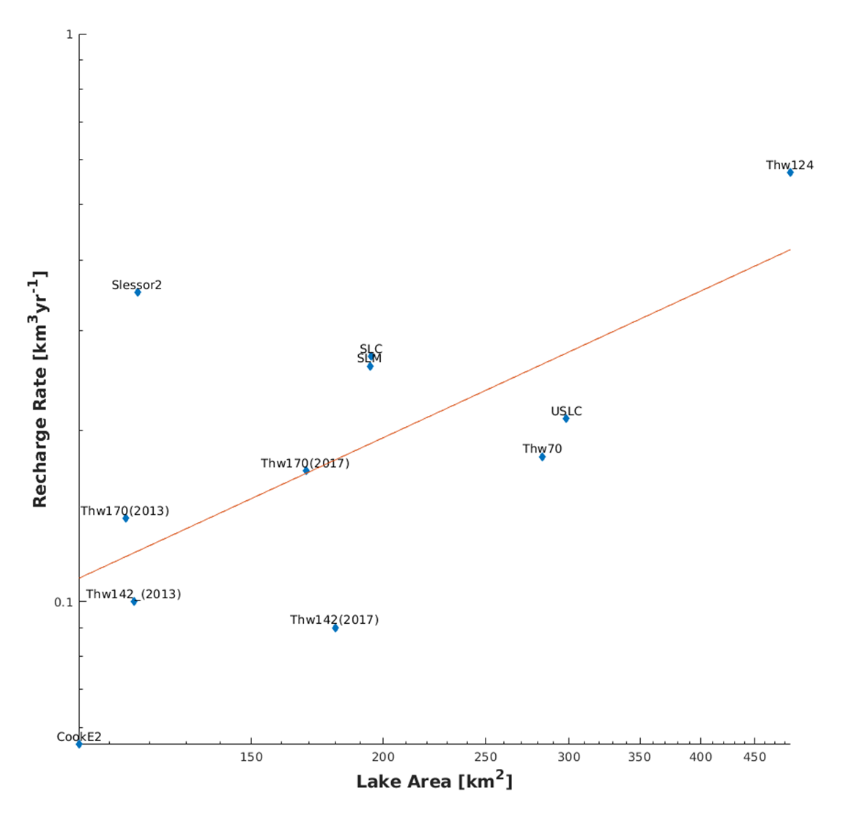
Fig. S16: Scatter plot of recharge rate against lake area

