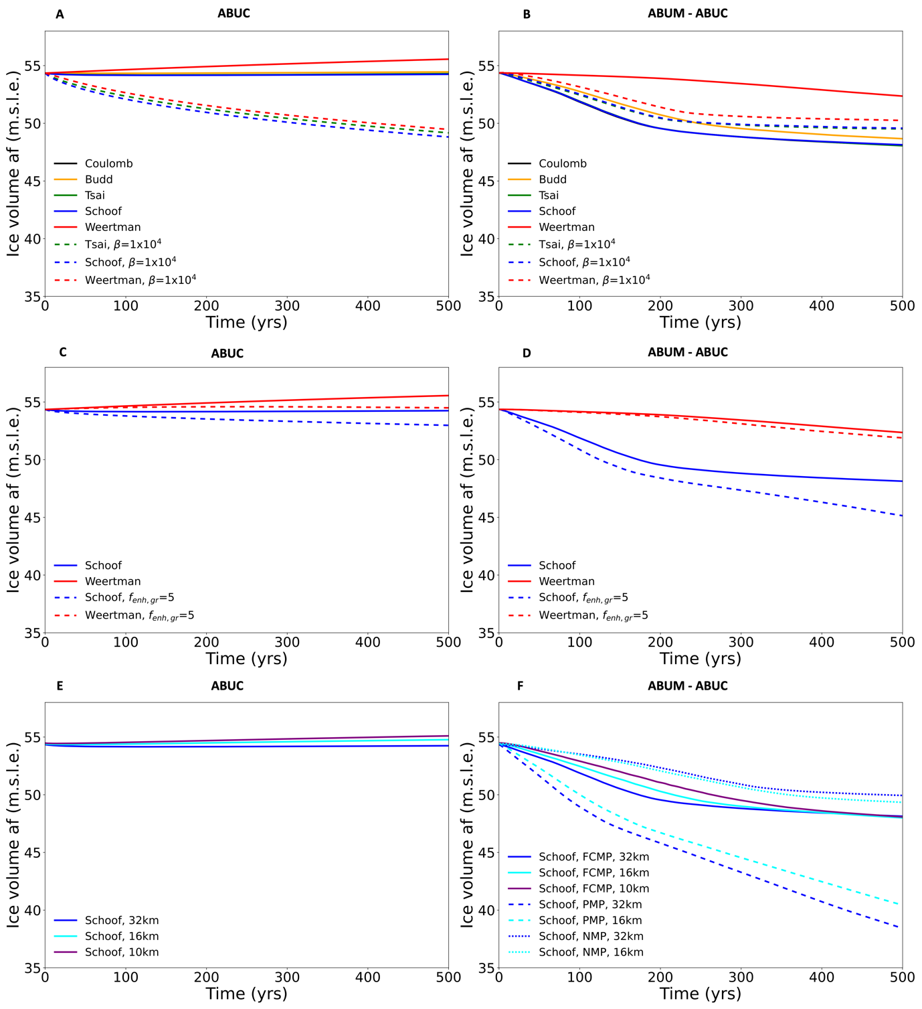
Fig. S1: Evolution over time of ice volume above flotation in the ABUMIP ABUC experiment with fixed ice shelf geometry (left panels), and the difference between the ABUM and ABUC experiment (right panels), using A-B) different sliding laws and basal roughness (32 km resolution, FCMP, f_{enh,gr} = 1) (solid green, black and blue lines overlap, only blue is visible), C-D) different flow enhancement factors (32 km resolution, FCMP), E-F) different resolutions and (only for ABUM-ABUC) sub-grid melt schemes (32 km resolution, f_{enh,gr} = 1).

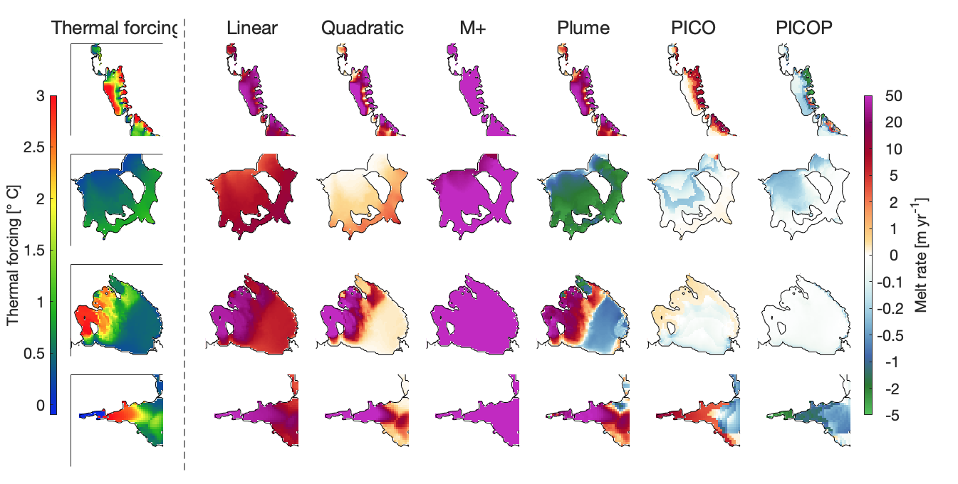
Fig. S2: Thermal forcing (leftmost column), and sub-shelf melt rates underneath the ice shelves at the start of the experiments at 16 km resolution using ocean forcing from the HR-CESM control simulation, with different sub-shelf melt parameterisations. For the forcing and each parameterisation, the rows show (top to bottom) the Amundsen Sea embayment, the Filchner-Ronne embayment, the Ross embayment, and the Amery embayment.
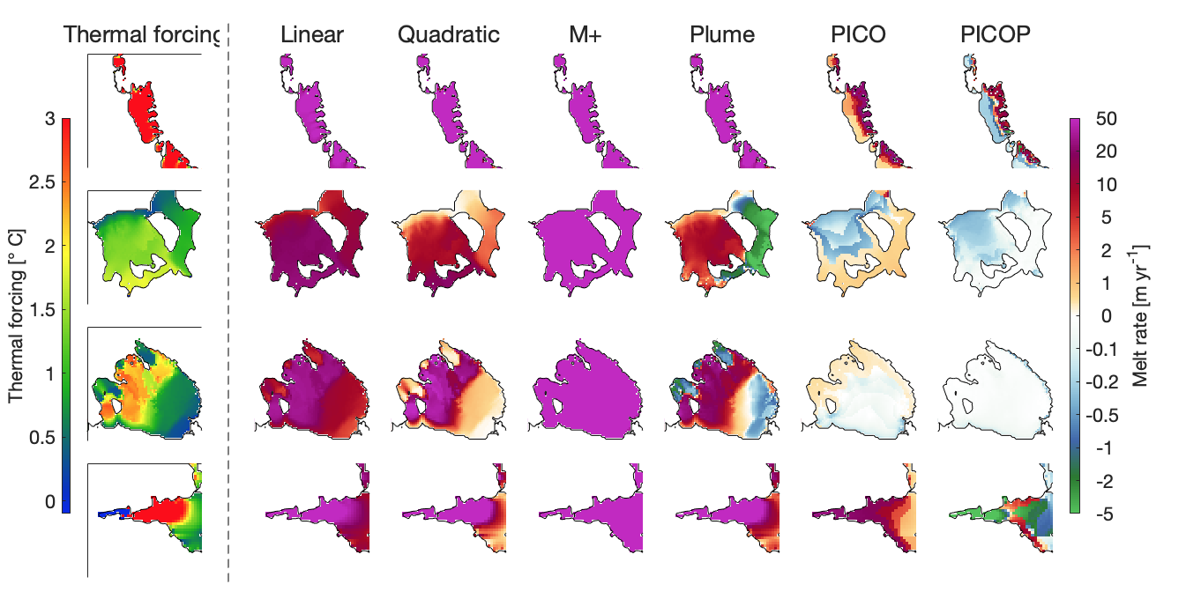
Fig. S3: Thermal forcing (leftmost column), and sub-shelf melt rates underneath the ice shelves at the start of the experiments at 16 km resolution using ocean forcing from the LR-CESM control simulation, with different sub-shelf melt parameterisations. For the forcing and each parameterisation, the rows show (top to bottom) the Amundsen Sea embayment, the Filchner-Ronne embayment, the Ross embayment, and the Amery embayment.

