APPENDIX A
The following figures present the data for the entire 23 mountain regions in the French Alps.
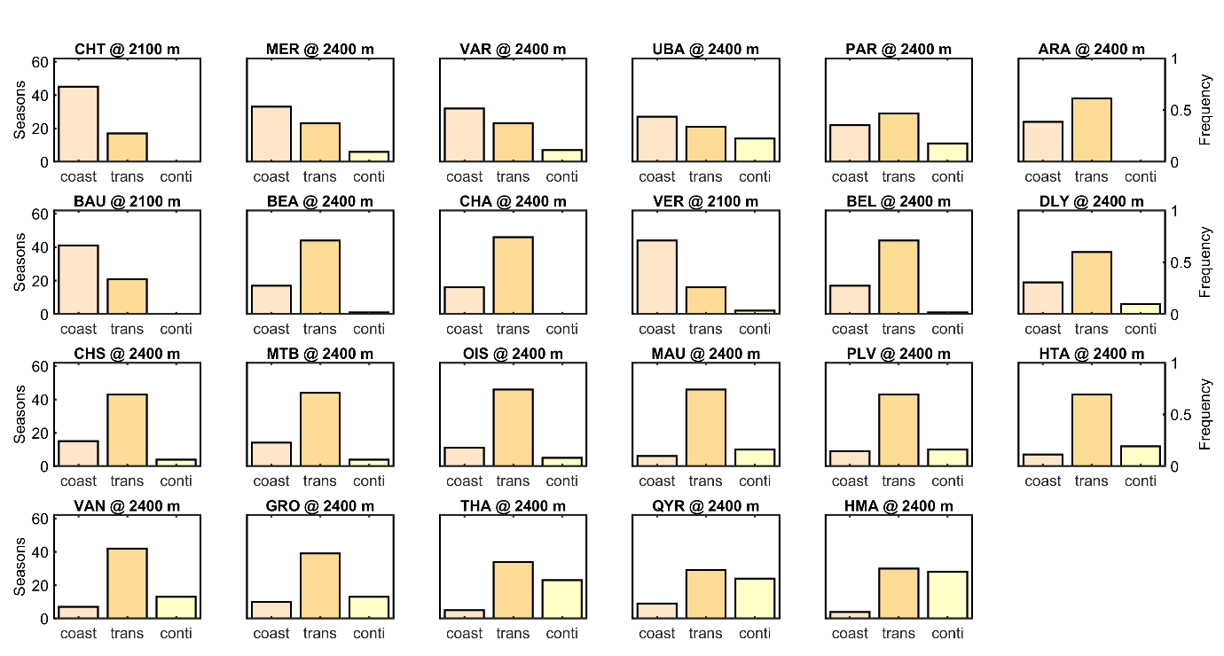
Figure 10: Number of seasons with coastal (apricot), transitional (orange) or continental (lemon) snow climate characteristics after Mock and Birkeland (2000) for the entire period 1958–2020 at an elevation of 2400 m (2100 m in Chartreuse, CHT, Bauges, BAU, and Vercors, VER). The 23 regions of the French Alps are grouped according to the frequency of seasons with coastal, transitional or continental influence). Regions with a majority of coastal seasons are in the upper left and regions with a strong continental influence are in the lower right. The regions with a clear majority of transitional seasons are organized from decreasing coastal to increasing continental influence. For acronyms see Table 2.

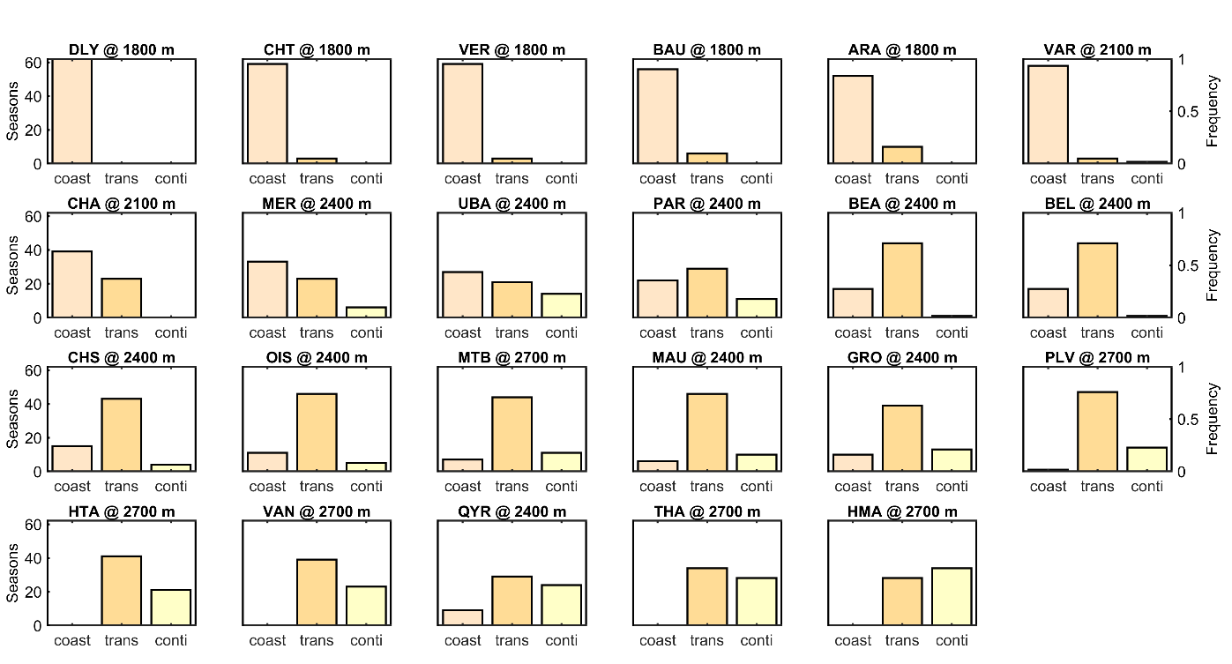
Figure 11: Number of seasons with coastal (apricot), transitional (orange) or continental (lemon) snow climate characteristics after Mock and Birkeland (2000) for the entire period 1958–2020 considering relevant release area elevation (see subplot title). The 23 regions of the French Alps are grouped according to the frequency of seasons with coastal, transitional or continental influence. Regions with a majority of coastal seasons are in the upper left and regions with a strong continental influence are in the lower right. The regions with a clear majority of transitional seasons are organized from decreasing coastal to increasing continental influence. For acronyms see Table 2.

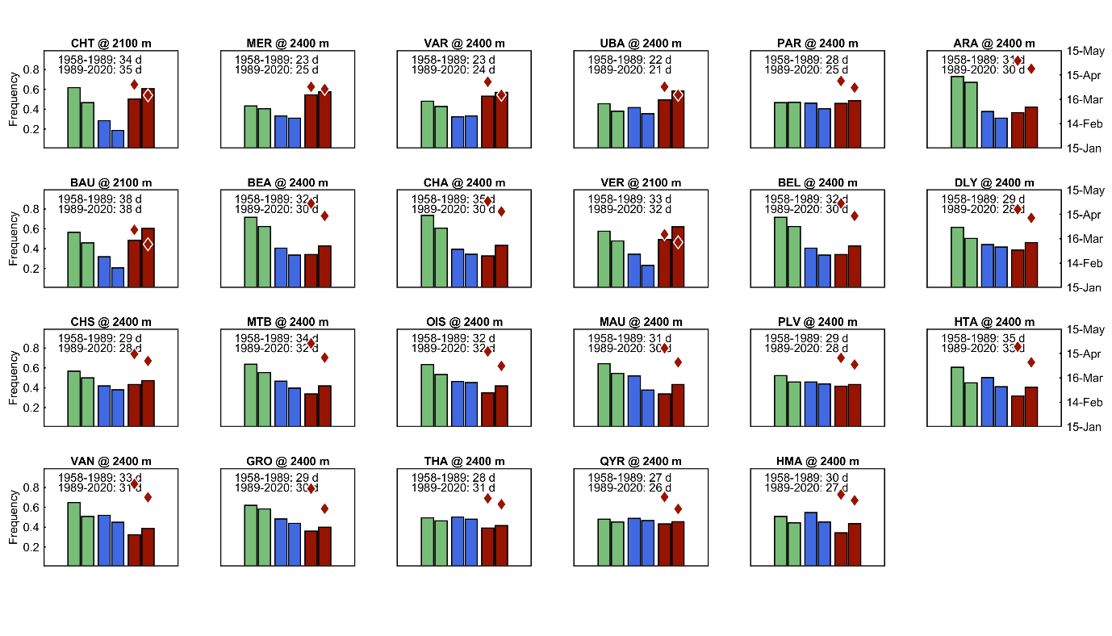
Figure 12: Avalanche problem types simulated for the 23 regions of the French Alps at an elevation of 2400 m (2100 m in Chartreuse, CHT, Bauges, BAU, and Vercors, VER). Bars represent frequency of new snow and wind slabs (green), persistent weak layer (blue bars) and wet snow (red bars) problem types for the first (left bar) and the last 31 years (right bar) of the period 1958–2020. Two red diamonds show the average onset date for wet snow avalanches for the two periods. Inserts show the average number of days with expected natural release for both periods. Regions are ordered the same as in Figure 10, i.e. regions classifying mostly as coastal snow climate are in the upper left and regions with a strong continental influence are in the lower right. For acronyms see Table 2.

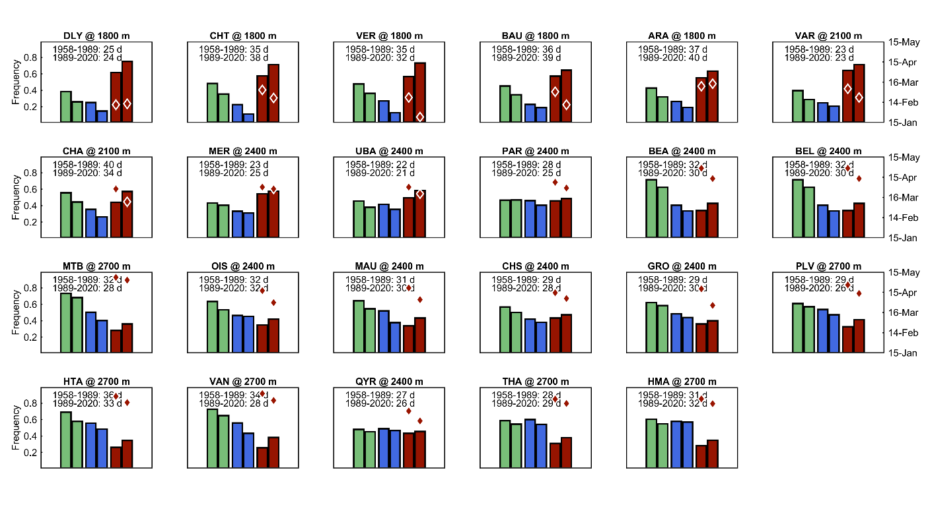
Figure 13: Avalanche problem types simulated for the 23 regions of the French Alps considering relevant release area elevation (see subplot title). Bars represent frequency of new snow and wind slabs (green), persistent weak layer (blue bars) and wet snow (red bars) problem types for the first (left bar) and the last 31 years (right bar) of the period 1958–2020. Two red diamonds show the average onset date for wet snow avalanches for the two periods. Inserts show the average number of days with expected natural release for both periods. Regions are ordered according to the results of a cluster analysis, from regions with relatively few persistent weak layer problems in the upper left to regions where persistent weak layers are a major issue in the lower right. Regions with relatively frequent new snow situations are in between. For acronyms see Table 2.

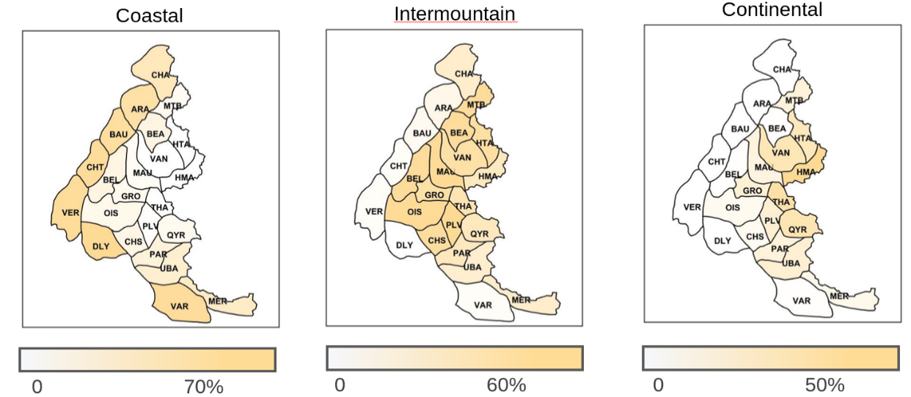
Figure 14: Maps of the French Alpine regions highlighting the frequency of costal, intermountain and continental snow climates during the period between 1958 and 2020. Simulations refer to relevant release area elevation in the regions. For acronyms see Table 2.

Table 2: Acronyms describing the 23 regions in the French Alps.
ARA | Aravis | MER | Mercantour
BAU | Bauges | MTB | Mont Blanc
BEA | Beaufortain | OIS | Oisans
BEL | Belledonne | PAR | Embrunnais Parpaillan
CHA | Chablais | PLV | Pelvoux
CHS | Champsaur | QYR | Queyras
CHT | Chartreuse | THA | Thabor
DLY | Dévoluy | UBA | Ubaye
GRO | Grandes-Rousses | VAN | Vanoise
HMA | Haute-Maurienne | VAR | Haut-Var Haut-Verdon
HTA | Haute-Tarentaise | VER | Vercors
MAU | Maurienne

