Supplementary Material
The first cultivation of the glacier ice alga Ancylonema alaskanum (Zygnematophyceae, Streptophyta): differences in morphology and photophysiology of field versus laboratory strain cells
Daniel Remias^{1,2} & Lenka Procházková^{3,4}
¹School of Engineering, University of Applied Sciences Upper Austria, Stelzhamerstr. 23, 4600 Wels, Austria
²Department of Ecology and Biodiversity, Paris Lodron University of Salzburg, 5020 Salzburg, Austria
³Department of Ecology, Faculty of Science, Charles University, Viničná 7, 12844 Prague, Czech Republic
⁴Centre for Phycology, Institute of Botany of the Czech Academy of Sciences, Dukelská 135, 37982 Třeboň, Czech Republic
Authors for correspondence: Daniel Remias, E-mail: daniel.remias@plus.ac.atꓼ Lenka Procházková, E-mail: lenka.prochazkova@natur.cuni.cz
PCR and Sanger sequencing
The internal transcribed spacer region 2 (ITS2 rDNA) was amplified from DNA isolates by PCR using existing primers of its1 (TCCGTAGGTGAACCTGCGG; White and others, 1990) and LSU (AGTTCAGCGGGTGGTCTTG; Piercey-Normore and DePriest, 2001) or Zyg_ITS_F (TCCGTAGGTGAACCTGCAG; Trumhová 2016) and LR3 (GGTCCGTGTTTCAAGACGG; Vilgalys and Hester 1990). For amplification of ribulose–1,5–bisphosphate carboxylase/oxygenase large subunit (rbcL), MaGo1F (ATGTCACCACAAACNGAAAC; Gontcharov and Melkonian, 2004) and rbcL7R (AAATAAATACCACGGCTACG; Hoham and others, 2002) primers were used. To obtain the 18S small subunit ribosomal RNA gene (18S rDNA), primers P2 (CTGGTTGATTCTGCCAGT; De Wever and others, 2009) and P4 (TGATCCTTCYGCAGGTTCAC; Moon-van der Staay and others, 2000) were applied; for the sequencing reaction they were supplemented with internal sequencing primers of 300F (GGAGAATTAGGGTTCGATTCCGGAG; Marin and others, 1998) and 528F (CGGTAATTCCAGCTCC; Marin and others, 1998). Amplification reactions were described in Procházková and others (2018). PCR products were purified and sequenced using an Applied Biosystems automated sequencer (ABI 3730xl) at Macrogen Europe (Amsterdam, Netherlands). The newly obtained sequences of A. alaskanum were submitted to the NCBI Nucleotide sequence database and are listed in Table S3.
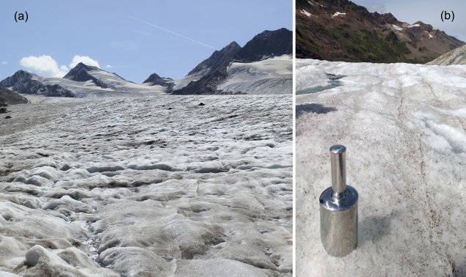
Fig. S1. Overview of the sampling sites of Ancylonema alaskanum: (a) Sampling location at Gurgler Ferner, a glacier in the Ötztal Valley, Tyrol, Austria (25 Aug 2020, field sample WP251). (b) Detailed view of the faintly brownish glacier ice surface before harvest.
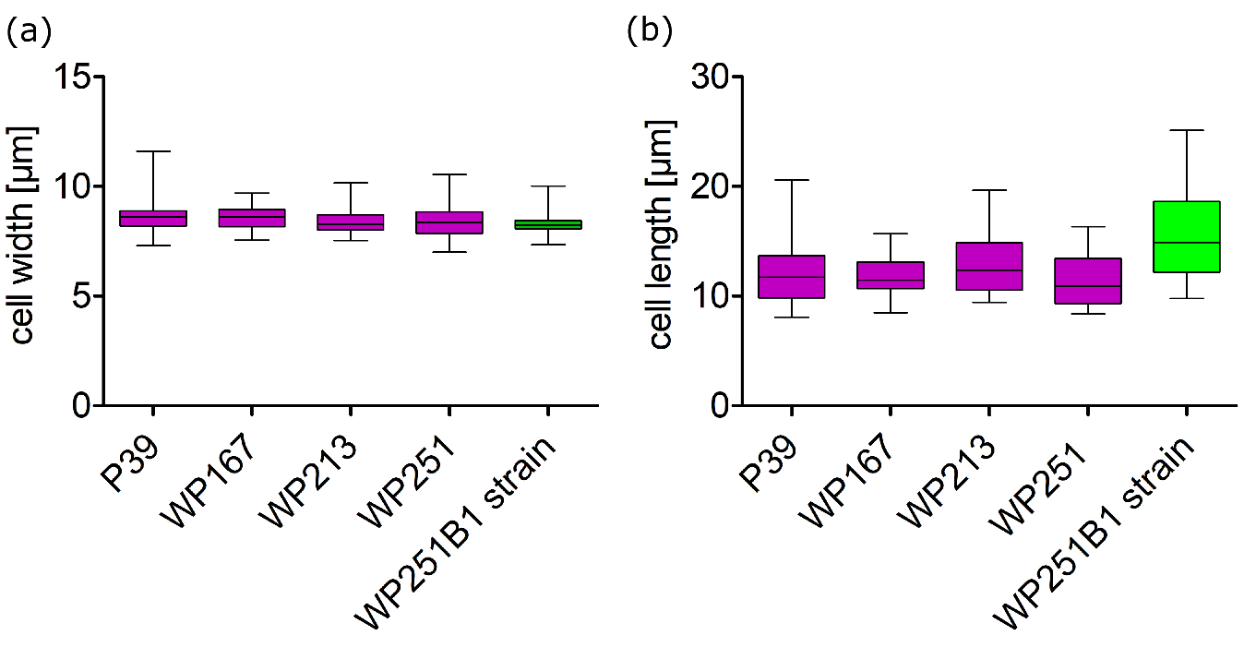
Fig. S2. Comparison of (a) cell widths and (b) cell lengths between Ancylonema alaskanum field samples (pink box plots: P39, n=83; WP167, n=47; WP213, n=22; WP251, n=27) and the Ancylonema alaskanum lab strain (green box plot: WP251B1 / CCCryo 565-23, n=52). The source locations according to the sample codes are listed in Table S1.
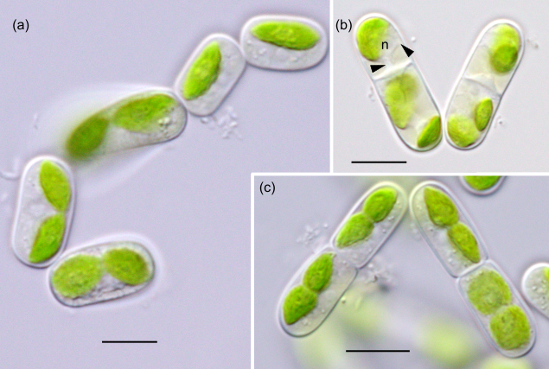
Fig. S3. Light microphotographs of Ancylonema alaskanum strain WP251B1 / CCCryo 565-23. (a) Cells without pigmented vacuoles forming a transient chain-like filament. (b) A central nucleus (n) suspended on a cytoplasmic bridge (arrowheads), as typical for Zygnemataceae. (c) Parietal shovel-like chloroplasts shown in lateral and ventral views. Scale = 10 µm.

Table S1. Ancylonema alaskanum field sample codes, collection dates, sampling sites, elevation (in meters above sea level) and geographic position (GPS). AT, Austria; CH, Switzerland.
Sample | Collection date | Glacier | Elevation | GPS
P39 | 6 September 2006 | Tiefenbach Ferner, AT | 3000 | 46°55′ N 10°56′ E
AS08 | 20 August 2009 | Gurgler Ferner, AT | 2820 | 46.8 N 10.98 E
WP167 | 30 August 2017 | Gurgler Ferner, AT | 2728 | 46°48.280′ N 10°58.804′ E
WP213 | 24 August 2018 | Morteratsch glacier, CH | 2161 | 46°25.195′ N 9°55.913′ E
WP251 | 25 August 2020 | Gurgler Ferner, AT | 2727 | 46°48.327′ N 10°58.73′ E

Table S2 Recipe for the growth medium “enhanced SFM” = eSFM (double the P and N compared to normal SFM).
Stock | Components | Stock solution | Stock added for 1 l medium
1. | HEPES puffer | 238.10 g l dH₂O⁻¹ | 1 ml
2. | Ca(NO₃)₂ × 4 H₂O | 100.00 g l dH₂O⁻¹ | 1 ml
3. | MgSO₄ × 7 H₂O | 20.00 g l dH₂O⁻¹ | 2.5 ml
4. | K₂HPO₄ × 3 H₂O | 5.00 g l dH₂O⁻¹ | 1.2 ml
 | + NaNO₃ | 50.00 g l dH₂O⁻¹
 | + Na₂CO₃ | 32.00 g l dH₂O⁻¹
5. | H₃BO₃ | 1.00 g l dH₂O⁻¹ | 1 ml
6. | Vitamin Solution: |  | 1 ml
 | Vitamin B12 | 0.20 mg l dH₂O⁻¹
 | Biotin (Vit H) | 1.00 mg l dH₂O⁻¹
 | Thiamine-HCl (Vit B1) | 100.00 mg l dH₂O⁻¹
 | Niacinamide (Vit B3) | 0.10 mg l dH₂O⁻¹
7. | Trace Metals: |  | 1 ml
7.1. | Preparation of Trace Metal Solution:
 | Na₂EDTA × 2 H₂O: 4.36 g
 | FeCl₃ × 6 H₂O: 3.15 g
 | Dissolve in 1 l dH₂O, then add 1 ml of Primary Trace Metals each:
7.2. | Primary Trace Metals:
7.2.1. | K₂CrO₄ | 0.194 g 100 ml dH₂O⁻¹
7.2.2. | CoCl₂ × 6 H₂O | 1.00 g 100 ml dH₂O⁻¹
7.2.3. | CuSO₄ × 5 H₂O | 0.25 g 100 ml dH₂O⁻¹
7.2.4. | MnCl₂ × 4 H₂O | 18.00 g 100 ml dH₂O⁻¹
7.2.5. | Na₂MoO₄ × 2 H₂O | 1.89 g 100 ml dH₂O⁻¹
7.2.6. | NiSO₄ × 6 H₂O | 0.27 g 100 ml dH₂O⁻¹
7.2.7. | H₂SeO₃ | 0.13 g 100 ml dH₂O⁻¹
7.2.8. | Na₃VO₄ | 0.184 g 100 ml dH₂O⁻¹
7.2.9. | ZnSO₄ × 7 H₂O | 2.20 g 100 ml dH₂O⁻¹

Table S3. Ancylonema alaskanum - molecular markers of field vs. strain material: NCBI accession numbers and pairwise comparison of the sequence similarities (%).

Marker | length  (base pairs) | Accession number - field cells  (sample code) | Accession number – strain WP251B1 = CCCryo 565-23 | Sequence  similarity
18S rDNA | 1529 | JF430424 (AS08) | OQ202166 | 100%
rbcL | 1020 | OQ202166 (WP251) | OQ222865 | 100%
ITS2 rDNA | 196 | OL898466 (WP167) | OQ234976 | 100%

Supplementary References
Marin B, Klingberg M and Melkonian M (1998) Phylogenetic Relationships among the Cryptophyta: Analyses of Nuclear-Encoded SSU rRNA Sequences Support the Monophyly of Extant Plastid-Containing Lineages. Protist 149 265–276. doi: 10.1016/S1434-4610(98)70033-1
Piercey-Normore MD and DePriest, PT (2001) Algal switching among lichen symbioses. American Journal of Botany 88(8) 1490–1498. doi: 10.2307/3558457
Procházková L, Remias D, Řezanka T and Nedbalová L (2018) Chloromonas nivalis subsp. tatrae, subsp. nov. (Chlamydomonadales, Chlorophyta): re–examination of a snow alga from the High Tatra Mountains (Slovakia). Fottea, 18(1) 1–18 doi: 10.5507/fot.2017.010
Trumhová K (2016) Diversity of the Micrasterias papillifera / M. radiosa (Desmidiales) species complex [Diploma thesis]. http://hdl.handle.net/20.500.11956/73737 Charles University.
Vilgalys R and Hester M (1990) Rapid genetic identification and mapping of enzymatically amplified ribosomal DNA from several Cryptoccocus species. Journal of Bacteriology 172 4238-4246. doi: 10.1128/jb.172.8.4238-4246.1990
White TJ, Bruns T, Lee S and Taylor J (1990) Amplification and direct sequencing of fungal ribosomal RNA genes for phylogenetics. In Innis MA, Gelfand, DH, Sninsky JJ and White T (Eds.), PCR protocols- a guide to methods and applications (Vol. 18, pp. 315–322). Academic Press. doi: 10.1016/B978-0-12-372180-8.50042-1

