1. **Available approaches to map debris covered glaciers in remote regions and their challenges**

Table S1 reviews approaches to glacier debris cover quantification. Geomorphological mapping of glacier debris cover in complex mountain environments is difficult (Bishop and others, 2001), the accuracy of the resulting maps is highly dependent on the expertise of the image analyst and their visual interpretation (Paul and others, 2004; Bhambri and others, 2011; Kaushik and others, 2019), and it is labor and time intensive for large regions.

The geomorphometric characteristics of satellite-derived DEM data may indicate the presence of debris covered glaciers. For instance, researchers (e.g. Paul, 2003; Paul and others, 2004; Bolch and Kamp, 2006; Shukla and others, 2010; Bhardwaj and others, 2014) have used slope thresholds under the assumption that above a certain slope (the critical slope angle for debris movement), debris will not accumulate. This may be problematic in some regions, such as where the transition from a glacier margin to an unglaciated region is gentle but still relatively debris free (Paul, 2003; Bolch and Kamp, 2006). In addition, no detectable change in surface slope may occur at the interface between clean-ice and debris-cover (Bhambri and others, 2011); post-depositional sedimentation by mass movement, a commonly found process in the polygenetic environment of the Himalayas (Benn and Owen, 2002; Bhambri and others, 2011), may cause confusion (Bhambri and others, 2011); and the available data may not have the right resolution (Bolch and Kamp, 2006; Racoviteanu and others, 2009).

More advanced approaches seek to combine satellite imagery with DEM data and more sophisticated automated classification methods. For instance, neural networks or Fuzzy C Mean clustering classifications gave good results for different types of debris cover (Bishop and others, 1999), but the long processing times associated with them may limit their applicability over large areas (Racoviteanu and others, 2009). Bishop and others (1999) report errors with such classification approaches where white ice was sometimes classified as shallow debris and/or thick debris, and shallow debris was sometimes classified as thick debris. Atwood and others (2010) and Racoviteanu and Williams (2012) applied decision tree algorithms and texture analysis combining DEM and thermal data to map debris cover. They concluded that the sophisticated and laborious processing of a decision tree prevents a completely automated process for delineating debris covered glacier tongues. Moreover, this method requires several post-processing steps (e.g. digital terrain analysis) to achieve reliable results (Bhambri and others, 2011). Recently, researchers used high resolution photogrammetric mapping using drone surveys based on DEM differencing and manual feature tracking to map debris-covered ice (Robson and others, 2015). Whilst, this method provides very accurate results it is labor intense, costly, and not applicable over large regions, especially for inaccessible glaciers (Immerzeel and others, 2014).

Researchers (Scherler and others, 2018; Herreid and Pellicciotti 2020; Fleischer and others, 2021) used the proportion of near infrared (NIR) and shortwave Infrared (SWIR) to map debris cover on glaciers. However, they encountered misclassification of snow and ice as debris (Fleischer and others, 2021), the maximum mapping accuracy in this method corresponds to threshold values that reduce the debris cover to a minimum insufficient image coverage to map debris cover (Scherler and others, 2018) or an over estimation can be observed (Fleischer and others, 2021). This method could not map thicker debris and ice-cored debris although this index is usually well-suited for mapping clean ice (Paul and others, 2002; Taschner and Ranzi, 2002; Paul, 2003; Paul and others, 2004; Bolch and Kamp, 2006; Shukla and others, 2010; Bhardwaj and others, 2014). Given that many methods exist, inter-comparison is important. Racoviteanu and others (2009) considered a number of semi-automated approaches for mapping debris covered glaciers that coupled morphometric analysis (slope-based) with thermal information, a neural network algorithm and concluded that there is no single optimal algorithm for debris-cover mapping that can be applied to large regions without some manual correction of resulting outlines. Such progress aside, delineation of debris covered glaciers remains a major problem for rapid, automated inventorying of glaciers from satellite data (Paul and others, 2004; Bolch and Kamp, 2006; Bolch and others, 2008; Shukla and others, 2010). In global scale assessment, there are challenges in mapping debris cover glaciers more precisely, suitable image selection is time-consuming especially when summer snow falls, a very short event could bury supraglacial debris cover quickly in accumulation areas. There are more uncertainties with small glaciers (<1 km2) if there is a mismatch between the time of glacier delineation and debris-cover mapping once the glacier has changed its extent. On the other hand, selecting the best index for mapping ice and debris cover is another main challenge.

Motivated by a need to map glacier cover over the Afghan Hindu Kush, where debris cover is common, and given the above review, this paper seeks to develop two indices that can be applied to: freely-available data sets; that yield sufficient spatial resolution for mapping of valley-confined glaciers; and that could be used for long-term analyses so as to quantify change. Sentinel satellite imagery has good spatial resolution for spectral bands but lacks thermal information and long-term datasets. ASTER has a better spatial resolution for the thermal band but data were not always available both spatially and temporally for Afghanistan. Thus, we used Landsat imagery and we explain the bases of these indices below.

**Table S1.** A review of glacier mapping studies

|  |  |  |  |  |  |
| --- | --- | --- | --- | --- | --- |
| **Methodology** | **Reference** | **Parameters** | **Data Input** | **Processing flow** | **Remarks** |
| **Manual delineation** | Stokes and others (2007) | Clean Ice and Debris covered Ice | Landsat TM and ETM+, a false-color composite of bands 5, 4, 3 (red, green, blue) | Manual digitizing | Accuracy is extremely dependent on the expertise of the image analyst and individual’s visual interpretation. Moreover, it is time consuming and labor intensive to apply to a large number of glaciers (Paul and others, 2004; Bhambri and others, 2011; Ghosh and others, 2014; Kaushik and others, 2019). |
| **Automatic or Semi-automated method** | Bishop and others 2001 | Clean Ice and Debris covered Ice | DEM | Geomorphometric based | 1. Requires high resolution DEMs for better accuracy that are not always available (Bolch and Kamp, 2006; Racoviteanu and others, 2009); furthermore, issues associated with data modeling and an object-oriented approach are still debated  2. DEM-based methods require intense user interaction by specialists (Paul and others, 2004) 3. The geomorphometric-based method fails in mapping a debris covered glacier when the glacier tongue transition to the unglaciated zone is gentle (Bolch and Kamp, 2006). |
| Shukla and others 2010 | Clean Ice and Debris covered Ice | Thermal image - IRS-P6 AWiFS and Optical image - TERRA-ASTER | Geomorphometric and optical based: 1. TM4/TM5 2. DEM (aspect and slope), Debris covered ice based binary Slope <15 |
| Paul and others 2004; Paul 2003; Bolch and Kamp 2005; Veettil 2012; Bhardwaj and others 2014 | Clean Ice and Debris covered Ice | Landsat Thematic Mapper (TM) DEM | Combination of Geomorphometric, optical, and thermal based: 1. TM4/TM5 2. TIR 3. Debris covered ice based on Slope 1-24 ratio |
| Bhambri and others 2011; Bolch and others 2007 | Clean Ice and Debris covered Ice | ASTER - digital elevation model (DEM) and thermal | 1. ASTER3/ASTER4 2. ASTER - thermal 2. DEM- morphometeric parameters (Slope, profile curvature, plan curvature |
| Bishop and others 1999 | Clean Ice and Debris covered Ice | SPOT Panchromatic data  Sentinel-2 imagery using texture, topographic, and spectral data | Artificial neural network (ANN) technology | 1. This method results in rapid and good quality maps of clean- and debris-covered ice but still errors occur due to existence of shadow, cloud cover, and seasonal snow in the imagery (Bolch and Kamp, 2006; Frey and others, 2012; Kaushik and others, 2019). 2. Neural networks or Fuzzy C Mean clustering classifications may provide more accurate results, especially for various types of debris cover (Bishop and others, 1999), but the long processing time may limit their applicability over large regions (Racoviteanu and others, 2009) |
| Atwood and others 2010; Robson and others 2015 | Clean Ice and Debris covered Ice | Advanced Land Observing Satellite (ALOS) Phased Array L-band SAR (PALSAR) | Decision tree  Object-Based Image Analysis (OBIA) | 1. This method requires several post-processing steps (e.g. digital terrain analysis) to achieve promising results (Bhambri and others, 2011).  2. SAR coherence data require expertise knowledge and expensive software in order to be processed (Frey and others, 2012) |
| Racoviteanu and Williams 2012 | Clean Ice and Debris covered Ice | ASTER - digital elevation model (DEM) and thermal | 1. Decision tree 2. Texture analysis | 1. These methods are sophisticated but require heavy processing; the decision tree prevents a completely automated process for delineating debris-covered glacier tongues.  2. The texture approach is limited by the fact that while debris-cover training areas (ROIs) may have distinctive texture values, these values or patterns may not be characteristic for all the debris cover across a region (Racoviteanu and Williams, 2012). |
| Paul and others 2002 | Clean Ice | Landsat Thematic Mapper (TM) data and a digital elevation model (DEM) | Optical based: TM4/TM5 | Distinguishing the supraglacial debris (SGD) on the glacial surface and periglacial debris (PGD) appearing outside the glacier boundary has been recognized as a major constraint due to similar surface reflectance (Shukla and others, 2010; Paul and others, 2015; Kaushik and others, 2019). |
| Taschner and Ranzi 2002 | Clean Ice and Debris covered Ice | Landsat Thematic Mapper (TM) | Thermal and optical based: TM4/TM5 Thermal band: TIR | The infrared radiometer may not record the thermal gap between pure debris and thicker debris superimposed on ice, the thicker debris layer may lead to a thermal insulation of the cooling ice (Taschner and Ranzi, 2002). |
| Immerzeel and others 2014 | Clean Ice and Debris covered Ice | Unmanned Aerial Vehicle (UAV) | Based on DEM differencing and manual feature tracking | This method provides more accurate results but it is labor intense, costly, and not applicable for large regions, and glaciers that are inaccessible (Immerzeel and others, 2014) |
| Fleischer and others 2020 | Clean Ice and Debris covered Ice | Landsat Thematic Mapper (TM) data and a digital elevation model (DEM) | NIR/SWIR | This index misclassifies the snow/ice as debris. This method is not able to map thicker debris and ice-cored debris while usually well suited for mapping clean ice (Paul and others, 2002; Taschner and Ranzi, 2002; Paul, 2003; Paul and others, 2004; Bolch and Kamp, 2006; Shukla and others, 2010; Veettil, and others, 2014; Bhardwaj and others, 2014). |

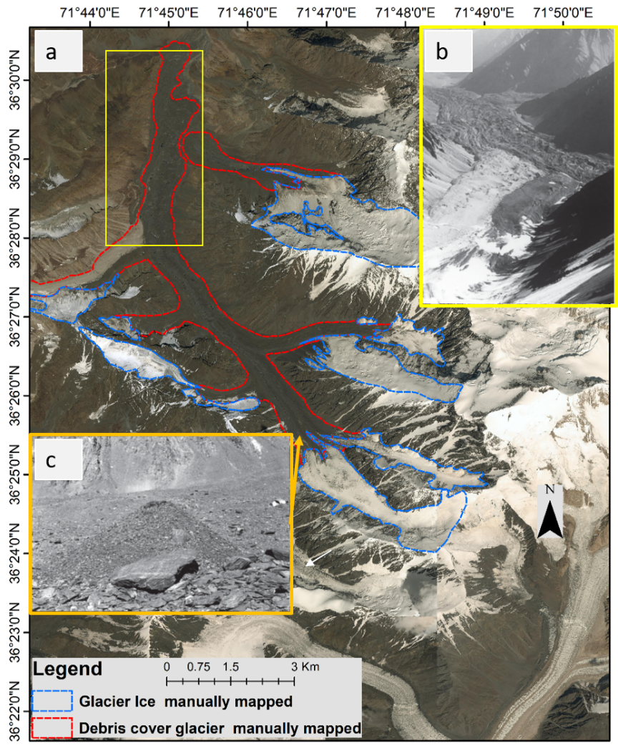

**Fig. S1.** Noshaq Glacier range (Fig. 1); 3a shows the 0.29 m RGB image in background (MoMP, 2020), with red lines showing the manually-mapped debris-covered ice extent and blue lines the manually-mapped ice extent. The view shown in Figure S1b (B. Ehmann) is bounded by the yellow box shown in 3a and shows the terminus of the debris-covered Qadzi Deh Glacier and, in the foreground, the Rakhe Kuchek Glacier, covered in part by lighter-colored debris. 3c shows argillite-covered glacier ice at an elevation of about 5,075 m on the Qadzi Deh Glacier (7,492 m) (Shroder, 1980).



**Fig. S2.** Landsat image tile used for the study with details of date that images were obtained

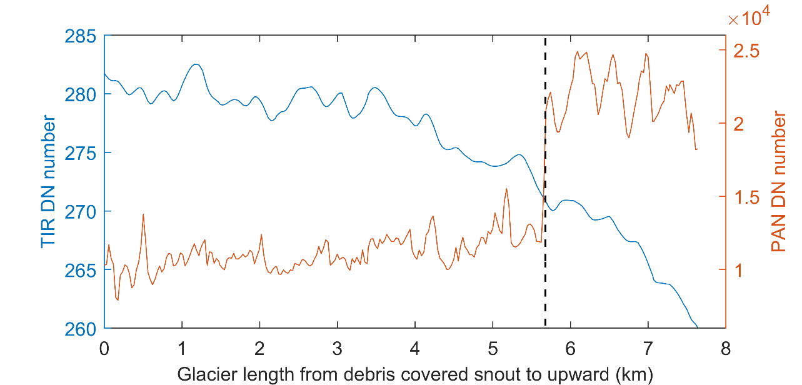

**Fig. S3.** Sectional profile of TIR and PAN band information for the Keshnikhan glacier (Fig. 1), the TIR and PAN profile were drawn across the centerline of the glacier and are based on pixel values; the crossing point illustrated by the dashed black line is the transition point between debris cover and clean ice.



**Fig. S4.** Illustration the effects of each step in Figure 2; a through i refer to labels in Figure 2. a. indicates that the index for clean ice mapping did not detect the ice area under shadow (red boxes). b. illustrates that the results improved after atmospheric correction was performed. c. shows that the debris covered C1 index mapped debris-covered ice but missed zones for a range of glaciers shown in green boxes, as well as misclassified zones in the red box. d. using slope threshold slope>37o removed the misclassifications in the red box, while still misclassified lower elevation zones shown in the green box. e. an elevation and an area threshold removed those misclassifications, while still some misclassifications remained, shown in the blue box f. a second slope threshold slope>24o removed those misclassifications. g. shows the second index for debris- covered ice C2 was applied and the missing debris area mapped (green boxes). h. Slope, elevation, and the area threshold applied to debris covered glacier C2. i. the second slope threshold slope >24o is applied to remove remaining misclassifications and the results improved, red arrows showing the snow-cover area mapped as ice that is manually removed.

1. **Top of Atmospheric Reflectance and Digital Number effect on indices**

We examined the differences in debris cover raster based on the calculation of the index (eq. 1 main manuscript) using original bands with DNs and bands with TOA correction. The test was performed on MirSmir glacier. Figure S5 shows that the DNs for 2016 and 2020 followed a typical pattern of glacier retreat, the 2020 DN line decreased in the snout and was stable in the middle and slightly increased near to the glacier. On the other hand, the index calculated using the TOA bands was of coarser spatial resolution and has a noisier signal.

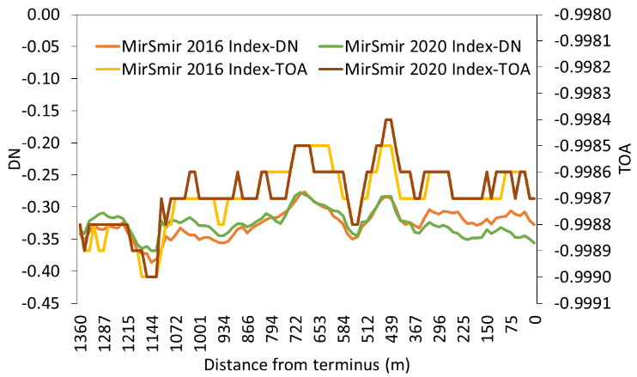

**Fig. S5.** Image shows MirSmir glacier with glacier outlines for 2020, black line is the debris profile shown in the graph.



**Fig. S6.** Mir Samir Glacier, background is 3 m resolution RGB image of PlanetScope imagery captured just three days after the fieldwork.



**Fig. S7.** Location map of the glaciers used for validation, background map is the elevation map of Himalayan region (ICIMOD 2022)

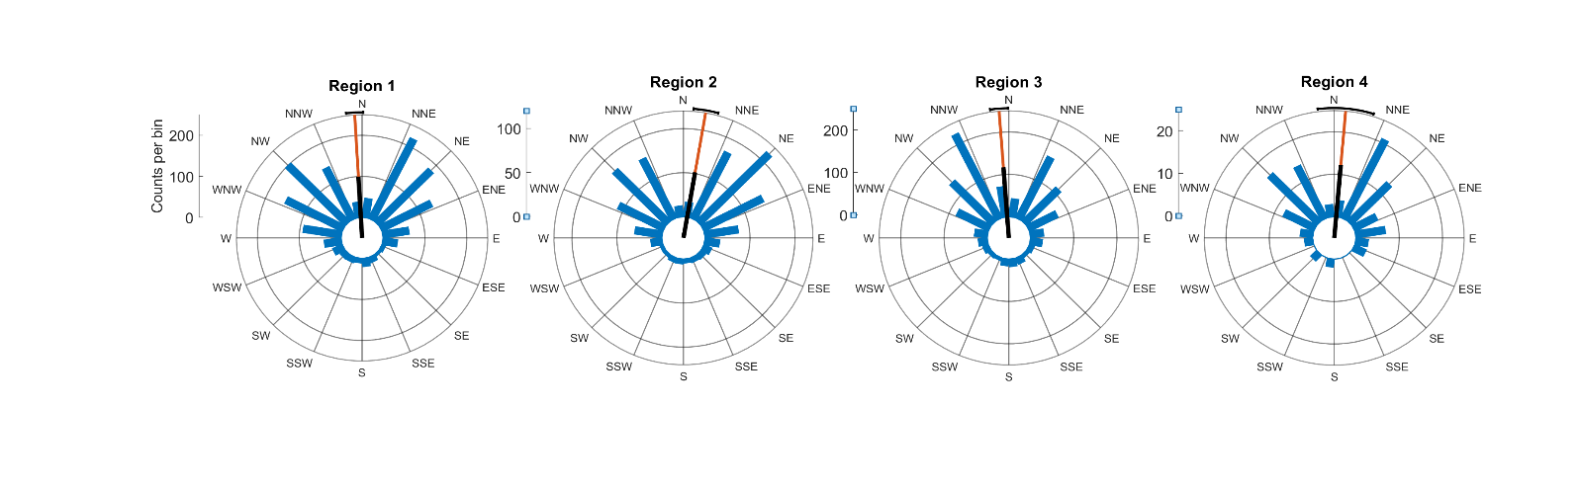

**Fig. S8.** Median aspect ratio of glaciers at 4 sub glacier regions, the black bar is the mean aspect

**Table S2.** Loadings of each original variables based on climatic zones on each principle component



**Table S3.** Loadings of each original variables based on geological classifications on each principle component



**Additional References in Supplementary Material Only**

**Atwood DK, Meyer F and Arendt** **A** (2010) Using L-band SAR coherence to delineate glacier extent. *Canadian Journal of Remote Sensing* **36**(1), 186-S195. Doi: [10.5589/m10-014](https://doi.org/10.5589/m10-014)

**Benn DI and 9 others** (2012) Response of debris-covered glaciers in the Mount Everest region to recent warming, and implications for outburst flood hazards. *Earth-Science Reviews* **114**(1-2), 156-174. doi: [10.1016/j.earscirev.2012.03.008](https://doi.org/10.1016/j.earscirev.2012.03.008)

**Bishop MP, Shroder JF and Hickman BL** (1999) SPOT panchromatic imagery and neural networks for information extraction in a complex mountain environment. *Geocarto International* **14**(2), 19-28. doi: [10.1080/10106049908542100](https://doi.org/10.1080/10106049908542100)

**Bishop MP, Bonk R, Kamp U and Shroder JF** (2001) Terrain analysis and data modeling for alpine glacier mapping. *Polar Geography* **25**(3), 182-201. doi: [10.1080/10889370109377712](https://doi.org/10.1080/10889370109377712)

**Frey H and 9 others** (2014) Estimating the volume of glaciers in the Himalayan–Karakoram region using different methods. *The Cryosphere* **8**(6), 2313-2333. doi: [10.5194/tc-8-2313-2014](https://doi.org/10.5194/tc-8-2313-2014)

**ICIMOD** (2022) Mountain Regions of Hindu Kush Himalayan (HKH) Region [Data set]. Kathmandu, Nepal: International Centre for Integrated Mountain Development doi: [10.26066/RDS.8743](https://doi.org/10.26066/RDS.8743)

**Immerzeel WW and 6 others** (2014) High-resolution monitoring of Himalayan glacier dynamics using unmanned aerial vehicles. *Remote Sensing of Environment* **150**, 93-103. doi: [10.1016/j.rse.2014.04.025](https://doi.org/10.1016/j.rse.2014.04.025)

**Racoviteanu A and Williams MW** (2012) Decision tree and texture analysis for mapping debris-covered glaciers in the Kangchenjunga area, Eastern Himalaya. *Remote sensing* **4**(10), 3078-3109. doi: [10.3390/rs4103078](https://doi.org/10.3390/rs4103078)

**Racoviteanu AE, Paul F, Raup B, Khalsa SJS and Armstrong R** (2009) Challenges and recommendations in mapping of glacier parameters from space: results of the 2008 Global Land Ice Measurements from Space (GLIMS) workshop, Boulder, Colorado, USA. *Annals of Glaciology* **50**(53), 53-69. doi: [10.3189/172756410790595804](https://doi.org/10.3189/172756410790595804)

**Stokes CR, Popovnin V, Aleynikov A, Gurney SD, Shahgedanova M** (2007)Recent glacier retreat in the Caucasus Mountains, Russia, and associated increase in supraglacial debris cover and supra-/proglacial lake development**.** Annals of Glaciology 46, 195-203. doi:10.3189/172756407782871468