Supplementary material to “Up-glacier propagation of surface lowering of Yala Glacier, Langtang Valley, Nepal Himalaya”
Sojiro Sunako, Koji Fujita, Takeki Izumi, Satoru Yamaguchi, Akiko Sakai and Rijan B. Kayastha

Table S1. Summary of the satellite datasets used in this study.
Date | Sensor | Scene ID / dataset name | Resolution | Role
(YYYYMMDD) |  |  | (m)
19881012 | Landsat 5 TM | LT51410401988286BKT00 | 30 | Georectification for MAP-DEM
20091107 | Landsat 5 TM | LT51410402009311KHC00 | 30 | Glacier outlines
20121006 | ASTER | ASTB121006050501 | 15 | Glacier outlines
20151023 | Landsat 8 OLI | LC81410402015296LGN01 | 15 | Glacier outlines
20151229 | World View-1 | HMA_DEM8m_AT_20151229_0721_  10200100496BE700_1020010046506C00 | 8 | Hypsometry calculation
20171022 | Pléiades | PGO_2017-10-22_Langtang | 2 (DEM)  0.5 (ortho) | GCP collection

Table S2. Summary of the camera and SfM processing settings and generated DEM and ortho image details.
Information/Parameter setting | 2007 | 2015
Camera and GCP
Camera | Canon EOS 5D  Canon EOS-1Ds Mark2 | Sony a7R
Focal length (mm) | 27–135 | 28
Number of Images | 14 | 519
Image size (pixels) | 4368 × 2912 (5D)  4992 × 3328 (1Ds Mark2) | 6000 × 4000
GSD* (m) | 1.38 | 0.05
Number of GCPs | 32 | 5
SfM-MVS processing Parameter
Alignment accuracy | Ultra high | High
Number of dense point clouds (×10⁵) | 87 | 1583
Quality for dense point clouds | Ultra high | High
Depth filtering | Moderate | Aggressive
Surface type | Arbitrary | Arbitrary
Face count (×10⁵) | 100 | 709
DEM/Ortho images
Source | Mesh | Mesh
DEM/Ortho Resolution (m) | 2.00/1.38 | 1.00/0.07
DEM size (pixels) | 15667 × 16162 | 3436 × 3499
Ortho image size (pixels) | 3800 × 4983 | 36270 × 35644
* Ground sampling distance.

Table S3. Number of points, mean ($σ_{bias}$), standard deviation ($σ_{stable}$) and uncertainty ($σ_{dh}$) of the elevation changes on the off-glacier area for each analysis period.
Analysis Period | Number of off-glacier points | $σ_{bias}$  (m / m a⁻¹) | $σ_{stable}$  (m / m a⁻¹) | $$σ_{dh}$$  (m / m a⁻¹)
1981–2007 | 7794 | 3.00 / 0.12 | 5.47 / 0.21 | 3.13 / 0.12
2007–2009 | 3459 | −0.35 / −0.17 | 1.53 / 0.77 | 0.49 / 0.24
2009–2012 | 3215 | 0.01 / 0.00 | 0.15 / 0.07 | 0.10 / 0.05
2012–2015 | 864 | 0.08 / 0.02 | 0.41 / 0.10 | 0.53 / 0.13
2007–2015 | 199417 | −0.34 / −0.04 | 1.41 / 0.18 | 0.35 / 0.04

Table S4. Summary of the glacier area estimated via manual delineation and linear estimation.
Year | Area (km²)
 | Manual delineation | Linear estimation
1981 | 2.42 | ––
2007 | 1.91 | 1.74
2009 | 1.84 | 1.69
2012 | 1.66 | 1.61
2015 | 1.54 | ––

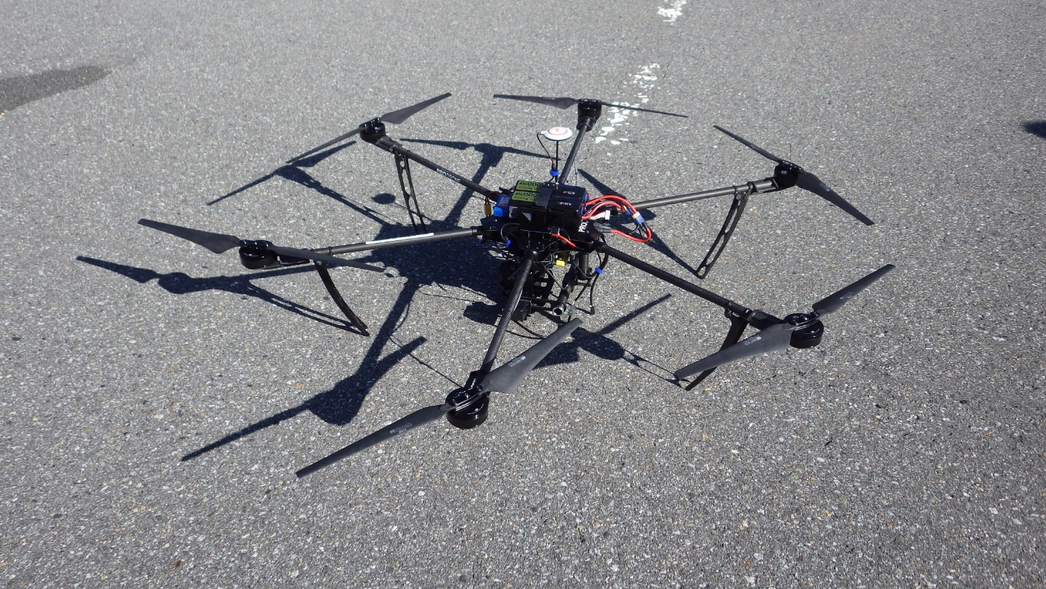

Fig. S1. Image of the hexacopter (PD6-NPL) used in this study. The greatest width is ~1.2 m.

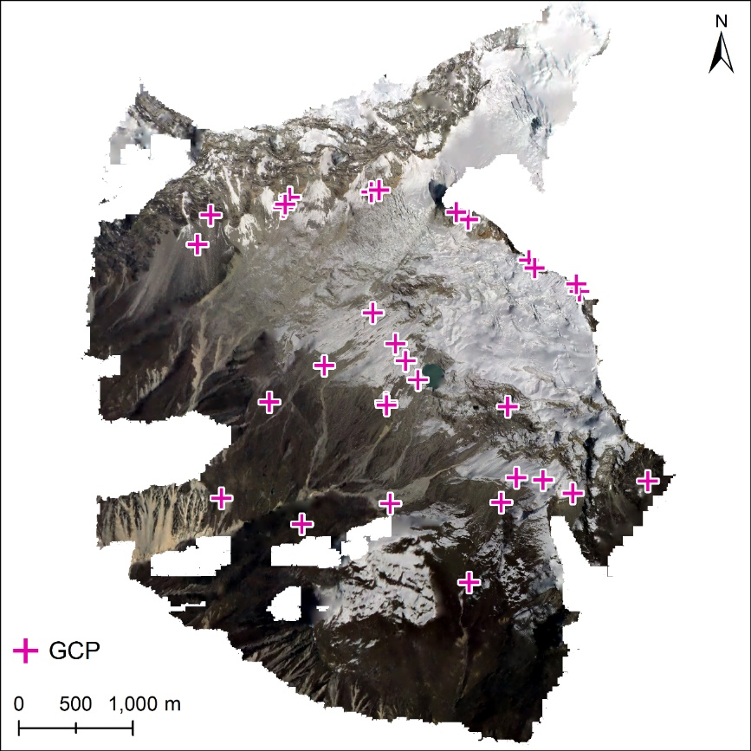

Fig. S2. GCP locations, which were derived from the Pléiades image, used to produce the 2007 DEM and ortho image.

Fig. S3. Histograms of the elevation differences between the 2015 GPS-DEM and the other DEMs. SD_{b} and SD_{a} are the standard deviations of the elevation changes before and after co-registration and bias calibration, respectively.

Fig. S4. Semivariograms of the elevation differences over the off-glacier areas for the five analysed intervals during the 1981–2015 period. Single spherical semivariogram models (red lines) are fitted to the empirical variograms (black dots). Grey lines show the range parameters ($L$). The empirical semivariograms are binned in 50 m intervals, with the exception of the 1981–2007 period, which is binned at 100 m interval to obtain a better fit and capture of the large scale trend.

Fig. S5. Altitudinal distribution of the elevation changes for each calculation period (a–d). Grey dots in (a–d) and dark grey dots in (a) show the elevation change values for the off-glacier areas, respectively.

Fig. S6. Spatial distribution of the elevation changes across Yala Glacier that were derived from: a) and b) Maurer and others (2019), c) Brun and others (2017) and d) Shean and others (2020). The glacier polygon is taken from the GAMDAM Glacier Inventory (Sakai, 2019).

Reference
Sakai A (2019) Brief Communication: Updated GAMDAM Glacier Inventory over the High Mountain Asia. The Cryosphere 13, 2043–2049 (doi:10.5194/tc-13-2043-2019)

