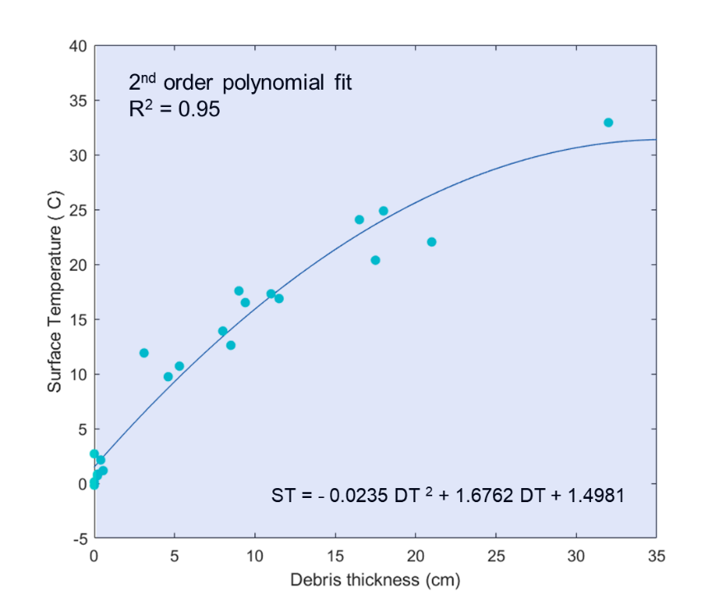
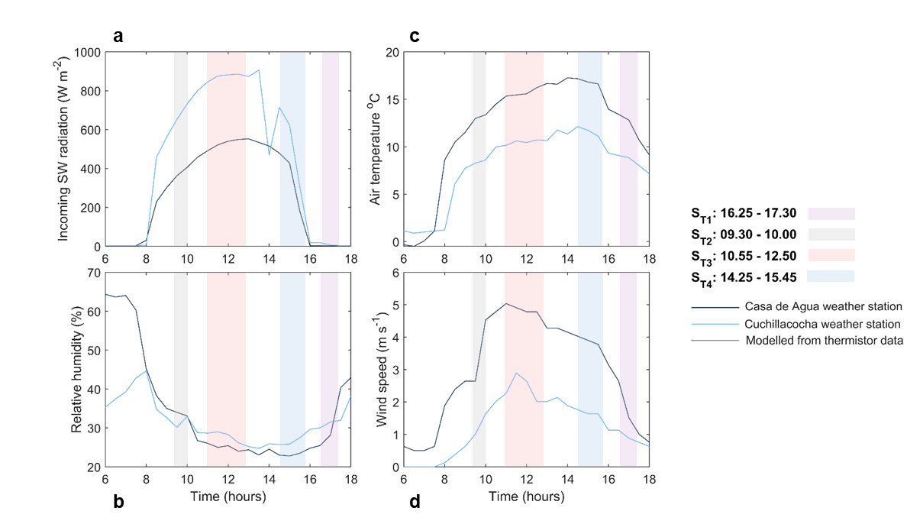
Supplementary material
Figure S2. Ground-based surface temperature and debris thickness measurements. The blue points show the mean surface temperature (measured in-situ with an Apogee TIR radiometer) and corresponding debris thickness (measured in-situ by manual excavation) at each of the 22 measurement sites. The dark blue line shows the 2nd order polynomial fit between debris thickness and surface temperature. The equation of the polynomial and the associated R² value are shown.
Figure S1. Meteorological variability during the thermal UAV surveys. (a)-(d) show the mean incoming shortwave radiation, air temperature, relative humidity and wind speed, respectively, recorded at the Casa de Agua (navy line) and Cuchillacocha (blue line) weather stations, with an average of the values recorded on 18 and 19 August (when the four thermal UAV surveys were conducted) shown. The shaded areas on each of the five plots show the time periods over which thermal UAV surveys were conducted. Note that the survey S_{T1} was conducted on 18 August 2019 while surveys S_{T2}, S_{T3} and S_{T4} were conducted on 19 August 2019.

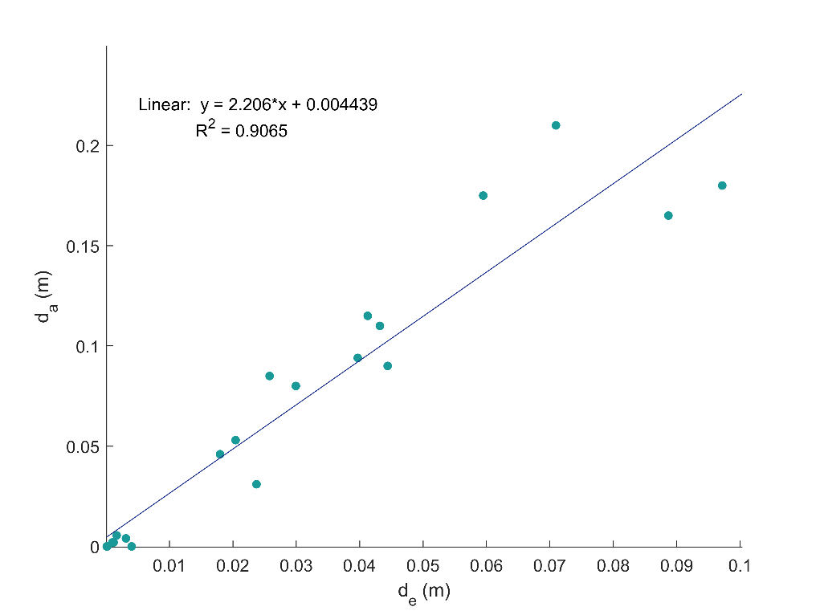
Figure S3. Relationship between expected debris thickness $d_{e}$ (modelled from radiometer-derived surface temperatures, assuming a purely linear vertical temperature gradient) and actual debris thickness $d_{e}$ (measured in-situ). $X$ was calculated as the gradient of the linear relationship between $d_{e}$ and $d_{a}$.

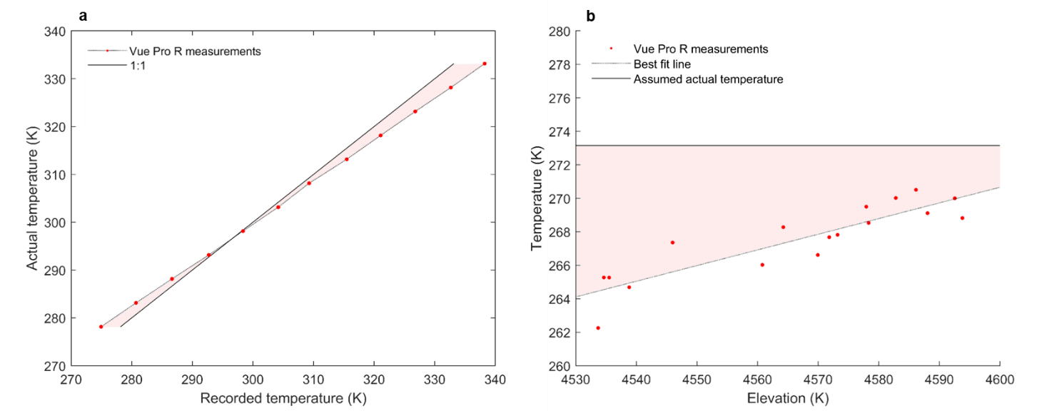
Figure S4. Vue Pro R measurements used for calibration of surface temperature values. The pink shaded area in (a) shows differences between the actual blackbody temperatures and those recorded by the Vue Pro R camera used in this study. These differences were used to calibrate the thermal imagery to account for the effects of sensor bias. The pink shaded area in (b) shows the altitude-dependent differences between the best fit line for altitude-dependent exposed-ice-cliff temperatures recorded by the Vue Pro R camera and actual exposed-ice-cliff surface temperatures, which were assumed to be 0 °C. These differences were used to apply an altitude-dependent correction factor to the sensor-bias-corrected thermal imagery to account for the effects of atmospheric attenuation and sensor drift.

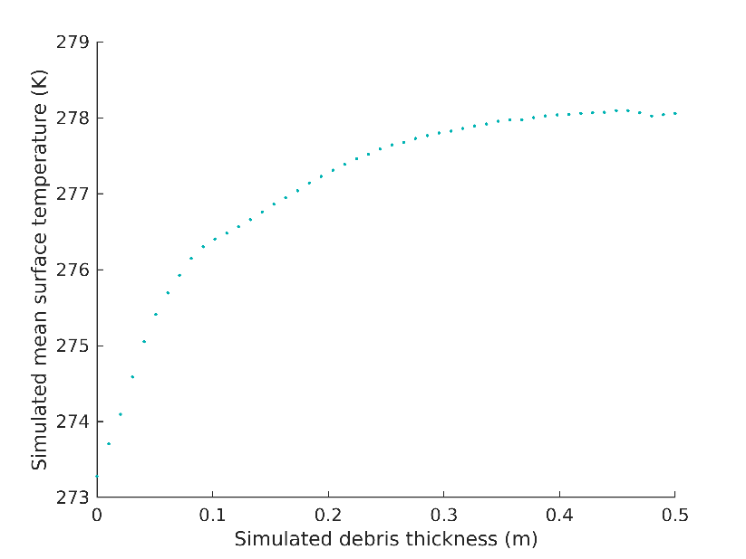

Figure S5. Relationship between modelled debris thickness and simulated mean surface temperature on 19th August 2019. Each point represents mean simulated surface temperature within each debris thickness bin (bin width = 0.01 m).

Table S1. Thermal UAV survey comparison. For each of the four thermal UAV surveys, the variances and standard deviations in recorded surface temperatures (°C) are given. Note that while each of the four surveys cover different areas, similar materials (ice, rock, water) are present within all of the survey areas.

Survey | Date | Time period | Variance | St. dev.
S_{T1} | 18/8/19 | 16.25 - 17.30 | 14.2 | 3.8
S_{T2} | 19/8/19 | 09.10 - 10.00 | 23.6 | 4.9
S_{T3} | 19/8/19 | 10.55 - 12.50 | 35.8 | 6.0
S_{T4} | 19/8/19 | 14.25 - 15.45 | 21.8 | 4.7

Table S2. Debris thickness model comparison. At each of the three locations where debris thickness was measured in-situ, a comparison of the modelled debris thickness values produced from the exponential model and the surface energy balance model is shown.

Debris thickness (cm)
Measured in the field | Modelled
 | Exponential relation | SEB model
~26 | 17.7 | 25.6
~22 | 17.3 | 20.6
~3-5 | 5.3 | 3.9

Table S3. Debris thickness model sensitivity analysis results. Changes in the mean modelled debris thickness in response to changes in input parameter values are shown. The uncertainties associated with each input parameter and the contribution of these uncertainties towards the overall uncertainty in the mean modelled debris thickness are also shown.
Model input parameter | Input parameter change | Mean change in $d$ (m) | Input parameter uncertainty | Overall uncertainty contribution (%)
$$T_{s}$$ | +1 °C  -1 °C | +0.035  -0.029 | ±1°C | 14.4
$$k_{eff}$$ | +0.1 Wm⁻² K⁻¹  -0.1 Wm⁻² K⁻¹ | +0.025  -0.025 | ±0.12 Wm⁻² K⁻¹ | 12.6
$${SW}_{in}$$ | +10 %  -10 % | -0.039  +0.052 | ±5 % | 7.4
$${LW}_{in}$$ | +10 %  -10 % | -0.019  +0.021 | ±4.5 % | 1.1
$$T_{air}$$ | +1 °C  -1 °C | -0.014  +0.017 | ±0.5 °C | 0.9
$$u$$ | +1 m s⁻¹  -1 m s⁻¹ | +0.020  -0.033 | ±0.3 m s⁻¹ | 0.9
$$α$$ | +0.1  -0.1 | +0.074  -0.053 | ±0.1 | 57.9
$$ε$$ | +0.02  -0.02 | +0.004  -0.004 | ±0.02 | 0.2
$$z_{0}$$ | +0.006  -0.006 | +0.011  -0.016 | ±0.001 | 0.1
$$X$$ | +10 %  -10 % | +0.018  -0.018 | ±0.1 | 4.5

Table S4. Sub-debris melt model sensitivity analysis results. Changes in the mean simulated sub-debris melt in response to changes in input parameter values are shown. The uncertainties associated with each input parameter and the contribution of these uncertainties towards the overall uncertainty in the mean simulated sub-debris melt rate are also shown.

Model input parameter | Input parameter change | Mean change in $M$ (cm d⁻¹) | Input parameter uncertainty | Overall uncertainty contribution (%)
$$d$$ | +10%  -10% | -0.035  0.039 | 44 % | 32.3
$$k_{eff}$$ | +0.1 Wm⁻² K⁻¹  -0.1 Wm⁻² K⁻¹ | 0.045  -0.050 | ±0.12 Wm⁻² K⁻¹ | 3.8
$${SW}_{in}$$ | +10%  -10% | 0.144  -0.143 | ±5 % | 6.0
$${LW}_{in}$$ | +10%  -10% | 0.158  -0.155 | ±4.5 % | 5.8
$$T_{air}$$ | +1°C  -1°C | 0.077  -0.076 | ±0.5 °C | 1.7
$$u$$ | +1 m s⁻¹  -1 m s⁻¹ | 0.074  -0.110 | ±0.3 m s⁻¹ | 1.0
$$α$$ | +0.1  -0.1 | -0.204  0.205 | ±0.1 | 48.7
$$ε$$ | +0.02  -0.02 | 0.034  -0.033 | ±0.02 | 1.3

Sensitivity analyses
The debris thickness model and the sub-debris melt model used in this study may be affected by uncertainties associated with input parameters. Surface temperature ($T_{s})$ inputs to the debris thickness model are likely to be affected by thermal camera accuracy and calibration accuracy, while effective conductivity ($k_{eff})$ may be impacted by thermistor accuracy. Meteorological inputs to both the debris thickness model and the sub-debris melt model, including incoming shortwave and longwave radiation (${SW}_{in}$ and ${LW}_{in}$), air temperature $(T_{air}$) and wind speed ($u$), may be impacted by instrument accuracy, as well as uncertainties associated with the transferability of measurements recorded at the weather stations to meteorological conditions on Llaca glacier tongue. Inaccuracies in the albedo ($α)$ and emissivity ($ε$) values assigned to different surface materials could also potentially impact model outputs, as could the surface roughness length ($z_{0}$) assigned to the glacier surface. The sensitivity of the debris thickness model and sub-debris melt model to each of these parameters were tested and the results are shown in Tables S3 and S4.
Error analyses
To estimate the uncertainty associated with the mean debris thickness modelled across the study area, uncertainties associated with each model input parameter were propagated (equation 11) using the calculated model sensitivities. The same approach was used to estimate the uncertainty associated with the mean sub-debris melt rate simulated across the study area over the 93-day model period. Details on the uncertainties associated with each model input parameter (shown in column 4 of Tables S3 and S4) are detailed below.
We assume that the error in $T_{s}$ is composed of an uncertain but spatially-uniform bias, as well as a spatially variable non-correlated noise. We expect the overall error resulting from the latter is small, since the measured surface temperatures of the exposed ice on the surface of supraglacial ice cliffs of similar elevation varied minimally, and furthermore do not consider it in our calculations. The measured surface temperatures of exposed ice cliffs did vary with altitude; however, this was likely the result of a systematic bias linked to the changing sensor-target distance (since the UAV was flown at a consistent altitude relative to sea-level, while the glacier surface was sloping), which was corrected for using an altitude-dependent calibration (detailed further in Section 2.4.2). The Vue Pro R thermal camera used to collect surface temperature data has an accuracy of ± 5 °C; we assume however that this accuracy was improved ± 1 °C following calibration of $T_{s}$, and consider this to be the standard deviation of the spatially-uniform bias. Uncertainty in $k_{eff}$ was estimated based on the mean of the standard deviations in the gradients between $\frac{∂T}{∂t}$ and $\frac{∂^{2}T}{∂z^{2}}$ (equation 1) (which gives the uncertainty in $K$), which was propagated through equation 2 (Section 2.5.1) to find the uncertainty in $k_{eff}$. As the exact models of the meteorological sensors at the Cuchillacocha weather station are unknown, uncertainty in ${SW}_{in}$, $T_{air}$ and $u$ were estimated based on the upper end of accuracies reported by the standard manufacturers of meteorological sensors. The accuracies reported for standard meteorological sensors for measuring $T_{air}$ $T_{air}$and $RH$ were propagated through equations 4-5 to estimate the uncertainty associated with the mean ${LW}_{in}$. Uncertainty in $α$ was estimated based on the range of albedo values previously observed on debris-covered glaciers in the Himalaya (e.g. Kayastha et al., 2000; Nicholson and Benn, 2012). Uncertainty in $ε$ as estimated based on the range of values reported by Salisbury and D’Aria (1992). Uncertainty in $z_{0}$ was estimated based on the 95% confidence interval reported by Brock et al. (2010). Uncertainty in $X$ was estimated from the standard deviation in the gradient between expected and actual surface temperatures ($\frac{d_{a}}{d_{e}}$) (equation 3). The uncertainty in $d$ (as an input parameter to the sub-debris melt model) was estimated based on the uncertainty in mean modelled debris thickness ($σ_{d}$) as a percentage of the mean debris thickness.
The percentage contribution of each of the model input parameters towards overall uncertainty in mean modelled debris thickness ($σ_{d}$) and mean simulated sub-debris melt rate ($σ_{M}$) are shown in the final column of Tables S3 and S4.

