Supporting Information for: Terminus change of Kaskawulsh Glacier, Yukon, under a warming climate: retreat, thinning, slowdown, and modified proglacial lake geometry
Authors: Brittany Main^{1, 2}, Luke Copland¹, Braden Smeda¹, Will Kochtitzky^{1,3}, Sergey Samsonov², Jonathan Dudley², Mark Skidmore⁴, Christine Dow⁵, Wesley VanWychen⁵, Dorota Medrzycka¹, Eric Higgs⁶, Laurent Mingo⁷
¹ Department of Geography, Environment and Geomatics, University of Ottawa, Ottawa, ON, Canada
² Canadian Centre for Mapping and Earth Observations, Natural Resources Canada, Ottawa, ON, Canada
³ School of Marine and Environmental Programs, University of New England, Biddeford, ME, USA
⁴ Department of Earth Sciences, Montana State University, Bozeman, MT, USA
⁵ Department of Geography and Environmental Management, University of Waterloo, Waterloo, ON, Canada
⁶ School of Environmental Studies, University of Victoria, BC, Canada
⁷ Blue System Integration Ltd., Vancouver, BC, Canada

Correspondence to: brittany.main@uottawa.ca
Supporting Text:
1. Changes in lake surface elevation, volume, and depth of proglacial lake
ASTER optical imagery was imported into ArcGIS (version 10.7), and visual inspection was undertaken to check for georeferencing, and any mismatches were realigned using the “shift” tool. The ortho-imagery was aligned using a bedrock outcrop on the north side of the glacier, the bedrock knob near the centre of the glacier terminus, and the mountains on the south side of the glacier. The lake outlines were then drawn using the “create features” tool in ArcGIS (version 10.7), and the area and perimeter were computed using the “compute geometries” tool. To ensure accuracy, a minimum of 75 points were used to delineate each outline.
Lake outlines from July 25, 2015 (before the drainage) and June 10, 2016 (after the drainage) were overlain, and the “erase” tool in ArcGIS (version 10.7) was used to isolate the area of newly exposed lakebed. The topography of the drained lakebed was extracted from the July 28/August 1, 2021 SfM DEM and converted into a Triangular Irregular Network, which was used as an input for the “polygon volume” tool in ArcGIS (version 10.7). This tool calculates the volume of a polygon beginning from a defined reference plane; this value was set at the lowest elevation of the 2016 drained lake surface (782.3 m asl), which was 14.6 m lower than the 2015 lake surface. This was then multiplied by the area of the 2016 lake and added to the 2015 drained lakebed volume to obtain the total lake volume change. The same process was used to calculate the change in lake volume between 2016 and 2021, which showed a 5.8 m decrease in water surface elevation.

2. Trend analysis
A custom R script was used to obtain velocity and elevation trends, by calculating descriptive statistics (e.g. mean, standard deviation, maximum/minimum values) on a pixel-by-pixel basis on stacked time-series of rasters. This script was run separately on multiple sequences of elevation rasters (using DEMs listed in Table 2) and velocity rasters (detailed below). A simple one-step linear regression was used to calculate each pixel’s slope and significance. Some of the rasters required resampling to ensure that each had the same extent and resolution, which was undertaken using the bilinear interpolation method in ArcGIS (version 10.7) before undertaking the trend analysis. A comparison with the Shean (2021) makestack.py method showed nearly identical results, with differences primarily due to the raster resampling process.
To assess the impact of the proglacial lake drainage on surface velocity, the mathematical slope of each pixel value through time was calculated separately for velocity rasters from 2010-2015 and 2016-2021 (Table S5). To obtain average trends for the entire terminus region, and for the north lobe and the south lobe separately, the “zonal statistics” tool was used in ArcGIS (version 10.7) to calculate the mean of the mathematical slope over each specific area. Velocities within 500 m of the front of the glacier were excluded due to large inaccuracies in the velocity data in this region associated with rapid changes and calving at the terminus, and regions of heavily debris-covered dead ice.

Supplementary References:
Shean, DE (2021) pygeotools Documentation. Release 0.2.0. https://pygeotools.readthedocs.io/en/latest/readme.html
Supplementary Figures:
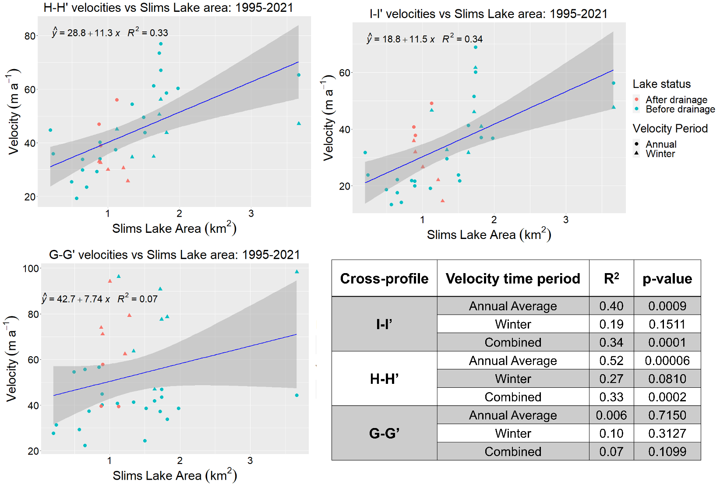
Figure S1. A comparison of ITS_LIVE, ALOS-PALSAR, RADARSAT-2 and RCM derived velocities (m a⁻¹) vs. Slims Lake area (km²) at the three cross-profiles I-I’, H-H’ and G-G’ (Fig.1) from 1995-2021. Solid blue line shows the 1:1 relationship between the two variables, with a confidence interval of 95% (shaded zone). Table contains corresponding regression analysis (R² and p-values) for the linear model, divided based on seasonal time-period (winter vs. annual averages) and by cross-profile location (Fig. 1).

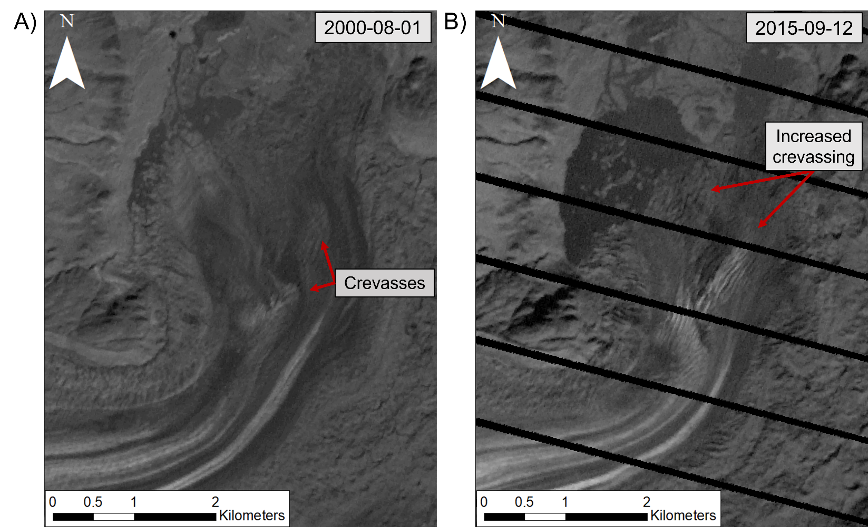
Figure S2. A comparison of crevassing extent and intensity at Kaskawulsh Glacier terminus between (a) 2000 and (b) 2015. Landsat-7, band 8 imagery (15 m resolution). Projection: UTM Zone 7N. Dates are in YYYY-MM-DD.

Table S1. List of optical data used in this study. Dates are in YYYY-MM-DD for data from 1956 onwards.
Platform | Date | Resolution (m) | Purpose
Historical Photos | 1899 & 1900 | NA | Determination of terminus extent
Air Photo Mosaic (1:70,000) | 1956-09-10 | 10 | Determination of proglacial lake and terminus extent
Landsat-1 | 1972-09-02 | 60 | Determination of proglacial lake and terminus extent
Landsat-1 | 1975-08-18 | 60 | Determination of proglacial lake and terminus extent
Landsat-2 | 1980-06-25 | 60 | Determination of proglacial lake and terminus extent
Landsat-5 | 1990-07-20 | 30 | Determination of proglacial lake and terminus extent
Landsat-5 | 1995-06-09 | 30 | Determination of proglacial lake and terminus extent
Landsat-5 | 1996-07-13 | 30 | Determination of proglacial lake extent
Landsat-5 | 1997-06-30 | 30 | Determination of proglacial lake extent
Landsat-5 | 1998-08-20 | 30 | Determination of proglacial lake extent
Landsat-5 | 1999-08-23 | 30 | Determination of proglacial lake extent
Landsat-7 | 2000-07-07 | 15 | Determination of terminus extent
Landsat-7 | 2000-08-01 | 15 | Determination of proglacial lake extent, crevasse analysis
Landsat-7 | 2001-07-19 | 15 | Determination of proglacial lake and terminus extent
Landsat-7 | 2002-06-20 | 15 | Determination of proglacial lake extent
Landsat-7 | 2002-07-06 | 15 | Determination of terminus extent
Landsat-5 | 2003-08-25 | 30 | Determination of proglacial lake and terminus extent
Landsat-5 | 2004-08-20 | 30 | Determination of proglacial lake and terminus extent
Landsat-5 | 2005-07-11 | 30 | Determination of proglacial lake and terminus extent
Landsat-7 | 2006-08-09 | 15 | Determination of proglacial lake and terminus extent
Landsat-5 | 2007-06-01 | 30 | Determination of proglacial lake and terminus extent
Landsat-7 | 2008-06-11 | 15 | Determination of proglacial lake and terminus extent
Landsat-7 | 2009-06-11 | 15 | Determination of proglacial lake extent
Landsat-7 | 2009-08-26 | 15 | Determination of terminus extent
Landsat-7 | 2010-05-25 | 15 | Seasonal comparison of proglacial lake extent
Landsat-7 | 2010-08-04 | 15 | Determination of terminus extent
Landsat-7 | 2010-09-14 | 15 | Determination of proglacial lake extent
Landsat-5 | 2011-06-23 | 30 | Determination of terminus extent
Landsat-7 | 2011-07-22 | 15 | Determination of proglacial lake
Landsat-7 | 2012-06-06 | 15 | Determination of proglacial lake extent
Landsat-7 | 2012-08-18 | 15 | Determination of terminus extent
Landsat-7 | 2013-05-25 | 15 | Seasonal comparison of proglacial lake extent
Landsat-7 | 2013-09-13 | 15 | Determination of proglacial lake and terminus extent
Landsat-8 | 2014-07-22 | 15 | Determination of proglacial lake and terminus extent
Landsat-8 | 2015-07-25 | 15 | Determination of proglacial lake extent
Landsat-8 | 2015-08-03 | 15 | Determination of terminus extent
RapidEye-3 | 2015-09-08 | 5 | Background imagery, determination of terminus extent
Landsat-7 | 2015-09-12 | 15 | Crevasse analysis
Landsat-8 | 2016-07-04 | 15 | Determination of proglacial lake extent
Sentinel-2 | 2016-09-25 | 10 | Determination of terminus extent
Sentinel-2 | 2017-06-19 | 10 | Seasonal comparison of proglacial lake extent
Sentinel-2 | 2017-08-08 | 10 | Determination of proglacial lake and terminus extent
Sentinel-2 | 2018-07-04 | 10 | Seasonal comparison of proglacial lake extent
Sentinel-2 | 2018-08-18 | 10 | Determination of proglacial lake and terminus extent
Sentinel-2 | 2019-06-14 | 10 | Seasonal comparison of proglacial lake extent
Sentinel-2 | 2019-08-03 | 10 | Background imagery for maps
Sentinel-2 | 2019-09-05 | 10 | Determination of proglacial lake and terminus extent
Sentinel-2 | 2020-09-06 | 10 | Determination of proglacial lake and terminus extent
Sentinel-2 | 2021-05-19 | 10 | Determination of proglacial lake extent
Sentinel-2 | 2021-06-01 | 10 | Determination of proglacial lake extent
Sentinel-2 | 2021-07-31 | 10 | Determination of proglacial lake extent
Sentinel-2 | 2021-09-19 | 10 | Determination of proglacial lake extent

Table S2. List of DEMs used in this study.
Date  (yyyy-mm-dd) | Platform | Resolution (m) | Uncertainty (m) |  | Purpose
 |  |  | Vertical | Horizontal
2003-05-06 | ASTER | 30 | 10 | 2 | Determination of glacier ice elevation, ice elevation trend & ice volume loss
2006-07-12
2016-06-10
2018-05-08
2020-07-16
2012-10-29 | SETSM WorldView | 30 | 10 | 2 | Determination of glacier ice elevation & ice elevation trend
2014-11-14
2021-07-28; 2021-08-01 | Fixed Wing Aircraft | 0.5 |  |  | Determination of glacier terminus floatation status, drained lake volumes & proglacial lake surface height

Table S3. Change in proglacial lake area at Kaskawulsh Glacier, 1956-2021.
Date  (yyyy-mm-dd) | North: Slims Lake (km²) | Uncertainty (km²) | South: Kaskawulsh Lake (km²) | Uncertainty (km²)
1956-09-10 | 0.66 | 0.1 | 0.35 | 0.1
1972-09-02 | 0.21 | 0.1 | 1.44 | 0.4
1975-08-18 | 0.46 | 0.3 | - | -
1980-06-25 | 0.04 | 0.1 | 1.36 | 0.5
1990-07-20 | 0.00 | - | 1.13 | 0.2
1995-06-09 | 0.19 | 0.1 | - | -
1996-07-13 | 0.23 | 0.2 | - | -
1997-06-30 | 0.65 | 0.3 | - | -
1998-08-20 | 0.71 | 0.2 | - | -
1999-08-23 | 0.56 | 0.2 | - | -
2000-08-01 | 0.49 | 0.1 | 1.35 | 0.1
2001-07-19 | 0.65 | 0.1 | - | -
2002-06-20- | 0.85 | 0.1 | - | -
2003-08-25 | 0.89 | 0.3 | - | -
2004-08-20 | 0.89 | 0.3 | - | -
2005-07-11 | 1.11 | 0.4 | 1.60 | 0.3
2006-08-09 | 1.51 | 0.2 | - | -
2007-06-01 | 1.49 | 0.2 | - | -
2008-06-11 | 1.34 | 0.1 | - | -
2009-06-11 | 1.98 | 0.1 | - | -
2010-09-14 | 1.81 | 0.1 | 1.96 | 0.2
2011-07-22 | 1.78 | 0.2 | - | -
2012-06-06 | 1.72 | 0.1 | - | -
2013-09-13 | 1.73 | 0.1 | - | -
2014-07-22 | 1.73 | 0.2 | - | -
2015-07-25 | 3.66 | 0.2 | 2.69 | 0.2
2016-07-04 | 1.13 | 0.1 | 3.15 | 0.1
2017-08-08 | 0.87 | 0.1 | - | -
2018-08-18 | 0.89 | 0.1 | 2.50 | 0.1
2019-09-05 | 1.00 | 0.1 | 1.76 | 0.1
2020-09-06 | 1.22 | 0.1 | 1.26 | 0.1
2021-05-19 | 1.23 | 0.1 | 1.03 | 0.1
2021-06-01 | 1.23 | 0.1 | 1.14 | 0.1
2021-07-31 | 1.36 | 0.1 | 3.01 | 0.2
2021-09-12 | 1.2 | 0.1 | 0.99 | 0.1

Table S4. Summary of SAR imagery used to derive glacier surface velocities in this study. RCM = RADARSAT Constellation Mission; FBS = Fine-beam single; F = Fine; UF = Ultra-fine; M = Medium. Velocity error was calculated from the mean of apparent motion over stable ground adjacent to the glaciers.
Sensor | Beam Path/ Swath | Date 1 | Date 2 | Resolution (m) | Mode | Velocity error (m a⁻¹)
ALOS PALSAR | 245 | 2007-12-21 | 2008-02-05 | 10 | FBS | 8.5 - 15.0
ALOS PALSAR | 243 | 2008-01-02 | 2008-02-17
ALOS PALSAR | 241 | 2008-01-14 | 2008-02-29
ALOS PALSAR | 242 | 2009-12-21 | 2010-02-05
ALOS PALSAR | 240 | 2010-01-02 | 2010-02-17
ALOS PALSAR | 244 | 2010-01-24 | 2010-03-11
RADARSAT-2 | F6 | 2011-01-03 | 2011-01-27 | 8 | F | 16.6
RADARSAT-2 |  | 2011-01-27 | 2011-02-20
RADARSAT-2 |  | 2011-02-20 | 2011-03-16
RADARSAT-2 | F6F | 2011-01-13 | 2011-02-06
RADARSAT-2 |  | 2011-02-06 | 2011-03-02
RADARSAT-2 |  | 2011-03-02 | 2011-03-26
RADARSAT-2 | F2N | 2010-12-31 | 2011-01-24
RADARSAT-2 |  | 2011-01-24 | 2011-02-17
RADARSAT-2 |  | 2011-02-17 | 2011-03-13
RADARSAT-2 | U10W2 | 2012-02-18 | 2012-03-13 | 3 | UF | 12.7
RADARSAT-2 |  | 2012-03-13 | 2012-04-06
RADARSAT-2 | U9W2 | 2012-02-21 | 2012-03-16
RADARSAT-2 |  | 2012-03-16 | 2012-04-09
RADARSAT-2 | U7W2 | 2014-02-03 | 2014-02-27 | 3 | UF | 7.2
RADARSAT-2 |  | 2014-02-27 | 2014-03-23
RADARSAT-2 | U17W2 | 2014-02-24 | 2014-03-20
RADARSAT-2 |  | 2014-03-20 | 2014-04-13
RADARSAT-2 | U7W2 | 2015-01-29 | 2015-02-22 | 3 | UF | 8.4
RADARSAT-2 |  | 2015-02-22 | 2015-03-18
RADARSAT-2 | U17W2 | 2015-02-19 | 2015-03-15
RADARSAT-2 |  | 2015-03-15 | 2015-04-08
RADARSAT-2 | U7W2 | 2016-01-24 | 2016-02-17 | 3 | UF | 6.7
RADARSAT-2 |  | 2016-02-17 | 2016-03-12
RADARSAT-2 | U17W2 | 2016-02-14 | 2016-03-09
RADARSAT-2 | U7W2 | 2017-01-18 | 2017-02-11 | 3 | UF | 5.6
RADARSAT-2 |  | 2017-02-11 | 2017-03-07
RADARSAT-2 | U17W2 | 2017-01-15 | 2017-02-08
RADARSAT-2 |  | 2017-02-08 | 2017-03-04
RADARSAT-2 | U7W2 | 2018-01-13 | 2018-03-02 | 3 | UF | 2.5
RADARSAT-2 | U6W2 | 2019-04-07 | 2019-05-01 | 3 | UF | 6.5
RADARSAT-2 | U17W2 | 2019-04-11 | 2019-05-05
RADARSAT-2 | U17W2 | 2020-01-24 | 2020-02-17 | 3 | UF | 5.4
RADARSAT-2 | U6W2 | 2020-01-27 | 2020-02-20
RCM | 15 | 2021-01-02 | 2021-01-14 | 16 | M | 14.7

Table S5. Analysis of mean trends in velocity for 2010-2015 and 2016-2021 from RADARSAT-2 and RCM image pair velocity rasters for the terminus region, as defined by the 2020 terminus outline shown in Figure 5, with the centreline along the medial moraine serving as the division between the two lobes (Fig.1). Note the north lobe feeds into Slims Lake, and south lobe feeds into Kaskawulsh Lake. The trends from 2010-2015 are not significant at the 95% confidence level, as p-values are greater than 0.05.

Time Period | Velocity Trend (m a⁻²) |  |  | p-value
 | North Lobe | South Lobe | Terminus Average | North Lobe | South Lobe | Terminus Average
2010-2015 | 3.6 | 2.9 | 2.0 | 0.14 | 0.09 | 0.39
2016-2021 | -4.0 | -2.9 | -3.5 | 0.03 | 0.03 | 0.03

