Glacier inventory and glacier changes (1994-2020) in the Upper Alaknanda Basin, Central Himalaya
Mishra and others (2022)

Supplementary Material
Table S1: Statistics of the CRU climate data (1901-2019). (Z-Mann Kandell statistics and β-Sen’s slope)
 |  | Z | p-value | β
30.75,79.25 | T_{A} (⁰C) | 5.42 | 0.0000 | 0.01
 | P_{A} (mm) | -2.77 | 0.0057 | -0.95
30.75,79.75 | T_{A} (⁰C) | 5.53 | 0.0000 | 0.01
 | P_{A} (mm) | -3.18 | 0.0015 | -1.03
Average Both grid | T_{A} (⁰C) | 5.48 | 0.0000 | 0.01
 | P_{A} (mm) | -2.95 | 0.0032 | -1.00
T_{A}- Annual temperature and P_{A}- Annual Precipitation
Table S2: Area changes (1994-2020) according to their morphology.
Glacier type | No | 1994 | 2020 | Area Change (km²) | Fractional Change (%) | Rate (%a⁻¹)
Cirque | 26 | 14.39 | 13.15 | 1.24 | 8.62 | 0.33
Compound | 11 | 185.03 | 182.38 | 2.65 | 1.43 | 0.06
Hanging | 40 | 31.04 | 28.19 | 2.85 | 9.18 | 0.35
Mountain | 69 | 53.81 | 48.12 | 5.69 | 10.57 | 0.41
Simple | 29 | 84.33 | 81.14 | 3.19 | 3.78 | 0.15
Total | 175 | 368.60 | 353.0 | 15.62 | 4.24 | 0.16

Table S3. Annual and seasonal trend analysis for the climatic records (1901-2019 & 1990-2019). (Z-Mann-Kendall test statistics, S-Sen’s slope estimator, M-Long term mean).
Period | 1901-2019 |  |  |  | 1990-2019
 | Z | β | M | Change  (⁰C/mm) | Z | β | M | Change  (⁰C/mm)
Mean Annual Temperature (⁰C) | 5.48 | 0.01 | 2.20 | 0.54 | 3.64 | 0.04 | 2.65 | 0.45
Mean Annual Precipitation (mm) | -2.95 | -1.0 | 695 | -0.17 | 0.57 | 1.66 | 642 | 0.08
Summer Temperature (⁰C) | 1.99 | 0.003 | 7.66 | 0.05 | 3.94 | 0.03 | 7.90 | 0.11
Summer Precipitation (mm) | -1.97 | -0.53 | 527 | -0.12 | 1.21 | 3.02 | 494 | 0.18
Winter Temperature (⁰C) | 6.56 | 0.01 | -3.25 | -0.37 | 2.89 | 0.05 | -2.60 | -0.58
Winter Precipitation (mm) | -2.59 | -0.43 | 168 | -0.30 | -0.89 | -1.40 | 148 | -0.28

Table S4: Comparison of different available glacier inventories with the present UAB inventory.
Glacier Size (km2) | RGI (2017) |  | ICIMOD (2011) |  | GSI (2008) |  | GAMDAM (2019) |  | Present study
 | Numbers | Total Area | Numbers | Total Area | Numbers | Total Area | Numbers | Total Area | Numbers | Total Area
<0.5 | 128 | 27.3 | 245 | 33.4 | 69 | 15.7 | 214 | 30.9 | 106 | 21.6
0.5-1.0 | 36 | 25.1 | 43 | 28.8 | 37 | 26.3 | 40 | 28.4 | 35 | 22.9
1.0-5.0 | 44 | 90.10 | 35 | 77.9 | 34 | 78.9 | 46 | 93.6 | 41 | 84.5
05.0-10.0 | 7 | 51.10 | 5 | 39.2 | 5 | 39.2 | 10 | 74.4 | 6 | 46.2
>10 | 8 | 160.50 | 10 | 175.5 | 14 | 276.7 | 8 | 183.2 | 10 | 179.4
Total | 223 | 354.02 | 338 | 354.78 | 159 | 436.88 | 318 | 410.46 | 198 | 354.6

Figure S1: Calculation of glacier length changes by drawing parallel lines.
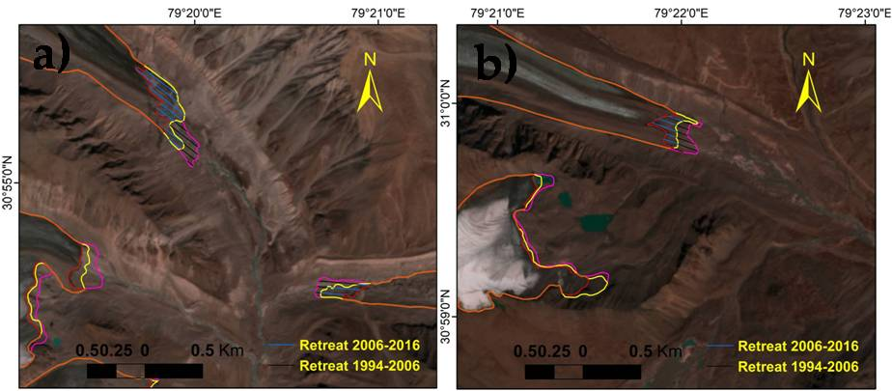

Figure S2. Trend analysis showing annual, summer (April-Sep) and winter (Oct-Mar), variations in temperature (left) and precipitation (right) during 1901-1990 & 1990-2019.

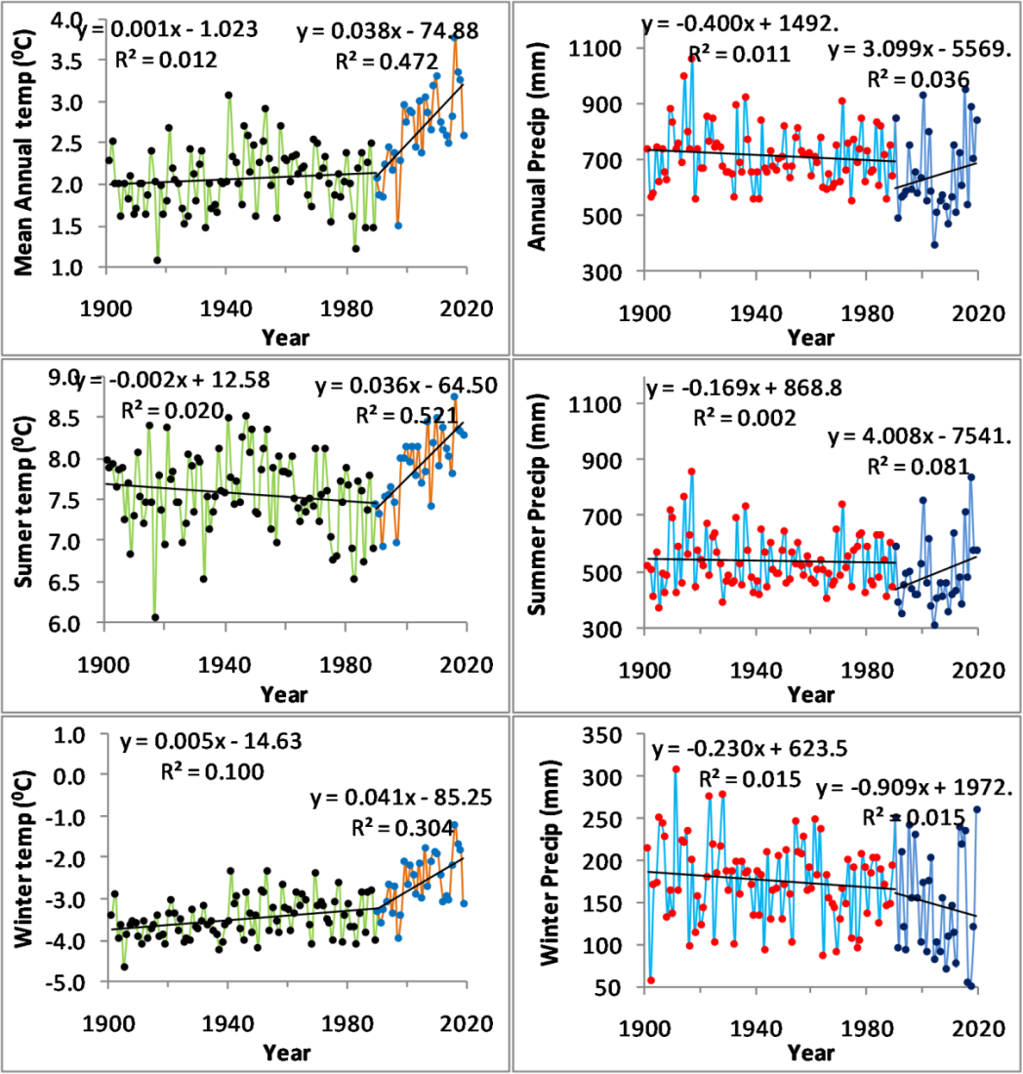
Figure S3: Comparison of glacier inventories (RGI (2016), ICIMOD (2011), GAMDAM (2019)). RGI and GAMDAM inventories have shown combined frontal area of Satopanth and Bhagirath Kharak glaciers and over and under estimated at many places. Seasonal snow packs and avalanche cones were marked as glacier boundary. Field photographs show (b) snow packs; (c) Avalanche cones & (d) two nearby compound basin valley thick debris covered glaciers separated by outwash plane.
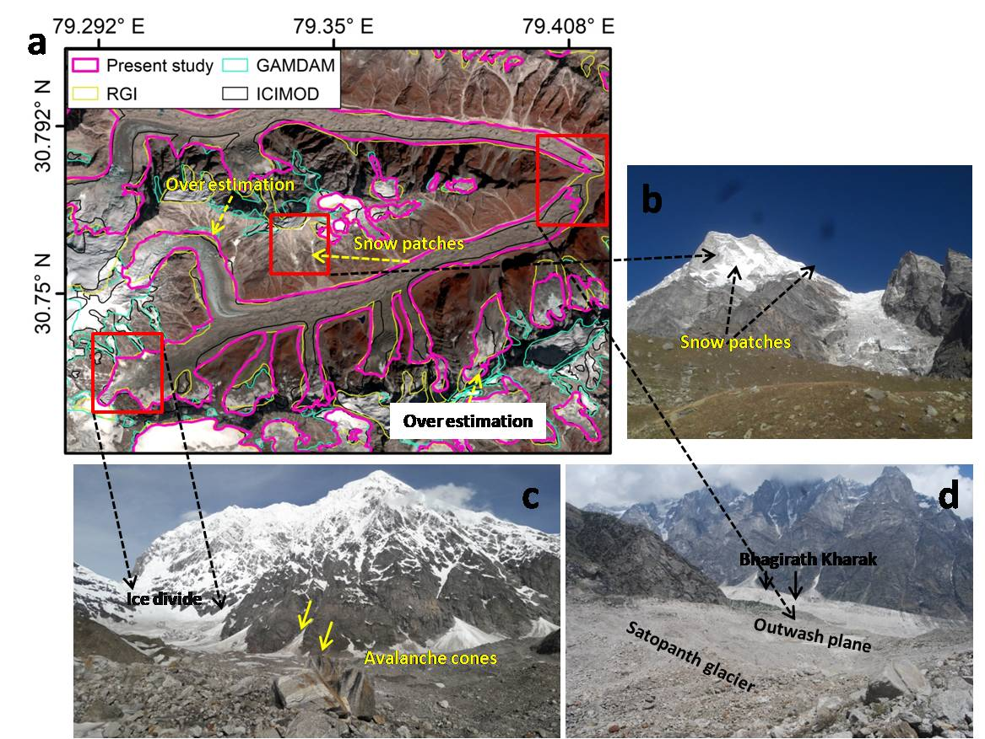

Figure S4: Correlation of non-climatic parameters with the area change (%) during the study period (1994-2020).
