Supplementary materials for “Large-ensemble climate simulations to assess changes in snow stability over northern Japan”
¹Yuta Katsuyama, ¹Takafumi Katsushima, and ¹Yukari Takeuchi
¹Tohkamachi Experimental Station, Forestry and Forest Products Research Institute, Tokamachi, 9480013, Japan
Corresponding author: Yuta Katsuyama

Supplement 1: Examples of hourly time-series of SWE in the historical experiment at Tokamachi
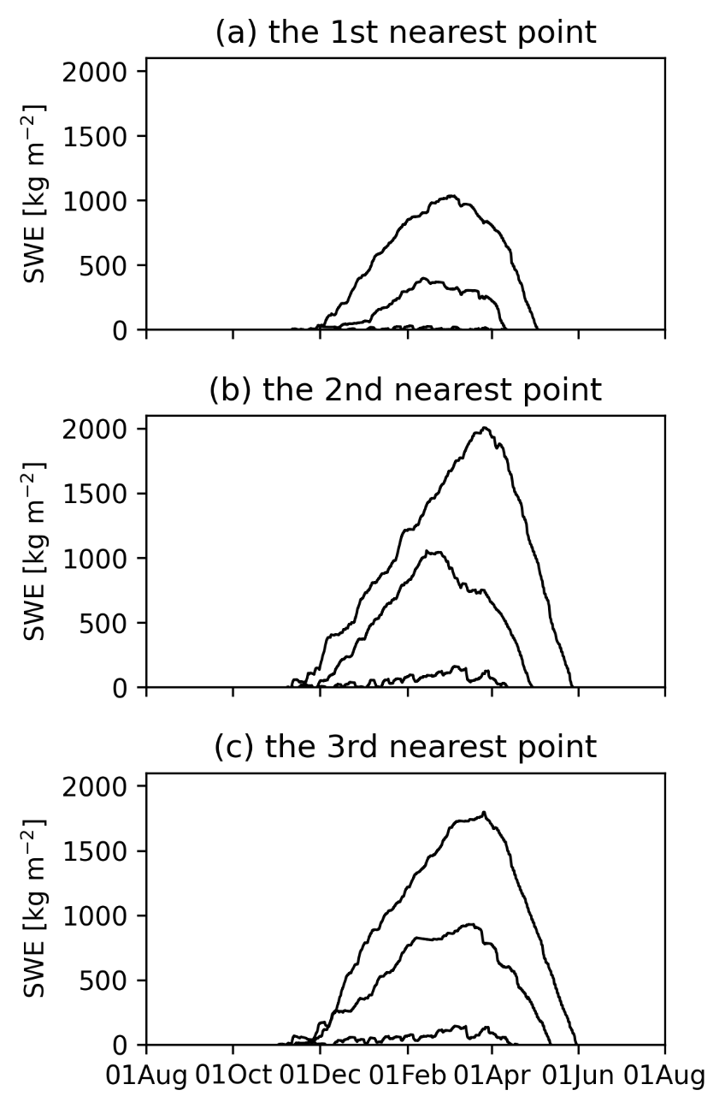
Fig. S1. Hourly time series, continuously from the beginning of the calculation independent of the leap year, of snow water equivalent (SWE) at each of (a) the first, (b) second, and (c) third nearest grid points to Tokamachi. The depicted lines were selected from ensemble members that attained the top, intermediate, and bottom seasonal maximum SWEs of all ensembles of the historical experiment (1,800 winter simulations) at each grid point. The calendar dates at the x-label were depicted without the leap-year day.

Supplement 2: Scatter plot of daily snow-depth anomaly between observation and calculation
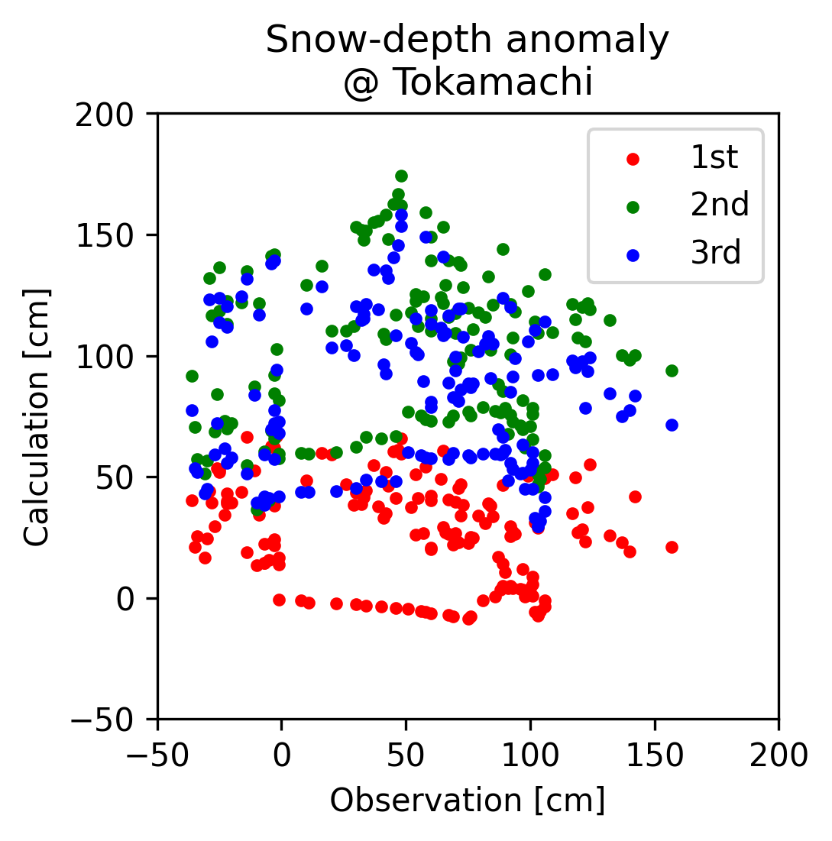
Fig. S2. Scatter plot of daily snow-depth anomaly from its climatology between observation and calculation at Tokamachi from December 1, 2010, to April 30, 2011. The calculation is a result based on an ensemble member of m001. The red, green, and blue markers indicate the first, second, and third nearest grid points to Tokamachi, respectively. The climatology of observation and calculation is calculated during 1991–2020 and during 1981–2010 at each point, respectively.

