Supplementary information for:

A site for deep ice coring at West Hercules Dome: results from ground-based geophysics and modeling

T.J. Fudge¹, Benjamin H. Hills^{1,2}, Annika N. Horlings¹, Nicholas Holschuh³, John Erich Christian^{4,5}, Lindsey Davidge¹, Andrew Hoffman¹, Gemma K. O’Connor¹, Knut Christianson¹, and Eric J. Steig¹

S1: Surface Horizontal Velocities
The horizontal velocities were measured at the three ApRES locations away from the divide (Figure S1). Due to cm-scale uncertainties in the positions of the antennae and conduit, the measurements have significant uncertainty; however, they are useful for comparison with the modeled horizontal velocities which are based on the balance velocity. For the model, we have assumed no divergence based on the reasonable fit of the modeled surface velocities to the measured ones. The modeled velocities assuming a circular dome significantly underestimate the measured velocities.

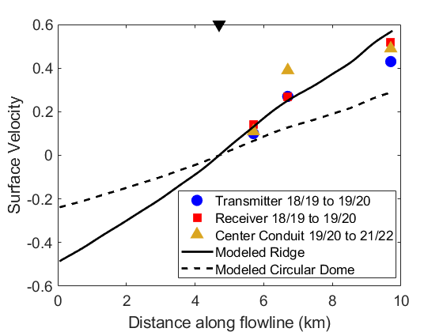
Fig. S1: Horizontal surface velocities measured with GNSS along the x135 transect. Measurements were made during ApRES acquisitions and are shown for n1000 (5.7km), n2000 (6.7km) and n5000 (9.7km). In the 2018 and 2019 seasons, the transmitter and receiver antennae positions were measured. A condiut was installed in 2019 which was used for the measurement pair between the 2019 and 2021 seasons. Black triangle at 4.7 km is the divide position. “Modeled Ridge” has no divergence, i.e. the flowband width remains constant. “Modeled circular dome” include divergence such that the velocity increases only half as fast.

S2: ApRES Data and Interpretation
In this section we show all the ApRES acquisitions from West Hercules Dome with repeat acquisitions over the three Hercules Dome field seasons. Each of the West Dome sites has measurements in 18/19, 19/20 and 21/22 (S1-S4), allowing for three different inferences of the vertical velocity with different durations between measurements: 18/19-19/20 (one year), 19/20-21/22 (two years), and 18/19-21/22 (three years).
Three of the four sites along x135 have effectively identical vertical velocity profiles between interferences (i.e. the black and grey profiles are equivalent in Fig. S1, S2, and S4). The ice-dynamic interpretation in the manuscript would not change if the second interference was used in substitution of the first. Conversely, we find a notably different velocity profile at the third site, n2000, between the first and second interferences (Fig. S3). The 18/19-19/20 profile has significant curvature, similar to the sites closer to the divide (n0 and n1000), whereas the 19/20-21/22 profile has less curvature and is more similar to n5000. The reason for the difference in the two vertical velocity profiles is undetermined. There is no obvious processing difference since the same techniques were used for the other three sites. Similarly, there is little horizontal velocity at these sites such that the total surface motion in the three years between the 18/19 and 21/22 occupations is about 0.5 m. It seems implausible that the vertical velocity could change significantly over such a small horizontal distance. As to the interpretation, a profile with less curvature is arguably more expected given the 2 km distance from the present divide, and thus outside of the zone of significant divide flow; however, the best fit surface velocity for the 19/20-21/22 data is even lower than the fit with the 18/19-19/20 data. The inferred surface velocity from 18/19-19/20 was already lower than any of the other 3 sites. Further investigations at West Dome, including more imaging of the bed and additional ApRES sites, may allow insight into the cause of the different vertical velocity profiles.

S1.2 Calculation of bed slope and impact on vertical velocity profile
The choice of bed slope to use in the fit of the ApRES vertical velocities is non-trivial. The main difficulty is what length-scale the slope should be calculated over. The most appropriate length likely scales with the height above the bed; ice directly above the bed will flow parallel to the bed slope locally on a scale of meters. Ice hundreds of meters above the bed is likely sensitive to the bed slope on a larger length scale such as hundreds of meters. In Fig. S5, we show the bed slope calculations for different length scales and different low-pass filtering of the bed. A further complication is that we resolve the bed only directly along the radar line. While the radar line closely approximates the flowline, off-nadir variations in the bed may also affect the local vertical velocity profile, particularly for near-bed ice.
Near the divide, the bedslope has limited influence on the vertical velocity profile because of the small horizontal velocities. The importance of the bed slope increases with the distance from the divide as the horizontal velocity increases. The choice of length scale is particularly influential at n5000; for the bed with no low-pass filtering, the slope switches signs at the 300 m calculation length.
The amount of smoothing also typically has a large influence. This is shown at both n2000 and n5000 where the bed slope can reverse sign based on the degree of smoothing (Fig. S5). For the modeling of internal layers, we used a bed with 1000-m low pass filtering to avoid introducing structure in the modeled layers that is not apparent in the measured layers. For fitting the ApRES vertical velocities, it is not clear that the same rationale is appropriate. This is best illustrated at n5000, where the choice of bed slope influences the inferred surface vertical velocity. Without the upward sloping bed, the surface vertical velocity exceeds the measured accumulation rate considerably (Section 3.5, Table 1). With the upward bed slope, found for lengths less than 250 m on the unfiltered bed, the surface vertical velocity is reduced and matches the measured accumulation rate more closely. The choice of bed slope highlights the challenge in interpreting the shape of the vertical velocity profile in regions with a rough bed. The challenge becomes more pronounced at the velocity increases, such as near South Pole (Hills and others, 2022).
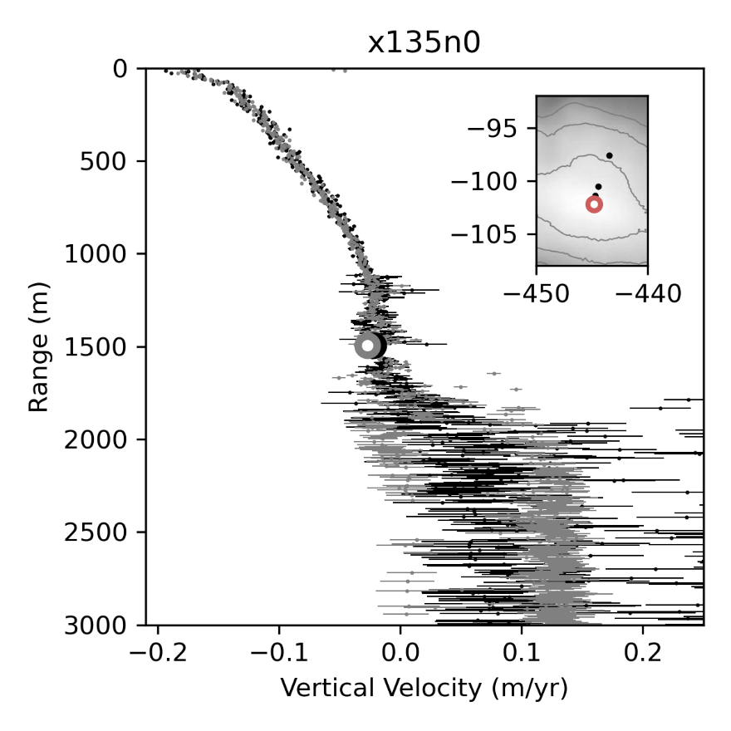
Fig. S2. ApRES-derived vertical velocity profiles from a single site, n0. Each individual dot represents the average vertical velocity calculated using the measured phase shift within a 20-m bin. Uncertainties are shown with horizontal lines. The large dot is the vertical velocity of the inferred bed interface depth (interpreted from echo intensity). The black profile is from the first interference between the 18/19 acquisition and the 19/20 acquisition. The grey profile is for the second interference between the 19/20 acquisition and the 21/22 acquisition. Inset) A map of Hercules Dome with surface elevation in grey colormap (as in Fig. 1), black dots showing all repeat acquisition ApRES sites, and red showing the specific site plotted in this figure.

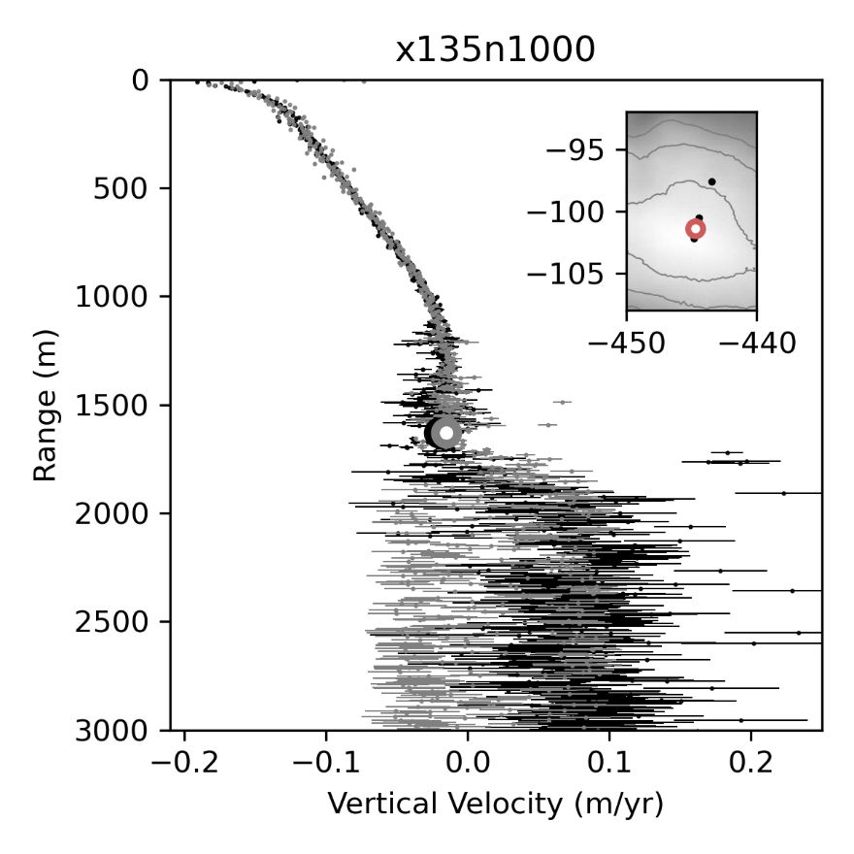
Fig. S3. Same as Fig. S1 but for site n1000.
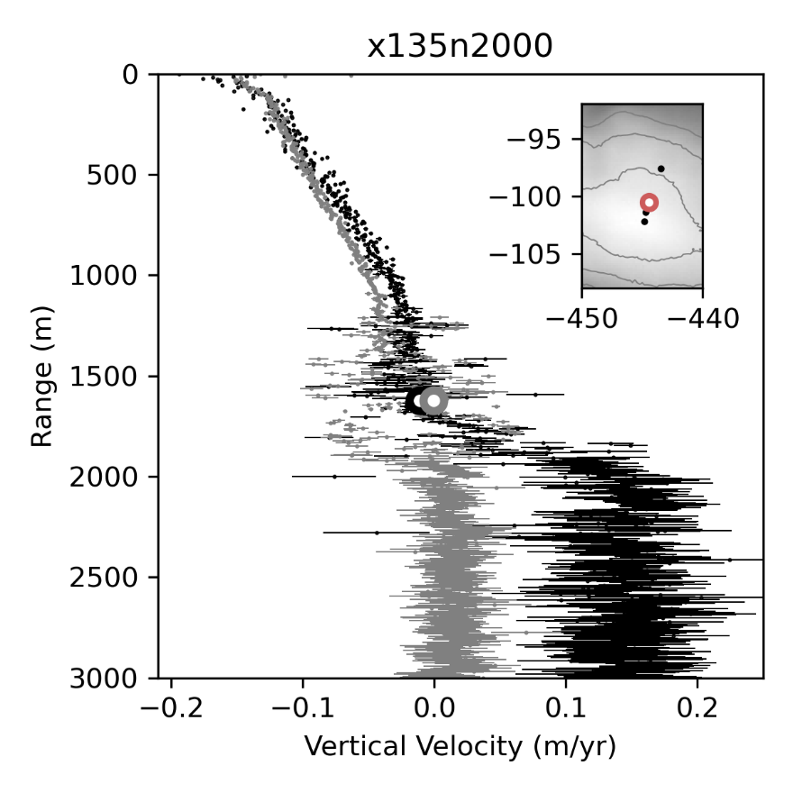
Fig. S4. Same as Fig. S1 but for site n2000.

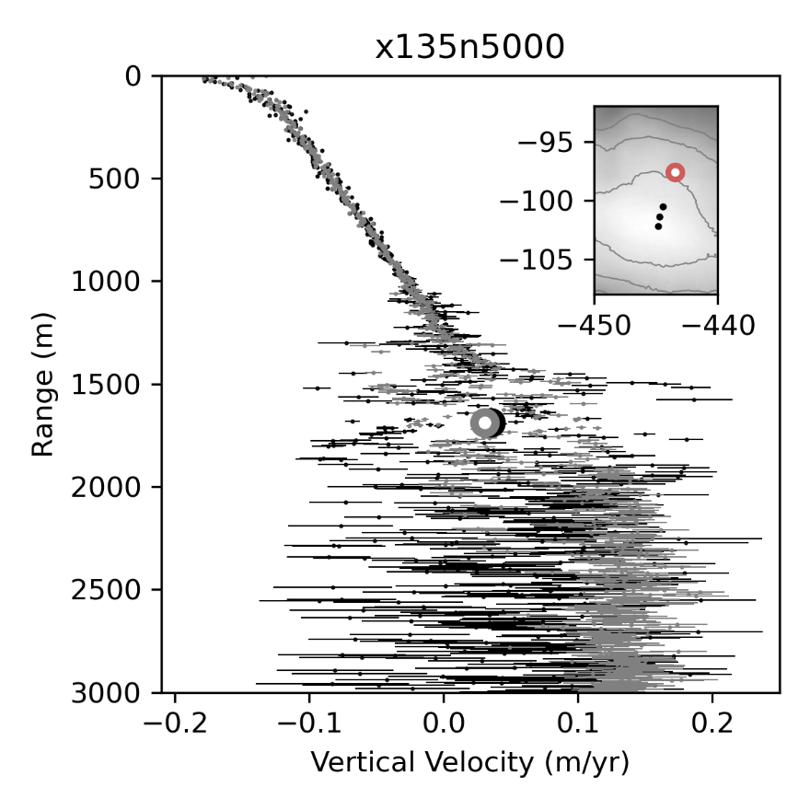
Fig. S5. Same as Fig. S1 but for site n5000.

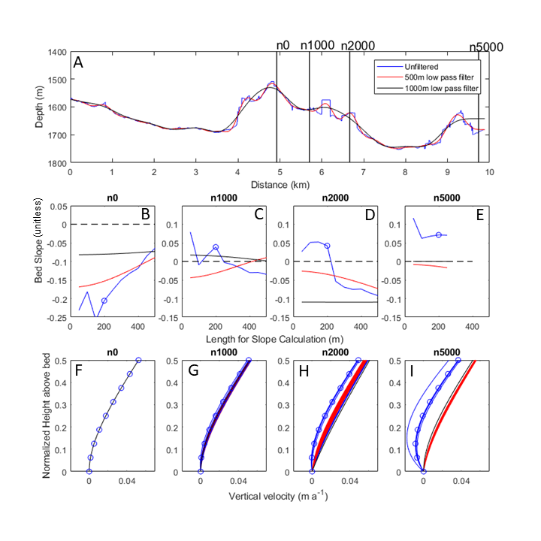
Fig. S6: Panel A shows the bed with different amounts of low pass filtering. Panels B-E show the slope calculated for different length scales centered at the location of the ApRES measurement with the three different amounts of low-pass filtering in the top panel. The bed slope values used in Table 1 are shown by blue circles. Bottom panels show the influence of the bed slope on vertical velocities in the lower half of the ice sheet computed using Eq. 8 with the same surface velocity (0.13 m a⁻¹) and shape profile (p=4).

S1.3 Modeled misfit

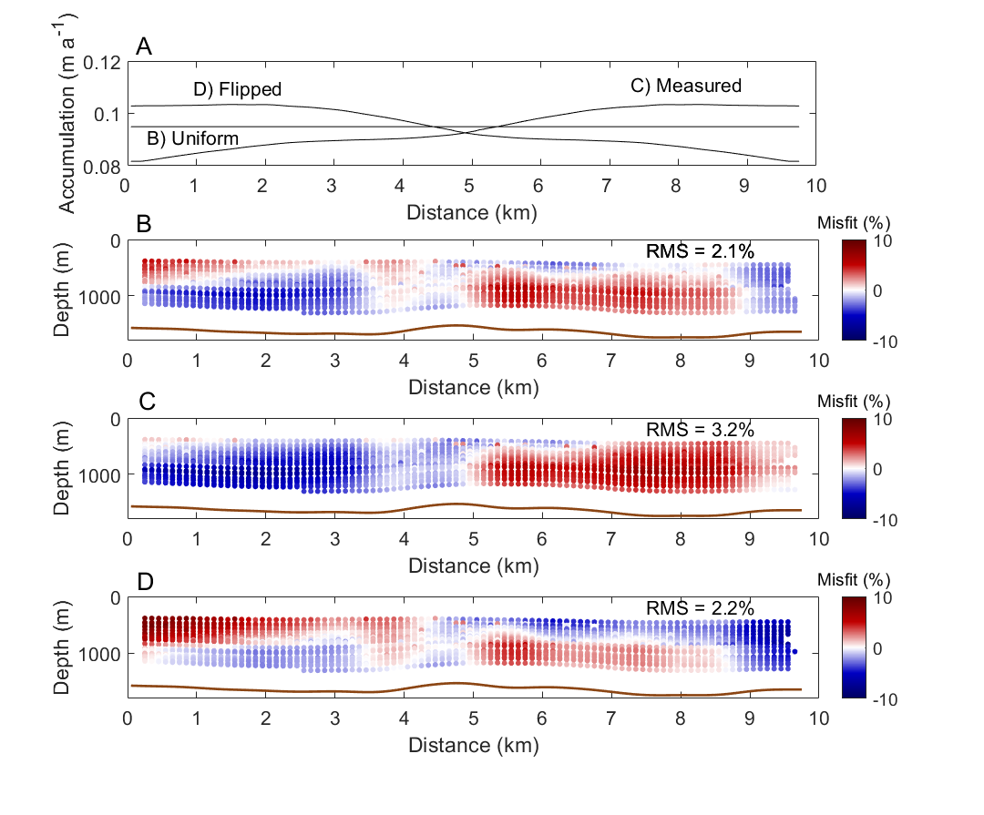
Fig. S7. Misfit of modeled to measured internal layers. A) Three accumulation gradients used for ages older than 2ka in the panels below. B,C,D) Relative misfit as described in Figure 10D.

