SUPPLEMENTARY MATERIAL TO
Glacier-wide seasonal and annual geodetic mass balances from Pléiades stereo images. Application to the Glacier d’Argentière, French Alps

Luc BERAUD, Diego CUSICANQUI, Antoine RABATEL, Fanny BRUN, Christian VINCENT, Delphine SIX

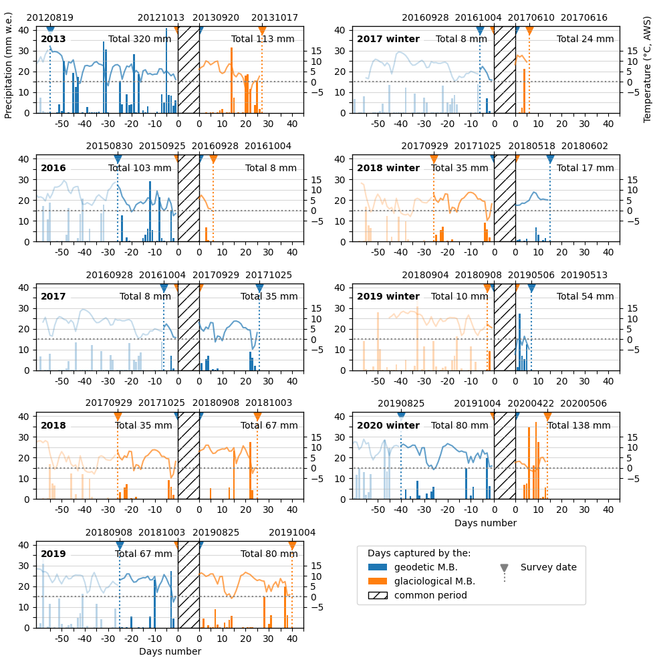
Fig. S1: The figure shows the meteorological data for the days of the periods between the field surveys and the satellite acquisitions, for each annual (left column) and winter (right column) mass balances. The grey hatching interval represents the period covered by both glaciological and geodetic mass balances (MB). The histograms represent precipitation (left axis) measured at the station in the valley (Chamonix) in mm w.e., with the total cumulative precipitation during the period that is not common to the two MB estimates written for each period. The lines represent the temperatures in °C (right axis) at the glacier AWS (2400 m a.s.l.). The vertical dashed lines indicate the date (written above) of the first and last data source (either satellite data or field survey), together with numbers of days (written below). The colours (blue for satellite geodetic MB, orange for field-based MB) allow to see which approach used data acquired before or after the other approach. Meteorological data before the first survey are shown in light colours. The date format is YYYYMMDD.

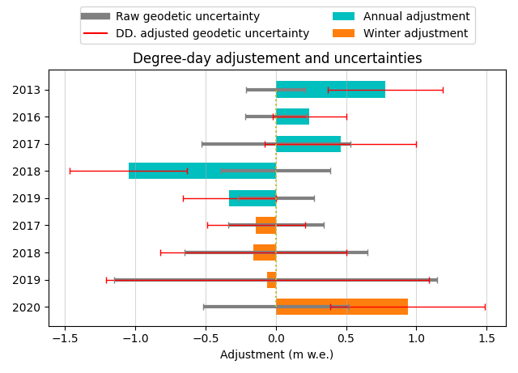

Fig. S2: Representation of degree-days adjustments and corresponding geodetic uncertainties for each annual and seasonal estimated mass balance. Blue and orange bars represent the amount of the degree-day (DD.) adjustments. The grey error bar (centred on 0 m w.e.) represents the uncertainty of the raw geodetic mass balance, and the red error bar the uncertainty of the adjusted mass balance.

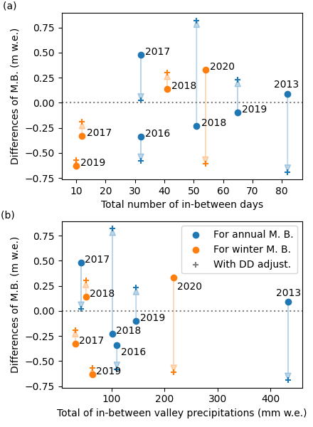

Fig. S3: Differences between glaciological and geodetic mass balances (M.B.) according to the sum of the day numbers (figure S3a) and precipitation (figure S3b) for the period that is not considered in common between the geodetic and glaciological mass balances. The dots represent the differences with the raw mass balance, the + sign represents the differences with the adjusted mass balance, and the arrow the degree-day adjustment.

