Supplementary Information

Glacier mass balance estimates over High Mountain Asia from 2000 to 2021 based on ICESat-2 and NASADEM

Yubin Fan^{1,2,3}, Chang-Qing Ke^{1,2,3*}, Xiaobing Zhou⁴, Xiaoyi Shen^{1,2,3}, Xuening Yu^{1,2,3}, Drolma Lhakpa⁵

¹ Jiangsu Provincial Key Laboratory of Geographic Information Science and Technology, Key Laboratory for Land Satellite Remote Sensing Applications of Ministry of Natural Resources, School of Geography and Ocean Science, Nanjing University, Nanjing, 210023 China.
² Collaborative Innovation Center of Novel Software Technology and Industrialization, Nanjing, 210023 China.
³ Collaborative Innovation Center of South China Sea Studies, Nanjing, 210023 China.
⁴ The Department of Geophysical Engineering, Montana Tech of the University of Montana, Butte, MT 59701 USA
⁵ Institute of Tibetan Plateau Atmospheric and Environmental Sciences, Tibet Meteorological Bureau, Lhasa 850000, China.

Fig. S1. Aggregated displacement information during co-registration for each 1° *1° grid over the HMA. The arrow size indicates the offset length in the X and Y directions, the directions represent the direction of the offset vector, and the colors denote the offset vector in the Z direction.

Fig. S2. Specific glacier mass balance (m w.e/yr) for the period from 2000 to 2021, aggregated over Kääb et al. (2015) (a) and HiMAP (b) regions.

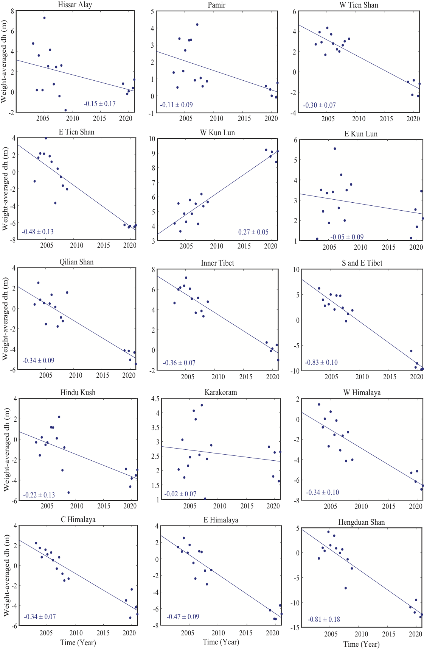
Fig. S3. Linear-fit of ICESat/ICESat-2 height differences between SRTM, only autumn and winter measurements were plotted. The blue line represents the linear trend line from 2003 to 2021 with the fitted elevation changes marked next to it.

Fig. S4. On-glacier elevation change rates (dh/dt) derived from this study (a, b), compared to that from ASTER DEMs (2000-2019, Hugonnet et al., 2021) (c, d) over the East Himalaya Mountains. The left panel (a, c) shows the histograms of dh/dt on glacier and non-glacier areas, and the right panel (b, d) shows the altitude distribution of glacier elevation change.

Table S1. Region-wide mass balance aggregated over RGI boundary from 2000 to 2021 obtained from different penetration corrections. Units are given in m w.e/yr. Method 1: using the penetration depths of doubling elevation differences of the X-band and C-band SRTM DEM can estimate the penetration depth. Method 2: using the penetration depths of ICESat extrapolation. Regions with large discrepancies are marked in bold. Method 3: ignoring the penetration in the autumn and using autumn-acquired ICESat-2 for mass balance estimation.

Region | Method 1 | Method 2 | Method 3
Hissar Alay | -0.18 ± 0.10 | -0.20 ± 0.09 | -0.05 ± 0.10
Pamir | -0.07 ± 0.12 | -0.05 ± 0.07 | -0.04 ± 0.12
W Tien Shan | -0.15 ± 0.10 | -0.19 ± 0.07 | -0.10 ± 0.09
E Tien Shan | -0.47 ± 0.07 | -0.46 ± 0.13 | -0.34 ± 0.07
W Kun Lun | +0.23 ± 0.13 | +0.18 ± 0.04 | +0.32 ± 0.14
E Kun Lun | -0.09 ± 0.07 | -0.02 ± 0.05 | +0.09 ± 0.06
Qilian Shan | -0.38 ± 0.12 | -0.28 ± 0.08 | -0.17 ± 0.11
Inner Tibet | -0.25 ± 0.06 | -0.38 ± 0.08 | -0.07 ± 0.06
S and E Tibet | -0.47 ± 0.11 | -0.71 ± 0.14 | -0.68 ± 0.12
Hindu Kush | -0.18 ± 0.15 | -0.16 ± 0.14 | -0.17 ± 0.15
Karakoram | -0.03 ± 0.12 | -0.02 ± 0.07 | +0.04 ± 0.12
W Himalaya | -0.42 ± 0.10 | -0.37 ± 0.06 | -0.37 ± 0.10
C Himalaya | -0.41 ± 0.08 | -0.39 ± 0.08 | -0.25 ± 0.07
E Himalaya | -0.35 ± 0.09 | -0.52 ± 0.08 | -0.34 ± 0.10
Hengduan Shan | -0.62 ± 0.10 | -0.74 ± 0.23 | -0.53 ± 0.09
Table S2. Region-wide mass balance compared with previous studies aggregated over Kääb boundary. Regions with large discrepancies are marked in bold.
Region | This study  (2000-2021) | Kääb et al., 2015 (2003-2009) | Brun et al., 2017  (2000-2016) | Shean et al.,2020 (2000-2018) | Jakob et al., 2021 (2010-2019) | Wang et al.,2021 (2003-2019)
Central Himalaya | -0.40 ± 0.07 | –0.31 ± 0.14 | −0.33 ± 0.20 | -0.36 ± 0.09 | -0.45 ± 0.14 | -0.53 ± 0.18
East Himalaya | -0.39 ± 0.08 | –0.76 ± 0.20 | −0.42 ± 0.20 | -0.55 ± 0.17 | -0.74 ± 0.28 | -0.82 ± 0.18
Hindu Kush | -0.18 ± 0.08 | –0.42 ± 0.18 | −0.12 ± 0.07 | -0.09 ± 0.06 | -0.23 ± 0.08 | -0.20 ± 0.18
Inner TP | -0.22 ± 0.06 | –0.06 ± 0.06 | −0.14 ± 0.07 | -0.22 ± 0.05 | -0.34 ± 0.09 | -0.32 ± 0.18
Karakoram | -0.02 ± 0.09 | –0.09 ± 0.12 | −0.03 ± 0.07 | -0.04 ± 0.04 | -0.05 ± 0.03 | -0.14 ± 0.18
Kunlun | +0.21 ± 0.07 | +0.18 ± 0.14 | +0.14 ± 0.08 | +0.04 ± 0.04 | +0.01 ± 0.05 | +0.14 ± 0.18
Nyainqentanglha | -0.58 ± 0.09 | –0.59 ± 0.27 | −0.62 ± 0.23 | -0.50 ± 0.15 | -0.95 ± 0.19 | -0.91 ± 0.18
Pamir Alai | -0.18 ± 0.06 | NA | −0.04 ± 0.07 | -0.04 ± 0.09 | -0.22 ± 0.22 | NA
Pamir | -0.08 ± 0.04 | –0.41 ± 0.24 | −0.08 ± 0.07 | -0.11 ± 0.04 | -0.24 ± 0.06 | -0.20 ± 0.18
Spiti Lahaul | -0.40 ± 0.08 | –0.42 ± 0.26 | −0.37 ± 0.09 | -0.31 ± 0.08 | -0.26 ± 0.08 | -0.48 ± 0.18
Tien Shan | -0.21 ± 0.06 | –0.37 ± 0.31 | −0.28 ± 0.20 | -0.29 ± 0.07 | -0.38 ± 0.06 | -0.38 ± 0.18
West Himalaya | -0.41 ± 0.08 | –0.37 ± 0.15 | −0.34 ± 0.09 | -0.37 ± 0.09 | -0.41 ± 0.16 | -0.54 ± 0.18

Table S3. Region-wide mass balance compared with previous studies aggregated over HiMAP boundary. Regions with large discrepancies are marked in bold.
Region | This study (2000-2021) | Shean et al.,2020 (2000-2018) | Jakob et al., 2021 (2010-2019)
Altun Shan | -0.07 ± 0.08 | -0.03 ± 0.08 | -0.28 ± 0.24
Central Himalaya | -0.41 ± 0.08 | −0.37 ± 0.08 | -0.44 ± 0.10
Central Tien Shan | -0.13 ± 0.04 | −0.23 ± 0.08 | -0.31 ± 0.05
Dzhungarsky Alatau | -0.47 ± 0.06 | −0.49 ± 0.16 | -0.56 ± 0.33
Eastern Himalaya | -0.38 ± 0.08 | -0.52 ± 0.15 | -0.69 ± 0.24
Eastern Hindu Kush | -0.18 ± 0.08 | −0.10 ± 0.07 | -0.27 ± 0.12
Eastern Kunlun Shan | -0.10 ± 0.05 | −0.07 ± 0.07 | -0.49 ± 0.11
Eastern Pamir | +0.09 ± 0.05 | +0.04 ± 0.06 | -0.22 ± 0.17
Eastern Tibetan Mountains | -0.31 ± 0.07 | −0.48 ± 0.20 | -0.78 ± 0.46
Eastern Tien Shan | -0.47 ± 0.07 | −0.49 ± 0.17 | -0.45 ± 0.14
Gangdise Mountains | -0.42 ± 0.06 | −0.38 ± 0.08 | -0.30 ± 0.36
Hengduan Shan | -0.58 ± 0.09 | −0.64 ± 0.15 | -0.92 ± 0.53
Karakoram | -0.02 ± 0.09 | −0.04 ± 0.04 | -0.06 ± 0.02
Nyainqentanglha | -0.57 ± 0.10 | −0.46 ± 0.14 | -0.89 ± 0.19
Pamir Alay | -0.18 ± 0.05 | −0.03 ± 0.10 | -0.21 ± 0.18
Qilian Shan | -0.39 ± 0.08 | −0.28 ± 0.07 | -0.30 ± 0.23
Tanggula Shan | -0.44 ± 0.06 | −0.38 ± 0.10 | -0.42 ± 0.14
Tibetan Interior Mountains | -0.05 ± 0.05 | −0.12 ± 0.05 | -0.10 ± 0.10
Western Himalaya | -0.40 ± 0.08 | −0.32 ± 0.08 | -0.25 ± 0.08
Western Kunlun Shan | +0.23 ± 0.07 | +0.04 ± 0.05 | +0.06 ± 0.04
Western Pamir | -0.09 ± 0.04 | +0.04 ± 0.06 | -0.22 ± 0.06
Northern/Western Tien Shan | -0.22 ± 0.04 | -0.27 ± 0.09 | -0.52 ± 0.28

Table S4. River basin discharge compared with previous studies. Units are given in Gt/yr, and N/A means data are not available in the region. ITP: Inner Tibetan Plateau, ITP_E: Inner Tibetan Plateau Extended. Regions with large discrepancies are marked in bold

River basin | This study | Kääb et al., 2015 | Brun et al., 2017 | Shean et al., 2020
Amu_Darya | -1.56 ± 0.39 | -4.00 ± 0.80 | −1.00 ± 0.80 | -0.97 ± 0.38
Brahmaputra | -4.92 ± 0.82 | -12.60 ± 1.90 | −5.10 ± 2.10 | -4.87 ± 1.01
Ganges | -3.32 ± 0.67 | -4.10 ± 0.60 | −2.70 ± 0.70 | -3.19 ± 0.58
Ili | -1.91 ± 0.29 | NA | −1.60 ± 0.90 | -1.94 ± 0.48
Indus | -4.99 ± 2.05 | -7.00 ± 0. 80 | −4.00 ± 2.00 | -3.53 ± 0.97
ITP | -1.01 ± 0.39 | NA | −0.40 ± 0.50 | -0.91 ± 0.29
ITP_E | -0.90 ± 0.13 | NA | NA | -0.66 ± 0.21
Irrawady | -0.03 ± 0.01 | NA | NA | -0.01 ± 0.01
Mekong | -0.10 ± 0.01 | NA | −0.09 ± 0.04 | -0.11 ± 0.03
Salween | -0.88 ± 0.12 | NA | −0.80 ± 0.30 | -0.74 ± 0.16
Syr_Darya | -0.13 ± 0.06 | NA | −0.30 ± 0.20 | -0.34 ± 0.15
Tarim | +2.91 ± 1.82 | +0.70 ± 1.00 | +0.40 ± 1.30 | -0.87 ± 0.71
Yangtze | -0.84 ± 0.12 | NA | −0.50 ± 0.30 | -0.75 ± 0.17
Yellow | -0.02 ± 0.01 | NA | NA | -0.08 ± 0.05

