SUPPLEMENTARY MATERIALS

Modeling seasonal growth of phototrophs on bare ice on the Qaanaaq Ice Cap, northwestern Greenland

Yukihiko Onuma^{1, 2}, Nozomu Takeuchi³, Jun Uetake⁴, Masashi Niwano⁵, Sota Tanaka³, Naoko Nagatsuka⁶ and Teruo Aoki⁶

¹ Institute of Industrial Science, The University of Tokyo, Chiba, 277-8574, Japan
^{2*} Earth Observation Research Center (EORC), Japan Aerospace Exploration Agency (JAXA), Tsukuba, 305-8505, Japan
³ Graduate School of Science, Chiba University, Chiba, 263-8522, Japan
⁴ Field Science Center for Northern Biosphere, Hokkaido University, Tomakomai, 053-0035, Japan
⁵ Meteorological Research Institute, Japan Meteorological Agency, Tsukuba, 305-0052, Japan
⁶ National Institute of Polar Research, Tokyo, 190-8518, Japan

Corresponding author: Yukihiko Onuma (yonuma613@gmail.com, onuma.yukihiko@jaxa.jp)

* Present affiliation
Table S1: Statistical results for seasonal changes in bio-volume of each taxon, electrical conductivity, pH, and mineral dust weight at the study sites in 2014. The results in the table were obtained using one-way analysis of variance. N indicates the total number of ice samples collected in each site during the observational period for each analysis.

Site | Ancylonema nordenskioldii | Ancylonema  alaskana | Sanguina  nivaloides | Phormidesmis priestleyi | Chroococcaceae cyanobacterium | EC | pH | Mineral weight
S1  N = 16 | F: 3.49  P: 0.09 | F: 3.49  P: 0.11 | F: 3.49  P: 0.10 | F: 3.49  P: 0.09 | F: 3.49  P: 0.01 | F: 3.49  P: 0.16 | F: 3.49  P: 0.0003 | F: 3.49  P: 0.02
S2  N = 16 | F: 3.49  P: 0.15 | F: 3.49  P: 0.43 | F: 3.49  P: 0.04 | F: 3.49  P: 0.32 | F: 3.49  P: 0.41 | F: 3.49  P: 0.29 | F: 3.49  P: 0.22 | F: 3.49  P: 0.08
S3  N = 13 | F: 4.10  P: 0.37 | F: 4.10  P: 0.44 | F: 4.10  P: 0.0003 | F: 4.10  P: 0.50 | F: 4.10  P: 0.25 | F: 4.10  P: 0.51 | F: 4.10  P: 0.34 | F: 4.26  P: 0.72
S4  N = 13 | F: 3.49  P: 0.56 | F: 3.49  P: 0.87 | F: 3.49  P: 0.02 | F: 3.49  P: 0.24 | F: 3.49  P: 0.29 | F: 3.49  P: 0.24 | F: 3.49  P: 0.28 | F: 4.10  P: 0.04

Table S2: Statistical results for inter-annual changes in bio-volume of each taxon, electrical conductivity, pH, and mineral dust weight at the study sites for 2012–2014. The results in the table were obtained using one-way analysis of variance (for S1 and S2) and by Student’s t-test (for S3 and S4).
Site | Ancylonema nordenskioldii | Ancylonema alaskana | Sanguina  nivaloides | Phormidesmis priestleyi | Chroococcaceae cyanobacterium | Electrical conductivity | pH | Mineral weight
S1  2012-2014 | F: 3.89  P: 0.03 | F: 3.89  P: 0.06 | F: 3.89  P: 0.42 | F: 3.89  P: 0.001 | F: 3.89  P: 0.002 | F: 3.89  P: 0.03 | F: 3.89  P: 0.0003 | F: 3.89  P: 0.76
S2  2012-2014 | F: 3.89  P: 0.01 | F: 3.89  P: 0.001 | F: 3.89  P: 0.33 | F: 3.89  P: 0.002 | F: 3.89  P: 0.03 | F: 3.89  P: 0.14 | F: 3.89  P: 9.0x10⁻⁵ | F: 3.89  P: 0.09
S3  2012 and 2014 | t: 2.78  P: 0.08 | t: 2.78  P: 0.06 | t: 2.78  P: 0.11 | t: 2.78  P: 0.13 | t: 2.31  P: 0.18 | t: 2.78  P: 0.33 | t: 2.31  P: 0.07 | t: 2.37  P: 0.07
S4  2012 and 2014 | t: 2.78  P: 0.14 | t: 2.57  P: 0.33 | t: 2.78  P: 0.08 | t: 2.78  P: 0.05 | t: 2.78  P: 0.08 | t: 2.31  P: 0.22 | t: 2.31  P: 0.07 | t: 2.57  P: 0.05

Table S3: Biological parameters of the glacier algae model. Initial cell concentration and growth rate were obtained by the fitting observed cell concentration of Ancylonema nordenskioldii to the glacier algae model using the growth period. The maximum cell concentration of the alga at each site was assumed to be the carrying capacity. The growth periods were derived from T_{ice} simulated using a land surface model with three reanalysis data sets. The cell abundance data (cells mL⁻¹) of each taxon at the study sites for three seasons are available at the following reference: Onuma et al., 2022a (https://doi.org/10.5281/zenodo.6955513).
Site | Initial cell concentration  (cells mL⁻¹) | Growth rate  (hour⁻¹) | Carrying capacity  (cells mL⁻¹)
S1 | 4.2 ± 3.0 | 0.9 × 10⁻²  ± 4.8 × 10⁻⁴ | 6.1 × 10⁴  (S1 on day 204 in 2012)
S2 | 81.3 ± 26.7 | 0.8 × 10⁻²  ± 5.6 × 10⁻⁴ | 4.7 × 10⁵  (S2 on day 204 in 2012)
S3 | No data | No data | 8.3 × 10⁴  (S3 on day 200 in 2012)
S4 | No data | No data | 4.5 × 10⁴  (S4 on day 200 in 2012)

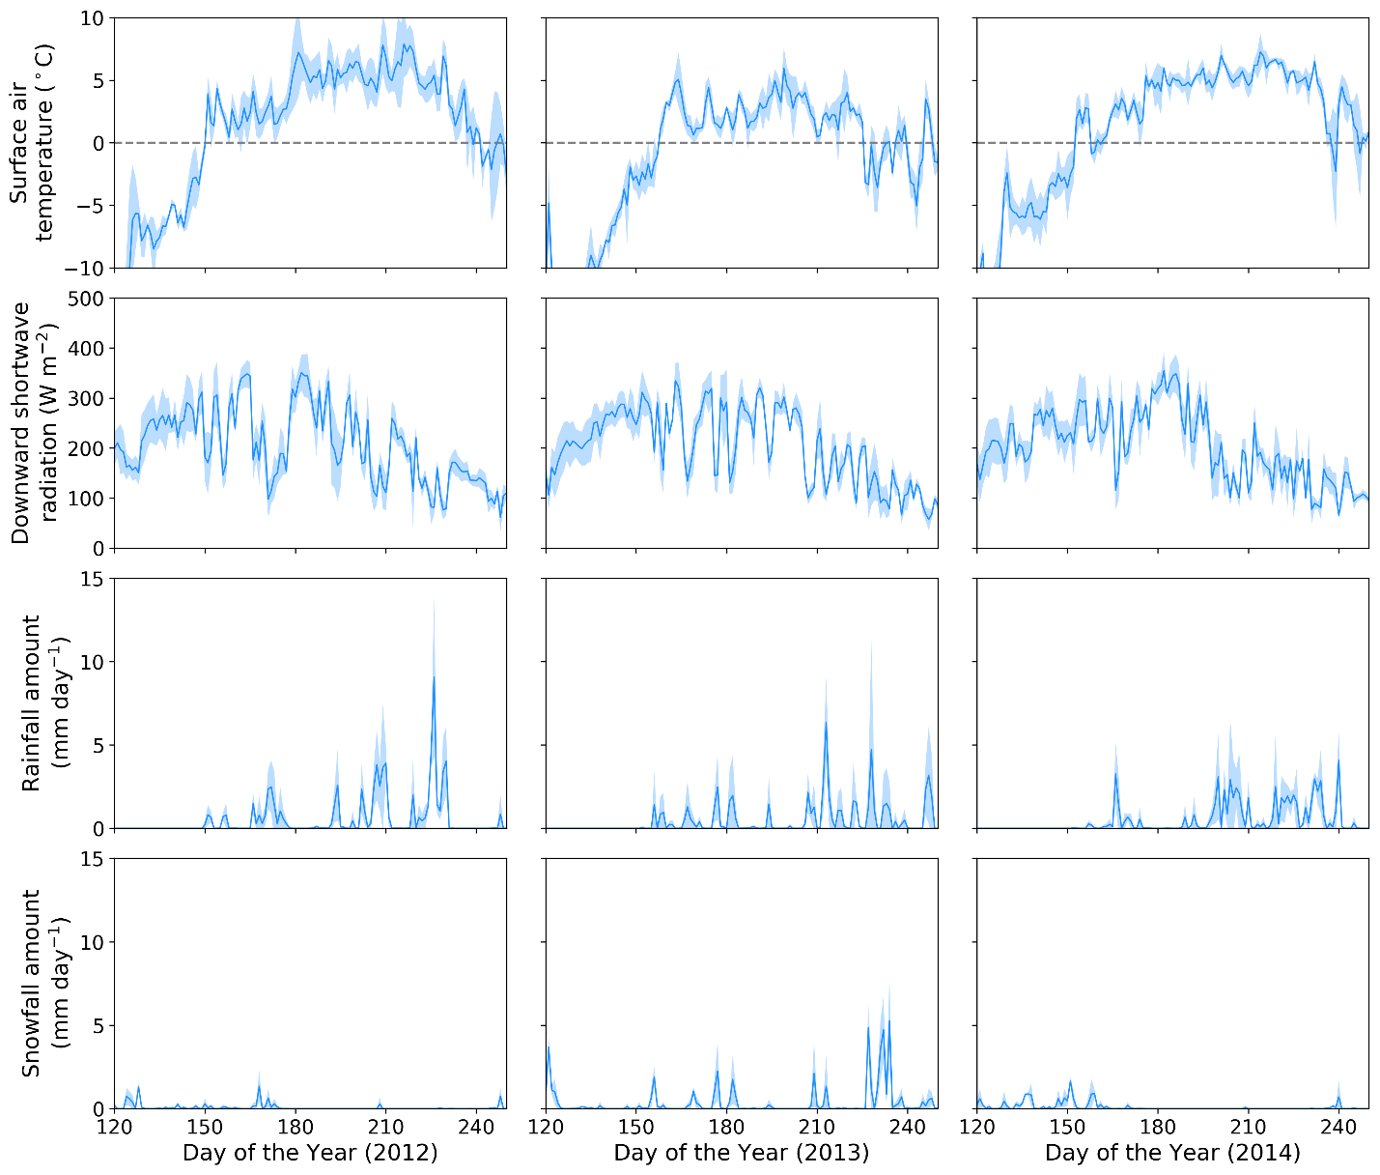
Fig. S1: Temporal changes in meteorological conditions for 2012–2014 seasons at S1 (247 m a.s.l.) in Qaanaaq Glacier. Blue solid line and shading indicate average values and minimum or maximum values derived from the three reanalysis data sets (WFDEI, GSWP3-FD, and CRUJRA), respectively.

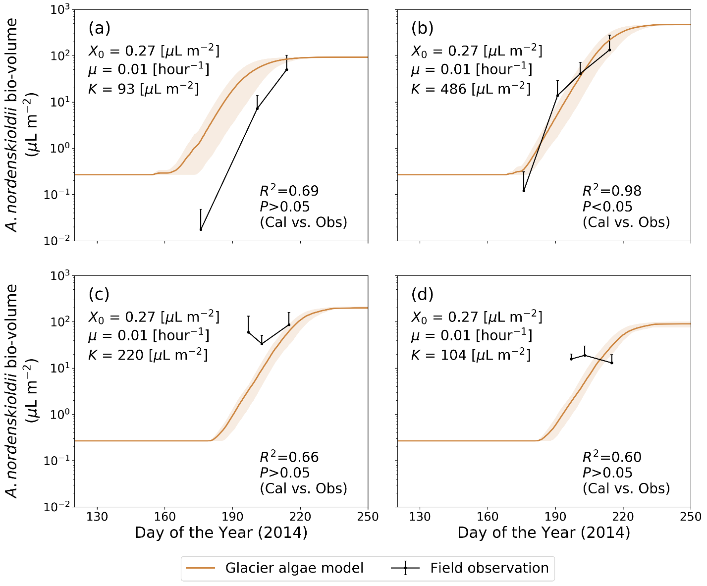
Fig. S2: Seasonal changes in the algal abundance of Ancylonema nordenskioldii during summer in 2014 simulated using the glacier algae model. (a) S1, (b) S2, (c) S3, (d) S4. Each solid line and shade indicate averaged and maximum or minimum bio-volume simulated with the glacier algae model using the different meteorological conditions, respectively. The initial bio-volume and growth rate at each site are values obtained by fitting the glacier algae model to the observation at S2. The maximum bio-volumes at each site for three seasons are assumed as the carrying capacity for (a), (b), (c), and (d).

