Supplementary material to :
Using ground-based thermal imagery to estimate debris thickness over glacial ice:
fieldwork considerations to improve effectiveness

Caroline Aubry-Wake¹, Pierrick Lamontagne-Hallé², Michel Baraër³, Jeffrey M. McKenzie², John W. Pomeroy¹

¹ Centre for Hydrology, University of Saskatchewan, Canmore, Canada
² Department of Earth and Planetary Sciences, McGill University, Montréal, Canada
³ Département de génie de la construction, École de Technologie Supérieure, Montréal, Canada

The supplementary material consist of six figures and one video file.
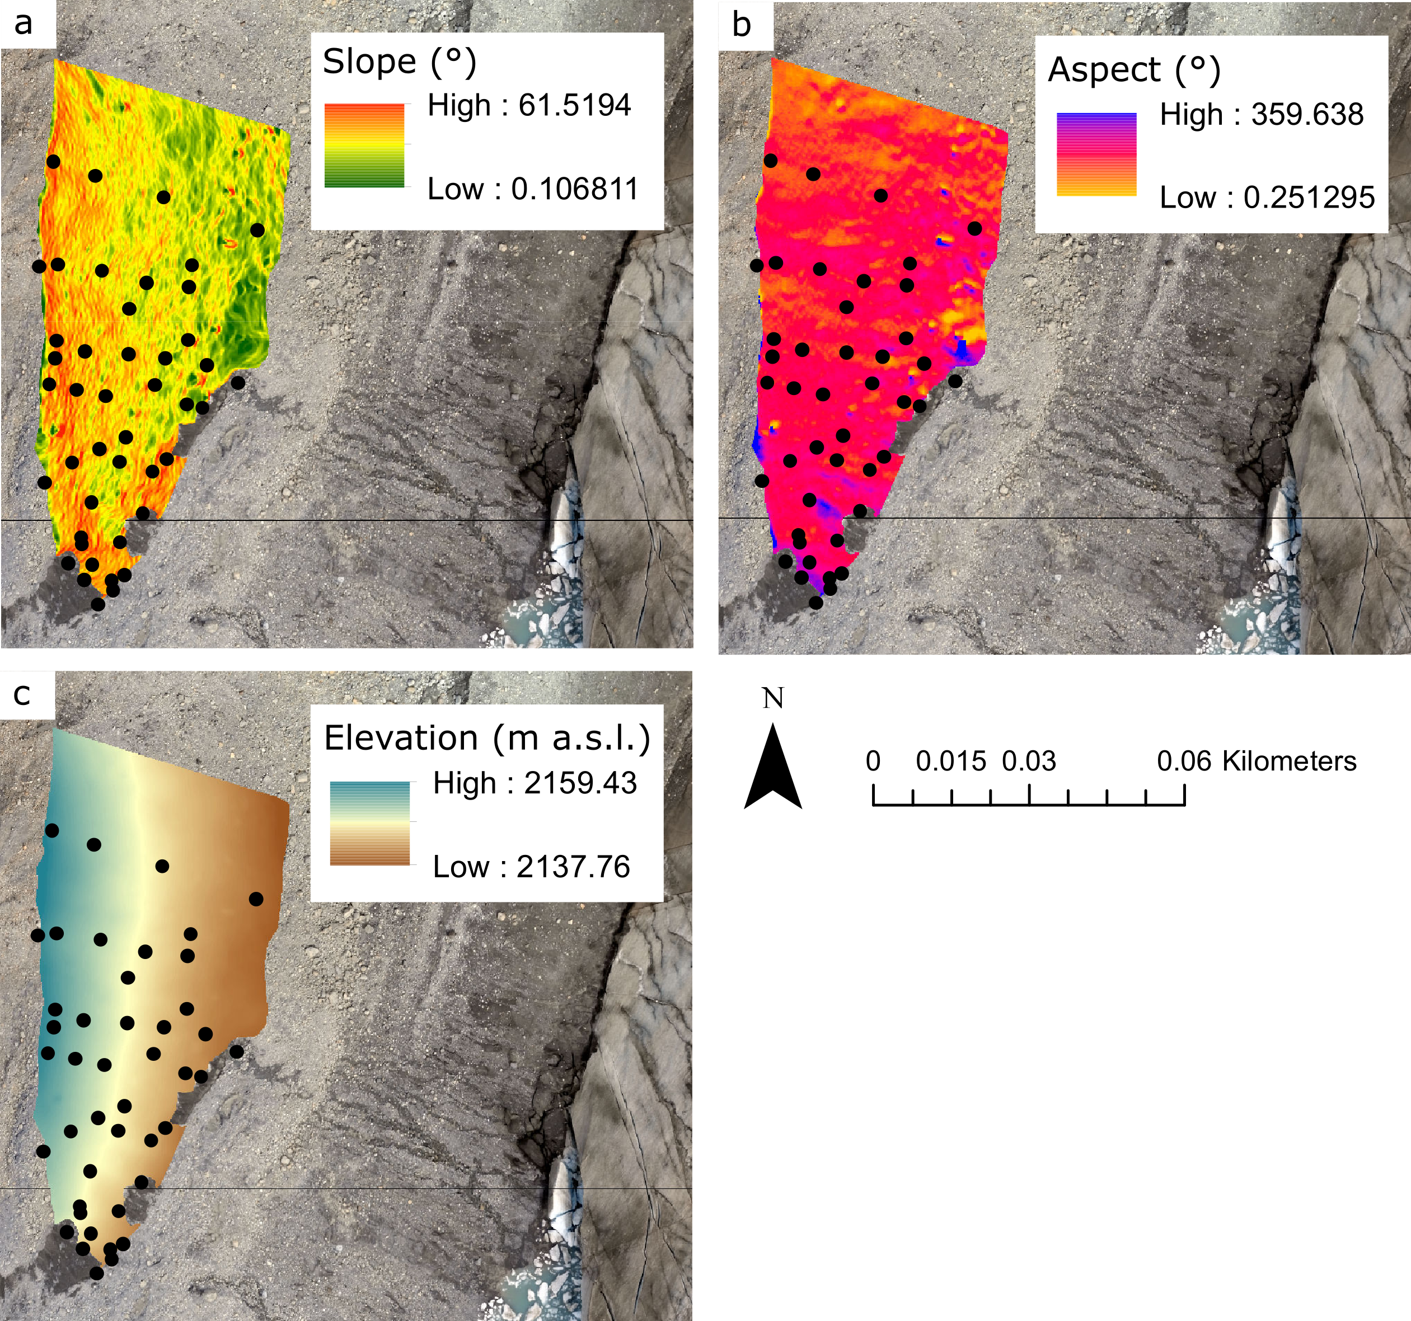
Figure S1. Slope, aspect and elevation of the study slope derived from UAV imagery. The black circle are the location of the 44 manual excavations.

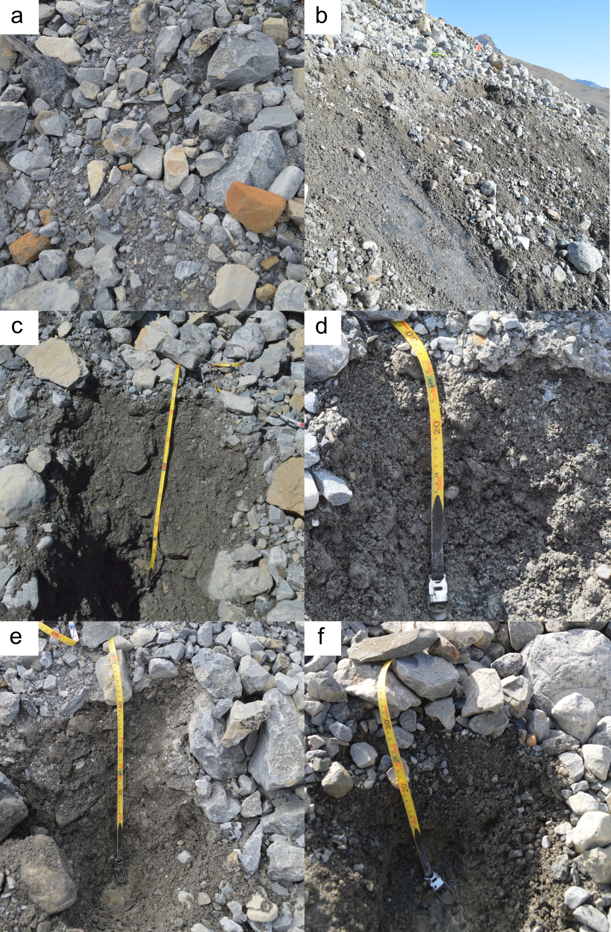
Figure S2. Representative surface for the continuous debris (a) and the discontinuous debris (b), with example manual excavations of 85 cm, (c), 27 cm (d), 50 cm (e) and 34 cm (f).

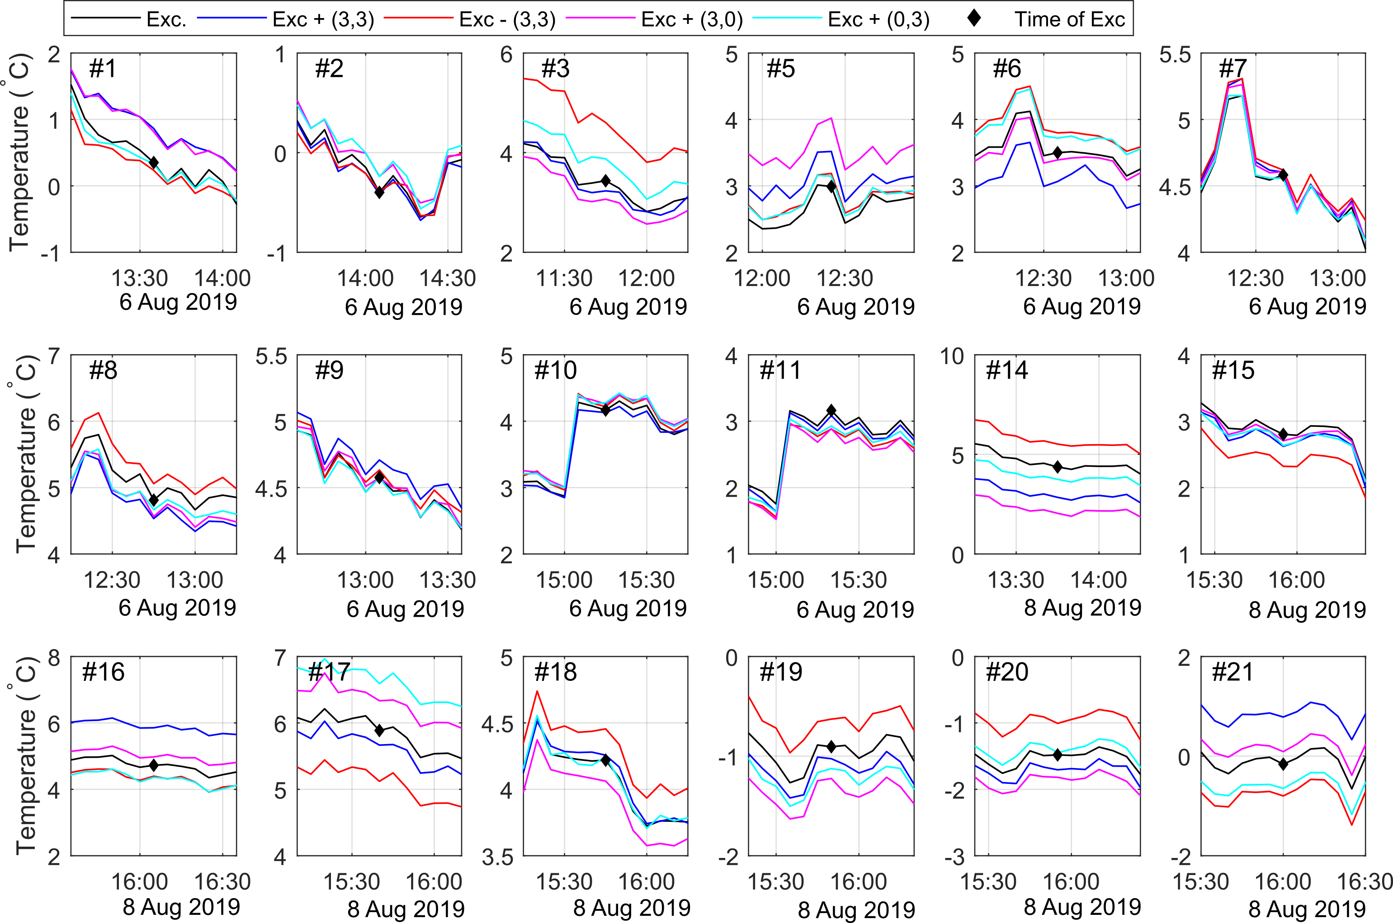
Figure S3. Surface temperature for a 3x3 pixel area at the location of the manual excavations (black) and for four adjacent areas that were left undisturbed (coloured line). The parenthesis in the legend shows the pixel offset for each location. The black diamond shows the time of the manual excavations. If the manual excavation caused a temperature anomaly, the black line would behave differently from the other undisturbed location (colour) after the manual excavation occurred.
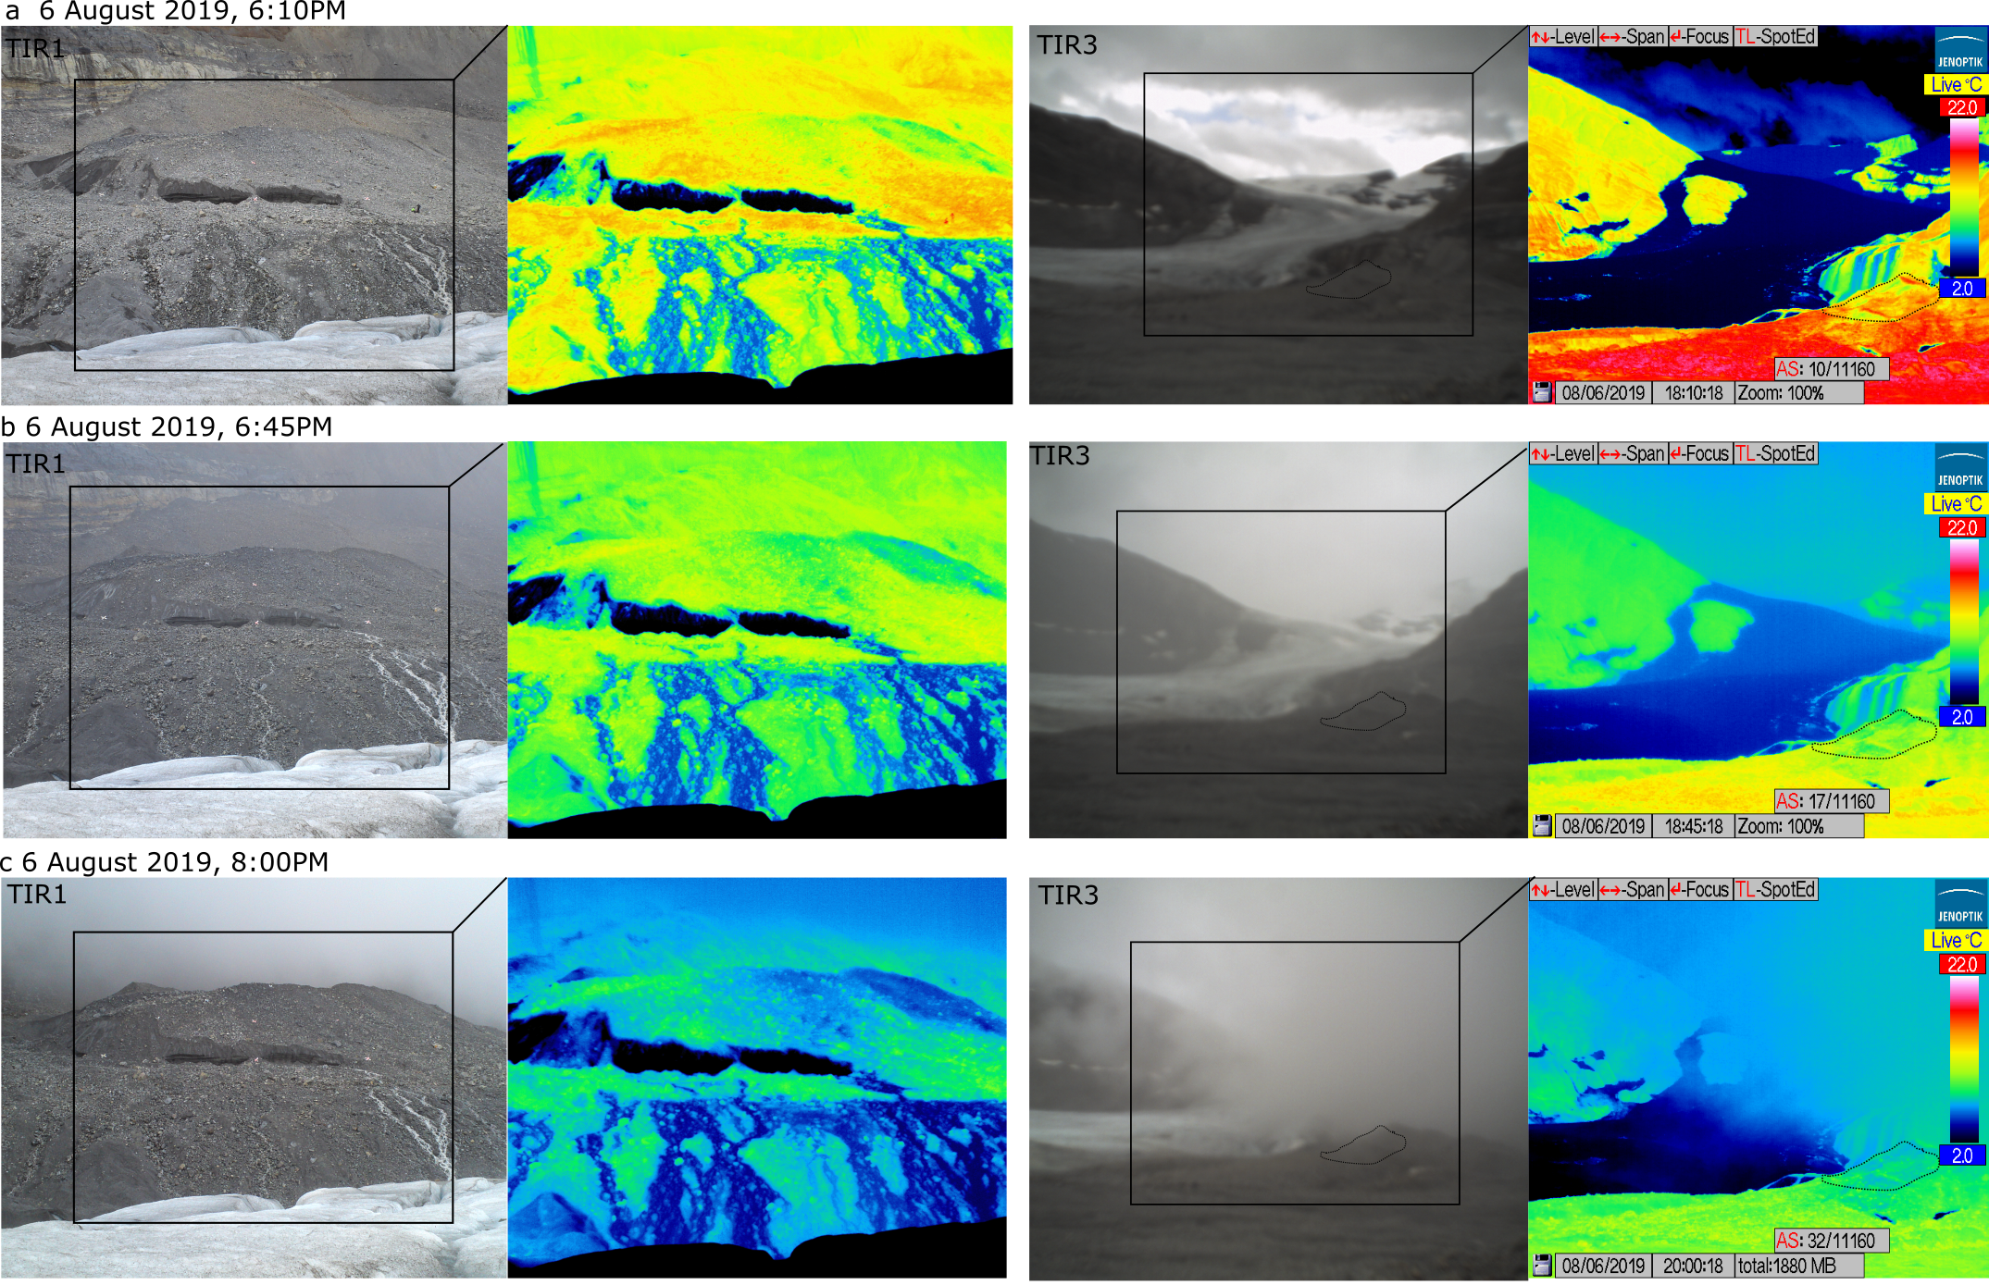
Figure S4. Visual and raw TIR images from TIR1 and TIR3 for 6 August 2019, at (a) the beginning of the rain event (6:10PM), (b) during the rain event (6:45PM) and c) with low clouds (8:00PM). Please note that the out-of-focus TIR3 images were not linked to the meteorological condition, but were due to a malfunction of the visual autofocus on the camera. The study slope in TIR3 is outlined in a dashed line.

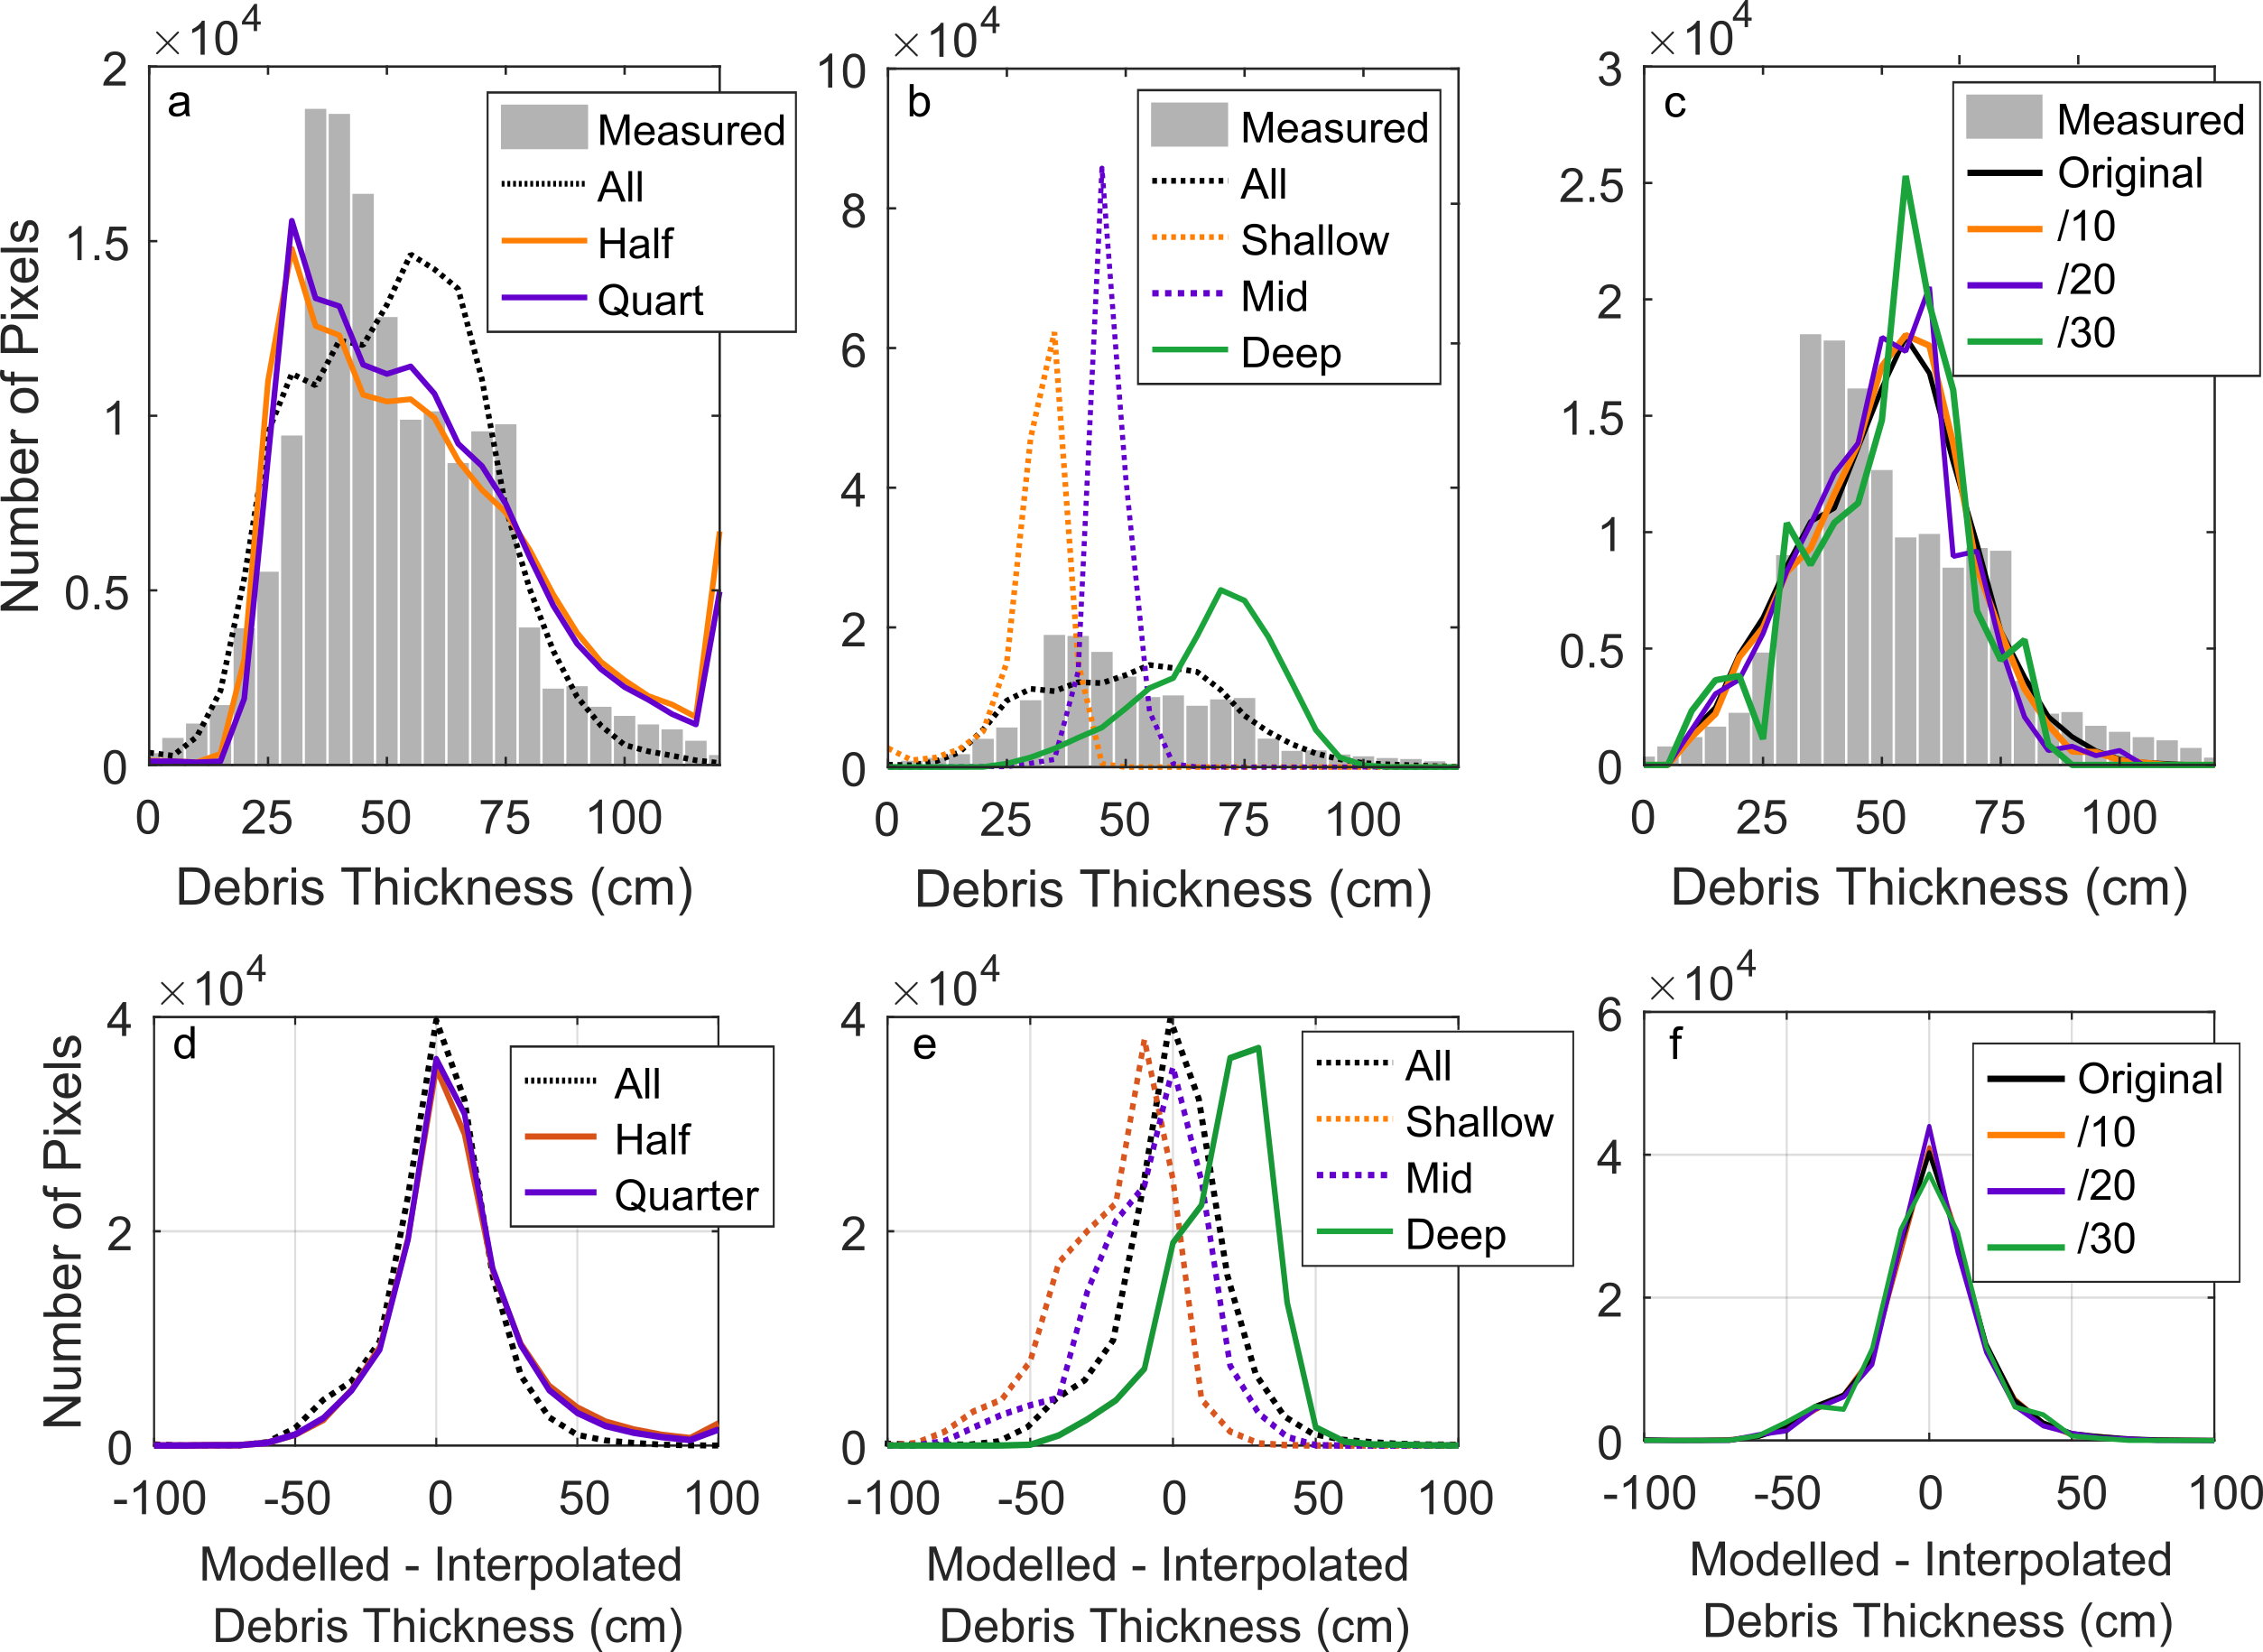
Figure S5. Distribution of the difference between modelled and measured debris thickness depending on the number of manual excavations used to calculate the empirical models (a), the depth distribution of the excavations used (b) and the spatial resolution of the TIR images (c), and the distribution of the difference between the modelled and measured debris thickness for the corresponding scenario (d-f).

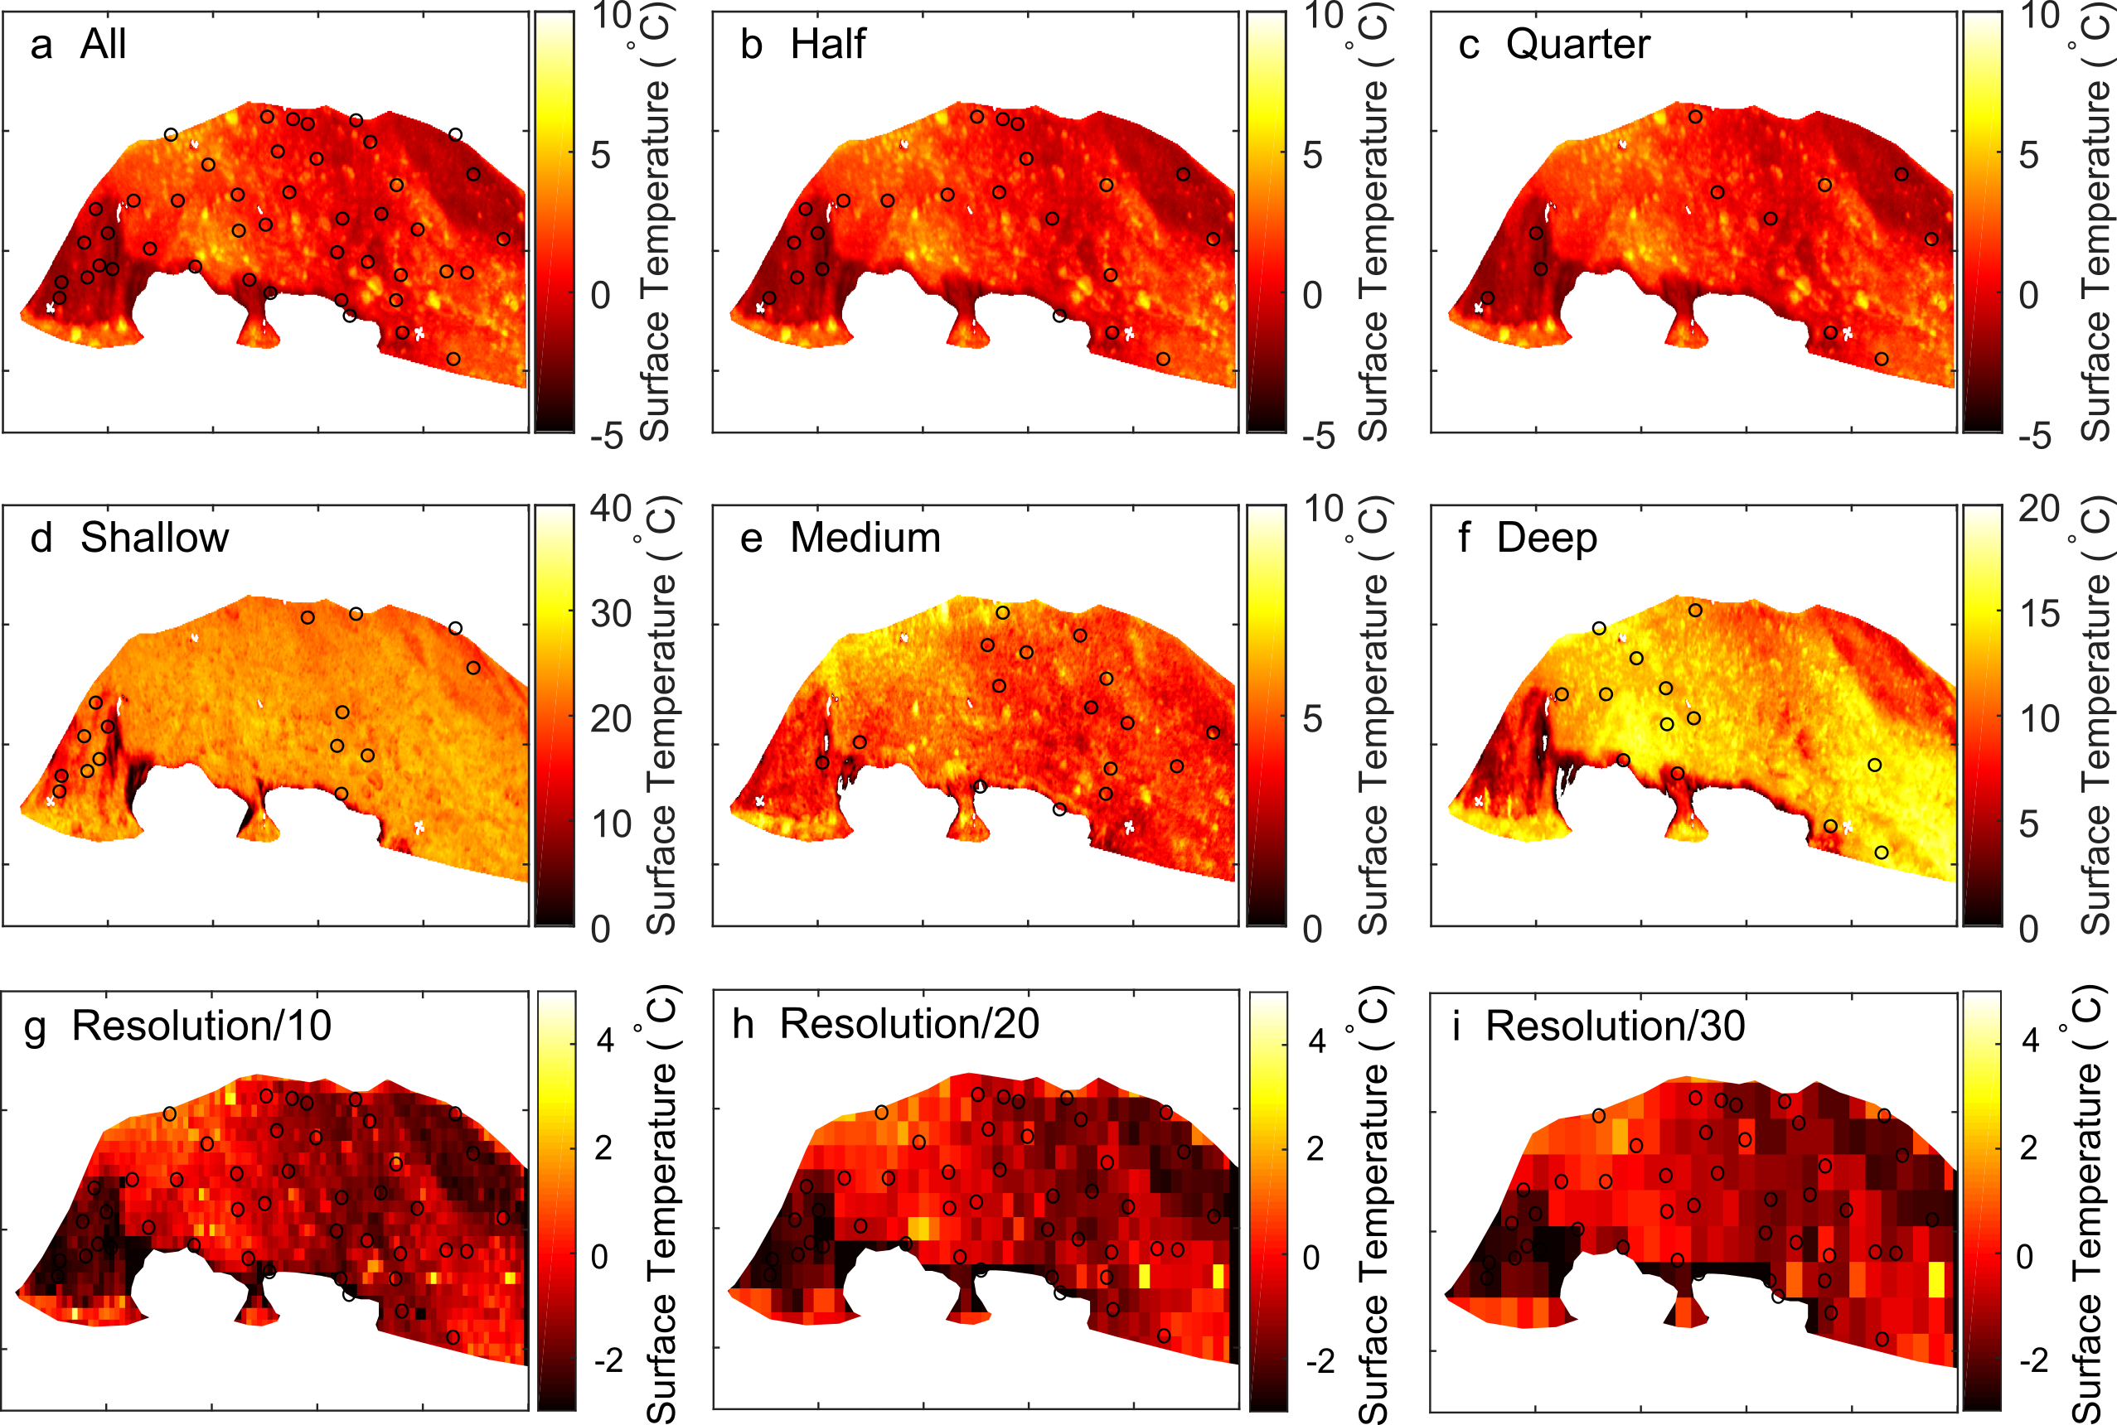
Figure S6. The raw TIR surface temperature used to derived modelled debris thickness in the scenarios with all the manual excavations (a), half the manual excavation (b), a quarter of the manual excavations (c), and with only shallow manual excavations (d), medium depth manual excavation (e) and deep debris (f). Note the variable values of the color bar across d-f.

