SUPPLEMENTARY MATERIAL - Application of visual stratigraphy from line scan images to constrain chronology and melt features of a firn core from coastal Antarctica
Rahul DEY^{1,2}, Meloth THAMBAN¹, Chavarukonam Madhavanpillai LALURAJ¹, Kanthanathan MAHALINGANATHAN¹, Bhikaji Laxman REDKAR¹, Sudhir KUMAR³, Kenichi MATSUOKA⁴
¹National Centre for Polar and Ocean Research (NCPOR), Ministry of Earth Sciences, Vasco-da Gama, Goa 403804, India
²School of Earth, Ocean and Atmospheric Sciences (SEOAS), Goa University, Goa 403206, India
³Hydrological Investigations Division, National Institute of Hydrology, Ministry of Jal Shakti, Roorkee-247667, India
⁴Norwegian Polar Institute, Framsentret, Postboks 6606, Langnes, 9296 Tromsø, Norway
Correspondence: Rahul Dey (rdey1801@gmail.com, rahuldey@ncpor.res.in)

- StratiCounter input templates and procedure
The StratiCounter program was run for the 50 m section of the ice core, based on a preliminary set of input layer templates obtained from manual identification of annual layers. Uncertain or ambiguous layers in manual counting are marked and given as input for the algorithm. We did not use the El Chichón (1983) and Agung (1964) eruption as reference points for StratiCounter because the number of possible layers between Pinatubo (1992) and El Chichón (1983) is less and would not provide a reliable layer parameter estimation, while the Agung (1964) and the tritium bomb anomaly peak (1961/62) are only two/three years apart and the tritium anomaly peak is a relatively more reliable reference point. Equal weights are given to all proxy records. All manually identified annual layers were marked as certain (0) and uncertain (1) and given as input for StratiCounter. In order to remove the dependence of the StratiCounter output on the initial manual layer counts, we again re-run the program using the improved layer template obtained from the initial output. To further assess the consistency of the chronology, we performed multiple runs of StratiCounter with different combinations of certain and uncertain input layers and found that the resulting age models were very similar (within ±1 year in the studied section). We followed a similar approach for obtaining an improved age-depth model using the VS records. The accuracy of the age-depth models is calculated as the deviation in age at the identified reference-points and shown in Table ST1.
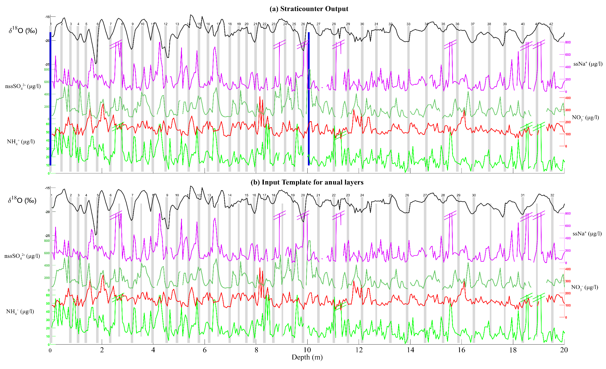Fig. S1 - Top 20 m section of the ice core, showing (a) annual layer output from the StratiCounter program and (b) Initial annual layer template given as an
input to StratiCounter. Gray bars show the annual layers identified. Note that the uncertain/ambiguous annual layers in the input template are shown with smaller bars and are not numbered, and therefore the count on annual layer markers are significantly different in both the panels. Blue bars show the two tie points, viz., core top (2017) and Pinatubo event (1992). Due to the high variability of the proxy records, the y-axis for ssNa and NH4 have been cropped to show maximum variability and the peaks cropped as a result are marked with breaks to differentiate them from missing data points.
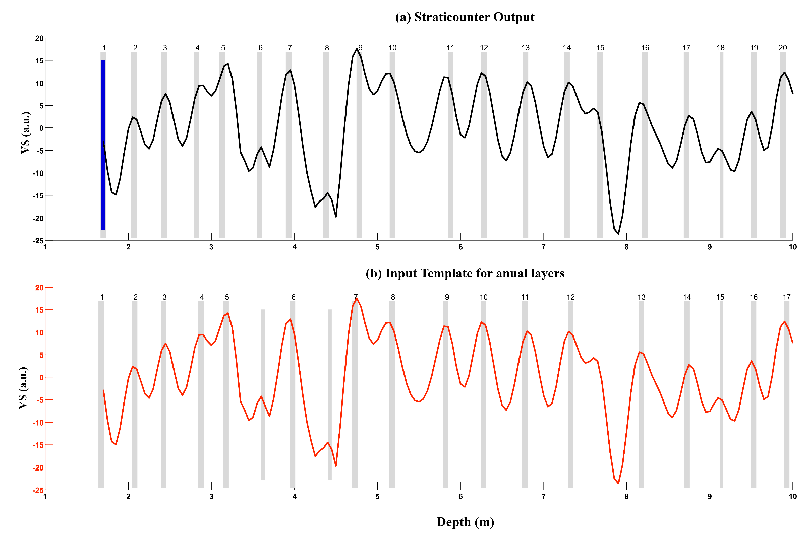
Fig. S2 - Same as figure S1, but for VS record for the top 1.7 – 10 m of the ice core. Blue bar is the year 2011, obtained as the nearest age point from multiproxy age model.
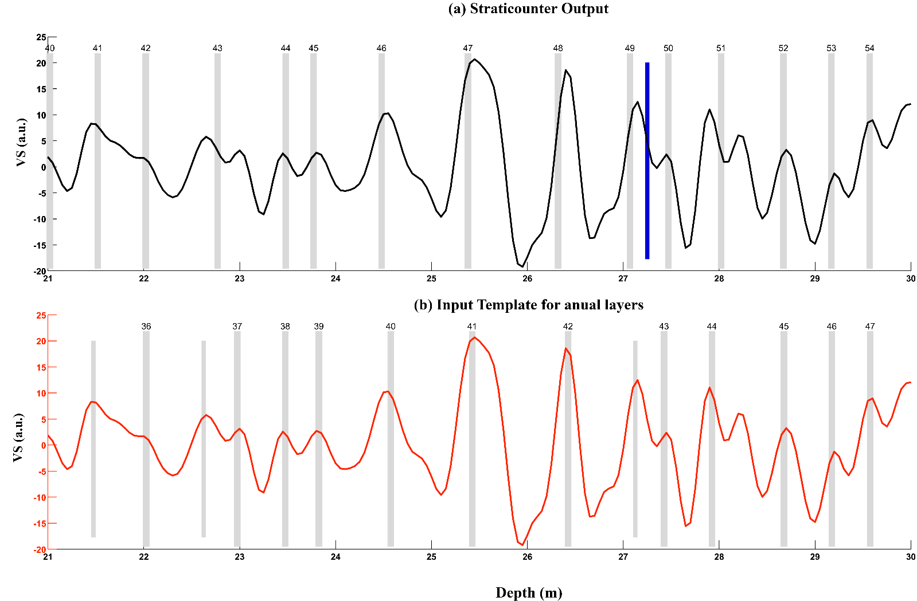
Fig. S3 - Same as figure S1, but for VS record of for the top 21 – 30 m of the ice core. Blue bar is the Tritium bomb marker (1961/62).
Table ST1. Age model errors (in years) for the multiproxy and VS age scale, calculated as the deviation from the known time markers from volcanic events and tritium anomaly. Negative values mean that the layer counting gives younger age at the depth of these volcanic tie points.
Marker Events | Multiproxy | VS
Pinatubo / Cerro Hudson (1992) | 0.1 | 0.1
El Chichón (1983) | -1.2 | -1.1
Agung (1964) | 0.2 | 0.3
Tritium anomaly (1962) | 1 | 1.1
Cerro Azul (1933) | 0.7 | 0.6

