Supplement to Maritime glacier retreat and terminus area change in Kenai Fjords National Park, Alaska, between 1984 and 2021
Taryn Black^{1,2}, Deborah Kurtz³
¹ Department of Earth and Space Sciences, University of Washington, Seattle, WA, USA
² Polar Science Center, Applied Physics Laboratory, University of Washington, Seattle, WA, USA
³ Kenai Fjords National Park, U.S. National Park Service, Seward, AK, USA

TABLES
Table S1. Net and decadal length change rates for each glacier. All values are in m a⁻¹.
Glacier | Net dL/dt | 1980s dL/dt | 1990s dL/dt | 2000s dL/dt | 2010s dL/dt | 2020s dL/dt
Bear Glacier | -139 | -12 | -146 | -115 | -172 | -294
Aialik Glacier | -0 | 111 | -53 | -6 | 1 | 11
Pedersen Glacier | -86 | 3 | -22 | -70 | -206 | 31
Holgate Glacier | 13 | 57 | -30 | 17 | 20 | 53
South Holgate Glacier - West | -10 | 6 | -7 | -8 | -5 | -97
South Holgate Glacier - East | -34 | 31 | 1 | -55 | -52 | -164
Northeastern Glacier | -56 | -44 | -63 | -46 | -57 | -83
Northwestern Glacier | -42 | -6 | -154 | 1 | -0 | 7
Ogive Glacier | 1 | -10 | 5 | 4 | -1 | 10
Anchor Glacier | -3 | 33 | -2 | 5 | -13 | -75
Reconstitution Glacier | -8 | 10 | -16 | -15 | -13 | 33
Southwestern Glacier | -42 | -69 | -7 | -11 | -57 | -162
Sunlight Glacier | -16 | -13 | -13 | -49 | 12 | -65
Paguna Glacier | 6 | 32 | 10 | 4 | 0 | -11
McCarty Glacier | -20 | 18 | -23 | -46 | -6 | -25
Dinglestadt Glacier | -24 | 12 | -11 | -32 | -27 | -92
Split Glacier | -15 | -60 | 9 | -29 | -12 | -69
Yalik Glacier | -61 | -50 | -43 | -58 | -65 | -158
Petrof Glacier | -28 | -68 | -22 | -13 | -35 | -36

Table S2. Net and decadal area change rates for each glacier. All values are in km² a⁻¹.
Glacier | Net dA/dt | 1980s dA/dt | 1990s dA/dt | 2000s dA/dt | 2010s dA/dt | 2020s dA/dt
Bear Glacier | -0.463 | -0.654 | -0.383 | -0.537 | -0.378 | -0.587
Aialik Glacier | -0.016 | 0.098 | -0.063 | -0.056 | -0.009 | 0.052
Pedersen Glacier | -0.114 | -0.077 | -0.033 | -0.202 | -0.158 | 0.003
Holgate Glacier | 0.006 | 0.070 | -0.057 | 0.034 | 0.005 | 0.052
South Holgate Glacier - West | -0.006 | 0.004 | -0.002 | -0.014 | -0.002 | -0.034
South Holgate Glacier - East | -0.013 | 0.020 | -0.013 | -0.028 | -0.009 | -0.050
Northeastern Glacier | -0.066 | -0.073 | -0.063 | -0.040 | -0.074 | -0.114
Northwestern Glacier | -0.044 | 0.012 | -0.177 | 0.005 | 0.002 | -0.020
Ogive Glacier | -0.002 | 0.005 | -0.013 | 0.010 | -0.002 | -0.009
Anchor Glacier | -0.003 | 0.020 | -0.003 | 0.001 | -0.010 | -0.038
Reconstitution Glacier | -0.011 | 0.008 | -0.022 | -0.017 | -0.008 | -0.001
Southwestern Glacier | -0.037 | -0.043 | -0.007 | -0.034 | -0.058 | -0.061
Sunlight Glacier | -0.024 | -0.079 | -0.015 | -0.047 | -0.012 | -0.003
Paguna Glacier | -0.001 | 0.011 | 0.007 | -0.003 | -0.002 | -0.052
McCarty Glacier | -0.049 | 0.012 | -0.001 | -0.170 | -0.036 | -0.031
Dinglestadt Glacier | -0.020 | 0.007 | -0.011 | -0.031 | -0.022 | -0.050
Split Glacier | -0.018 | -0.029 | 0.001 | -0.032 | -0.010 | -0.112
Yalik Glacier | -0.185 | -0.415 | -0.093 | -0.231 | -0.176 | -0.371
Petrof Glacier | -0.062 | -0.084 | -0.058 | -0.061 | -0.067 | -0.047

FIGURES
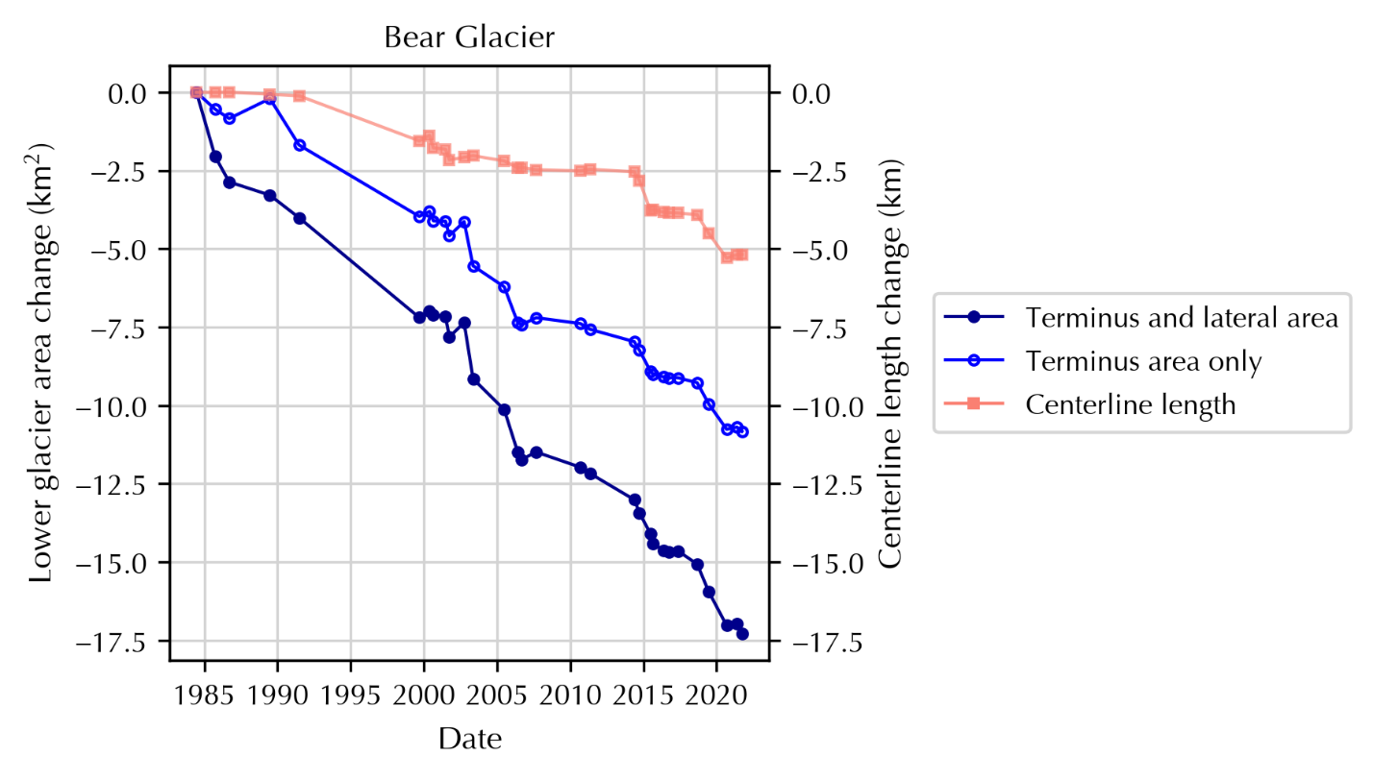
Fig. S1. Observed change in lower glacier area (dark blue, closed circles), terminus area (blue, open circles), and centerline length (pink, squares) at Bear Glacier.

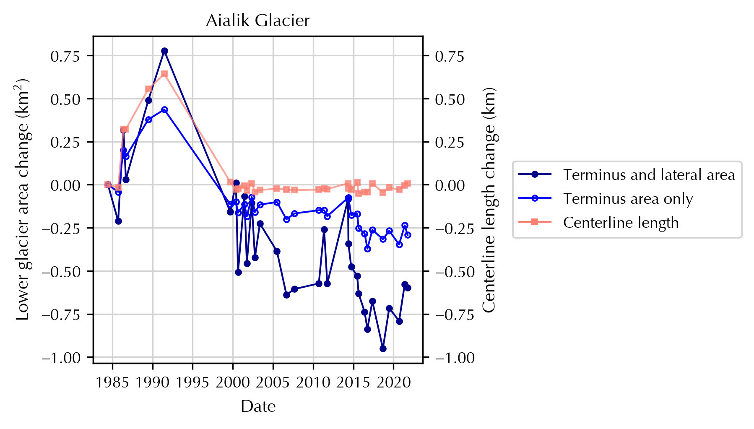
Fig. S2. Observed change in lower glacier area (dark blue, closed circles), terminus area (blue, open circles), and centerline length (pink, squares) at Aialik Glacier.
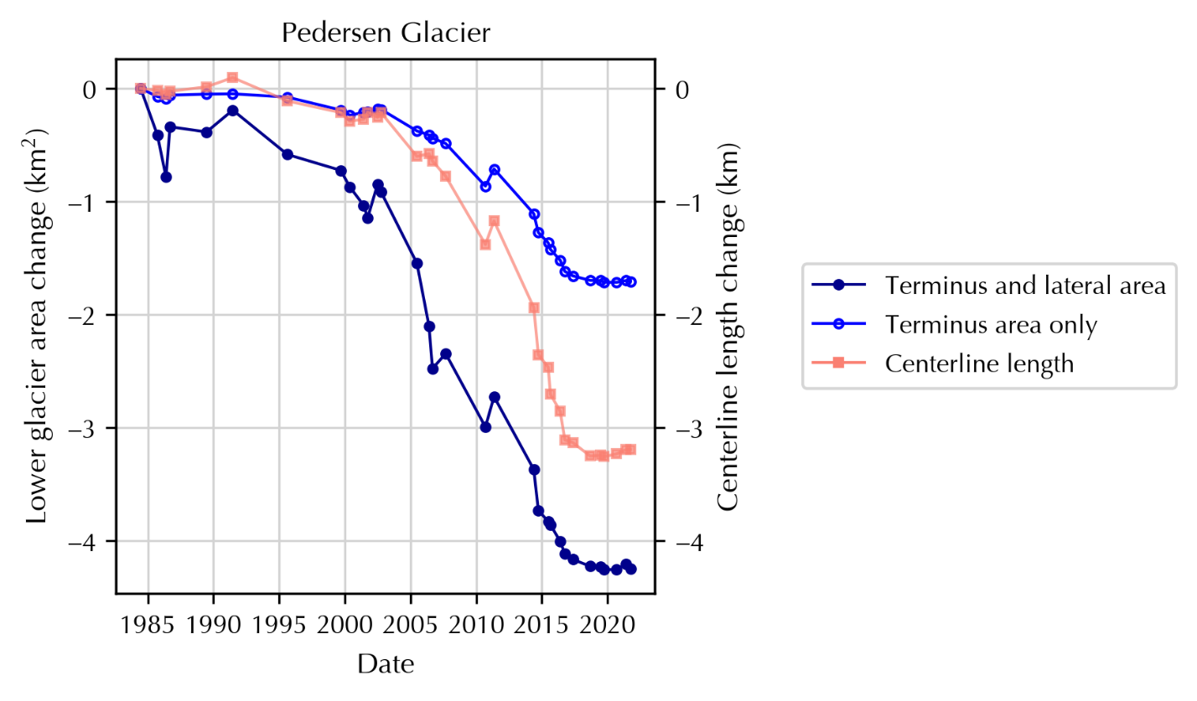
Fig. S3. Observed change in lower glacier area (dark blue, closed circles), terminus area (blue, open circles), and centerline length (pink, squares) at Pedersen Glacier.

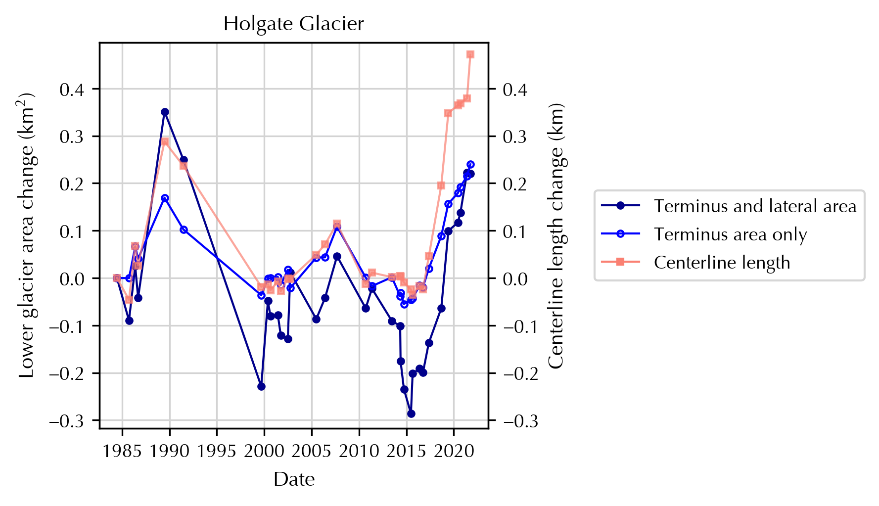
Fig. S4. Observed change in lower glacier area (dark blue, closed circles), terminus area (blue, open circles), and centerline length (pink, squares) at Holgate Glacier.
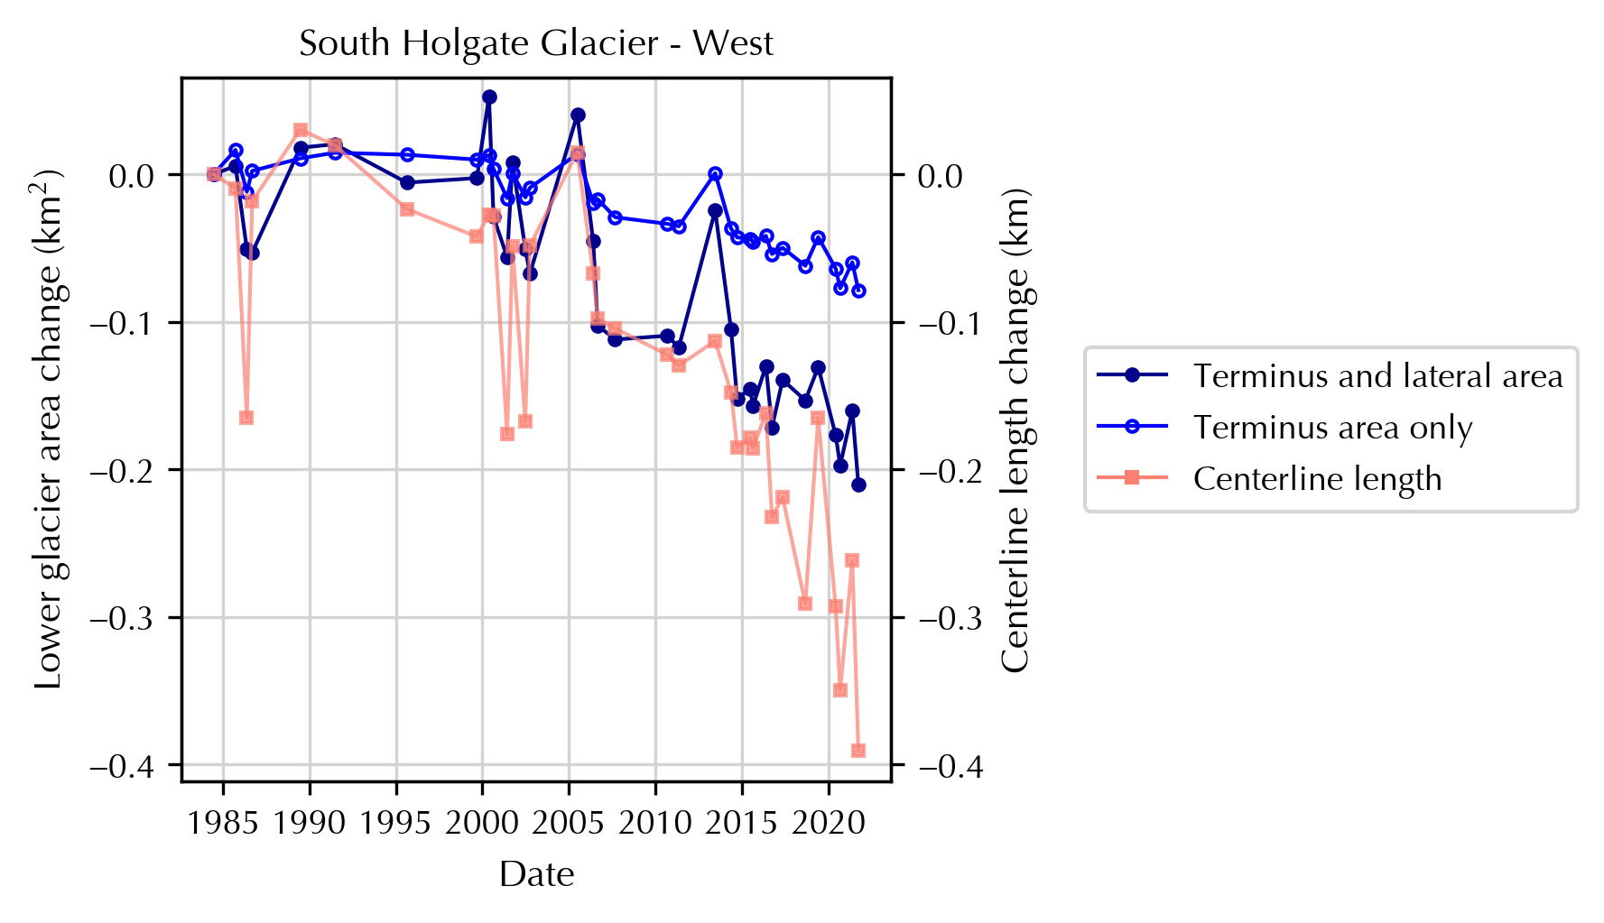
Fig. S5. Observed change in lower glacier area (dark blue, closed circles), terminus area (blue, open circles), and centerline length (pink, squares) at South Holgate Glacier – West.

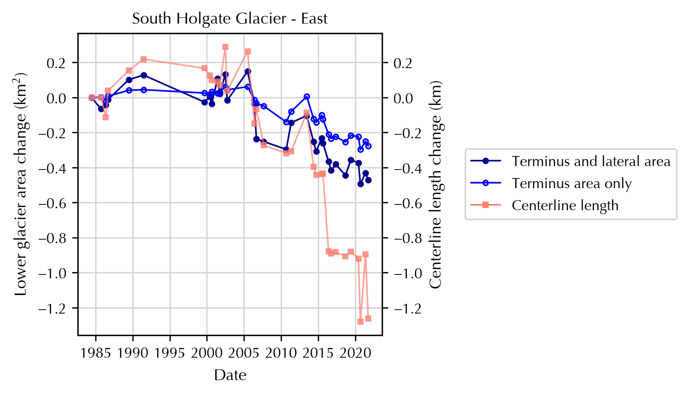
Fig. S6. Observed change in lower glacier area (dark blue, closed circles), terminus area (blue, open circles), and centerline length (pink, squares) at South Holgate Glacier – East.
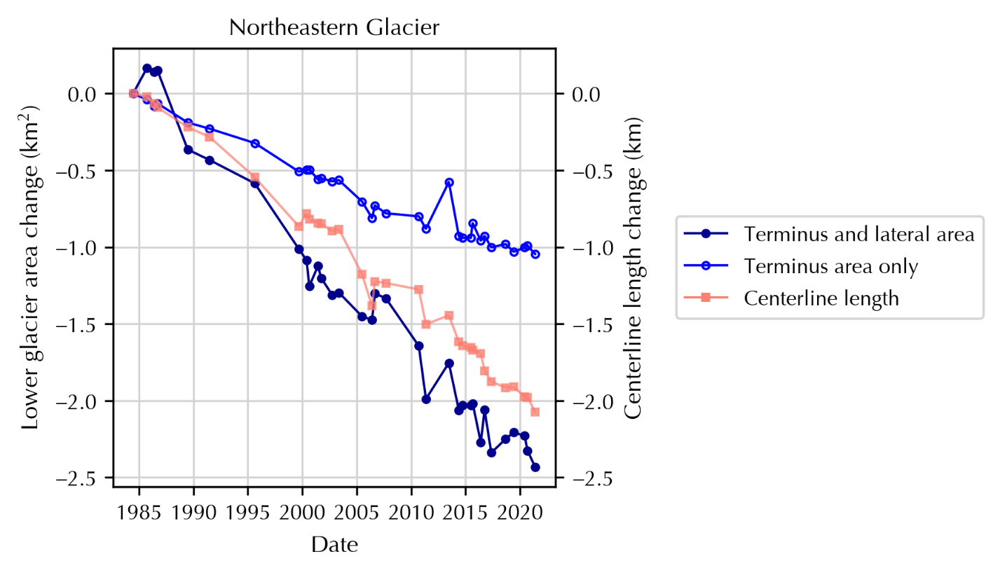
Fig. S7. Observed change in lower glacier area (dark blue, closed circles), terminus area (blue, open circles), and centerline length (pink, squares) at Northeastern Glacier.

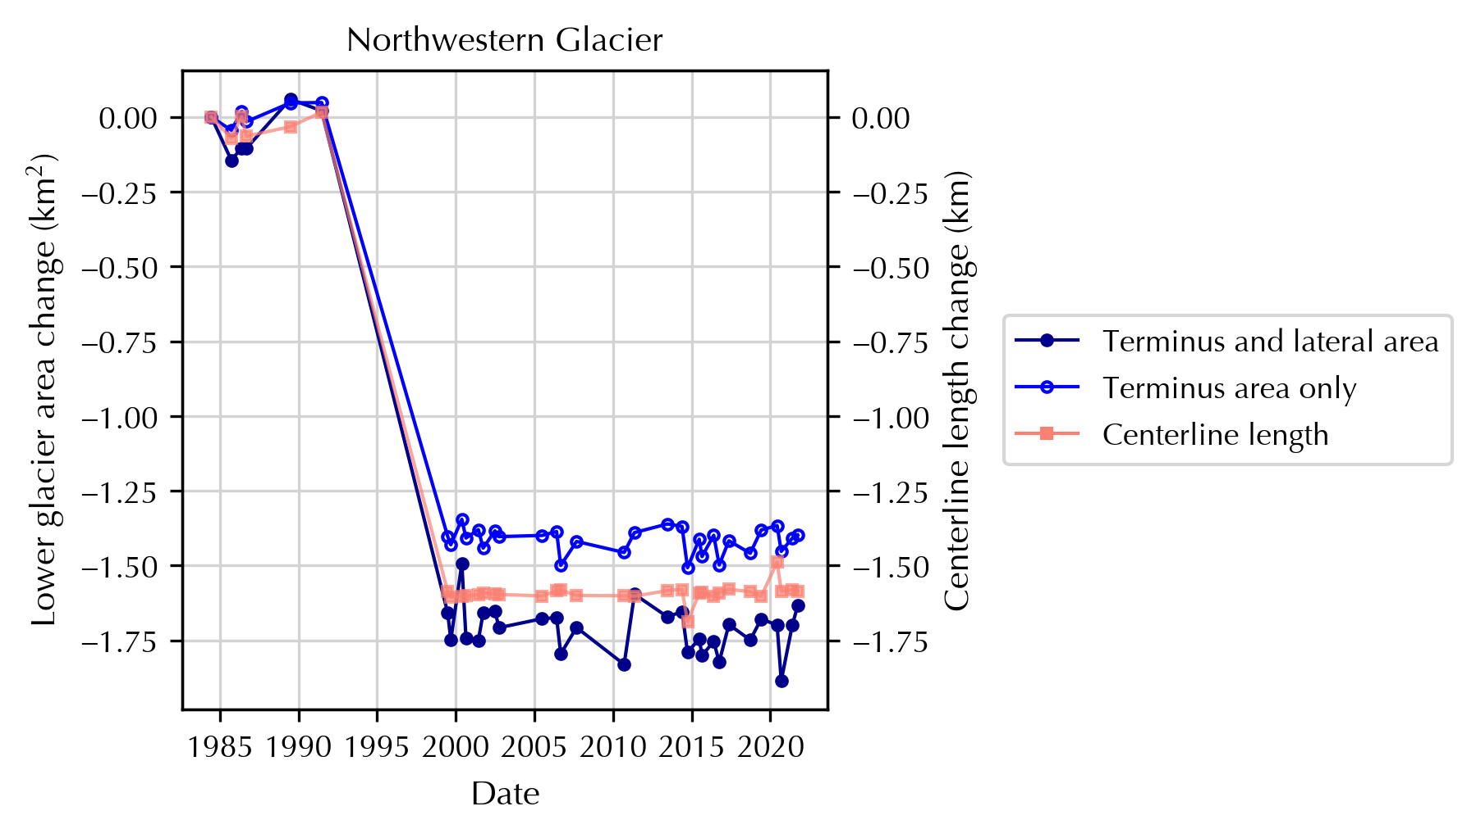
Fig. S8. Observed change in lower glacier area (dark blue, closed circles), terminus area (blue, open circles), and centerline length (pink, squares) at Northwestern Glacier.
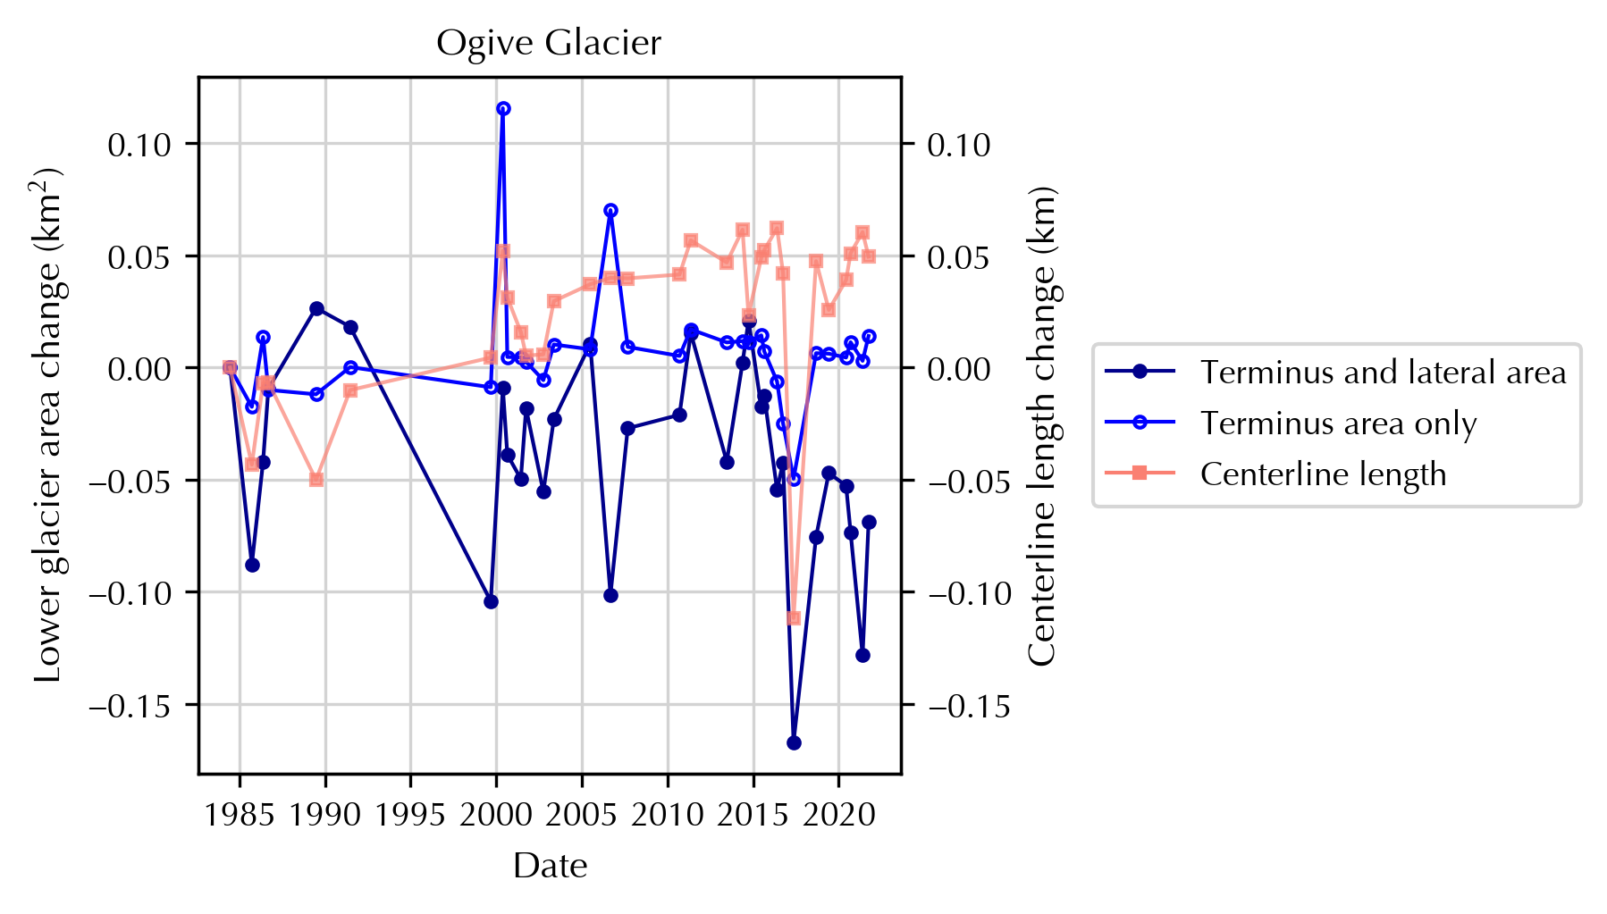
Fig. S9. Observed change in lower glacier area (dark blue, closed circles), terminus area (blue, open circles), and centerline length (pink, squares) at Ogive Glacier.

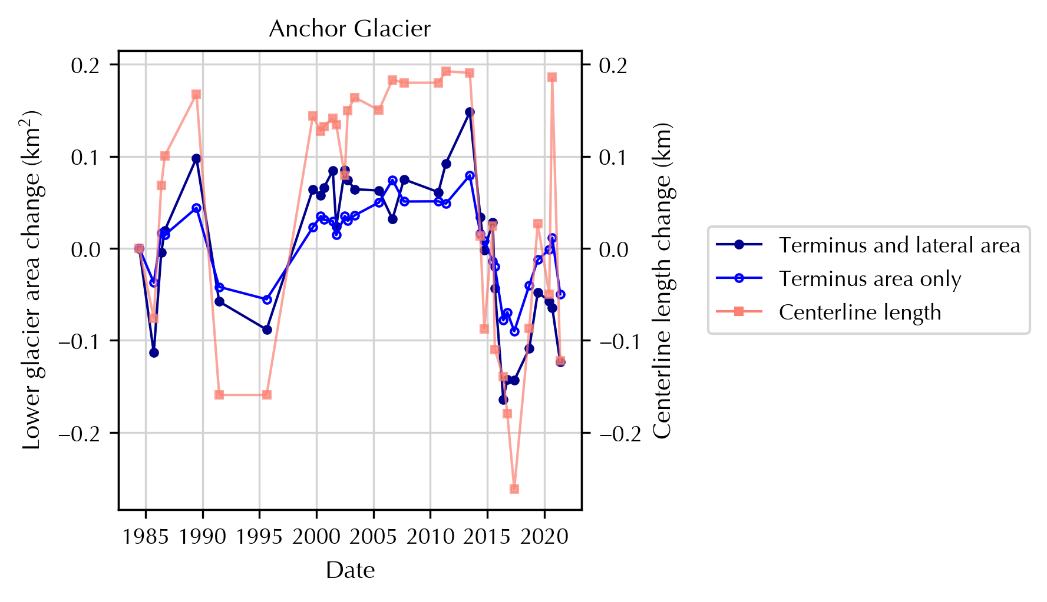
Fig. S10. Observed change in lower glacier area (dark blue, closed circles), terminus area (blue, open circles), and centerline length (pink, squares) at Anchor Glacier.
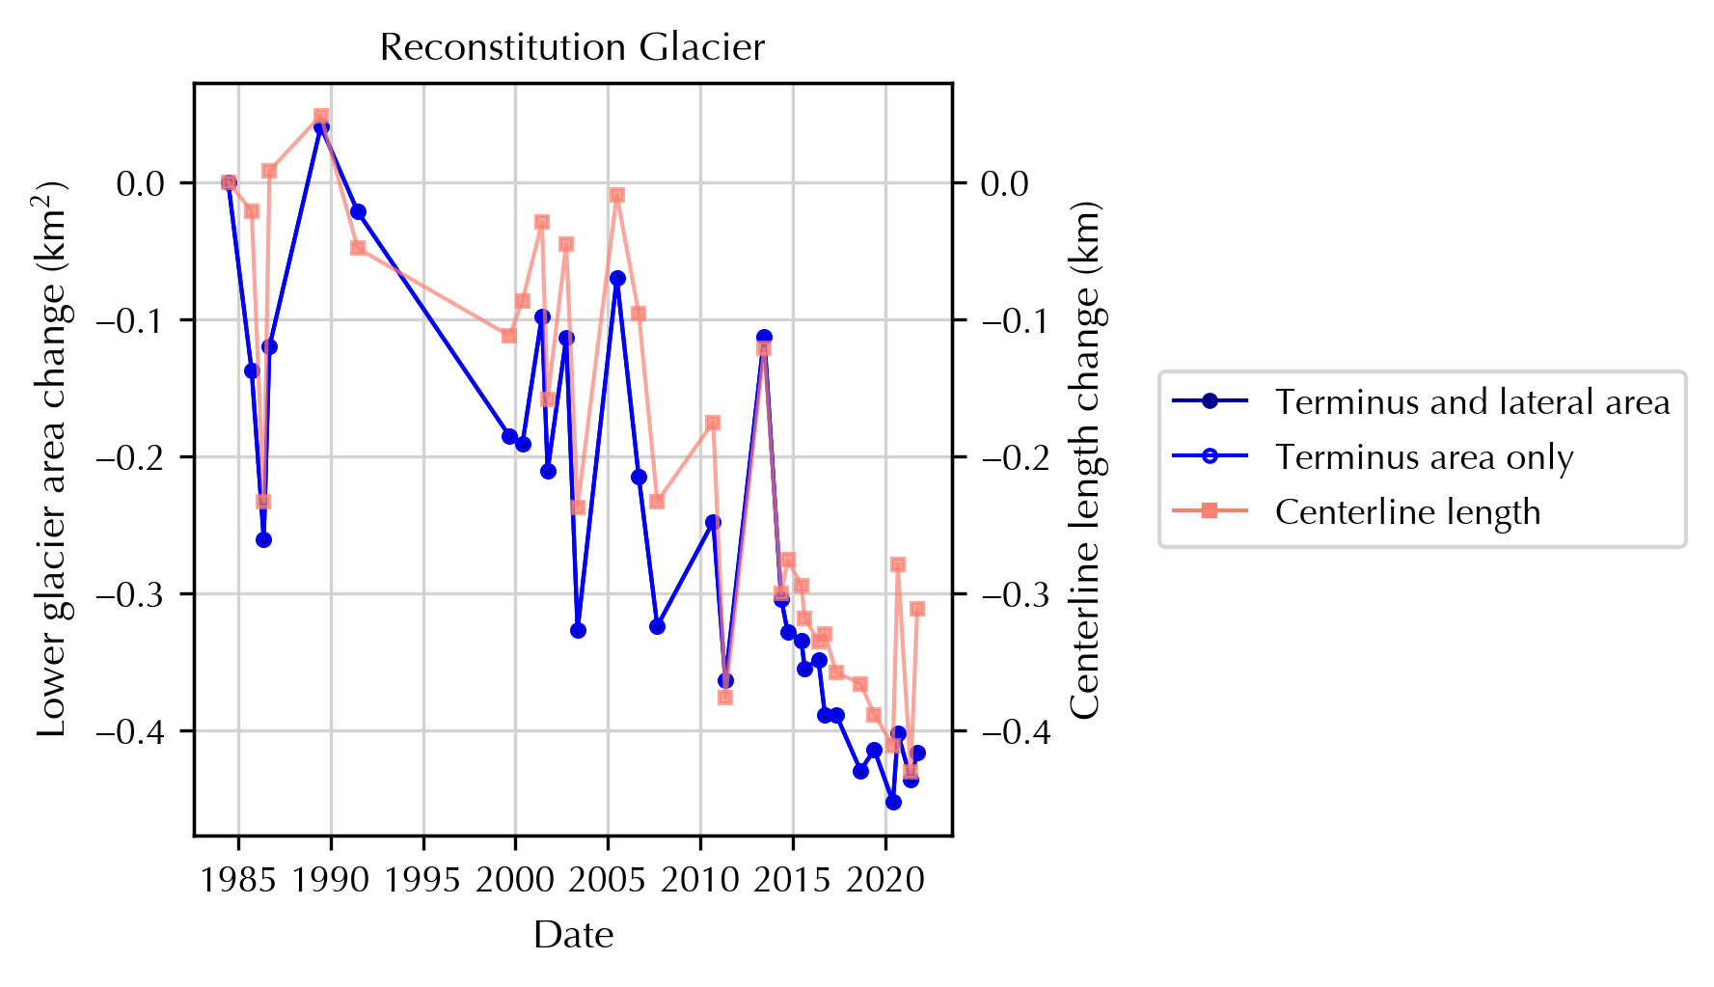
Fig. S11. Observed change in lower glacier area (dark blue, closed circles), terminus area (blue, open circles), and centerline length (pink, squares) at Reconstitution Glacier.

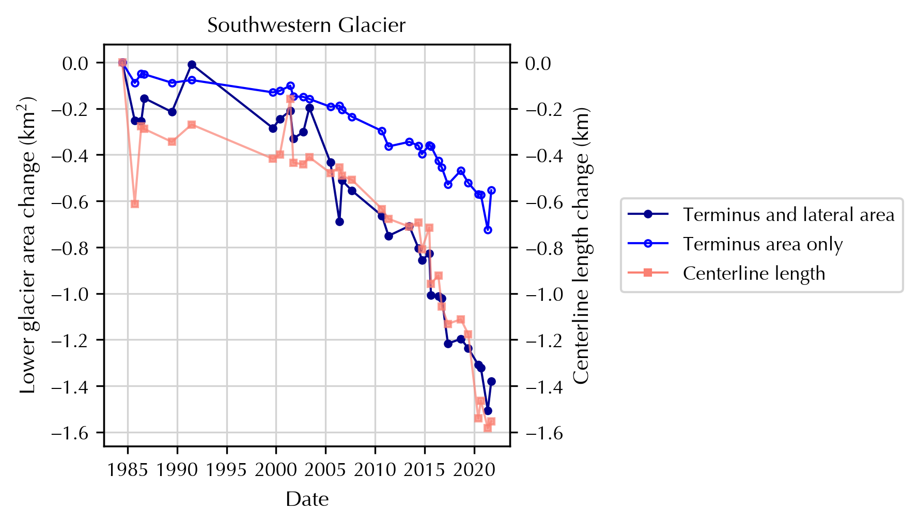
Fig. S12. Observed change in lower glacier area (dark blue, closed circles), terminus area (blue, open circles), and centerline length (pink, squares) at Southwestern Glacier.
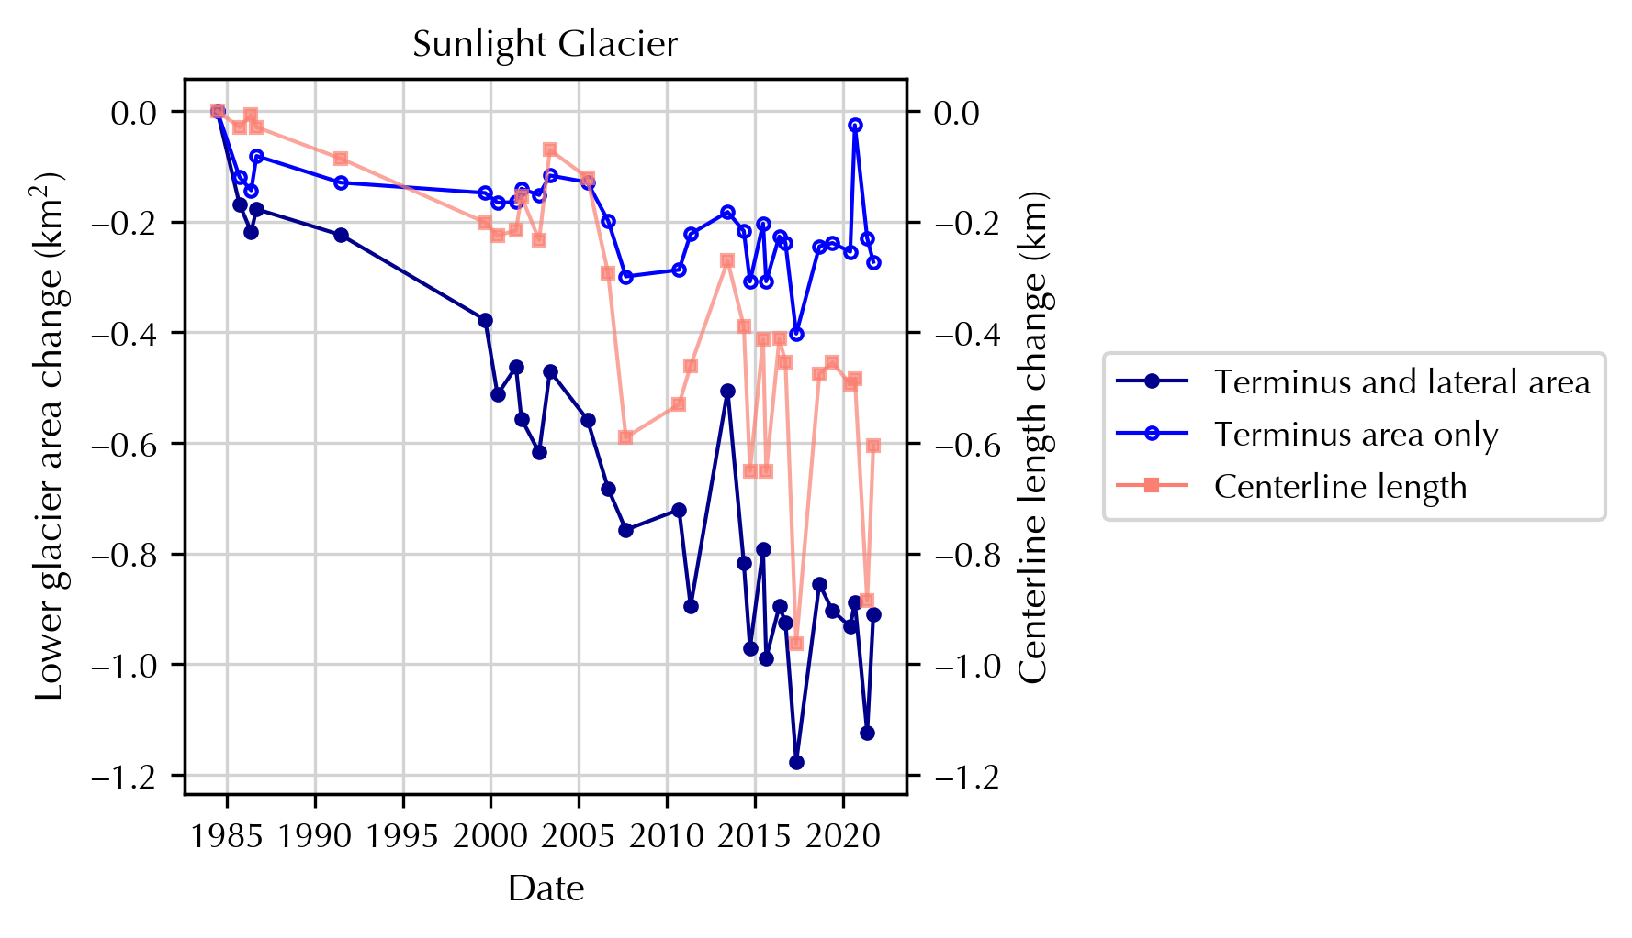
Fig. S13. Observed change in lower glacier area (dark blue, closed circles), terminus area (blue, open circles), and centerline length (pink, squares) at Sunlight Glacier.

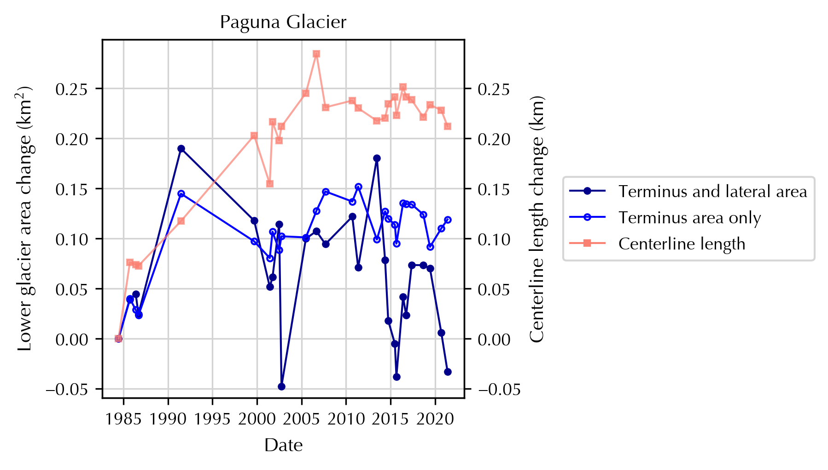
Fig. S14. Observed change in lower glacier area (dark blue, closed circles), terminus area (blue, open circles), and centerline length (pink, squares) at Paguna Glacier.
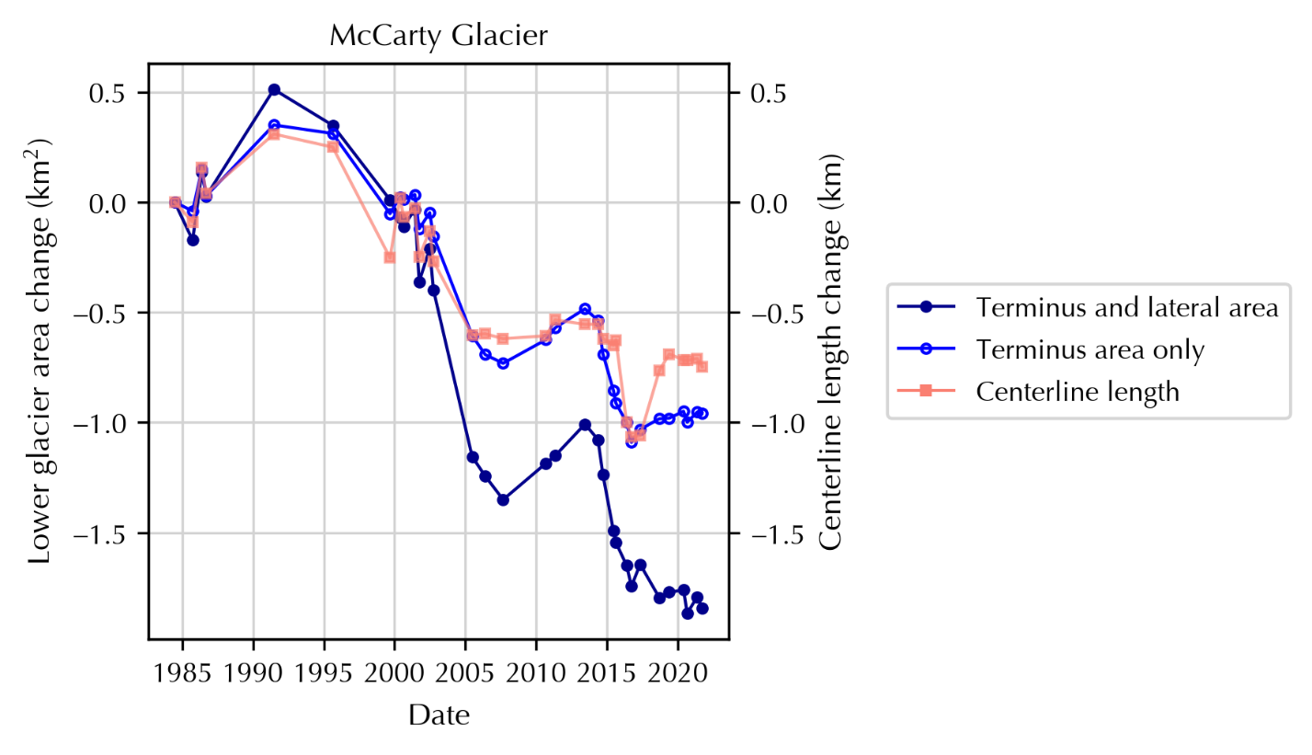
Fig. S15. Observed change in lower glacier area (dark blue, closed circles), terminus area (blue, open circles), and centerline length (pink, squares) at McCarty Glacier.

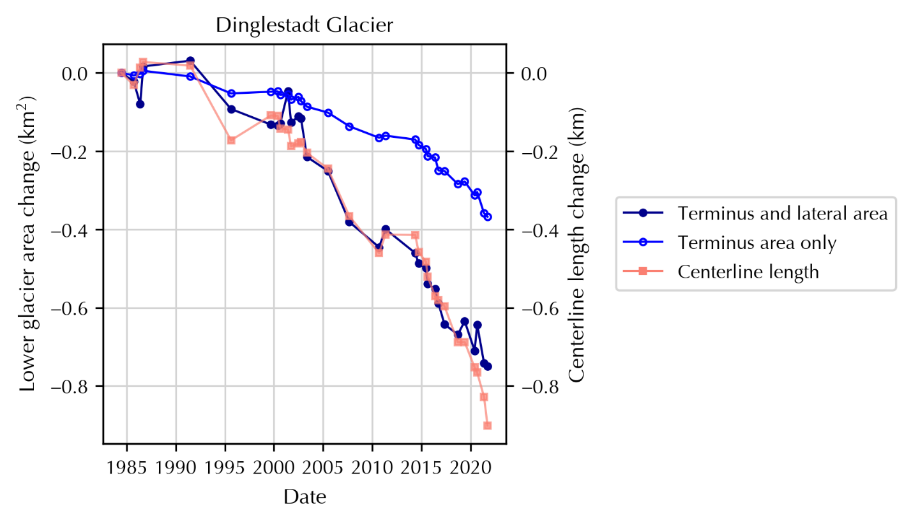
Fig. S16. Observed change in lower glacier area (dark blue, closed circles), terminus area (blue, open circles), and centerline length (pink, squares) at Dinglestadt Glacier.
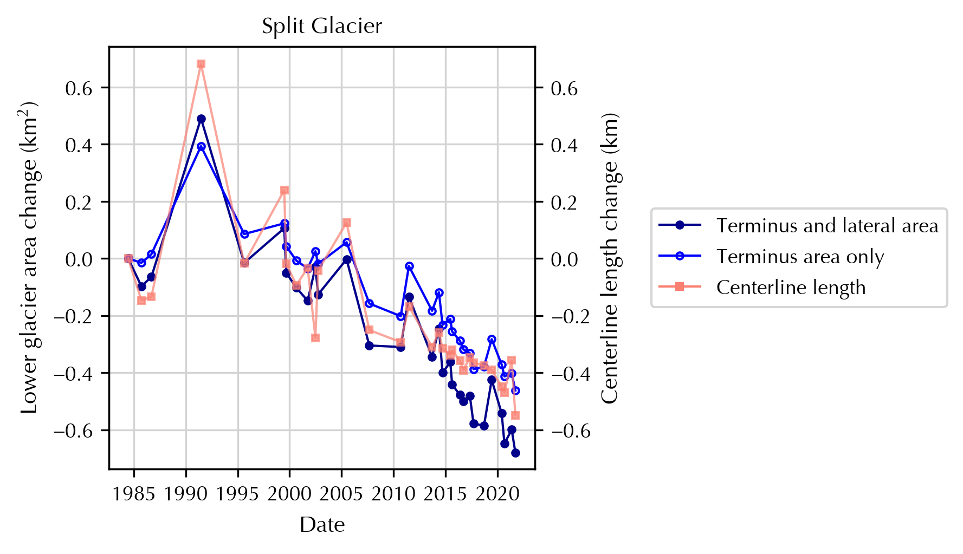
Fig. S17. Observed change in lower glacier area (dark blue, closed circles), terminus area (blue, open circles), and centerline length (pink, squares) at Split Glacier.

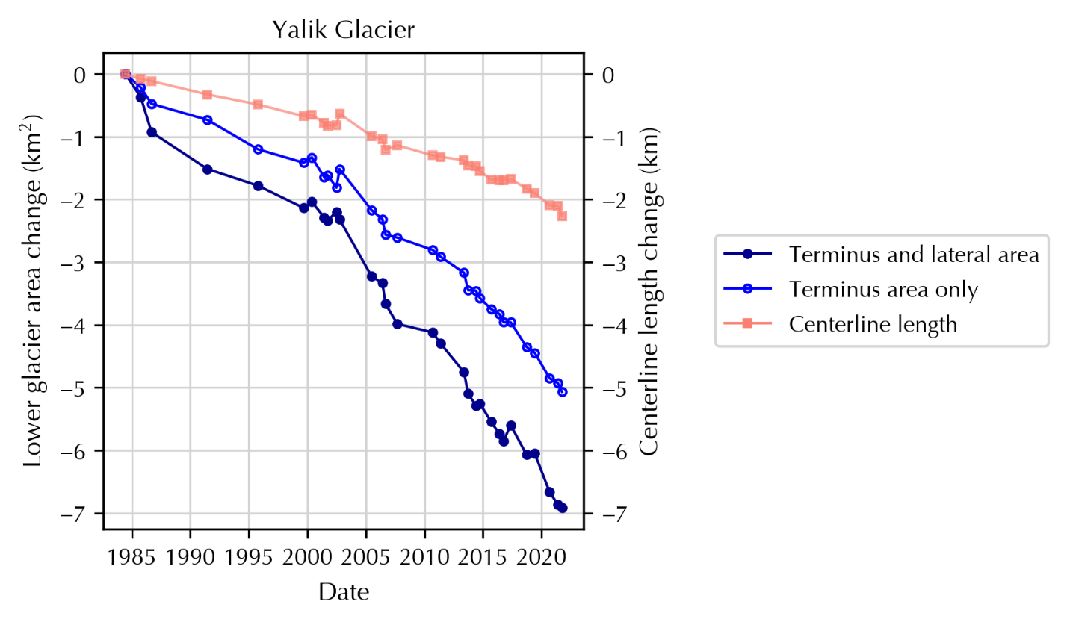Fig. S18. Observed change in lower glacier area (dark blue, closed circles), terminus area (blue, open circles), and centerline length (pink, squares) at Yalik Glacier.
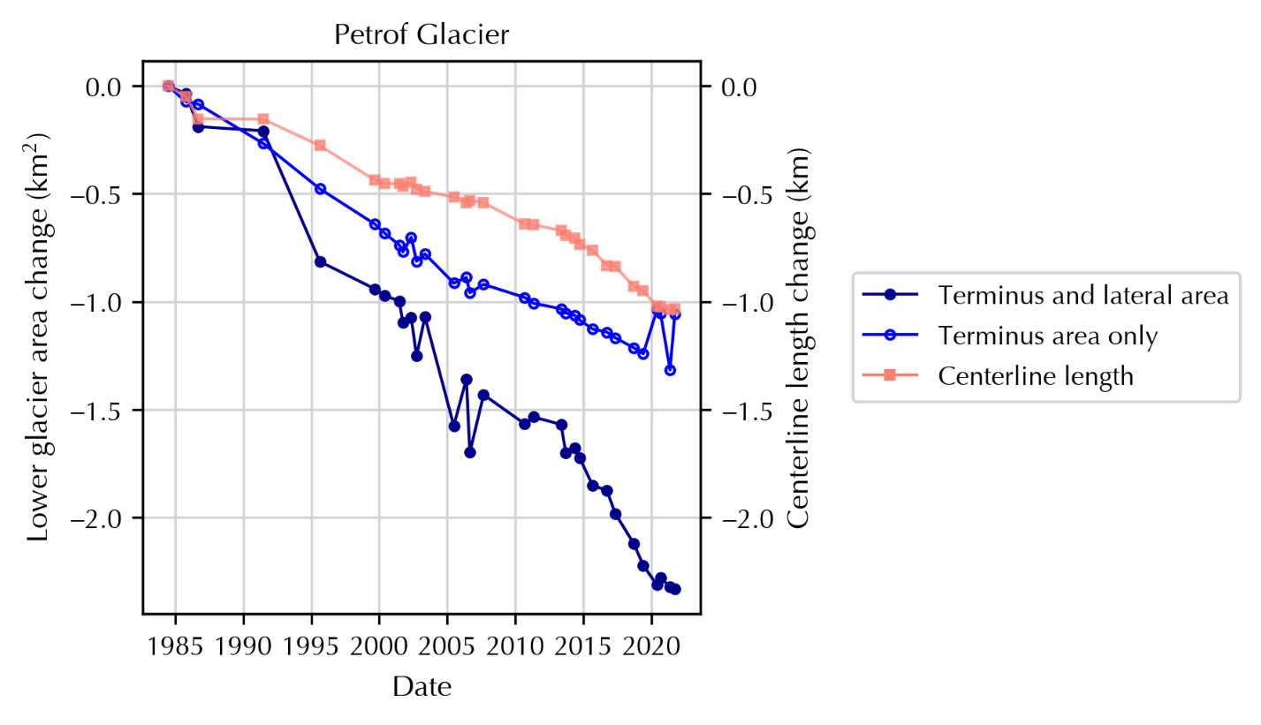
Fig. S19. Observed change in lower glacier area (dark blue, closed circles), terminus area (blue, open circles), and centerline length (pink, squares) at Petrof Glacier.

