Supplementary Materials for Multi-decadal elevation changes of the land terminating sector of West Greenland
Jun Saito,1∗ Toby Meierbachtol,1 Joel Harper 1
1 Department of Geosciences, University of Montana, Missoula, Montana, 59812, USA
Correspondence: Jun Saito <jun.saito@umontana.edu>

Table S1. Table of ArcticDEM Used.

Image ID | Date  [yyyy-mm-dd]
SETSM_WV02_20130528_1030010023602900_1030010023CB1F00_seg1_2m_v3.0_dem | 2013-05-28
SETSM_WV02_20130528_10300100235B5200_10300100236F4C00_seg1_2m_v3.0_dem | 2013-05-28
SETSM_WV01_20130406_1020010022917B00_10200100200A1300_seg1_2m_v3.0_dem | 2013-04-06
SETSM_WV01_20130322_10200100203BDA00_1020010022E96A00_seg1_2m_v3.0_dem | 2013-03-22
SETSM_W2W2_20130212_103001001F7C9B00_1030010020505900_seg1_2m_v3.0_dem | 2013-02-12
SETSM_W2W2_20130401_1030010020CF4A00_1030010021AB8D00_seg1_2m_v3.0_dem | 2013-04-01
SETSM_WV02_20130401_1030010021147F00_103001002154C900_seg1_2m_v3.0_dem | 2013-04-01
SETSM_W2W2_20130413_103001002143D700_103001002158B300_seg1_2m_v3.0_dem | 2013-04-13
SETSM_WV01_20130402_102001001F7A9F00_10200100219D8C00_seg1_2m_v3.0_dem | 2013-04-02
SETSM_WV02_20130329_103001002146BD00_103001002080C300_seg1_2m_v3.0_dem | 2013-03-29
SETSM_WV02_20170919_103001006FB93600_10300100704A5400_seg1_2m_v3.0_dem | 2017-09-19
SETSM_WV01_20170912_1020010066D5D000_102001006525EE00_seg1_2m_v3.0_dem | 2017-09-12
SETSM_WV01_20170912_102001006802AC00_102001006A2C9200_seg1_2m_v3.0_dem | 2017-09-12
SETSM_WV01_20170501_102001005F9C5D00_102001005FEA0400_seg1_2m_v3.0_dem | 2017-05-01
SETSM_WV01_20170426_102001005F6E8A00_102001005F66CC00_seg1_2m_v3.0_dem | 2017-04-26
SETSM_WV03_20170426_104001002C9B4A00_104001002B8DF500_seg1_2m_v3.0_dem | 2017-04-26
SETSM_WV01_20170805_10200100657CC500_1020010064D99900_seg1_2m_v3.0_dem | 2017-08-05
SETSM_WV03_20170827_1040010032944300_1040010031864F00_seg2_2m_v3.0_dem | 2017-08-27
SETSM_WV03_20170807_1040010030458500_1040010030A5DD00_seg1_2m_v3.0_dem | 2017-08-07
SETSM_WV03_20170807_1040010030458500_1040010030A5DD00_seg5_2m_v3.0_dem | 2017-08-07
SETSM_WV03_20170626_104001002F2B0F00_104001002EC08F00_seg1_2m_v3.0_dem | 2017-06-26
SETSM_WV03_20170820_10400100304BB200_104001003208E000_seg1_2m_v3.0_dem | 2017-08-20
SETSM_WV01_20170711_1020010063BE0000_1020010064099C00_seg1_2m_v3.0_dem | 2017-07-11
SETSM_WV02_20170710_103001006C65BF00_103001006D517C00_seg1_2m_v3.0_dem | 2017-07-10

Table S2. Mean SMB of total and individual north, central and south regions during the 1960–1990.

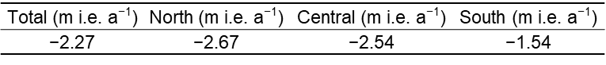

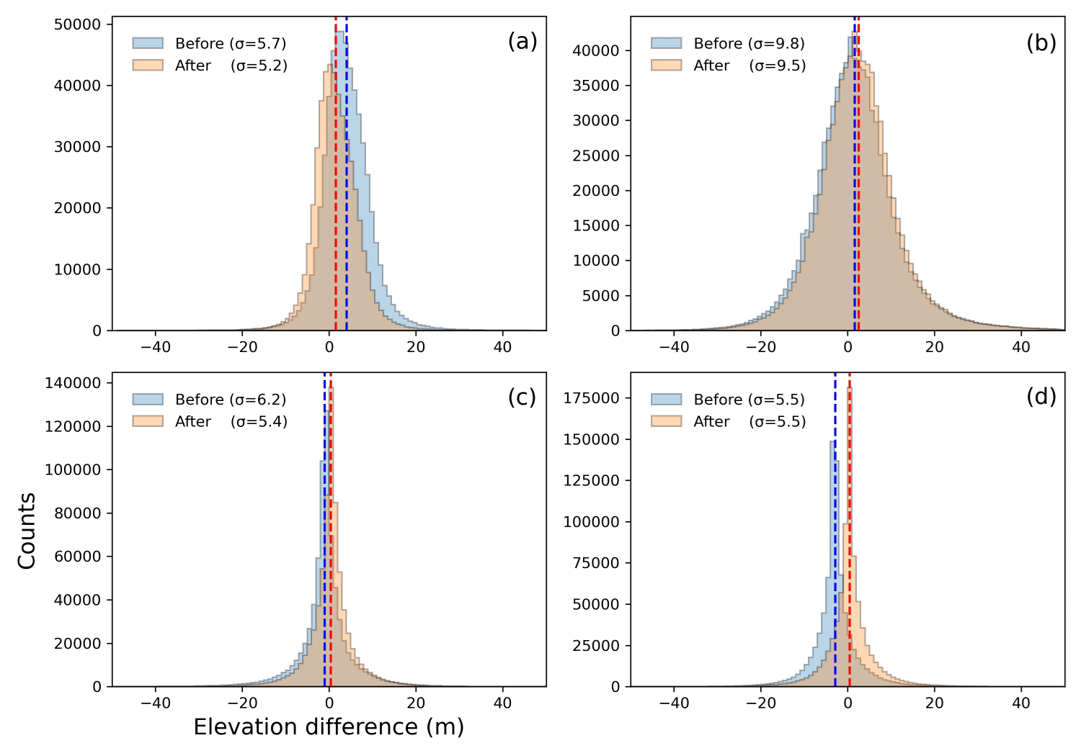
Fig. S1. Histogram of elevation differences in the ice-free area between each DEMs ((a)
AeroDEM, (b) GIMP DEM, (c) ArcticDEM strips (2013) and (d) ArcticDEM strips (2017)) and
ArcticDEM mosaic. Each vertical dash line shows mean value (Blue: Before co-registration, Red:
After co-registration).

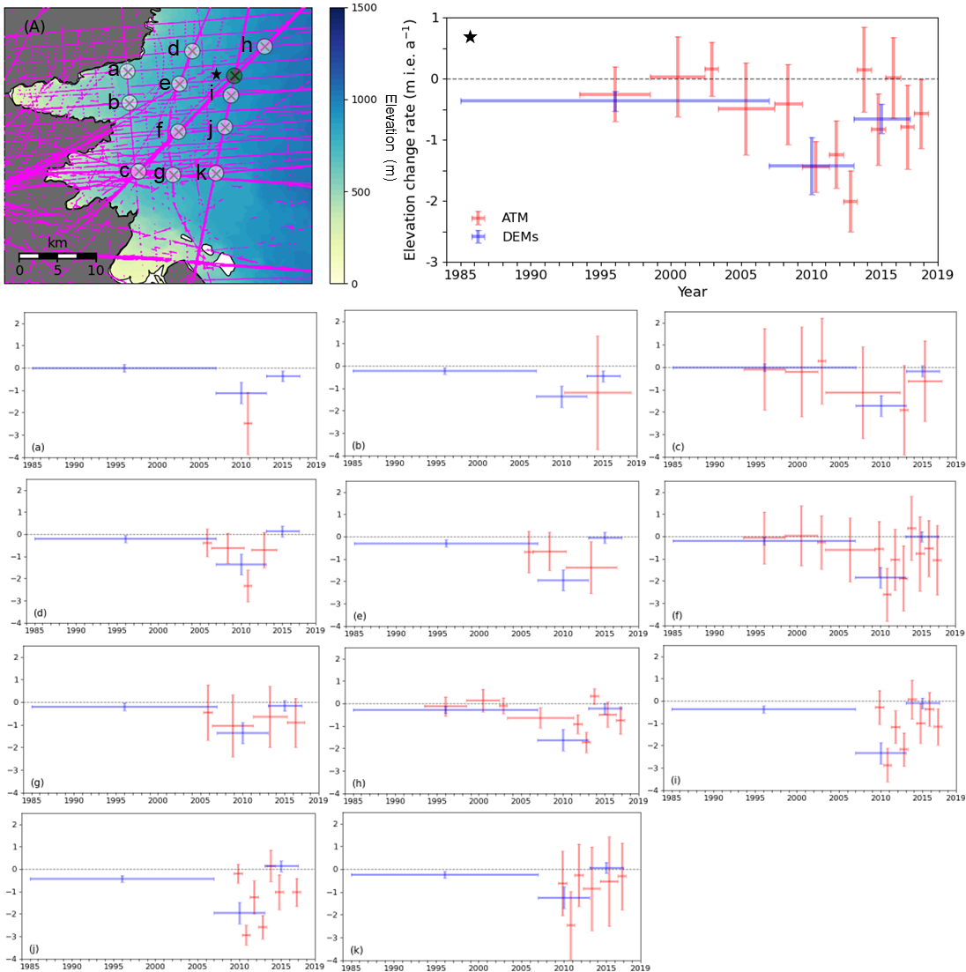

Fig. S2. IceBridge ATM flight lines from 1993 to 2018 (purple) over (A) Isunnguata Sermia and Russel
Glacier. Shaded circle indicates each area with ATM cross-overs in the study sector. The rate of
elevation changes at each area are shown in (a)–(k). The elevation changes obtained from ATM data (red) and
DEM analysis (blue). The uncertainty is given by the vertical error bar.

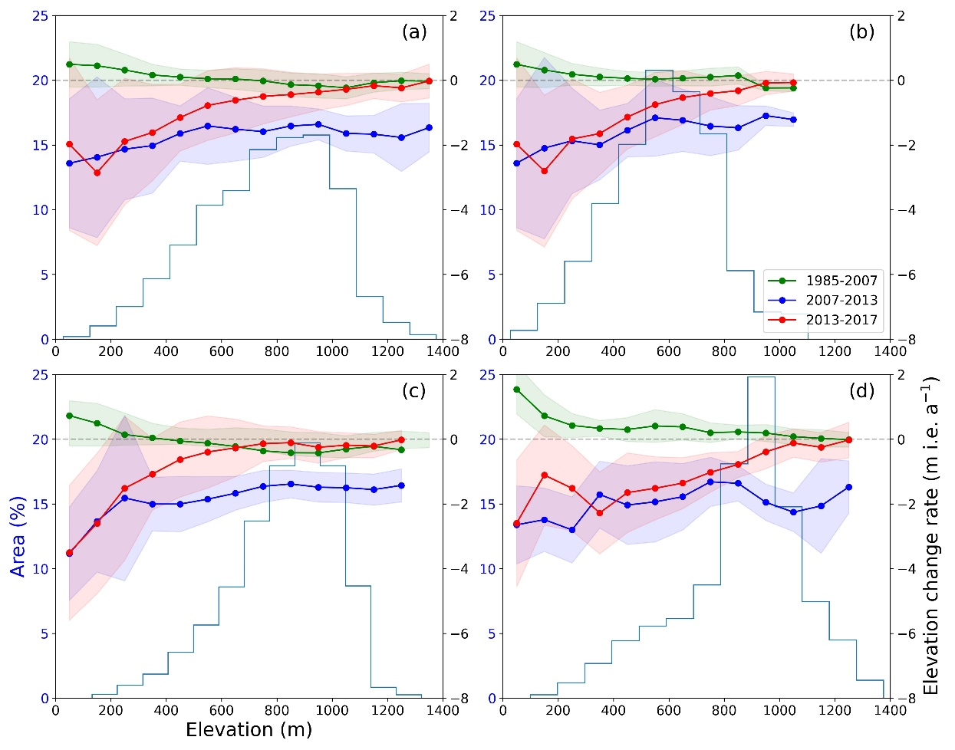
Fig. S3. The average elevation change rate in 100 m elevation bands for (a) the entire study area and
individual (b) north, (c) central, and (d) south sectors. Thin blue line in each panel illustrates hypsometry.
Shaded regions indicate standard deviation of elevation change rate distribution.

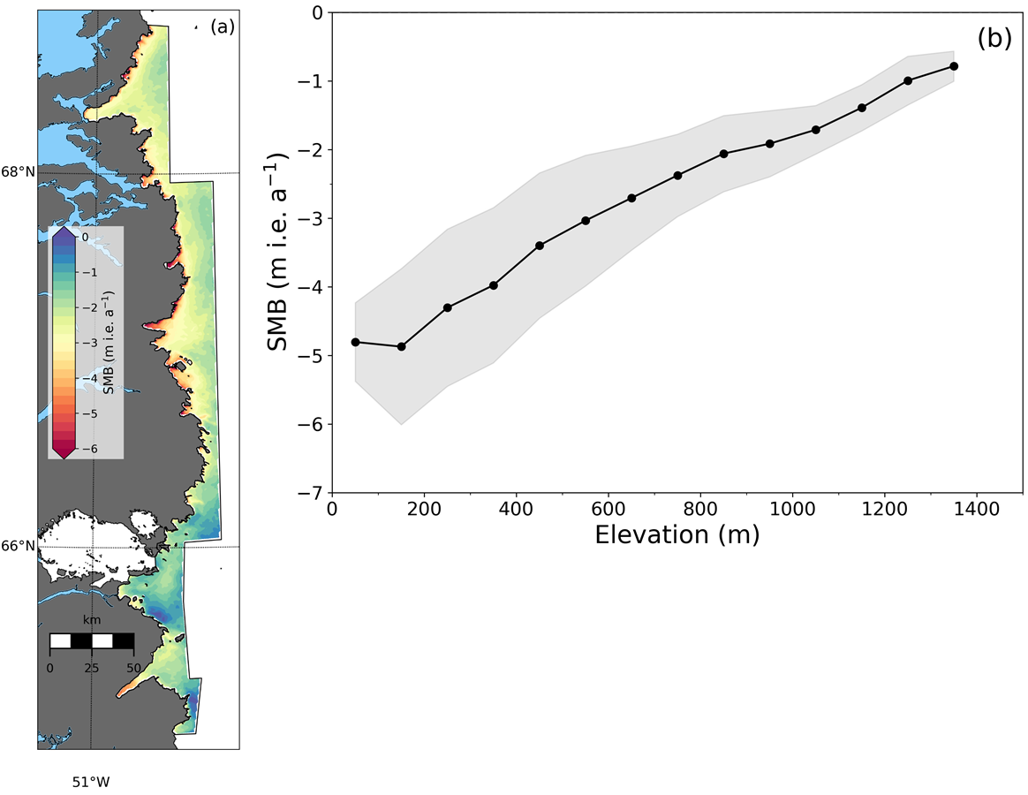
.
Fig. S4. The spatial distributions of SMB change rate (a) and the rate of SMB change averaged over
100 m elevation intervals during the 1960–1990 (b). Shading reflects standard deviation of SMB change rate
over the study period.

