Supplemental Information

Characteristics, Recent Evolution, and Ongoing Retreat of Hunt Fjord Ice Shelf,
Northern Greenland

Naomi Ochwat¹, Ted Scambos¹, Mark Fahnestock², Sharon Stammerjohn³

1 Cooperative Institute for Research In Environmental Sciences, University of Colorado Boulder
2 Geophysical Institute, University of Alaska Fairbanks
3 Institute for Arctic and Alpine Research, University of Colorado Boulder

Additional information on the Satellite Pour l’Observation de la Terre (SPOT) images, the elevation adjustment to the 1978 photogrammetrically derived DEM, and the central portion of the grounding lines locations.

SPOT Imagery
Additional imagery from SPOT is available but was not used in our study. SPOT 1 retrieved an image of the area in 1988 and SPOT 3 in 1994. Both images do not show a substantial change in the ice shelf ice front or in the structural patterns of the ice shelf (Supplemental Fig. 1).
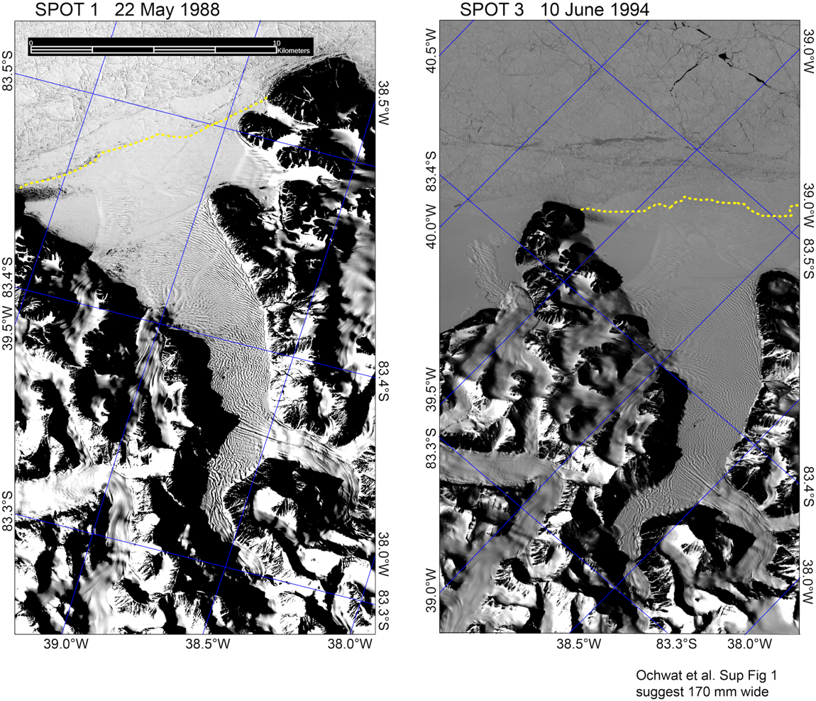
Figure S1. SPOT images from 1988 and 1994. The yellow dashed line indicates the ice shelf front. Note that the projections differ.

DEM adjustment
We assessed the mean elevation difference (i.e., bias) between the 1978 air-photo DEM (Korsgaard et al., 2016) and the ArcticDEM (Porter et al., 2008; Morin et al., 2016; https://www.pgc.umn.edu/data/arcticdem) in seven largely snow- and ice-free land surface regions adjacent to Hunt Fjord Ice Shelf. Assessments were made using co-registered sub-scenes from the two DEMs resampled to 25 m ground-equivalent grid cells. We adjusted the elevation of the 1978 DEM in each of the 7 regions so that the mean difference between it and the ArcticDEM in these ice-free areas was zero. In each case, the adjustment was negative, indicating the 1978 DEM had too low a reference datum, ranging between -0.03 to -6.56. The mean offset and standard deviation of the elevation change in the regions was -3.85 ± 2.18 m.
This correction placed the 1978 DEM elevations over the HFIS provenance regions at near-zero in the thinnest ice regions, similar to the Arctic DEM values, but indicated significantly higher surface elevations in the areas near the mouths of the tributary glaciers, consistent with thinning. In contrast, the corrected 1978 DEM and Arctic DEM indicated elevation increase in provenance region E, interpreted as due to compression by the glacier outflow lobe in HFIS (provenance region D) on region E against the eastern fjord wall.

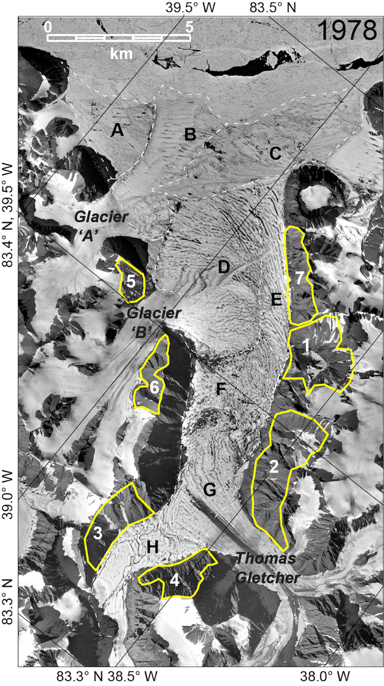
Figure S2. 1978 airphoto DEM shown the regions used to adjust the DEM to the Arctic DEM.

Grounding Line Thicknesses
To calculate the average elevation change and thickness of ice at the grounding lines for the 1978 and ArcticDEM, 58 points across the central portion of the grounding lines were averaged. The locations of the end points of the central portion are reported in Table S1. Shapefiles of the grounding line (file: “groundinglines_shapefile.zip”) and central portion points (file: “gl_central_points_zip.zip”) are provided.
Table S1. Grounding line central portion end point locations

 | Glacier A | Glacier B | Thomas Gletscher  North | Thomas Glestcher South
Latitude and Longitude of 1978 DEM
start | 83° 25.3458' N,  39° 17.6196' W | 83° 24.7912' N, 38° 58.6025' W | 83° 21.9675' N, 38° 32.5294' W | 83° 18.9728' N,  38° 33.7698' W
end | 83° 25.2446' N,  39° 16.3162’ W | 83° 24.6221’ N, 38° 57.7158’ W | 83° 22.1306’ N, 38° 32.6187’ W | 83° 19.1211’ N  38° 33.2397’ W
length of segment (m) | 341 ± 5 | 378 ± 3 | 312 ± 4 | 311 ± 2
Latitude and Longitude of ArcticDEM
start | 83° 25.3458’ N,  39° 17.6196' W | 83° 24.649' N, 39° 1.2663' W | 83° 21.8914' N, 38° 30.8438' W | 83° 18.8689' N,  38° 33.6423' W
end | 83° 25.2446' N  39° 16.3162' W | 83° 24.6085' N, 38° 59.9352' W | 83° 22.0524' N, 38° 30.8795' W | 83° 18.8878' N,  38° 32.2817' W
length of segment (m) | 341 ± 5 | 333 ± 4 | 330 ± 4 | 350 ± 4

