The eastern limit of “Kunlun-Pamir-Karakoram Anomaly” reflected by changes in glacier area and surface elevation
Qian Liang^{1, 2}, Ninglian Wang^{1, 2, 3}, Xuewen Yang^{1, 2}, Anan Chen^{1, 2}, Ting Hua^{1, 2}, Zhijie Li^{1, 2} and Daqing Yang³

Supplementary Tables and Figures
Table S1. List of Landsat OLI images used for compiling the glacier inventory around 2016.
Image | Year | Date
LC81330352016211LGN01 | 2016 | 2016/7/29
LC81330362016211LGN01 | 2016 | 2016/7/29
LC81350352015222LGN00 | 2015 | 2015/8/9
LC81350352016209LGN00 | 2016 | 2016/8/9
LC81350352017195LGN00 | 2017 | 2017/7/26
LC81360352015213LGN00 | 2015 | 2015/8/1
LC81370352015220LGN00 | 2015 | 2015/8/8
LC81370352016223LGN00 | 2016 | 2016/8/10
LC81370352017209LGN00 | 2017 | 2017/7/28
LC81380352015211LGN00 | 2015 | 2015/7/30
LC81380352016214LGN00 | 2016 | 2016/8/1
LC81390342015234LGN00 | 2015 | 2015/8/22
LC81390352015202LGN00 | 2015 | 2015/7/20
LC81390352015234LGN00 | 2015 | 2015/8/22
LC81390352016253LGN00 | 2016 | 2016/9/21
LC81400342015225LGN00 | 2015 | 2015/8/12
LC81400342016196LGN00 | 2016 | 2016/7/22
LC81400352016196LGN00 | 2016 | 2016/7/22
LC81410342015232LGN00 | 2015 | 2015/8/20
LC81410342016219LGN00 | 2016 | 2016/8/6
LC81410352015232LGN00 | 2015 | 2015/8/20
LC81410352016203LGN00 | 2016 | 2016/8/10
LC81420342015239LGN01 | 2015 | 2015/8/27
LC81430342017235LGN00 | 2017 | 2017/8/23
LC81440352014234LGN01 | 2014 | 2014/8/22
LC81440352015205LGN00 | 2015 | 2015/7/24
LC81440352017210LGN00 | 2017 | 2017/7/29
LC81440362015253LGN00 | 2015 | 2015/9/10
LC81450352014209LGN01 | 2014 | 2014/7/28
LC81450352016263LGN00 | 2016 | 2016/9/19
LC81450362015276LGN00 | 2015 | 2015/10/3
LC81450362016279LGN00 | 2016 | 2016/10/5
LC81460352016206LGN00 | 2016 | 2016/7/24
LC81460362014232LGN00 | 2014 | 2014/8/20
LC81460362016254LGN00 | 2016 | 2016/9/10
LC81470352016293LGN00 | 2016 | 2016/10/19
LC81470352017231LGN00 | 2017 | 2017/8/19
Table S2. Changes of the glacier area in the east, central and West Kunlun Mountains over the period of 1970s-2016.
Year | East
 | Area (km²) | Area change (km²) | Change (%) | Change rate (% a⁻¹)
1973 | 326±11 | - | - | -
2006 | 277±11 | -49±11 | -14.89±5 | -0.45±0.14
2016 | 265±5 | -12±12 | -4.45±7 | -0.45±1
Total | - | -61±12 | -18.68±6 | -0.43±0.13
Year | Central
 | Area (km²) | Area change (km²) | Change (%) | Change rate (% a⁻¹)
1977 | 2832±384 | - | - | -
2006 | 2821±106 | -11±135 | -0.37±4 | -0.01±0.10
2016 | 2755±51 | -67±117 | -2.36±4 | -0.24±0.4
Total | - | -77±98 | -2.73±3 | -0.07±0.07
Year | West
 | Area (km²) | Area change (km²) | Change (%) | Change rate (% a⁻¹)
1972 | 8401±280 | - | - | -
2009 | 8000±285 | -401±400 | -4.77±4 | -0.13±0.10
2016 | 7945±141 | -55±318 | -0.69±4 | -0.10±0.57
Total | - | -455±313 | -5.42±3 | -0.12±0.07
Table S3. List of the TanDEM-X DEM used for the calculation of glacier elevation difference.
TanDEM-X DEM | First across acquisition date
TDM1_DEM__30_N34E099_V01_C | 2013/10, 09/31, 12/25
TDM1_DEM__30_N35E080_V01_C | 2013/9/3, 11/02, 12/05
TDM1_DEM__30_N35E081_V01_C | 2013/09/03, 09/14, 09/25, 10/28
TDM1_DEM__30_N35E082_V01_C | 2013/09/25, 10/12, 10/28, 11/30
TDM1_DEM__30_N35E090_V01_C | 2012/07/26, 2013/9/27
TDM1_DEM__30_N35E091_V01_C | 2013/10/24, 12/24
TDM1_DEM__30_N35E092_V01_C | 2013/12/07, 12/18, 12/29; 2014/01/09
TDM1_DEM__30_N36E077_V01_C | 2013/11/07; 2014/01/01, 01/12, 01/23, 02/03
TDM1_DEM__30_N36E084_V01_C | 2013/11/14, 11/25, 12/17, 12/28
TDM1_DEM__30_N36E085_V01_C | 2013/08/13, 09/14, 10/07, 11/14, 11/25
TDM1_DEM__30_N36E087_V01_C | 2013/10/02, 10/24, 11/09, 11/20
TDM1_DEM__30_N36E090_V01_C | 2013/09/27, 10/30, 11/10
TDM1_DEM__30_N36E091_V01_C | 2013/10/13, 10/24, 10/30, 12/02
DEM Co-registration
Table S4. Displacement vectors in X and Y directions between the master (SRTM) and slave DEM.
Region | Item | TanDEM-X DEM | STD
East | X(m) | 25.5 | 8.05
 | Y(m) | 20.3
Middle | X(m) | 40.8 | 4.98
 | Y(m) | 53.1
West | X(m) | 65.8 | 9.6
 | Y(m) | 57.5
*Note: positive values of X and Y indicate shifts to east and north, respectively; while negative values reveal opposite shifts.
Table S5. Changes of the glacier area in the Kunlun Mountains over the period of 1970s-2016.
Period | Number | Area (km²) | Area change (km²) | Change (%) | Change rate  (% a⁻¹)
CGI-1 | 7232 | 11559±375 | - | - | -
CGI-2 | 8452 | 11099±402 | -460±550 | -3.98±4 | -0.11±0.10
2016 | 8309 | 10965±198 | -134±448 | -1.21±4 | -0.17±0.44
Total | - | - | -593±424 | -5.41±4 | -0.12±0.08
Table S6. Comparisons of the changes of the glacier area in the Kunlun Mountains with that in the other regions in the Tibet Plateau.
Region | Period | Area change (km²) | Shrinkage rate (% a⁻¹) |  | Source
Qilian Mountains | 1956-2015 | -396.89±116.90 | 0.37 | He and others, 2019
East Kunlun | 1970s-2016 | -60.87±6 | 0.43±0.06 | This study
Central Kunlun | 1970s-2016 | -77.22±61 | 0.07±0.04 | This study
West Kunlun | 1970s-2016 | -455.36±181 | 0.12±0.04 | This study
West Karakoram | 1973-2014 | -28.86 | 0.03 | Qureshi and others, 2017
Eastern Pamir | 1960s-2016 | -263.24 | 0.23±0.02 | Zhang and others, 2016
Central Himalaya | 1976-2009 | -775.4±224.0 | 0.59±0.17 | Shangguan and others, 2014

Table S7. Comparison of glacier mass balance in the different glacierized regions of the Kunlun Mountains from Brun and others (2017), Shean and others (2020) and the results in our study.
Region | Brun (m w.e. a-¹)  2000-2016 | Shean (m w.e. a⁻¹)  2000-2018 | Our study (m w.e. a⁻¹)  2000-2013
west Kunlun Mountains | 0.14±0.08 | 0.11±0.17 | 0.13±0.30
Ulugh Muztagh | 0.2±0.25 | 0.04±0.12 | -0.09±0.05
Bukatage Mountains | -0.05±0.44 | -0.16±0.16 | -0.00±0.07
Aemye Ma-chhen Range | - | -0.58±0.26 | -0.43±0.15

Table S8. Advancing glaciers in the Kunlun Mountains over the period of CGI-2 to 2016.
GLIMS ID | Mean Slope/° | Area (km²) in CGI2 | Area (km²) in our 2016 inventory | Advancing distance (km)
G090846E36001N | 21.90 | 5.720132195 | 5.761844297 | 0.21
G090868E35998N | 21.50 | 8.287156442 | 8.363837845 | 0.09
G091032E36060N | 10.10 | 83.93961766 | 88.40616941 | 1.11
G085792E37260N | 26.70 | 3.644956492 | 4.519172218 | 0.33
G085827E37264N | 26.50 | 1.965191015 | 2.00343074 | 0.13
G090693E35807N | 7.60 | 30.47438089 | 30.76776273 | 0.26
G082061E35462N | 19.10 | 9.569344309 | 9.9756303 | 0.09
G081119E35540N | 16.10 | 1.662452698 | 1.727269163 | 0.14
G081483E35351N | 8.50 | 84.97041168 | 89.4736426 | 1.25
G080525E35502N | 9.20 | 51.47779297 | 53.68687177 | 1.06
G080574E35527N | 9.40 | 44.19548496 | 44.98251988 | 0.56
G080653E35705N | 25.70 | 0.972817019 | 1.012381061 | 0.10
G080360E35864N | 19.20 | 0.813161033 | 0.845032164 | 0.11
G080365E35847N | 16.90 | 4.145941695 | 4.188757173 | 0.06
G080270E35776N | 33.10 | 0.453110379 | 0.497778951 | 0.12
G079479E36105N | 18.80 | 16.22652872 | 16.35570537 | 0.09
G079487E36151N | 20.60 | 2.902309127 | 3.041822303 | 0.14
G079500E36161N | 29.80 | 1.235922466 | 1.297539701 | 0.13
G079437E36228N | 20.60 | 1.882739413 | 1.949514745 | 0.14
G079158E36213N | 18.80 | 1.554084519 | 1.662296542 | 0.23
G078719E36277N | 22.20 | 1.329953969 | 1.375253647 | 0.14
G077257E36683N | 27.60 | 0.290711873 | 0.307745028 | 0.23
G076765E36766N | 22.80 | 0.731667595 | 0.773236597 | 0.16
G076459E36916N | 27.50 | 0.463333077 | 0.486872114 | 0.05
G079588E36125N | 23.10 | 4.653545014 | 4.780179277 | 0.05
G079627E36102N | 22.50 | 20.9965745 | 21.24467559 | 0.13
G079438E35908N | 15.00 | 20.66261127 | 20.77784131 | 0.09
G079097E36208N | 19.00 | 12.91923178 | 13.21799604 | 0.34
G079628E35798N | 13.00 | 13.74840175 | 13.82452125 | 0.76
G079675E35801N | 16.80 | 19.131282 | 19.20339171 | 0.05
G079820E35807N | 23.40 | 6.486733927 | 6.506935258 | 0.07
G079844E35788N | 18.30 | 13.54561688 | 13.7448845 | 0.20
G081105E35481N | 14.30 | 61.90516696 | 61.83411047 | 0.06
G079193E36184N | 19.20 | 20.38938419 | 20.40125973 | 0.02
G079277E36179N | 19.40 | 27.601582 | 17.47486248 | 0.04
G079435E36172N | 18.70 | 26.25318596 | 25.49103985 | 0.09
G079393E36202N | 20.00 | 2.146959545 | 2.192135157 | 0.05
G079474E36135N | 17.50 | 10.97619372 | 11.20437789 | 0.15

Table S9. Previously published region-wide mass balance estimates for West Kunlun Mountains. For results based ICESat and GRACE we do not provide the areas measured, as they do not correspond directly to the sampled area.
Region | MB (m w.e. a⁻¹) | Period | Area measured (km²) | Study | Data sources
West Kunlun | 0.15±0.03 | 2000-2013 | 4625 | This study | SRTM  TanDEM-X DEM
 | 0.16±0.10 | 2003-2019 | - | Wang and others (2020) | GRACE  ICESat-2
 | 0.14±0.08 | 2000-2016 | 9910 | Brun and others (2017) | ASTER
 | 0.18±0.14 | 2003-2008 |  | Brun and others (2017) | ICESat
 | 0.23±0.24 | 2003-2009 | 1020 | Bao and others (2015) | GLAS

Correction of the residual error for elevation difference
While the correction of spatial co-registration could reduce the data source error, there also remains residual error in elevation differences between different DEMs (Zemp and others, 2013; Nuth, 2011). Paul and others (2008) indicated that the reason for the residual of elevation difference was attributed to the low spatial resolution of SRTM, which could not integrally express the steep terrain of high mountains. Gardelle and others (2012) revealed insisted that there was a correlation between elevation difference in different DEMs and maximum curvature, and the relationship between glacier area and non-glacier area showed good consistency. Hence, we can correct the error in the glacier area by the relation between the elevation difference and the maximum curvature in the non-glacier area. The formula is as follows:
$${dh}_{new}={dh}_{old}-f\left(MC\right)$$
Where the ${dh}_{new}$ and ${dh}_{old}$ represent the elevation difference prior to and after correction, the $f\left(MC\right)$ is the function relation between elevation difference and maximum curvature in non-glacier area, MC is the maximum curvature of the pixel. Figure S1 (a), (b) and (c) show the fitted functions for the selected areas, which were used to complete the correction for elevation difference.

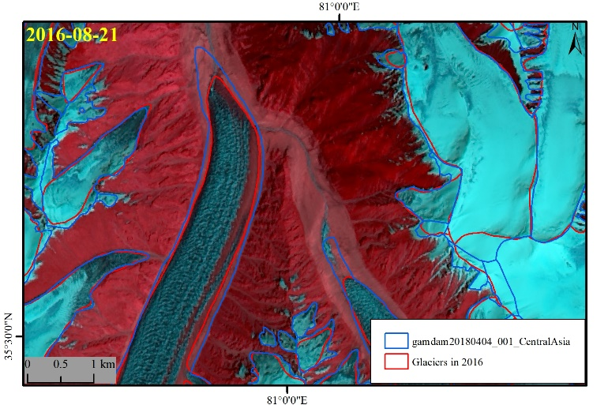
Figure S1. Glacier outlines delineation of our new inventory and the comparison between that and the GAMDAM inventory published in 2019.

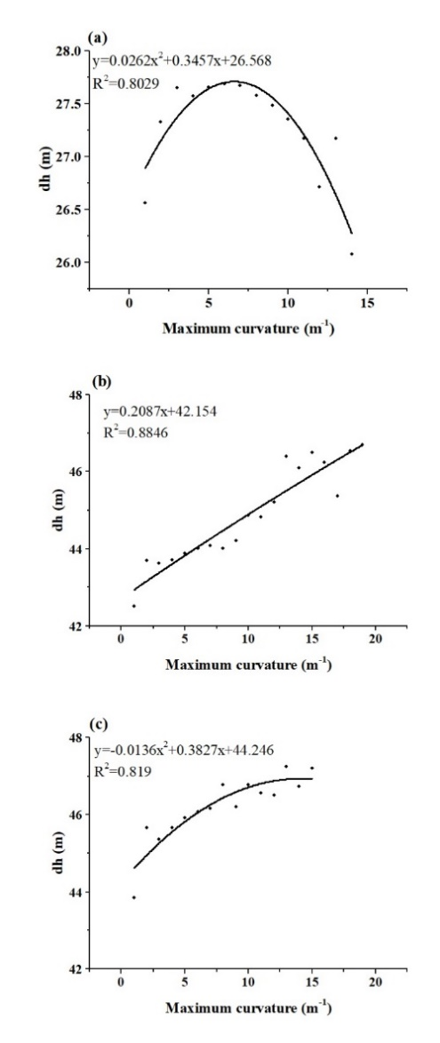
Figure S2. Fitted equations between the elevation difference and maximum curvature in the non-glacier area.
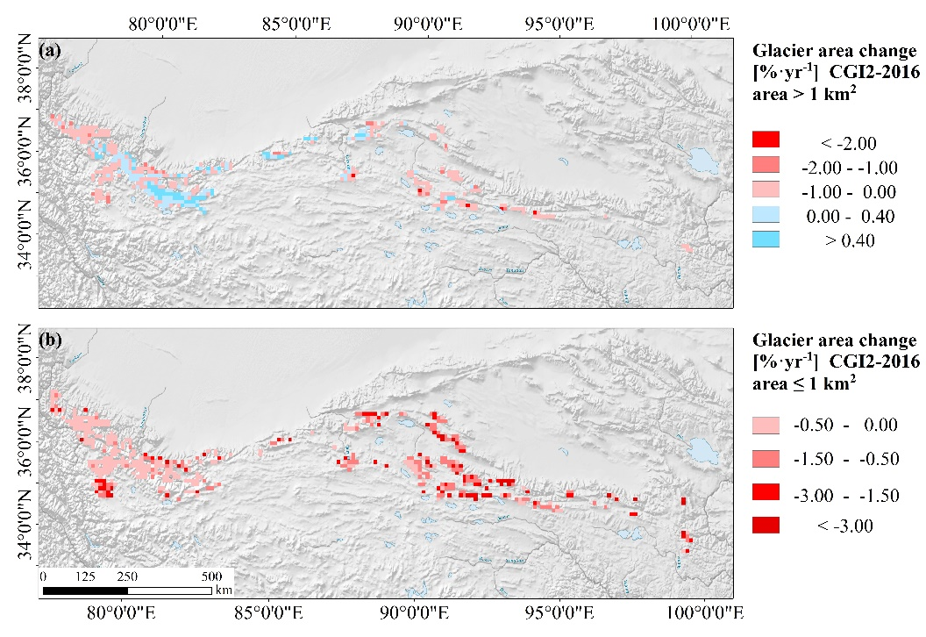
Figure S3. Glacier area change in size (a) $≤$1 km² and (b) > 1km² from CGI-2 to 2016 in Kunlun Mountains, aggregated over 0.1° grid cell.
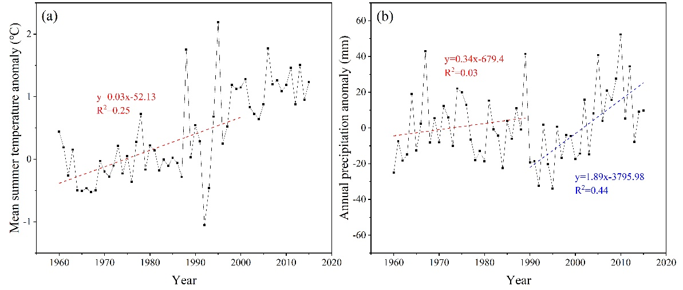
Figure S4. Trends of (a) mean summer temperature, and (b) annual precipitation derived from 17 meteorological stations.
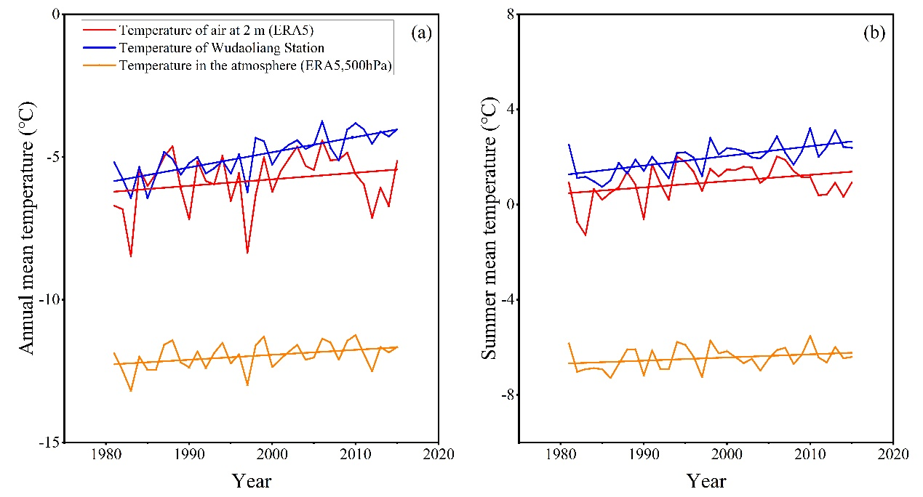
Figure S5. Comparisons of variations in air temperatures observed at Wudaoliang Station and retrieved from the ERA5 reanalysis data over the period of 1980-2015.
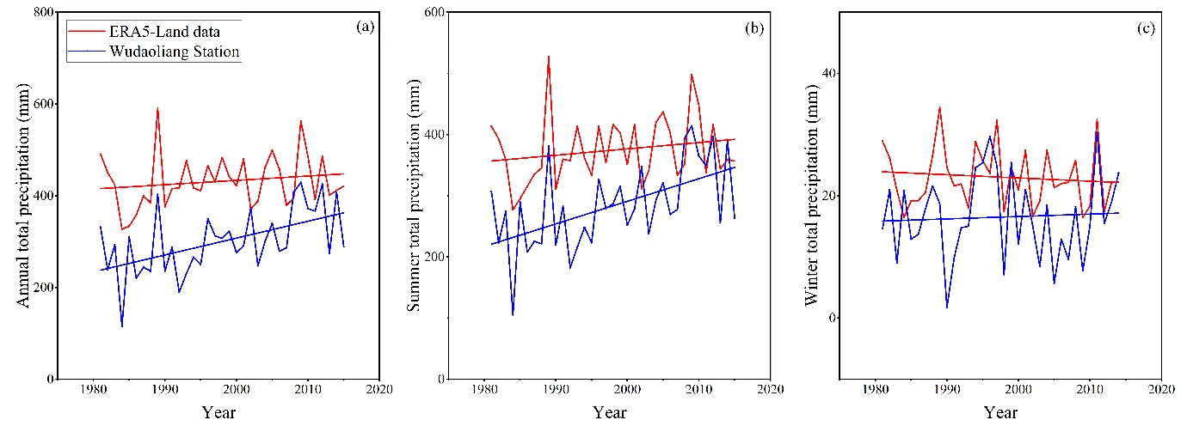
Figure S6. Comparisons of variations in precipitations observed at Wudaoliang Station and retrieved from the ERA5 reanalysis data over the period of 1980-2015.

References
Bao WJ, Liu SY, Wei JF and Guo WQ (2015) Glacier Changes During the Past 40 Years in the West Kunlun Shan. Journal of Mountain Science 12(2), 344-357. doi: 10.1007/s11629-014-3220-0.
Brun F, Berthier E, Wagnon PK, Kääb A and Treichler D (2017) A spatially resolved estimate of High Mountain Asia glacier mass balances from 2000 to 2016. Nature Geoscience 10, 668–673. doi: 10.1038/ngeo2999.
Gardelle J, Berthier E and Arnaud Y (2012) Impact of resolution and radar penetration on glacier elevation changes computed from DEM differencing. Journal of Glaciology 58(208): 419-422. doi: 10.3189/2012JoG11J175.
Nuth C and Kääb A (2011) Co-registration and bias corrections of satellite elevation data sets for quantifying glacier thickness change. Cryosphere 5(1): 271-290. doi: 10.5194/tc-5-271-2011
Paul F (2008) Calculation of glacier elevation changes with SRTM: is there an elevation-dependent bias? Journal of Glaciology 54(54): 945-946. doi: 10.3189/002214308787779960.
Qureshi MA, Yi CL, Xu XK and Li YK (2017) Glacier status during the period 1973-2014 in the hunza basin, west karakoram. Quaternary International S1040618216300465. doi: 10.1016/j.quaint.2016.08.029.
Shangguan DH and 10 others (2017) Glacier changes in the koshi river basin, central himalaya, from 1976 to 2009, derived from remote-sensing imagery. Annals of Glaciology 55(66), 61-68. doi: 10.3189/2014AoG66A057.
Shean DE and 5 others (2020) A Systematic, Regional Assessment of High Mountain Asia Glacier Mass Balance. Frontiers in Earth Science 7, 363. doi: 10.3389/feart.2019.00363.
Wang QY, Yi S and Sun WK (2020) Continuous estimates of glacier mass balance in High Mountain Asia based on ICESat‐1,2 and GRACE/GRACE Follow‐On data. Geophysical Research Letters 47. doi: 10.1029/2020GL090954
Zhang Z and 5 others (2016) Glacier changes since the early 1960s, eastern Pamir, China. Journal of Mountain Science 13(2), 276-291. doi: 10.1007/s11629-014-3172-4.
Zemp M and 16 others. (2013). Reanalysing glacier mass balance measurement series. Cryosphere 7(4): 1227-1245. doi: 10.5194/tc-7-1227-2013.

