Appendix A: Cyclone Identification

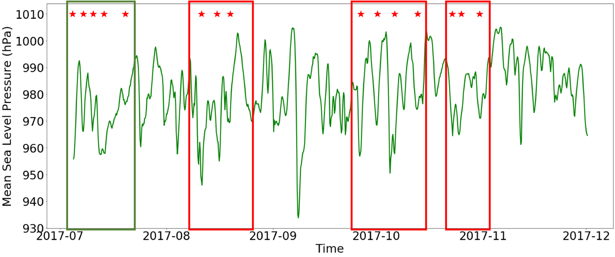
Fig. 14. Time series of the mean sea level pressure at the location of the buoy. The red star symbols indicate the time when the storm cores were closest to the buoys’ location. The red boxes denote the three sets of cyclones analysed in Table 1. The green box denotes the five storms previously examined by Vichi and others (2019) and Alberello and others (2020).

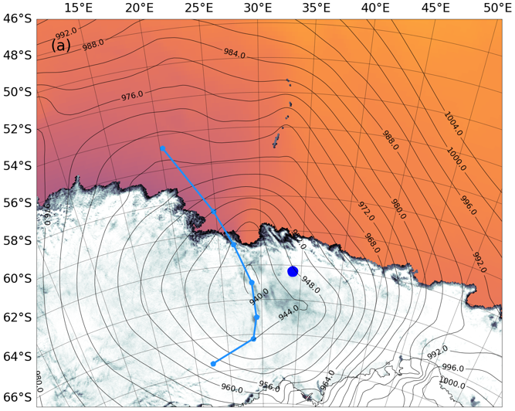 | 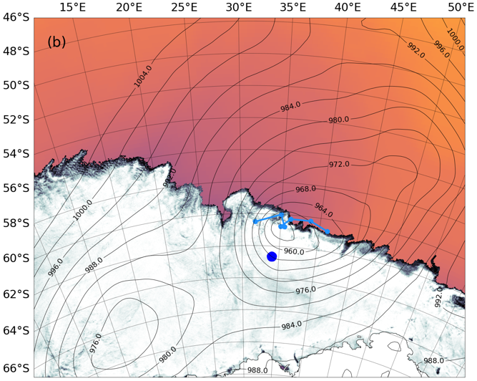
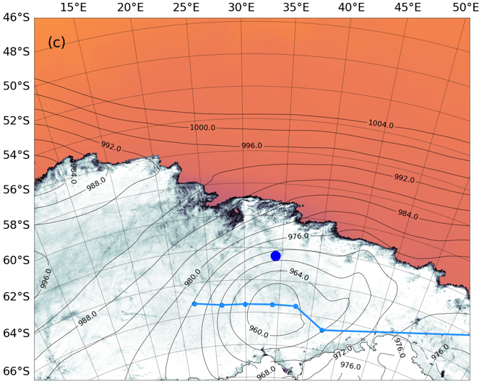 | 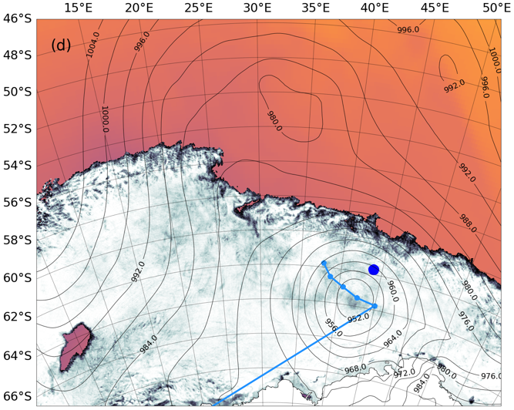
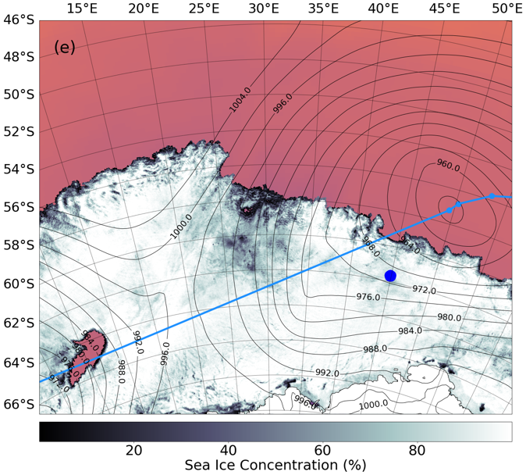 | 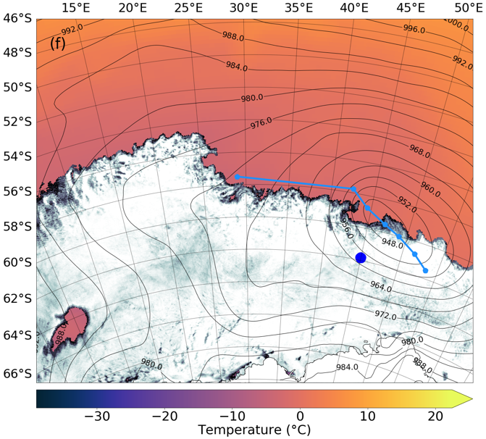

Continued

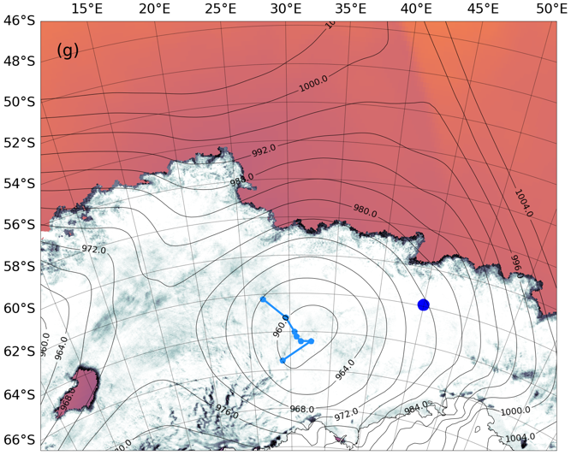 | 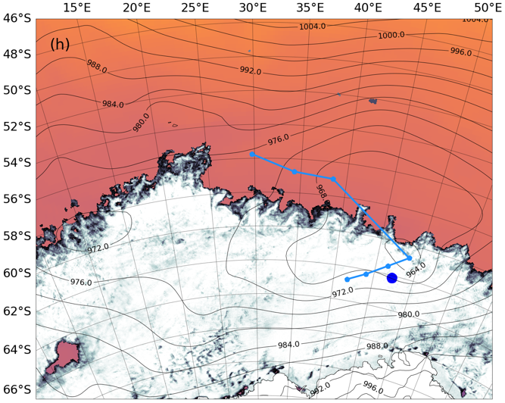
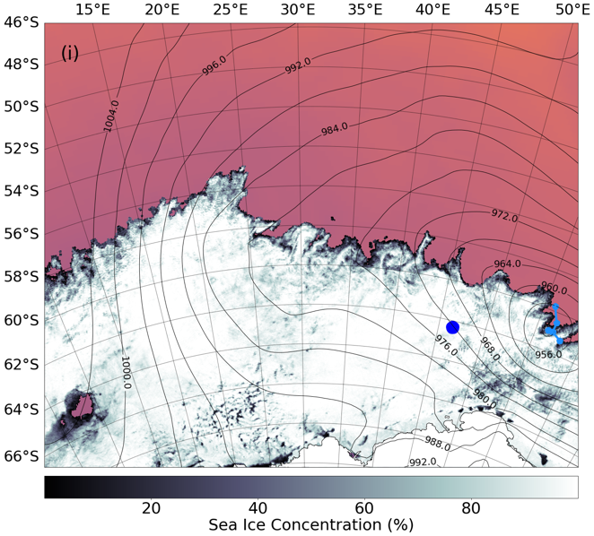 | 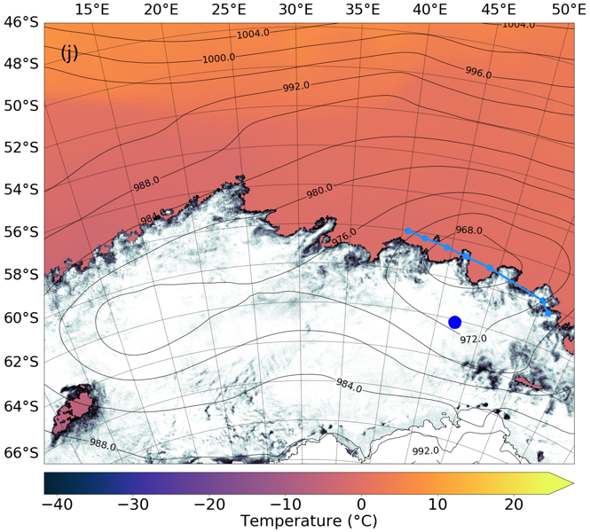
Fig. 15. Maps of the ERA5 mean sea level pressure (mslp) and 2-m temperature fields of when each cyclone was closest to the buoy – (a) Cyclone A1 on the 11th August at 04:00, (b) Cyclone A2 on the 15th August at 16:00, (c) Cyclone A3 on the 19th August at 12:00, (d) Cyclone B1 on the 26th September at 12:00, (e) Cyclone B2 on the 1st October at 08:00, (f) Cyclone B3 on the 6th October at 08:00, (g) Cyclone B4 on the 12th October at 12:00, (h) Cyclone C1 on the 23rd October at 00:00, (i) Cyclone C2 on the 25th October at 16:00, and (j) Cyclone C3 on the 31st October at 00:00. The grey shadings show the AMSR2 ice concentration for the corresponding day. The dark-blue circle denotes the buoy for the corresponding time of when each cyclone was closest to it. The light-blue line denotes the trajectory (in a north-west to south-east or south-west to north-east migration) of each cyclone core from 12 hours before to 12 hour after each cylone was closest to the buoy. The light-blue markers denote the four-hourly postion of each cyclone’s core.

Appendix B: WIIOS Trajectory

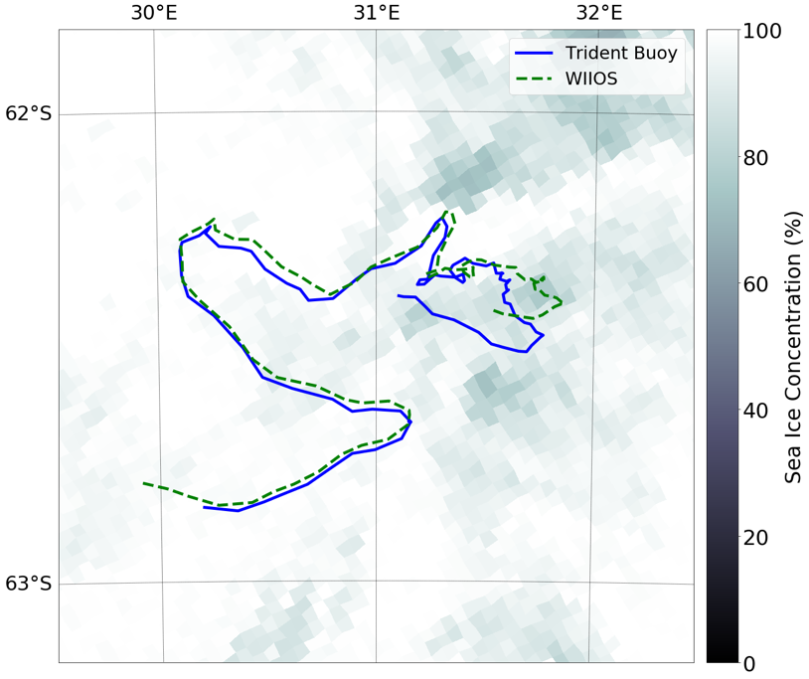
Fig. 16. The trajectories of the trident buoy (blue line) and the WIIOS (green line). The WIIOS was deployed at 12:00 on the 4th July and drifted until 16:00 on the 19th July. The Trident buoy was deployed 12 hours after the WIIOS at 00:00 on the 5th July and is only shown until 16:00 on the 19th July.

