**SUPPLEMENTARY MATERIALS**

**Revisiting mechanics of ice-skate friction: From experiments at a skating rink to a unified hypothesis**

James H. Lever, Austin P. Lines, Susan Taylor, Garrett R. Hoch,

Emily Asenath-Smith, Devinder S. Sodhi

Cold Regions Research and Engineering Laboratory, US Army Engineer Research and Development Center, Hanover, New Hampshire, 03755, USA

**Vertical-blade model: validation**

We coded in MATLAB the vertical-blade skate model of Lozowski and Szilder (2013) and validated it against the speed-skating conditions described in that paper (Tables S1 – S2). The self-lubrication theory embedded in this model also underpins the tilted-blade model of Lozowski and others (2013).

**Table S1**. Ice and water properties

|  |  |  |
| --- | --- | --- |
| ice conductivity (*ki*) | 2.25 | W m-1 K-1 |
| ice density (*ri*) | 919 | kg m-3 |
| specific heat of ice (*ci*) | 2040 | J kg-1 |
| water density (*rw*) | 997 | kg m-3 |
| latent heat of fusion (*lf*) | 334000 | J kg-1 |
| viscosity of water at 0°C (*mw*) | 1.787 x 10-3 | Pa s |

**Table S2.** Baseline skater properties

|  |  |  |
| --- | --- | --- |
| skater | Baseline |  |
| blade width (*w*) | 1.1 | mm |
| blade radius (*R*) | 25 | m |
| mass (*m*) | 75 | kg |
| velocity (*V*) | 12 | m s-1 |
| ice temp (*Ti*) | -5 | deg C |
| ice thickness (*H*) | 0.025 | m |
| temp difference of ice (top minus bottom, *DTb*) | 1 | deg C |

The model solves for the variation of the water-film thickness along the blade, *h(x*), assuming that it begins at the front of the contact zone:

$\frac{dh}{dx}=\frac{μ_{w}V}{hρ_{w}l_{f}}-\frac{k_{i}ΔT_{b}}{HVρ_{w}l_{f}}-\frac{k_{i}ΔT_{i}}{\sqrt{πκ_{i} x V}ρ_{w} l_{f}} - \frac{m g h^{3}}{μ_{w}L w^{3}V}-\frac{k_{blade} ΔT_{blade}}{\sqrt{πκ_{blade}xV}ρ_{w}l_{f}}$, (S1)

where the terms on the righthand side represent, respectively: the frictional power generated by shearing of the water film; slow heat conduction into the ice owing to top-bottom temperature difference; rapid heat condition into the ice from the sudden jump to 0°C at the front of the contact zone; squeeze-flow thinning of the water film; heat conduction into the skate blade. We added this last term, which was not included by Lozowski and Szilder (2013), to assess under what conditions heat flow into the blade becomes important.

Lozowski and Szilder (2013) assumed that skate crushed ice along its contact zone at constant pressure, *p*, equal to ice hardness measured via drop-ball tests by Poirier and others (2011):

$p=14.7-0.6T_{i}$, (S2)

where *p* is in MPa for *Ti* in °C. A vertical force balance then yields the length of blade-ice contact, *l*, assuming a skater on one blade and constant crushing width equal to blade width. Blade radius then provides the predicted rut depth, *d*, neglecting water-film thickness:

$d={l^{2}}/{2R}$. (S3)

The model then computes the ploughing force, *Fp*, and the water-shearing force, *Fs*, which are assumed to be the only frictional forces:

$F_{p}=pwd$, (S4)

$F_{S}=μ_{w}Vw\int_{0}^{L}{\frac{1}{h}dx}$. (S5)

Thus, the friction coefficient is *m* = (*Fp+Fs)/mg*. Note that although the model includes the ploughing force in total skate friction, it omits the corresponding ploughing power in the water-film heat budget (through Equation S1). Effectively, the particles and the power expended to create them are lost to subsequent interactions between the blade and the ice.

Table S3 and Figure S1a show the results from our MATLAB model for the baseline speed skate at 12 m s-1, and Figure S1b shows a friction map for the same skater at different velocities and ice-surface temperatures. These results agree with those of Lozowski and Szilder (2013) as closely as we can determine them from the original plots.

**Table S3**. MATLAB model predictions neglecting blade heat transfer. Results for the baseline speed skater are identical with those by Lozowski and Szilder (2013). The speed-skate and hockey skate values are for input conditions that mimic our single-skate glide passes, with the hockey skate modeled as a half-blade width (two-patch) ice-contact geometry.

|  |  |  |  |
| --- | --- | --- | --- |
| **Parameter** | **Baseline speed skater** | **Speed skater** | **Hockey skater** |
| length of contact, *l* (mm) | 37.8 | 33.0 | 28.5 |
| depth of rut, *d* (mm) | 0.029 | 0.068 | 0.121 |
| duration of contact, *Dt* (s) | 0.0031 | 0.0165 | 0.0071 |
| ice hardness, *p* (MPa) | 17.7 | 17.7 | 17.7 |
| ploughing force, *Fp* (N) | 0.56 | 1.26 | 3.21 |
| shear force, *Fs* (N) | 2.02 | 1.67 | 1.78 |
| friction coefficient, *m* | 0.0035 | 0.0048 | 0.0066 |
| max. film thickness, *h_max* (mm) | 0.52 | 0.13 | 0.25 |
| rut cross-sectional area, *Ar* (mm2) | 0.032 | 0.071 | 0.182 |

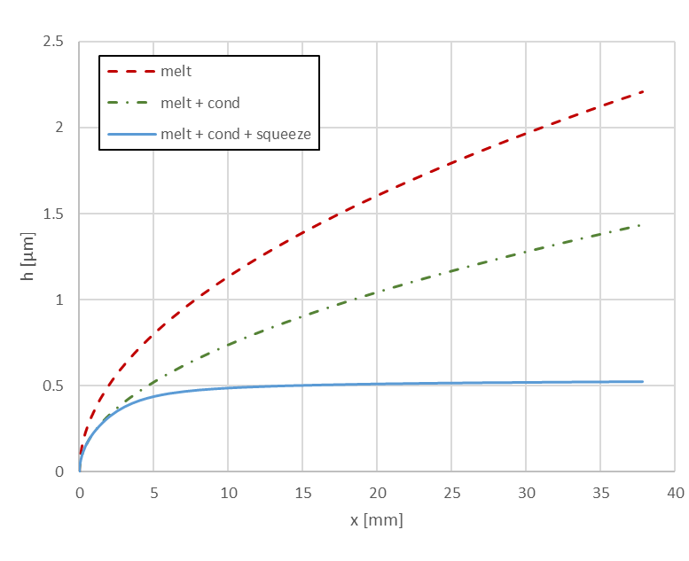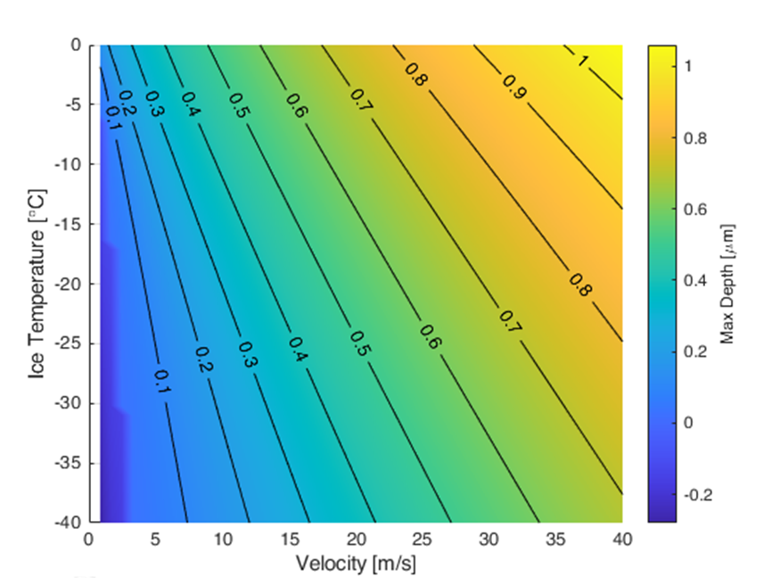

(a)

(b)

**Fig. S1.** MATLAB implementation of vertical-skate model for baseline speed skater: (a) water-film thickness, *h(x)*, for cases of melt only, and then accounting for the effects of rapid heat conduction into the ice and squeeze flow; (b) friction-coefficient map for the same skater, varying velocity and ice-surface temperature. These results agree with those of Lozowski and Szilder (2013).

**Vertical-blade model: single-skate glide passes neglecting blade heat transfer**

We varied the MATLAB model’s input parameters to mimic those relevant to single-skate glide passes of our speed-skate and hockey-skate trials. Table 1 of the main paper provides the skater and blade parameters. We used single-skate glide speeds of 2 m s-1 for the speed skater and 4 m s-1 for the hockey skater, and set -5°C as the baseline ice temperature. Table S3 summarizes the results. Note that predicted friction coefficients are higher than for the Lozowski and Szilder (2013) baseline speed skater but are within the ranges measured by de Koing and others (1992) and Federolf and others (2008). Predicted increases in plowing forces, mainly owing to differences in skate geometries, account for most of the increases in friction.

Figure S2 shows the MATLAB model predictions for water-film thickness profiles along the blade neglecting blade heat transfer (labeled “melt + cond + squeeze”), per Lozowski and Szilder (2013). The profiles rise continuously rather than plateau near the front as with the baseline speed skater at 12 m s-1 (Fig. S1), and maximum thicknesses are 30 – 50 % lower than that of the baseline case. Importantly, these predicted films are thinner than the 0.3 – 0.8 mm average roughness for the speed-skate and hockey-skate blades, respectively (Table 1, $R_{a}^{*}$).

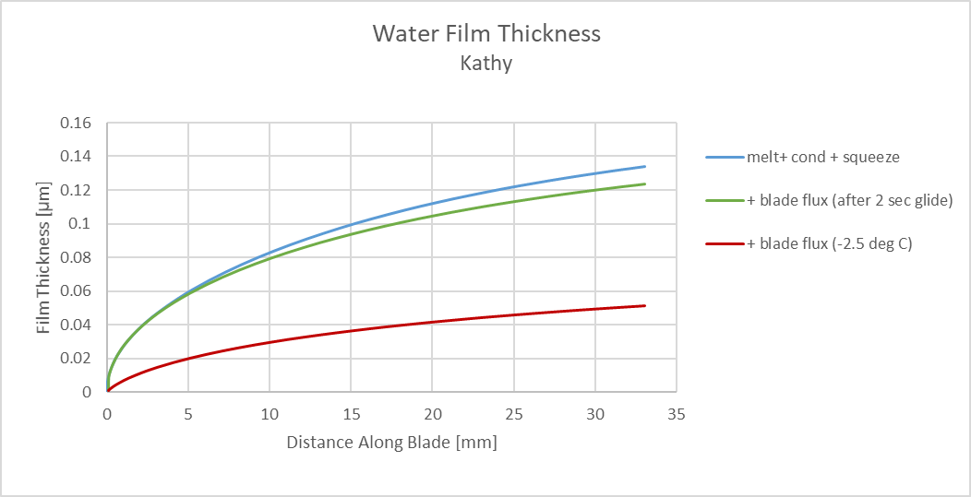

(a)

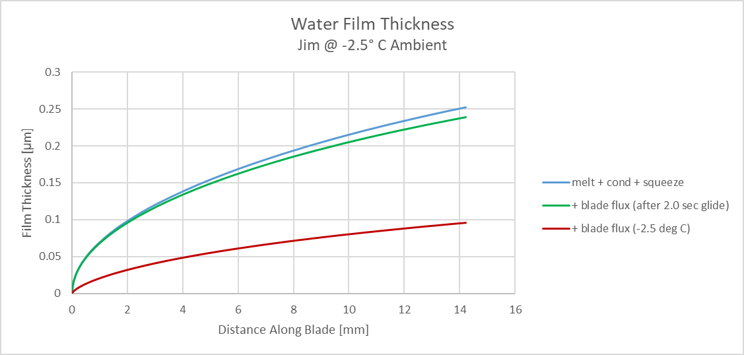

(b)

**Fig. S2.** Water-film thickness profiles for speed skate (a) and hockey skate (b) at -2.5°C ambient. The profiles “melt + cond + squeeze” follow Lozowski and Szilder (2013) and neglect heat conduction into the blades. Profiles labeled “+ blade flux (-2.5 deg C)” include heat conduction into uniform-temperature blades at -2.5°C to mimic initial touch-down conditions. After 2 s of gliding (profiles “+ blade flux (after 2 sec glide)”), thermal gradients at the blade-ice interfaces have reduced such that blade heat conduction has little effect on film thicknesses.

**Vertical-blade model: single-skate glide passes including blade heat transfer**

Heat transfer into the skate blades depends on the instantaneous blade-ice temperature gradients, which in turn depend on the thermal history of the blade. The models by Lozowski and Szilder (2013), Le Barre and Pomeau (2015) and van Leeuwen (2017) all neglect blade heat transfer rather than attempt to simulate thermal processes during actual skating, a significant complication. However, Lozowski and others (2013) note that blade heat flux may not be negligible at recreational speeds (3 m s-1) and for outdoor skating at any speed, depending on ambient temperature.

We examined two simplified cases: (1) heat conduction into a blade initially at -2.5°C, and (2) heat conduction into the same blade after a single-skate glide of 2 s. The initial -2.5°C temperature approximates measured near-surface air temperatures during our skating trials, so Case 1 mimics the blade at initial touch-down for one blade-length of travel. A 2-s glide is an upper bound for the glide duration of the skaters prior to entering the IR-camera observation window.

We used a 2D finite-element model (FEM) to simulate transient heat conduction into the blade, created and solved within SolidWorks modeling package. Thermal properties were for 304 stainless steel (conductivity 16 W m-1K-1, specific heat 500 J kg-1 k-1) and the 1.04-mm speed-skate and 3.0-mm hockey-skate blades were both 17 mm high. The blade-ice boundary condition was 0°C, applied for Case 1 for the duration of one contact-length passage, 0.0165 s and 0.0071 s, respectively for the speed- and hockey-skate blades (Table S3), and applied for 2 s for Case 2. The boundary condition at the top of the blade remained at -2.5°C. We applied a heat transfer coefficient of 14 W m-2 K-1 along the two vertical faces to simulate forced-confection heat transfer to the ambient air (Holman 1976). The results were not sensitive to this heat-transfer coefficient. For the hockey-skate blade, we ran two ice-contact geometries: full contact across the 3.0-mm blade width, and half-blade contact by two 0.75-mm-wide patches along the outside edges to mimic the reduced ice contact from the hollow grind (see Fig. 7a of main paper). The results were quite similar, and we report the half-blade results here.

Figure S2 compares the resulting water-film profiles to those with no blade heat transfer, and Table S4 summarizes the changes in friction coefficients. Note that the modeled ploughing force is not affected by heat transfer, so the increases in friction are a consequence of thinner water films. As expected, high blade heat transfer at touch-down significantly reduced predicted water-film thicknesses and thus more than doubled the friction. After 2 s of glide, however, blade heat transfer has reduced to where neglecting its influence is a reasonable approximation. This result is consistent with the measured gradient during our speed skate pass on 210112 Run 1, when ~ 10% of the frictional heat flux entered the blade.

**Table S4.** The effect of blade heat flux on predicted friction coefficients. The hockey skate results are for the half-blade (two-patch) ice-contact geometry.

|  |  |  |  |
| --- | --- | --- | --- |
| **Blade and ambient temperature** | **No blade heat flux** | **Initial blade heat flux** | **Blade heat flux after 2 s of glide** |
| **Speed skate, -2.5°C** | 0.0048 | 0.0104 | 0.0049 |
| **Hockey skate, -2.5°C** | 0.0066 | 0.0125 | 0.0068 |
| **Speed skate, -10°C** | 0.0065 | 0.0299 | 0.0070 |
| **Hockey skate, -10°C** | 0.0074 | 0.0296 | 0.0080 |

We repeated these model runs assuming that the ambient air temperature was -10°C to mimic outdoor skating conditions (Table S4, Fig. S3). Despite slightly lower ploughing forces resulting from increased ice hardness, predicted friction increased at the colder temperatures owing to thinner water films. Importantly, the influence of blade heat condition was much more pronounced, with predicted touch-down friction more than quadrupling as water-film thickness reduce to less than 35 nm. For micron-scale blade roughness, such thin films would place the skates in the boundary-friction regime and invalidate the use of equations for frictional heat and squeeze flow formulated for hydrodynamic lubrication.

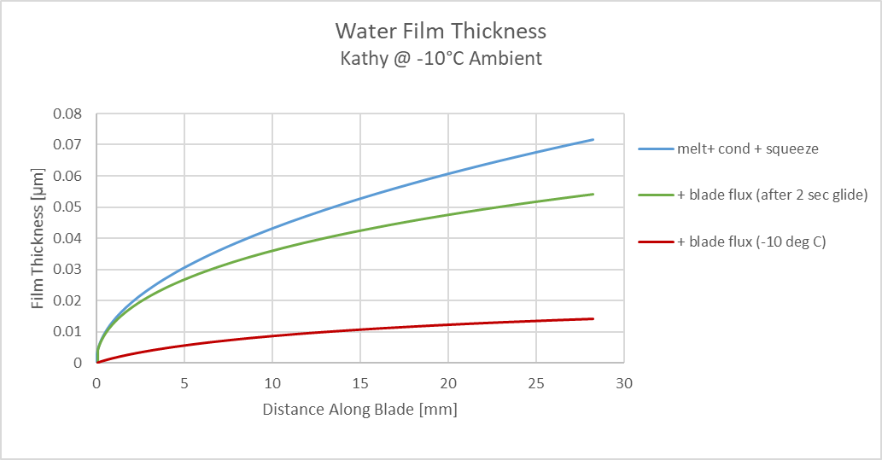

(a)

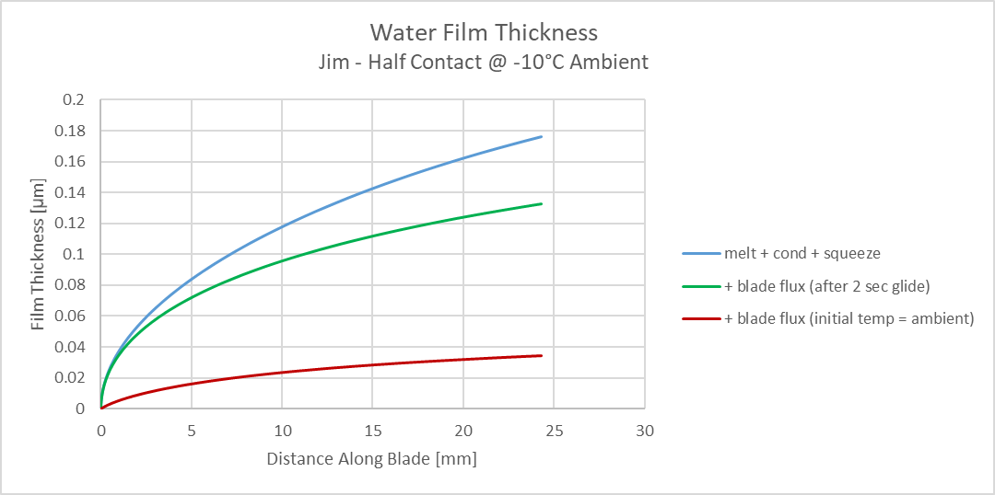

(b)

**Fig. S3**. Water-film thickness profiles for speed skate (a) and hockey skate (b) for ambient temperature of -10°C. The profiles “melt + cond + squeeze” follow Lozowski and Szilder (2013) and neglect heat conduction into the blades. Profiles labeled “+ blade flux (-10 deg C) include heat conduction into uniform-temperature blades at -10°C to mimic initial touch-down conditions. After 2 s of gliding (profiles “+ blade flux (after 2 sec glide)”), thermal gradients at the blade-ice interfaces have reduced such that blade heat conduction has less effect on film thicknesses.

Skaters do not normally experience strong variations in friction from the beginning to the end of a stride. To explore this transition, we replaced the computationally demanding 2D FEM models for blade and ice heat fluxes with analytical 1D transient-conduction equations (Carslaw and Jaeger 1959). Validation runs against the 2D FEM results showed that the 1D equations produced negligible errors for predicted friction coefficients and water-film thicknesses, confirming a useful simplification made by Lozowski and Szilder (2013).

Figure S4 shows the model-predicted transitions for maximum water-film thickness at the end of the contact zone, *h_max*, and the corresponding COF as functions of glide time for ambient temperatures -2.5°C to -20°C for our hockey skate. The transitions occur rapidly with glide time for the first ~ 0.3 s, after which heat flux into the blade becomes small (less than 20% of total heat flux) and *h_max* and *m* stabilize. Predicted friction is higher at colder temperatures, and the transitions to stable conditions take a bit longer. Given that skating strides can be less than 0.5 s in total duration (Marino 1977), it may be important to consider heat flux into the blade for accurate simulations. Within the framework of the Lozowski and Szilder (2013) model, neglecting blade heat flux is reasonable for long-duration gliding. However, water-film thickness decreased significantly with decreasing ambient temperature and were much thinner than average blade roughness ( ~ 0.8 mm) for all temperatures and glide times. Also, high blade heat fluxes, and consequently higher predicted friction, just after touch-down complicates attributing the higher touch-down friction measured by de Koing and others (1992) to greater ploughing friction as predicted by Lozowki and others (2013).



**Fig. S4.** Transitions of hockey-skate water-film thickness, *h_max*, and coefficient of friction as functions of glide time and ambient temperature. Heat flux into the blade, which causes these predicted transitions, becomes negligible after 0.2 – 0.3 s of glide time.

**Ice-surface temperatures after blade passage**

We sought insight into the expected ice-surface temperature profiles and cool-down rates after single-skate glide passes by driving our 2D ice FEM with simplified boundary conditions that mimic those of the Lozowski and Szilder (2013) model. That model assumes that 0°C melting begins at the front of the contact zone and continues until the centerline of the blade passes. To drive our ice model, we imposed 0°C surface temperature across the width of our skate blades (1.04 mm, and two widths of 0.75 mm, for the speed skate and hockey skate, respectively) for the skate-passage times of 0.0165 s and 0.0071 s (Table S3). After those times, and for all surface nodes outside of the contact widths, we imposed insulated boundary conditions. Except for the short delays to refreeze the thin water-films after skate passage, these initial and boundary conditions reflect those imposed on the ice by the Lozowski and Szilder (2013) model. Figure S5 compares predicted and measured ice-surface temperatures for a speed-skate glide pass, and Figure S6 compares results for a hockey-skate glide pass, both with essentially vertical blades.

**Fig. S5.** Predicted and measured ice-surface temperatures after speed-skate glide pass on 210112 Run1: (a) profiles across the rut, with elapsed time in seconds from blade passage, and (b) cool-down of the maximum and 3 x 3-pixel average temperature at the rut center. The IR-based measurements (symbols) were from the center of a fairly uniform, smooth rut (same location as Fig. 9a in main paper).

(b)

(a)

**Fig. S6.** Predicted and measured ice-surface temperatures after hockey-skate glide pass on 201124 Run2: (a) profiles across the rut, with elapsed time in seconds from blade passage, and (b) cool-down of the 3 x 3-pixel average temperatures at three locations along the rut. The IR-based measurements (symbols) were from a double-peak rut similar to that shown on Fig. 9b in main paper.

(b)

(a)

Common features for both ice-surface comparisons are the much broader lateral disturbances and slower cool-down rates of the measured temperatures compared with the 2D model. The broader measured profiles could result from squeeze flow of water or a warm, ice-rich slurry, or from lateral scattering of warm ice particles. This may account, in particular, for the warm temperatures between the two ruts made by the hockey skate (Fig. S6a). The double temperature peaks from the hockey skate are also inset towards the center compared with the model results, which suggests that the warmest contacts were inboard of the deepest parts of the ruts (see also Fig 7a of the main paper). The slower cool-down rates of the measured ice temperatures could result from lower thermal conductivity of ice fractured under the blades.

**IR mixing of ice-surface temperatures**

IR emissions from an ice surface derive from a shallow volume of ice, and the mixing of these emissions within the 3 – 5 mm sensitivity of our A6703 camera yields an equivalent temperature to that of the temperature at ~ 30 mm depth (Lever and others 2018). During cool-down after skate passage, the temperature gradient in the ice causes the camera to read an IR-mixed temperature colder than the actual surface temperature. To quantify this error, we implemented a 1D transient heat-conduction model using a finite-difference scheme (Simonson 1967). As boundary conditions, we mimicked those imposed by the Lozowski and Szilder (2013) model: apply 0°C at the surface for one skate-passage time of 0.01 s, and then insulate the surface. Figure S7 shows the resulting subsurface temperature gradients and the IR mixing error as functions of the glide duration on ice at -5°C. The IR mixing error drops below -0.04°C for glide durations of longer than 0.017 s or 0.007 s after the skate centerline passes and the ice begins to cool down.

(b)

(a)

**Fig. S7**. (a) Subsurface temperatures after imposing 0°C at t = 0 to t = 0.01 s on the surface of -5°C ice. Times in seconds shown for each curve. IR emissions mix to provide a measured temperature corresponding to 30 mm depth. (b) Ice surface temperature and IR error versus time. IR-mixing error becomes less than -0.04°C after 0.017 s from onset of 0°C or 0.007 s after the skate centerline passes.

We repeated the analyses for ice with ½ its intact thermal conductivity after skate passage, to mimic the effect of slower cool-down rates in fracture ice beneath the rut. This increased the IR mixing error to -0.07°C at 0.007 s after the skate centerline passes. We conclude that IR mixing error had negligible effect on measured rut temperatures.

**References**

Carslaw HS and Jaeger JC (1959) *Conduction of Heat in Solids*. Second Edition, Oxford University Press, London

de Koning JJ, de Groot G and van Ingren Schenau GJ (1992) Ice friction during speed skating. *Journal of Biomechanics* **25**(6) 565 – 571, https://doi.org/10.1016/0021-9290(92)90099-M

Federolf PA, Mills R and Nigg B (2008) Ice friction of flared ice hockey skate blades. *Journal of Sports Sciences*, **26**(11): 1201–1208. DOI: 10.1080/02640410802027360

Holman JP (1976) *Heat Transfer*. Fourth Edition, McGraw-Hill, New York, NY.

Le Barre M and Pomeau Y (2105) Theory of ice-skating. *Int. Journal of Non-Linear Mechanics*, **75**, 77 – 86, https://doi.org/10.1016/j.ijnonlinmec.2015.02.004

Lever, JH, Taylor S, Song AJ, Courville ZR, Lieblappen R, and Weale JC (2018) The mechanics of snow friction as revealed by micro-scale interface observations. *Journal of Glaciology*, **64**(243) 27 – 36. doi: 10.1017/jog.2017.76

Lozowski EP and Szilder K (2013) Derivation and new analysis of a hydrodynamic model of speed skate ice friction. *International Journal of Offshore and Polar Engineering*, Vol. 23, No. 2, June 2013, 104–111.

Lozowski E, Szilder K and Maw S (2013) A model of ice friction for a speed skate. *Sports Engineering*, **16** 239 – 253. DOI 10.1007/s12283-013-0141-z.

Marino GW (1977) Kinematics of Ice Skating at Different Velocities, Research Quarterly. American Alliance for Health, Physical Education and Recreation, **48**(1) 93-97, DOI: 10.1080/10671315.1977.10762155

Poirier L, Thompson RI, Lozowski EP and Maw S (2011) Getting a grip on ice friction. In: 21st Int Offshore and Polar Eng Cong, Maui, USA, ISOPE, vol 3, pp 1071–1077.

Simonson JR (1967) *An Introduction to Engineering Heat Transfe*r. McGraw-Hill, London.

van Leeuwen JMJ (2017) Skating on slippery ice. *SciPost Phys.* **3**, 042, doi:10.21468/SciPostPhys.3.6.042