Table S1: UAS and camera specification
 | UAS and sensor Specifications
 | Dimensions |  | Unfolded: 322×242×84 mm (length×width×height)
 | Max Flight Time (no wind) |  | 31 minutes (at a consistent 25 kph)
 | Max Flight Distance (no wind) |  | 18 km (at a consistent 50 kph)
 | Max Wind Speed Resistance |  | 29–38 kph
 | Operating Temperature Range |  | -10°C to 40°C
 | Takeoff Weight |  | 907 g
 | Storage |  | 8 GB (Internal), External Micro SD™
 | Global Navigation Satellite System |  | GPS+GLONASS
Sensor |  | 1” CMOS  Effective Pixels: 20 million
Lens |  | FOV: about 77°, 35 mm Format Equivalent: 28 mm Aperture: f/2.8–f/11, Shooting Range: 1 m to ∞
ISO range |  | Photo:100-3200 (auto)
Shutter Speed |  | Electronic Shutter: 8–1/8000s
Image Resolution |  | 5472×3648

Table S2: Overview of UAS survey conducted in May and November 2019
 | Total # of flights | Total # of images captured | # of images used | Area mapped | Flying altitude | GSD (spatial resolution)
May 16 -17, 2019 | 9 | 2101 | 2081 | 0.62 km² | 90 m | 2.1 cm/pixel
Nov 20 -21, 2019 | 13 | 3042 | 3026 | 1.197 km² | 90 m | 2.1 cm/pixel

Table S3: Estimated pixel matching and model construction errors from SfM processing workflow.
 | May 2019 | Nov 2019
2D keypoints for bundle adjustment | 26,723,614 | 43,438,291
3D keypoints for bundle adjustment | 9,217,775 | 14,971662
Mean reprojection error | 0.134 | 0.140
Mean GCP X error/sigma  RMSE | -0.003758 m ± 0.028974 m  0.029216 m | 0.000149 m ± 0.012517 m  0.012518 m
Mean GCP Y error/sigma  RMSE | 0.006088 m ± 0.029652 m  0.030270 m | 0.000611 m ± 0.008463 m  0.008485 m
Mean GCP Z error/sigma  RMSE | -0.024147 m ± 0.066237 m  0.070502 m | -0.000719 m ± 0.015976 m  0.015992 m
Maximum DSM resolution | 0.0217 m | 0.0212 m
Average Point cloud density | 274 per m³ | 298 per m³

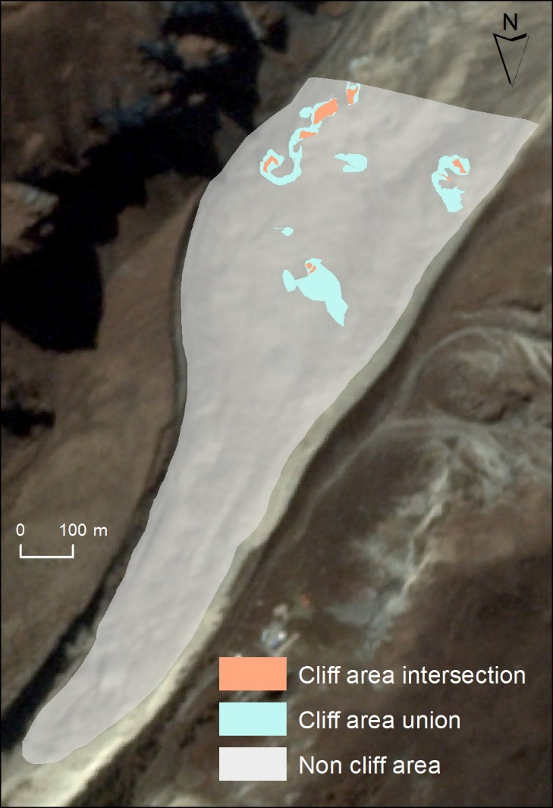
Figure S4: Areas that were interpreted and selected as representing ice cliffs and non ice cliff.
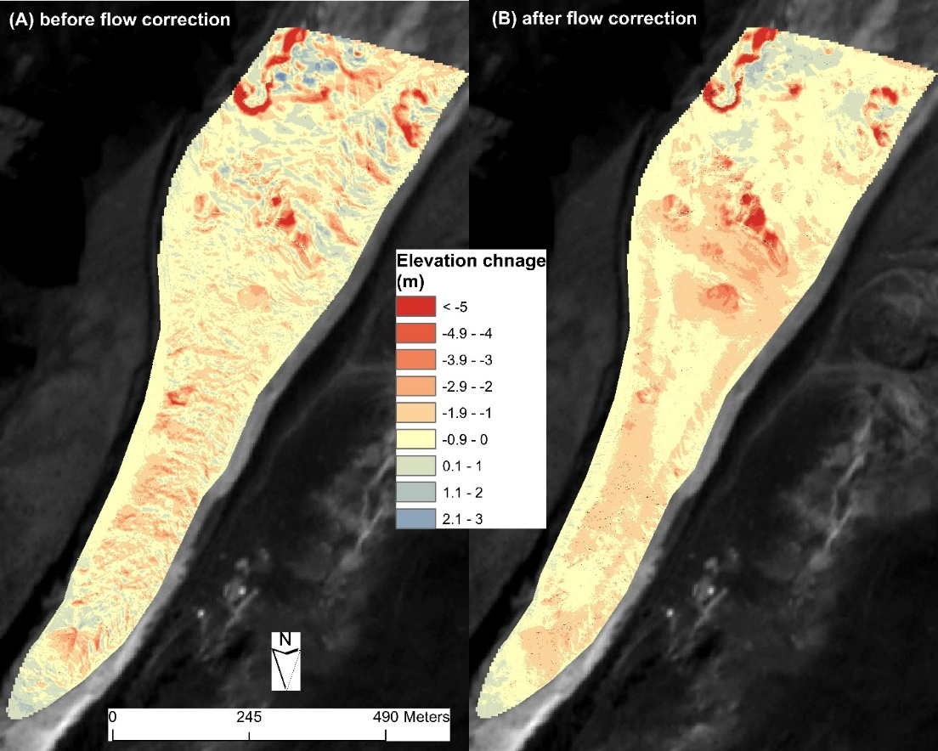
Figure S5: Comparison of elevation difference (DH) before and after flow correction.

